**Task #1 (10 points)**

**Give one example of weak type entity and strong type entity with indicating relationship between them. Draw ER diagram for this. Make sure to use any real life examples, but DO NOT USE examples already covered in the lecture slides. Using examples from the lecture slides will result in 0 points for this task.**

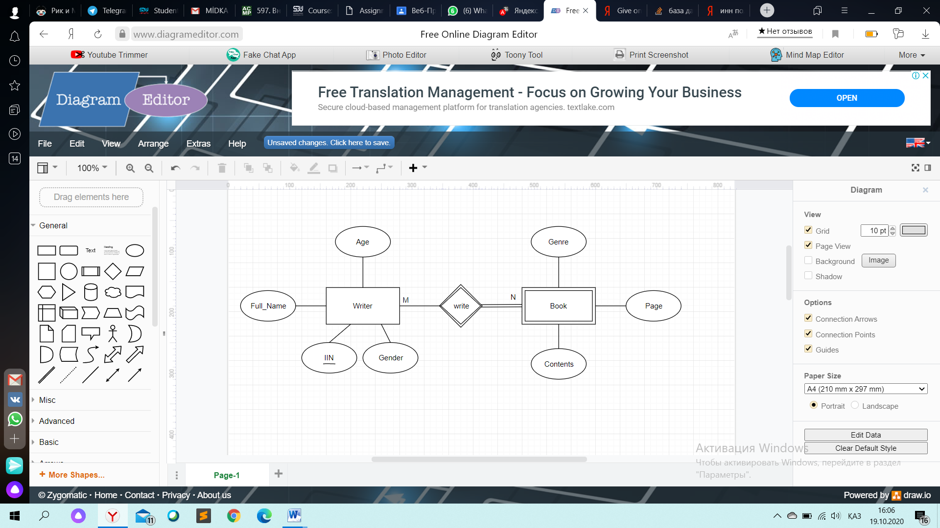

“Writer” – strong entity; “Book” – weak entity A weak entity is one that can only exist when owned by another one. A BOOK can only exist if it is written by a WRITER.

Weak relationship is “Wear”. Because it’s between a strong and weak entity, therefore indicated by two diamonds.

The “Writer” entity partially participates in the “Book” entity, but can have total participation in the “Book” entity, so it is assigned as a single line. The “Book” entity always has total involvement with “Writer”, so it is assigned as a double line.

Attributes of strong “Writer” entity: “Age”, “Full_Name”, “Gender”, “IIN”(ИИН)(is the Primary key, because it is unrepeated).

Attributes of weak “Book” entity: “Genre”, “Page”, “Contents”. Weak entity can not has the primary key.

Cardinality: There are many writers. There are many books. (M:N).

**Task #2 (10 points)**

**Give one example of entity type hierarchy. Draw ER diagram for this. Indicate what is super-entity here and what are sub-entities here. DO NOT USE examples already covered in the lecture slides. Using examples from the lecture slides will result in 0 points for this task.**

The circle is another symbol for isA. E-ER diagram – shows specialization circle (isA relationship), and inheritance symbol (subset symbol). Film can be Melodrama or Thtiller in this example.

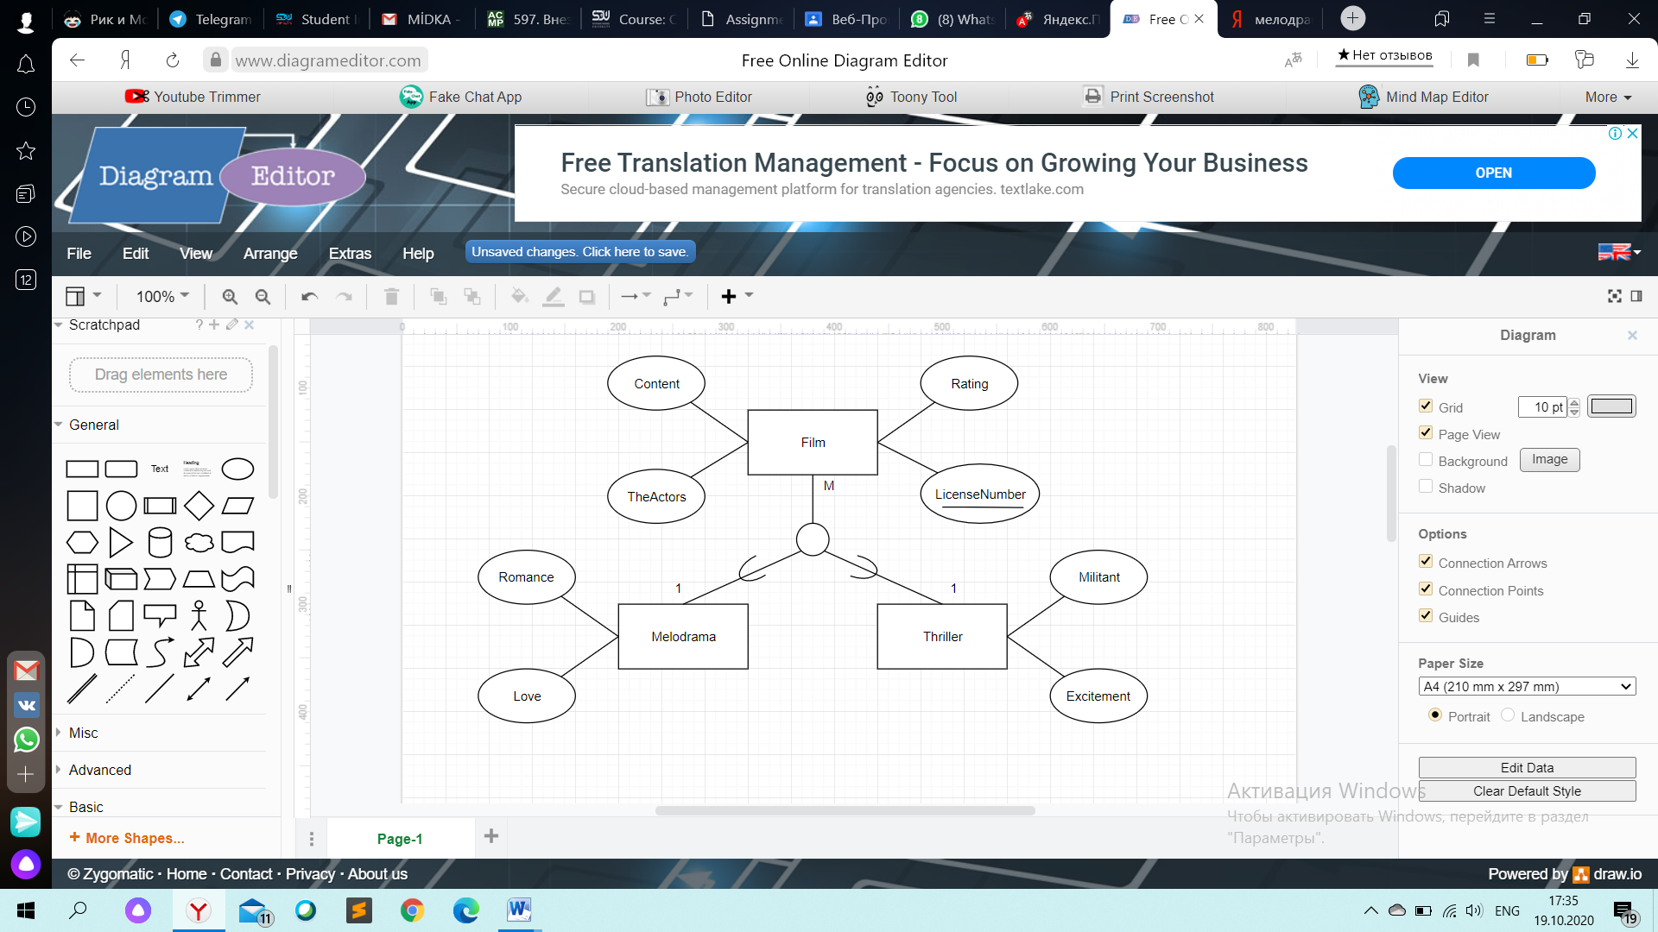

Super – entity: “Film”.

The main Film here. The Film may actually be different (such as “HorrorFilm”, “Сomedy” and etc.). Here I take the “Melodrama” and “Thriller” as sub – entities.

They are sub-entities, because it's a kind of film. They are films.

This relationship connects “Film” and “Melodrama”, “Film” and “Thriller”.

Attributes of super-entity “Film”: “Content”, “License”(Primary key), “Raiting” and “TheActors”.

Attributes of sub-entity “Melodrama”: “Romance”, “Love”, *“Content”, “License”(Primary key), “Raiting” and “TheActors”.*

Attributes of sub-entity “Thriller”: “Militant”, “Excitement”, *“Content”, “License”(Primary key), “Raiting” and “TheActors”.*

“Content”, “License”(Primary key), “Raiting” and “TheActors” are in the attributes of sub – entities, because it inherits from the attributes of super-entity “Film”.

Cardinalities: There are many films. There is one film, which genre is called “Melodrama” (M:1). There are many films. There is one lesson, which genre is called “Thriller” (M:1).

**Task #3 (10 points)**

**Give one example of the case when the object can be considered as entity or as relationship. Draw both versions of the cases when the object is depicted as entity and second version when the object is depicted as relationship. DO NOT USE examples already covered in the lecture slides. Using examples from the lecture slides will result in 0 points for this task.**

All we need in this task is that show some objects can be entity or relationship in some cases.

**Case1 - Object as relationship:**

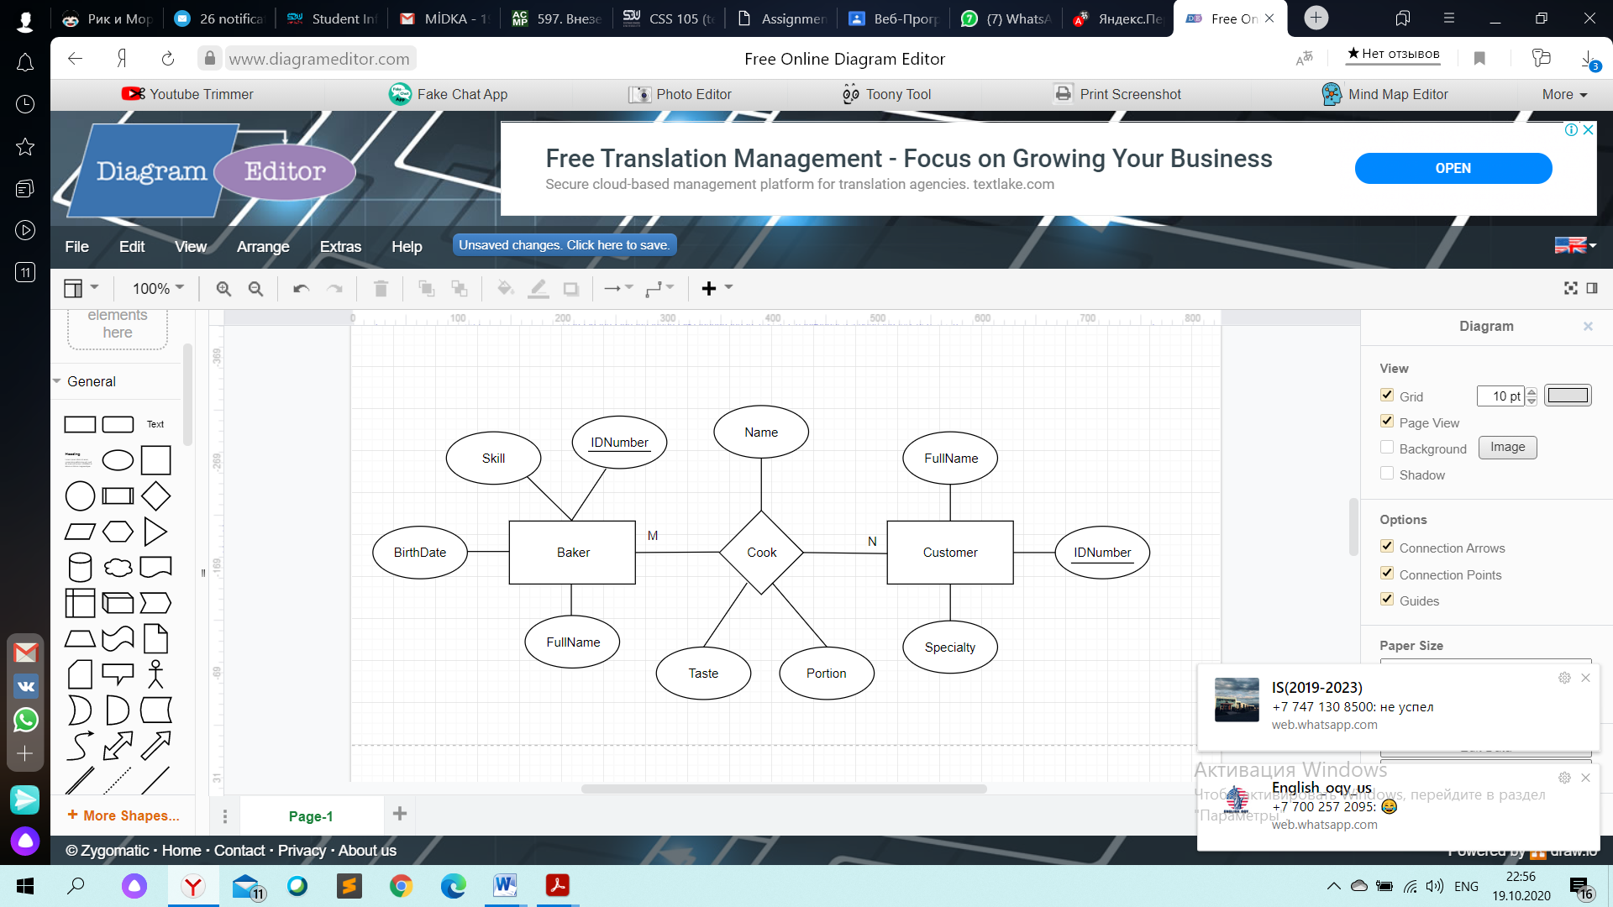

“Baker” and “Customer” entities connects with “Cook” relationship and single lines.

The Baker cooks for customers therefore “Cook” is relationship.

Some Baker cooks for some customer, just as some Baker cooks for some customer. Each entity is involved in a different entity, and so they will have a single line.

Attributes of entity “Baker”: “IDNumber”(Primary key), “Skill”, “BirthDate”, “FullName”. Attributes of entity “Customer”: “FullName”, “IDNumber” (Primary key), “Specialty”. Attributes of relationship “Cook”: “Name”, “Taste”, “Portion”.

Cardinality: There are many cooks(еда) and many bakers.(M:N).

**Case2 - Object as entity:**

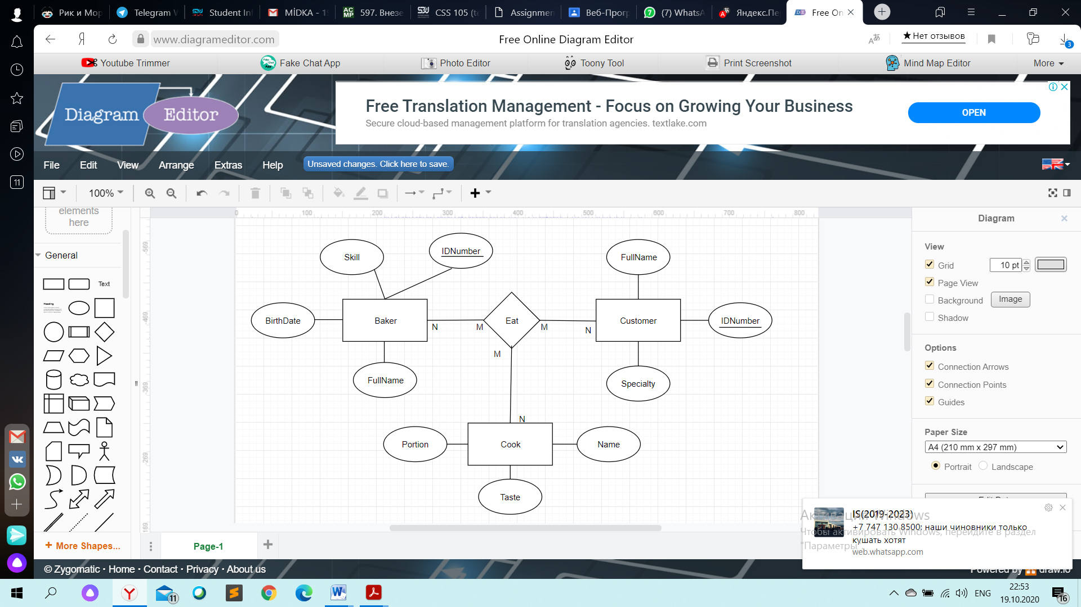

In this case “Cook” is the entity.

The "eat “relationship connects the entities “baker”, “customer”, and “cook". Both baker and customer can eat cook. so" eat” is a relation, and “cook” changes from the relation to the entity.

Attributes of entity “Cook”: “Portion”, “Taste”, “Name”.

Cardinalities: You can eat at any time. There are many bakers (M: N). You can eat at any time. There are many cusomers (M: N). You can eat at any time. There are many cook (M: N).

**Task #4 (15 points)**

A dentist’s office needs to keep information about patients, the number of visits they make to the office, work that must be performed, procedures performed during visits, charges and payments for treatment, and laboratory supplies and services. Assume there is only one dentist, so there is no need to store information about the dentist in the database. There are several hundred patients. Patients make many visits, and the database should store information about the services performed during each visit and the charges for each of the services. There is a standard list of charges, kept outside the database. The office uses three dental laboratories that provide supplies and services, such as fabricating dentures. Draw a complete E-R diagram for this example. *Make sure to indicate all primary keys, weak-strong entities, total participations, etc.

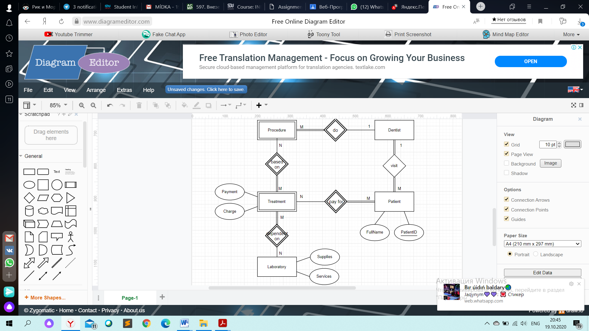

“Patient", “Dentist", “Laboratory", “Procedure” and “Treatment " are entities that describe our task.

“Patient", “Dentist", “Laboratory " are strong entities, because are independent from anything. “Procedure” depends on “Dentist” and “Treatment” depends on “ Procedure” , therefore weak entities.

The patient visits the dentist for treatment. The dentist is doing some of the procedures. Treatment depends on the procedures. The patient pays for the treatment. Treatment depends on the laboratory.

A “visit “occurs between two strong entities, so the” visit " relationship is strong.

Attributes of strong “Patient” entity: “PatientID” (Primary key), “FullName”. Attributes of strong “Laboratory” entity: “Suppplies” and “Services”. Attributes of weak “Treatment” entity: “Charge” and “Payment”.

Cardinality: There are many patients here, but only one dentist works. (1:m). One dentist works, but there are many procedures. (1:m). There are many methods of treatment and many procedures. Treatment depends on the procedures(M:N). There are many patients here and there are many treatments. The patient pays for the treatment (M:N). Treatment depends on the laboratory. There are many treatments available. There are three laboratories here. (M:N).

The dentist and the patient need each other. The doctor does not need the procedure, so he has partial participation. The procedure has total participation to the dentist, because the procedure is impossible if there is no dentist in it. The procedure can exist without treatment, so the procedure has a partial participation in the treatment. The procedure depends on the treatments, so the treatment has full participation in the procedure. Treatment depends on the laboratory, so the treatment has full participation in the laboratory and Vice versa, the laboratory has partial participation in the treatment. The patient needs treatment; therefore, the patient has full participation in the treatment. Conversely, the treatment does not need the patient, but the treatment has a partial involvement to the patient.

**Task #5 (15 points)**

Develop an EE-R diagram for the dental group described in task #4, but expand it by assuming that some of the dentists are surgeons, who can perform oral surgery. Also assume some of the professionals are dental hygienists, who can perform routine work such as cleaning and taking X-rays. A patient typically begins an ordinary visit by starting with a dental hygienist who performs routine work, and then a dentist who does a checkup during the same initial visit. The work needed is usually determined at this visit. If follow-up visits are required, each of the next visits will be with one dentist. If a patient requires oral surgery, at least one of his or her visits must be with one of the surgeons, even though the rest of the work needed might be performed by his or her regular dentist. When surgery is performed, there must be a qualified assistant present. Only some of the hygienists are qualified to assist in surgeries. Assume this database does not keep track of appointments, only of actual visits, work, billing, and payments.

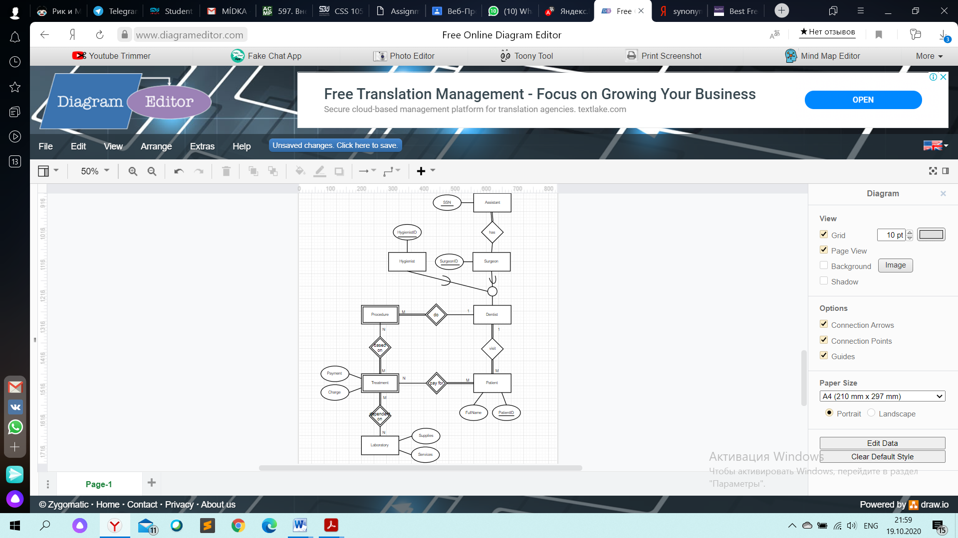

Here everything is like in problem number 4. But here dentists can be hygienists or surgeons. The circle is another symbol for ISA. E-ER diagram – shows the specialization circle (isA relation) and the inheritance symbol (subset symbol). The dentist can be a hygienist or a surgeon in this example.

Cardinality: The patient visits the dentist (M:N). The dentist can be a hygienist or a surgeon. There are many hygienists (M:N). There are many surgeons (M:N). One surgeon has one assistant (1:1).

Attributes of entity “Hygienist”: “HygienistID” (Primary key)

Attributes of entity “Surgeon”: “SurgeonID” (Primary key)

Attributes of entity “Assistant”: “SSN” (Primary key)

**Task #6 (5 points)**

Give example of derived attribute not covered on a lecture, show its graphical representation. Using examples from the lecture slides will result in 0 points for this task.

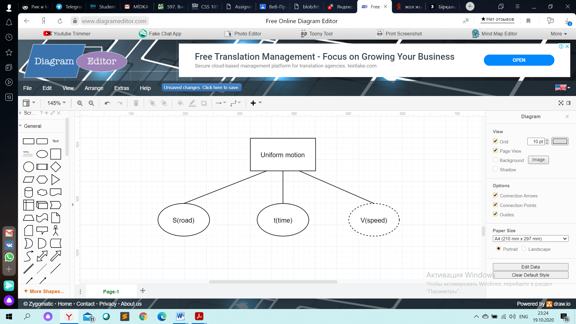

The “S(road)”, “t(time)” are stored attributes The “V(speed)” is the derived attribute

We can find the speed by relative to "S(road)" and "t(time)" so “V(speed)” is a derived attribute here.