**Task 1 (20 points)**

**Consider the following relation that stores information about students living in dormitories at a college: College (lastName, stuId, homeAdd, homePhone, dormRoom, roommateName, dormAdd, status, mealPlan, roomCharge, mealPlanCharge)**

Answer the following questions:

a. Using these assumptions and stating any others you need to make, list all the nontrivial functional dependencies for this relation:

stuId > lastName,homeAdd,status,dormRoom,roommateName,mealPlan)

dormRoom > dormAdd,roomCharge

homeAdd > homePhone

mealPlan > mealplanCharge

b. What are the candidate keys for this relation? Identify the primary key.

candidate key = stuid . primary key = stuid

c. Is the relation in third normal form? If not, find a 3NF lossless join decomposition of Books that preserves dependencies.

This is not in 3NF, because a transitive dependency exists between (dependency between nonprime attributes) these dependencies

dormRoom->dormAdd,roomCharge

homeAdd->homePhone

mealPlan->mealplanCharge

So, we can decompose it into the following set of table without any lossless decomposition,

1:​ (stuId,lastName,homeAdd,status,dormRoom,roommateName,mealPlan)

2: (dormRoom,dormAdd,dormCharge)

3: (homeAdd,homePhone)

4: (mealPlan,mealplanCharge)

d. Is the relation or resulting set of relations in Boyce-Codd Normal Form? If not, find a lossless join decomposition that is in BCNF. Identify any functional dependencies that are not preserved.

These 4 tables are in BCNF.

because stuId is a superkey in table 1.

dormRoom is a superkey in table 2.

homeAdd is a superkey in table 3.

mealPlan​ ​ is a superkey in table 4.

**Task 2 (25 points)**

**Consider the following table that holds basic information about members of a club: ClubMember(memberId, lastName, firstName, telephone)**

a. Assume you need to store the date the member joined the club and the date the membership ended. Create and/or modify the table to store these dates:

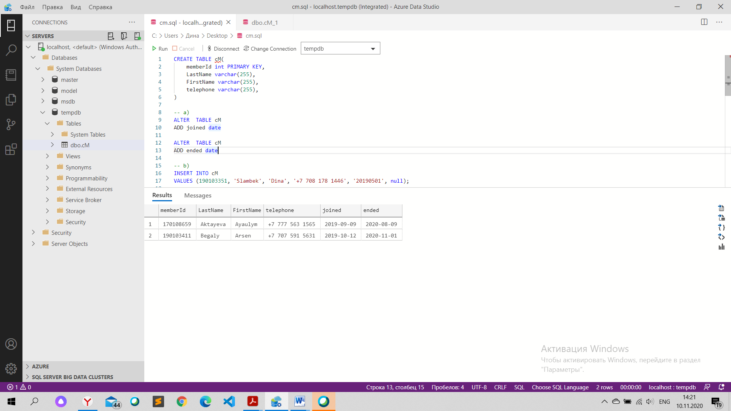

b. Insert five records indicating that five members joined the club within the past year, all on different dates:

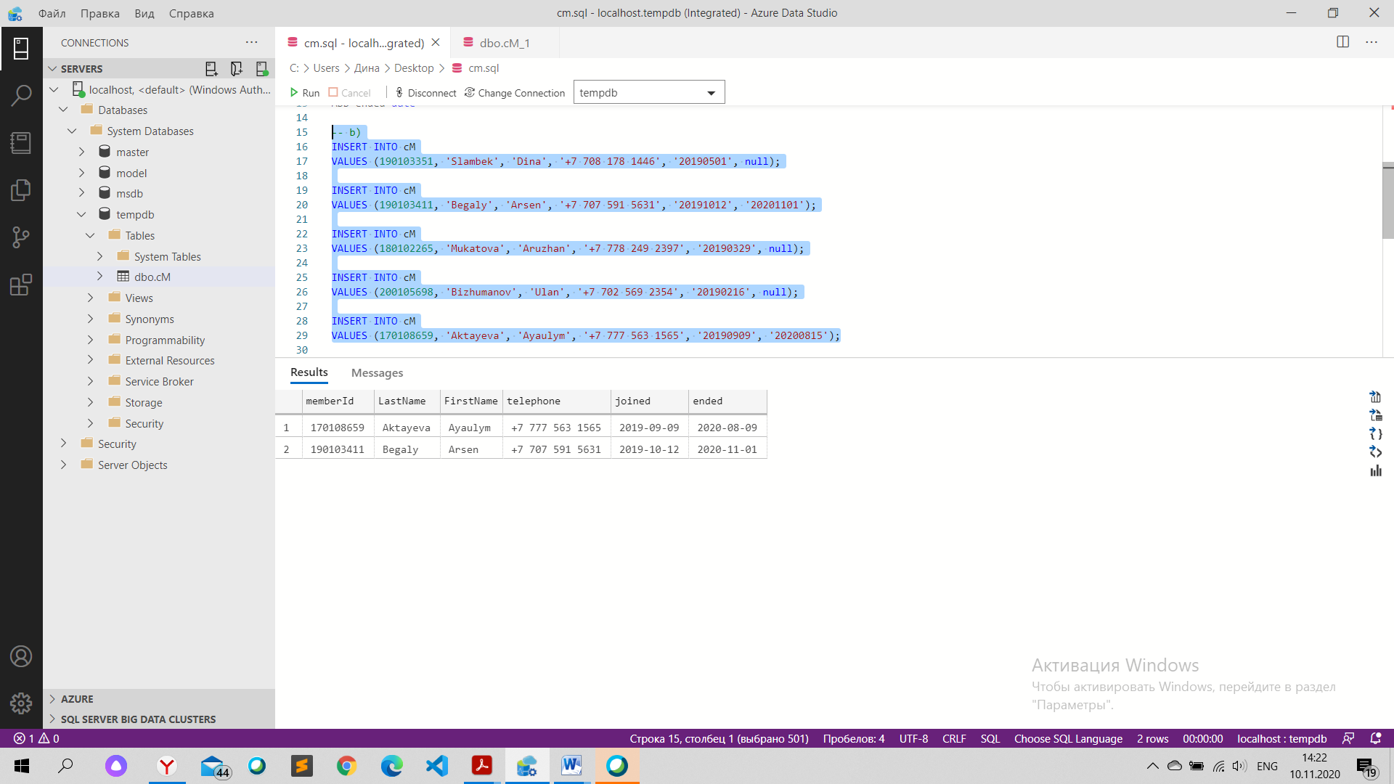

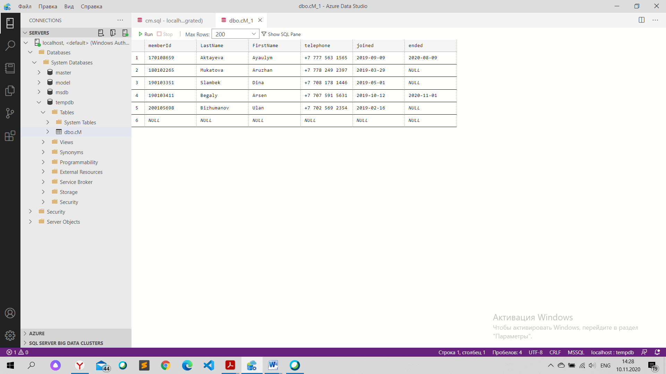

c. Write and execute an SQL query to find all the members who belong to the club as of today:

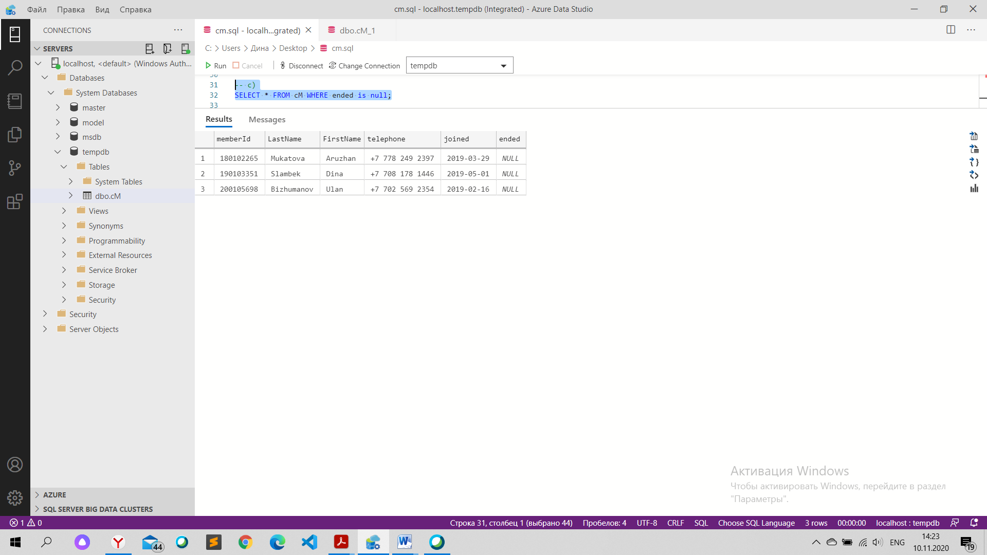

d. Modify the table to show that one member dropped his or her membership three months ago:



e. Repeat the query in part (c) to demonstrate that the person who dropped membership is no longer an active member:

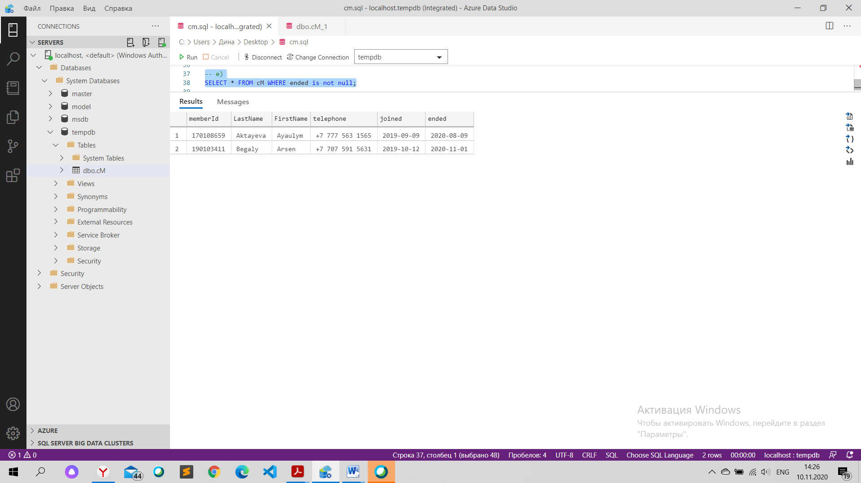

CREATE TABLE cM(

    memberId int PRIMARY KEY,

    LastName varchar(255),

    FirstName varchar(255),

    telephone varchar(255),

)

-- a)

ALTER  TABLE cM

ADD joined date

ALTER  TABLE cM

ADD ended date

-- b)

INSERT INTO cM

VALUES (190103351, 'Slambek', 'Dina', '+7 708 178 1446', '20190501', null);

INSERT INTO cM

VALUES (190103411, 'Begaly', 'Arsen', '+7 707 591 5631', '20191012', '20201101');

INSERT INTO cM

VALUES (180102265, 'Mukatova', 'Aruzhan', '+7 778 249 2397', '20190329', null);

INSERT INTO cM

VALUES (200105698, 'Bizhumanov', 'Ulan', '+7 702 569 2354', '20190216', null);

INSERT INTO cM

VALUES (170108659, 'Aktayeva', 'Ayaulym', '+7 777 563 1565', '20190909', '20200815');

-- c)

SELECT * FROM cM WHERE ended is null;

-- d)

SELECT * FROM cM WHERE ended < '20200810';

-- e)

SELECT * FROM cM WHERE ended is not null;