**Abstract**

Numerical 3D simulation supported with an experimental investigation is carried out over three different models, conical of 47 and 32 degrees and a sphere of radius 1 inch, to study the shock patterns generated. The present work makes use of the “Laminar High Mach Number Flow” module, and the results obtained from the CFD tool were supported by the, which are in acceptable agreement.

Keywords: Symmetric model, laminar boundary layer, wind tunnel, CFD simulation, Shock formation

1. Introduction

The presence of a small disturbance in a fluid is reported to the whole fluid by a wave moving at the speed of sound relative to the fluid. Adapt to the presence of an object or an obstacle, and as a result the change in the properties of the fluid with continuous and gentle changes in the flow lines will be gradual. It moves faster than the speed of sound. The fluid in front of the object will not be able to sense the presence of the object, and as the fluid passes over the object, sudden changes in the properties of the fluid occur.

Ultrasonic currents adapt to the presence of an obstacle by their shock waves. The shock wave process is accompanied by rapid and sudden changes in the properties of the fluid so that relatively large changes in pressure, temperature and density occur across the wave thickness.

In the present study, a numerical 3D simulation supported with experimental investigation is carried out over 3 different models, conical of 47 degree and 32 degree and a sphere of 1 inch, to study the high Mach number flow properties and the generated shock patterns. The work makes use of “Laminar High Mach Number Flow” module. The results obtained from finite elements simulation method are then compared with the results of the wind tunnel tests over the same models.

1. Numerical Investigation Development
   1. Geometry of Models under the study: The symmetrical models are a cone with 47 degrees, a cone with 32 degrees and a sphere of radius 1 inch, which are shown in figures 1 to 3.

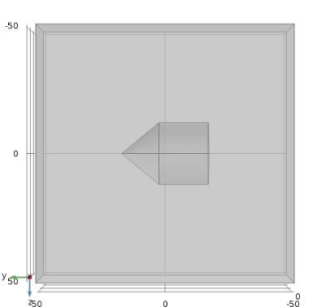

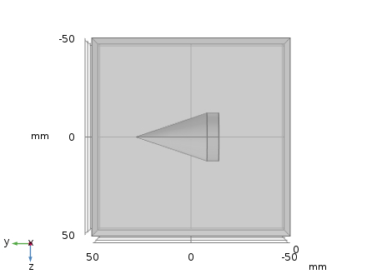

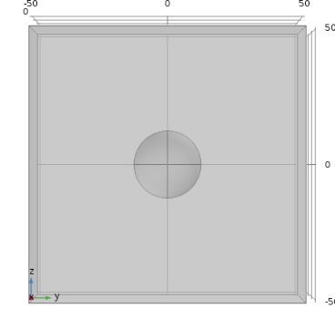

The models are studied to be inside the wind tunnel’s test section, and the resultant domains are shown in the figures 4 to 6. The models contain an inlet and outlet with walls around the model. The angle-of-attack and the dimensions of the domain are the same for all the cases. The dimensions of the boundaries are chosen based on the real dimensions of the supersonic wind tunnel so that the results would be comparable.

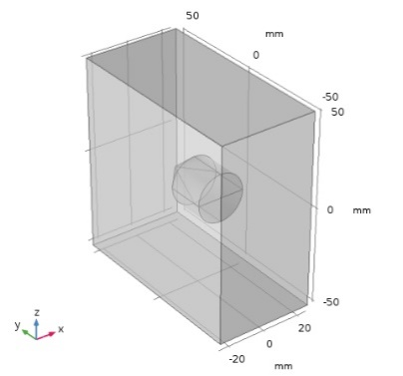

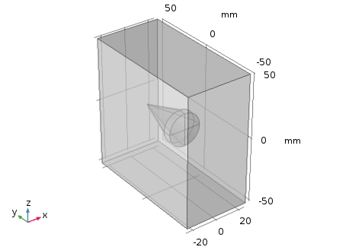

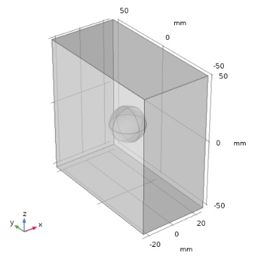

* 1. Governing Equations

In the current study, Laminar stationary compressible Navier-Stokes equations are solved which consist of conservation laws of mass, momentum and enthalpy. The equations are solved for 3D flow over symmetric models which are simulated to be inside the supersonic wind tunnel’s test section.

* 1. Boundary and Initial Conditions

The boundary conditions are chosen to be as follows:

* Wall: Slip Condition
* Model: No Slip Condition
* Inlet: M=1.6, T0=443.24 K, P0=1.94 atm.
* Outlet: Supersonic

The initial conditions are specified as below:

* Domain Variables: p=1 atm, T=293.15 K
* Domain Velocity: ux = 0 m/s, uy = 544 m/s, uz = 0 m/s.
  1. Grid and Solver

As the flow contains shock waves, the solution is done, first by implementing a stationary solver using iterative method which made the initial condition for the rest of the solution. Then the generated grid went under adaptive refinement based on the the solution’s results for two times followed by solving the domain again with the renewed mesh and the stationary solver. Mesh refinement is depicted in figures 7 to 16.

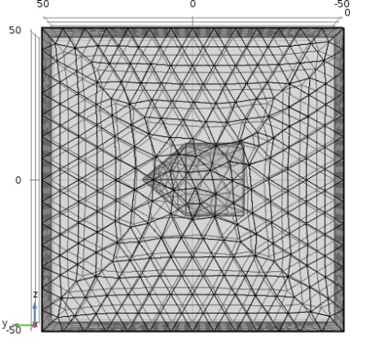

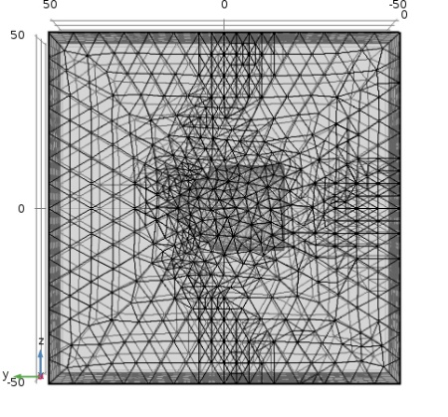

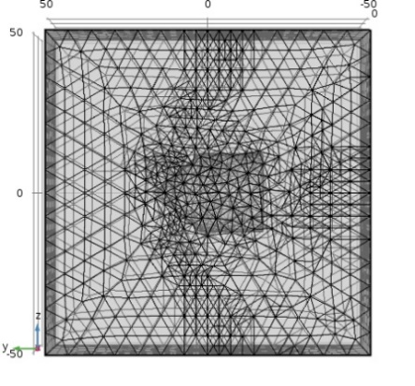

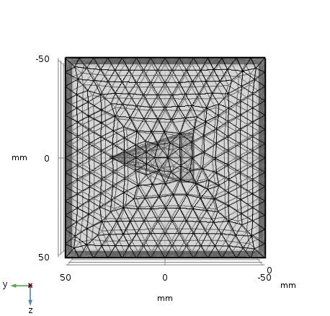

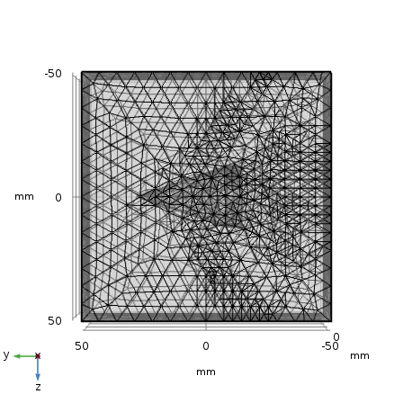

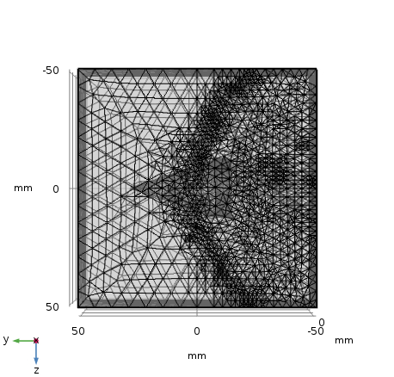

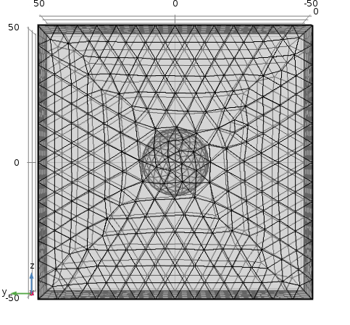

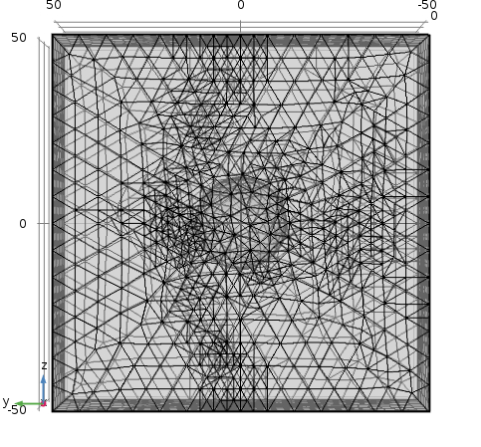

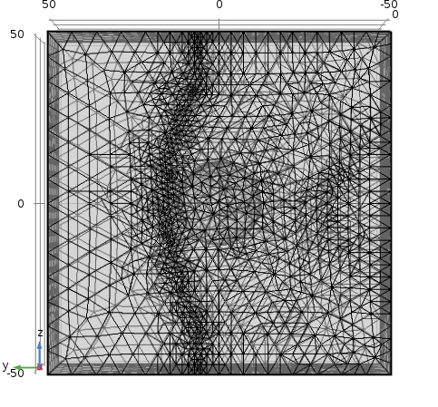

1. Experimental Setup
   1. Wind Tunnel

Experiments were conducted in the TE 24 supersonic wind tunnel of the Plint & Partners LTD brand. It is a continuous flow, open-circuit wind tunnel equipped with a changeable convergent-divergent nozzle as shown in figure 1.

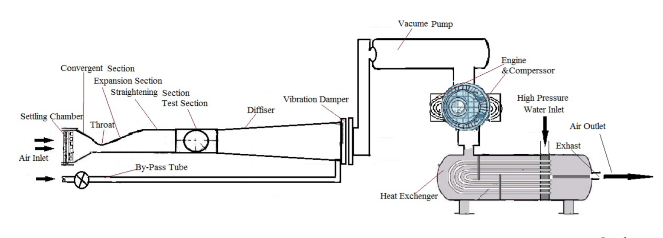

The working section of the wind tunnel is a convergent-divergent nozzle with a removable top part (liner) and stationary floor. The shape of the liner can be changed to vary the nozzle throat area and control the maximum air velocity at the divergent part of the working section.

This combination provides a Mach number range from 1.6 to 2.5 and it’s also appropriate for subsonic tests.

The sidewalls are flat and parallel through the nozzle and test section.

Models are thus normally mounted with wings vertical, and the strut translates horizontally to keep the model in the center of the tunnel as the pitch angle is changed.

The supersonic tunnel has a test section with a length of 1.8 m and a cross section of 101.6 × 0.0508 mm with adjustable air velocity at the turbulence intensity of approximately 0.25%.

* 1. Model Description

The models used in the current investigation are sphere, cone1 with 47° angle and cone2 with 32° angle. The free-stream Mach number is 1.6 and the initial conditions are p=1 atm, T=293.15 K.

In this experimental investigation, pressure measurements were done by mercury manometer; mercury height in the manometer’s tubes, give us the local pressure on the models. The nozzle shape which provides 1.6 Mach, is shown in figure 18.

1. Results and Discussion
   1. Numerical Simulation

Density contours which highlight pressure waves are presented including with surface plots of pressure, Mach and temperature, for the three cases through figures 19 to 34.

