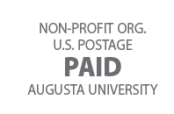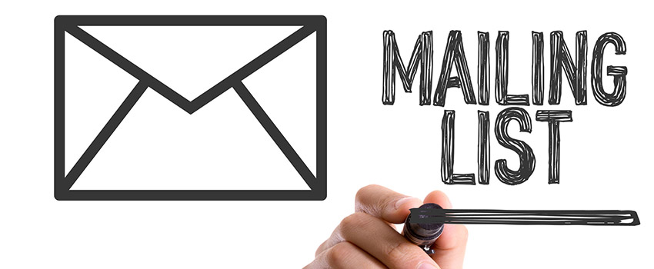

#### WHAT IS DIRECT MAIL?

Direct mail is an integrated marketing strategy that uses a mail service to deliver a custom promotional piece to a carefully selected target audience.

**DIRECT MAIL MARKETING MATERIALS:**

* Brochures
* Catalogs
* Postcards
* Newsletters
* Dimensional mailers
* Flyers

#### DIRECT MAIL / DIGITAL WORLD

When used effectively, direct mail is an integral marketing tactic for connecting and building your business and brand awareness to your customers.

The key to achieving success through direct mail marketing in a rapidly growing digital world is a multi-channel approach; making the most of your marketing dollars!

**Are you ready for your marketing to start getting the attention it deserves?**

