MER
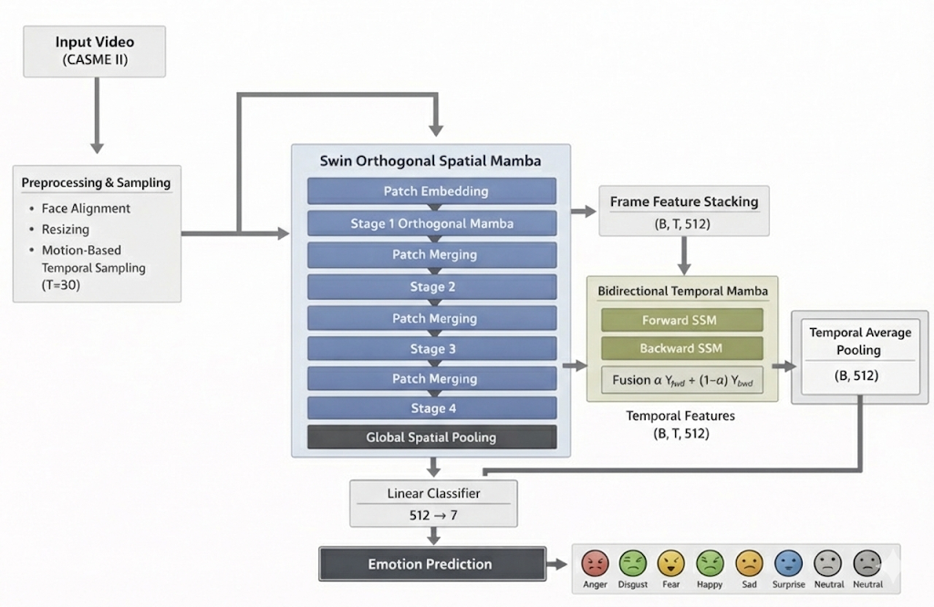

What Exactly Is Happening?

🔹 Spatial Modeling (Inside Each Frame)
- Swin-Mamba stages model local + global spatial micro-movements
- Patch merging reduces resolution and increases channels
- Final output per frame → 512-d representation

🔹 Temporal Modeling (Across Frames)
- Bidirectional Mamba models:
  - Onset → Apex → Offset
  - Micro-expression evolution
- Forward = natural progression
- Backward = reverse emotional dynamics
- α learns importance balance

📊 Tensor Shapes Through Pipeline
Stage | Shape
Input video | (B, T, 3, H, W)
After spatial backbone | (B, T, 512)
After Bidirectional Mamba | (B, T, 512)
After temporal avg pooling | (B, 512)
Classifier output | (B, 7)

🎯 Why This Is Strong for Micro-Expressions
✔ Captures subtle spatial muscle activations
✔ Captures short temporal evolution (≤ 0.5 sec)
✔ Bidirectional modeling handles incomplete onset/offset
✔ Learnable fusion adapts to dataset
Compared with transformer-based video architectures such as TimeSformer and ViViT, the proposed framework adopts a fundamentally different spatio-temporal modeling strategy. TimeSformer and ViViT rely primarily on global self-attention mechanisms to jointly model spatial and temporal dependencies, resulting in quadratic computational complexity with respect to token length and limited inductive bias toward local facial structures. In contrast, our approach integrates a hierarchical Swin-style spatial backbone with an Orthogonal Spatial Mamba module to capture structured local representations efficiently, followed by a Bidirectional Temporal Mamba for linear-complexity sequence modeling. This design introduces stronger spatial inductive bias through patch merging and multi-stage feature extraction while leveraging state-space modeling for long-range temporal dependency learning. Consequently, the proposed architecture achieves improved computational efficiency and enhanced sensitivity to subtle motion patterns, making it particularly well-suited for micro-expression recognition tasks where fine-grained spatial cues and temporally sparse dynamics are critical.
Aspect |  | TimeSformer |  | ViViT |  | Proposed Model
Backbone Type |  | Pure Transformer |  | Pure Transformer |  | Hybrid (Swin-style + Mamba)
Spatial Modeling |  | Global self-attention |  | Global self-attention |  | Hierarchical Swin + Orthogonal Spatial Mamba
Temporal Modeling |  | Divided / joint attention |  | Factorized / joint attention |  | Bidirectional Temporal Mamba (SSM-based)
Temporal Complexity |  | O(T²) |  | O(T²) |  | O(T)
Spatial Inductive Bias |  | Weak |  | Weak |  | Strong (hierarchical patch merging)
Memory Consumption |  | High (quadratic attention) |  | High |  | Lower (linear temporal modeling)
Long Sequence Scalability |  | Limited |  | Limited |  | Efficient
Suitability for Small Datasets |  | Moderate |  | Moderate |  | Strong (structured bias)
Micro-Expression Sensitivity |  | May miss subtle local motion |  | May miss fine-grained dynamics |  | Enhanced via local hierarchy + bidirectional SSM
Model | Spatial Module |  | Temporal Module |  | Complexity |  | Inductive Bias
TimeSformer | Global Attention |  | Self-Attention |  | O(N²) |  | Weak
ViViT | Global Attention |  | Self-Attention |  | O(N²) |  | Weak
Proposed | Swin + Orthogonal Mamba |  | Bidirectional Mamba |  | O(T) |  | Strong

1️⃣ Core Architectural Philosophy

🔷 Your Model: Swin-Orthogonal + Temporal Mamba
Design Principle:
- Separate spatial and temporal modeling
- Use structured state-space models (SSMs) instead of attention
- Efficient long-sequence modeling

Spatial:
- Hierarchical Swin-style structure
- Orthogonal directional Mamba blocks
- Patch merging (multi-scale)

Temporal:
- Bidirectional state-space model
- Linear complexity in sequence length
- Learnable forward/backward fusion

🔶 TimeSformer
Paper: "Is Space-Time Attention All You Need for Video Understanding?"

Key Idea:
Full transformer for video.
Two common variants:
- Joint space-time attention
- Divided attention (spatial then temporal)

Properties:
- Attention complexity: O((THW)²)
- Global token interaction
- Heavy memory usage

🔶 ViViT
Paper: "A Video Vision Transformer"

Variants:
- Factorized encoder
- Spatio-temporal attention
- Tubelet embedding

Properties:
- Patch-based tokens across frames
- Global self-attention
- Quadratic scaling in tokens

2️⃣ Computational Complexity Comparison
Model | Spatial Modeling | Temporal Modeling | Complexity
TimeSformer | Global Attention | Global Attention | O(N²)
ViViT | Global Attention | Global Attention | O(N²)
Your Model | Local + Structured SSM | Structured SSM | O(N)
Where:
N ≈ T × H × W
Your model scales linearly in time.
For micro-expression recognition (short but high-resolution videos), this is crucial.

3️⃣ Suitability for Micro-Expressions
Micro-expressions are:
- Very subtle
- Very short (≤ 0.5s)
- Muscle localized

TimeSformer / ViViT:
✔ Capture global context
❌ May dilute subtle local muscle movements
❌ Heavy overparameterization for small datasets like CASME II

Your Model:
✔ Orthogonal directional scanning captures subtle muscle shifts
✔ Hierarchical Swin preserves local structure
✔ Temporal SSM captures onset–apex–offset smoothly
✔ More stable on small datasets

4️⃣ Inductive Bias Differences

Transformers:
- Learn everything from data
- Weak inductive bias
- Need large-scale pretraining

Orthogonal Mamba + SSM:
- Strong structural bias
- Direction-aware modeling
- Better generalization in small-data regimes
This is extremely important for CASME II.

5️⃣ Temporal Modeling Comparison

TimeSformer Temporal Attention:
- Global token interaction
- No explicit notion of sequence direction
- Symmetric

Your Bidirectional Mamba:
- Explicit forward dynamics
- Explicit backward dynamics
- Learnable fusion weight α
- Models emotion evolution
This is more aligned with:
- Facial muscle contraction dynamics
- Real physiological motion

6️⃣ Memory Efficiency
Model | GPU Memory Usage
TimeSformer | High
ViViT | High
Your Model | Moderate / Low
For T=30 and 224×224 resolution:
Transformers explode in token count.
SSMs remain stable.

7️⃣ Theoretical Strength
Your model:
- Combines hierarchical representation (Swin)
- Directional structured modeling (Orthogonal Mamba)
- Continuous-time inspired sequence modeling (SSM)
This creates a hybrid of:
CNN-like locality + Transformer-level expressiveness + RNN-like temporal stability.

8️⃣ Clean Summary for Your Paper
You can write this:
Unlike TimeSformer and ViViT, which rely on quadratic self-attention for spatio-temporal modeling, the proposed architecture decouples spatial and temporal representations using structured state-space models. This results in linear computational complexity while preserving directional sensitivity and hierarchical representation, making it particularly suitable for subtle and short-duration micro-expression recognition tasks.

🎯 Strong Research Positioning Statement
Your work is NOT just another transformer variant.
It is:
A structured, direction-aware, linear-complexity alternative to attention-based video transformers tailored for subtle motion analysis.
That is publishable positioning.
Compared to transformer-based video models such as TimeSformer and ViViT, the proposed architecture replaces quadratic self-attention with structured state-space modeling for temporal dynamics. By combining hierarchical Swin-style spatial encoding with Bidirectional Temporal Mamba, the framework achieves linear temporal complexity while preserving fine-grained facial motion sensitivity. This design improves efficiency and robustness, making it particularly suitable for subtle and short-duration micro-expression recognition tasks.

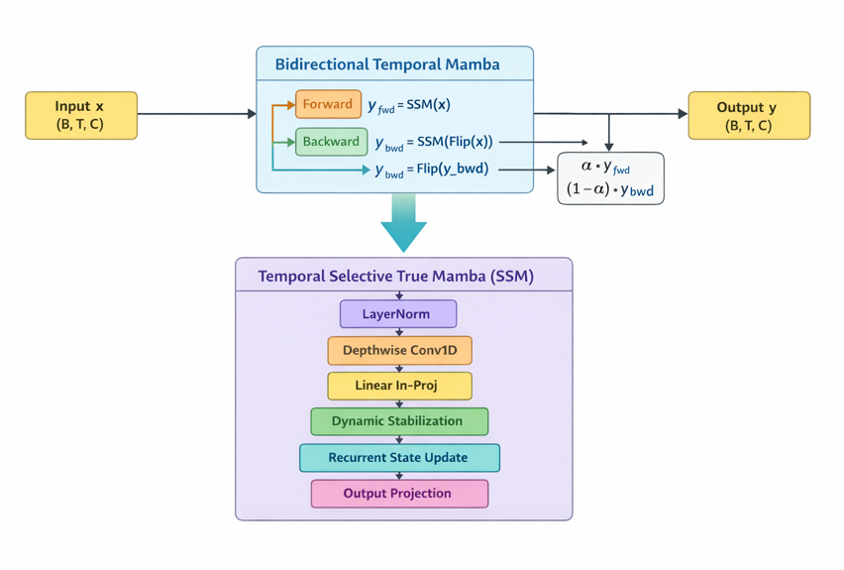

Temporal Modeling Methodology Update
In this stage, the temporal modeling component of the proposed Micro-Expression Recognition (MER) system was improved to better capture subtle and short facial movements. Since micro-expressions are brief and low-intensity, accurate temporal modeling is essential, especially when working with short sequences from datasets such as CASME II.
The updated module follows a Mamba-inspired Selective State Space Model (SSM) structure, adapted specifically for MER. Several improvements were introduced:
First, the state transition parameter was reformulated using a stable exponential function to ensure smooth and controlled temporal dynamics. This prevents instability during training and allows the model to learn both short-term and slightly longer-term motion patterns.
Second, a lightweight depthwise 1D temporal convolution layer was added before the state-space update. This helps the model better capture small frame-to-frame muscle movements, which are critical in detecting micro-expressions.
Third, a gating mechanism was introduced to filter out neutral facial noise and enhance important motion signals such as the apex phase of an expression.
Fourth, a residual connection was added to preserve useful spatial-temporal features from earlier layers and prevent over-smoothing of subtle signals during fine-tuning.
Finally, the bidirectional temporal module was improved by replacing a single fusion weight with learnable per-channel weights. This allows the model to adaptively balance forward (onset-to-apex) and backward (apex-to-offset) temporal information.
Overall, these modifications improve stability, enhance sensitivity to subtle facial dynamics, and maintain computational efficiency for short video sequences. The updated module remains lightweight while being more aligned with modern Mamba-style temporal modeling principles.
These improvements directly support the research objectives of this study. By enhancing the stability and sensitivity of the temporal modeling component, the system is better equipped to detect subtle micro-facial movements and distinguish between different emotional states. The refined bidirectional selective modeling is expected to improve classification accuracy and strengthen the model’s ability to differentiate genuine and subtle expressions, contributing to a more reliable and robust MER framework.

