Machine Learning for Spatial Enhancement of PM2.5 Prediction over India
Course project 3, CAMS EAC4 reanalysis, India, 2020–2024. Detailed per-step documentation: docs/steps/; timeline of all work and decisions: docs/steps/journal.md; terms: docs/steps/glossary.md.

Summary
We estimate fine particulate matter (PM2.5) over India from atmospheric and aerosol variables of the CAMS EAC4 reanalysis (3-hourly, 0.75°, 2020–2024), evaluate the models only at grid locations not used in training (whole spatial blocks held out), and use them to produce 0.25° maps.
- Accuracy (RQ1). At held-out locations the best method explains about two thirds of the variance: R² 0.68, RMSE 41 µg m⁻³, MAE 19 µg m⁻³ over 27 held-out blocks. The 6-block test set gives R² 0.72, but with very wide uncertainty.
- Models (RQ2). LightGBM is the best ML model (test R² 0.59; beats the neural network and random forest in 100% of bootstrap samples); linear models are far behind (R² 0.30), so the relationships are strongly non-linear.
- Features (RQ3). Aerosol optical depth matters most, followed by the daily and seasonal cycles, location and altitude (surface pressure); wind matters least.
- Regions and seasons (RQ4). Best in central India and the monsoon; worst in the northeast and in the pre-monsoon fire season, and at night. All methods under-predict the rare severe-pollution hours.
- New locations (RQ5). How much one method beats another depends strongly on which places are held out: with only 6 test blocks, a single block can decide a comparison.
- ML vs interpolation (RQ6). ML beats interpolation where neighbours are not representative (Himalaya; 100–300 km from known cells). Combining both (LightGBM + kriged residuals) removes LightGBM’s low bias and halves the under-prediction of severe pollution, but over many held-out places its RMSE is only slightly better than kriging or LightGBM alone. Fine maps from interpolated CAMS fields add little verifiable detail.

1. Objective and research questions
Develop and evaluate ML models that estimate PM2.5 at a location s and time t from CAMS atmospheric and aerosol conditions at the same s and t, test them at CAMS grid locations not used for training, and use them to make spatially enhanced PM2.5 maps over India.
- How accurately can PM2.5 be estimated from CAMS atmospheric and aerosol variables?
- How do different ML models compare?
- Which atmospheric and aerosol features are most important?
- How does performance vary across regions and seasons of India?
- How well do the models generalise to grid locations not used in training?
- How does ML-based spatial enhancement compare with standard spatial interpolation?

2. Data
Source. CAMS global reanalysis EAC4 (Copernicus Atmosphere Data Store), a chemistry–weather model with assimilated satellite observations. Box 6–38° N, 68–98° E; native grid 0.75° × 0.75° (~80 km); 3-hourly (00, 03, …, 21 UTC); 2020-01-01 to 2024-12-31: 14,616 time steps, 60 monthly downloads, no gaps, no missing values.
Variable | Role | Units used
PM2.5 (pm2p5) | target | µg m⁻³
AOD at 550 nm (aod550) | predictor | –
10 m wind u, v (u10, v10) | predictors | m s⁻¹
2 m temperature, dewpoint (t2m, d2m) | predictors | °C
surface pressure (sp) | predictor (≈ altitude) | hPa
derived: wind speed, relative humidity, local solar hour (sin/cos), day of year (sin/cos) | predictors | –
latitude, longitude | predictors | °
Domain. The 494 grid cells at least 50% inside India (Natural Earth 10 m state boundaries), grouped into 6 regions by state: Indo-Gangetic Plain (IGP, 84 cells), northwest (83), central (150), south (97), northeast (43), Himalaya (37). The 50% rule excludes 127 border/coast cells, including the Mumbai and Chennai cells (kept excluded by decision), and the island territories. Seasons follow the India Meteorological Department: winter (Jan–Feb), pre-monsoon (Mar–May), monsoon (Jun–Sep), post-monsoon (Oct–Dec).
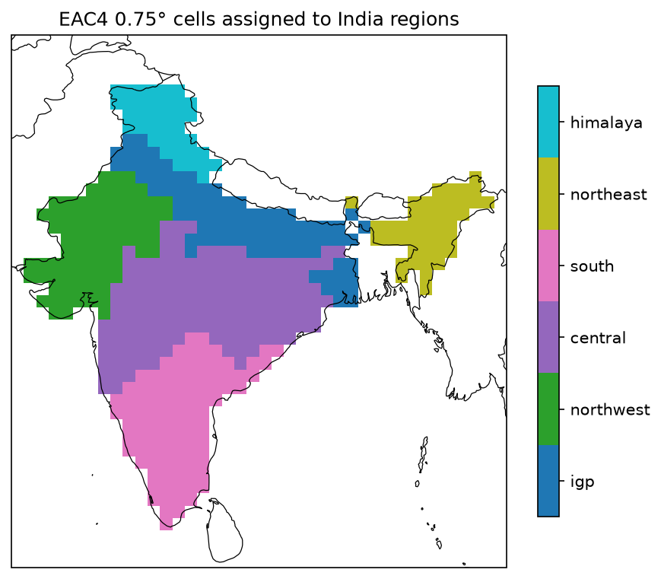
Regions
PM2.5 in the data. Mean 72.2, median 51.9, 95th percentile 207, maximum 5,651 µg m⁻³ (Assam, March 2021, fire season). The IGP is 2–4 × more polluted than other regions in winter (mean 218 µg m⁻³) and post-monsoon (207); the northeast peaks in March (fires); every region is cleanest in the monsoon. PM2.5 is highest at night (02:30–05:30 IST) and lowest in the afternoon (14:30 IST) everywhere: the shallow night-time boundary layer traps pollution. 2020 has the lowest annual mean (66 µg m⁻³, COVID-19 lockdown).
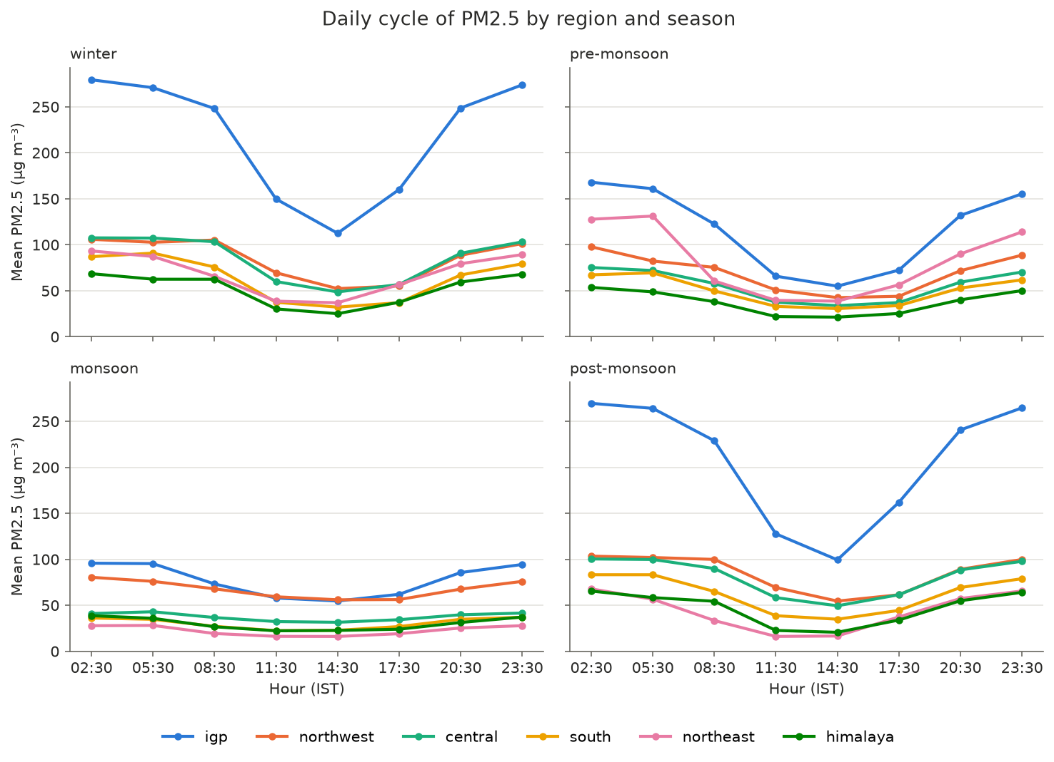
Daily cycle by region

3. Methods

3.1 Spatial hold-out
Neighbouring cells are strongly correlated: even after removing the predictors and a large-scale trend, only ~30% of the variance is “new” between cells 75 km apart, and the correlation length (variogram range) is ~900 km. Randomly held-out cells would therefore have near-identical neighbours in training and give inflated scores. We split by blocks of 5 × 5 cells (~380 km), a compromise between independence (~75–80% of the local correlation gone) and having enough blocks (33) to balance regions: 95 test cells in 6 blocks (19%), 399 training cells in 27 blocks, the latter divided into 5 cross-validation folds of whole blocks. Test and training cells have the same mean PM2.5 (72.6 vs 72.1). Test cells are a median 83 km (max 283 km) from the nearest training cell.
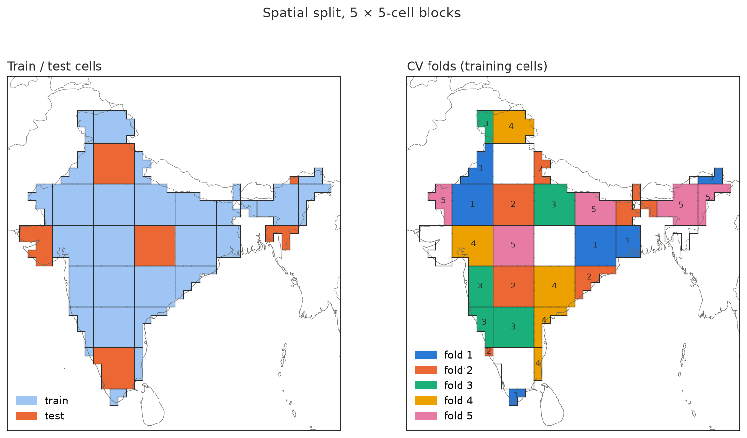
5 × 5 block split

3.2 Methods compared
Family | Method | Uses
Interpolation | nearest cell, inverse-distance weighting (IDW, 8 neighbours), Delaunay-linear (scattered-point bilinear), ordinary kriging (seasonal exponential variograms) | PM2.5 at training cells, same time step
Regression | linear regression; ridge; random forest; LightGBM (gradient-boosted trees); MLP (neural network) | predictors at the cell itself
Hybrid | LightGBM + kriged residuals (regression kriging); LightGBM + IDW residuals | both
Tuning. Each ML model got the same budget: 8 random settings, scored by 5-fold block-wise CV on training cells (5% of time steps), including the choice of raw or log(1 + PM2.5) target. All non-linear models chose the log target. Final models were fitted on all 5.8 M training rows (ridge, LightGBM) or 2 M rows (RF, MLP), and every prediction is clipped to [0, training maximum].
Hybrid. LightGBM predicts PM2.5 from the predictors; its errors at training cells (out-of-fold, i.e. from models that did not see those cells) are kriged to the target cell and added. The residual variograms reach a sill at ~490 km.

3.3 Evaluation
RMSE, MAE, R² and bias on the test cells, overall and by region, season, distance to the nearest training cell, hour of day, pollution level (India AQI categories) and year. Because the test set is only 6 blocks:
- Block bootstrap: resample whole test blocks 2,000 times for 95% ranges of every score and of paired differences between methods.
- CV check: the same comparison on the 399 training cells, each fold predicted only from the other four (27 blocks). The hybrid uses nested residuals (20 extra model fits) so that a fold’s own data never reaches its correction.

3.4 Feature importance and maps
SHAP values (exact TreeSHAP) of the final LightGBM on 200,000 rows from all India cells, plus permutation importance on test cells for single features and groups of related features. Maps: 0.25° grid inside India’s official boundary (Natural Earth, India point of view, including all of Jammu & Kashmir and Ladakh); predictors interpolated bilinearly, then LightGBM and the hybrid applied; compared with bilinear regridding and kriging of CAMS PM2.5.

4. Results

4.1 Accuracy and model comparison (RQ1, RQ2)
Test cells (6 blocks, 1.39 M values), with 95% block-bootstrap ranges:
Method | RMSE | 95% range | MAE | R² | bias
LightGBM + kriged residuals | 45.9 | 17.7–81.5 | 17.4 | 0.72 | −1.3
LightGBM + IDW residuals | 45.0 | 21.1–77.2 | 18.8 | 0.73 | −1.6
nearest cell | 53.7 | 25.2–84.1 | 24.0 | 0.61 | −7.9
LightGBM | 55.0 | 19.5–98.2 | 19.1 | 0.59 | −7.9
IDW | 55.1 | 25.3–92.6 | 23.8 | 0.59 | −7.2
kriging | 55.6 | 21.6–96.1 | 22.6 | 0.58 | −6.7
MLP | 59.2 | 22.7–105.1 | 21.8 | 0.53 | −11.0
Delaunay-linear | 59.8 | 24.6–95.1 | 25.2 | 0.52 | −10.3
random forest | 62.7 | 21.9–111.7 | 22.6 | 0.47 | −11.3
ridge | 71.3 | 36.1–119.1 | 35.1 | 0.31 | −5.1
linear regression | 72.0 | 37.2–119.3 | 36.8 | 0.30 | −6.8
CV check (training cells, 27 blocks, 5.8 M values):
Method | RMSE | 95% range | MAE | R² | bias
LightGBM + kriged residuals | 41.1 | 29.5–52.7 | 19.2 | 0.68 | −0.4
LightGBM | 41.9 | 30.4–53.1 | 19.4 | 0.66 | −6.3
kriging | 42.0 | 31.2–52.8 | 21.1 | 0.66 | −0.5
LightGBM + IDW residuals | 45.3 | 32.9–57.5 | 21.8 | 0.61 | −1.3
IDW | 45.8 | 36.1–55.1 | 24.5 | 0.60 | +2.4
nearest cell | 47.8 | 38.7–57.1 | 24.5 | 0.56 | +0.8
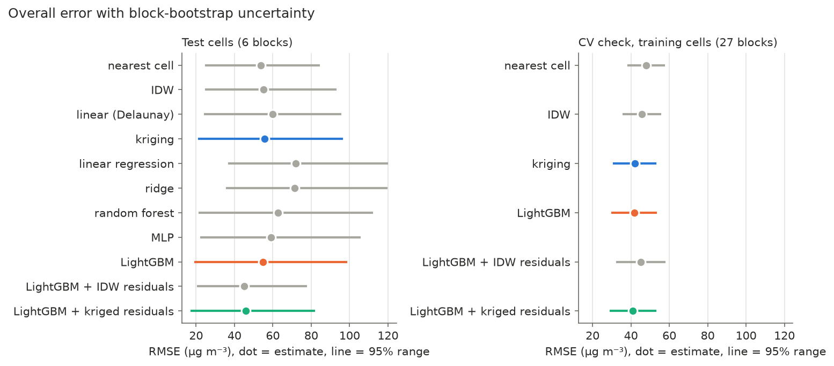
Overall RMSE with block-bootstrap ranges
- LightGBM is the best ML model: it beats the MLP (−4.2 µg m⁻³ RMSE) and the random forest (−7.8) in every bootstrap sample. Linear models reach only R² ≈ 0.3: effects are non-linear and change with season (e.g. temperature is negatively related to PM2.5 in winter and positively in the monsoon).
- Realistic accuracy at a new location is R² ≈ 0.7 (RMSE ≈ 41, MAE ≈ 19 µg m⁻³), with a plausible range of about 0.5–0.8 depending on the location. RMSE is dominated by rare extremes; MAE is the better guide to the typical error.

4.2 ML vs interpolation, and the hybrid (RQ5, RQ6)
Paired differences in RMSE (a − b), 95% range, and share of bootstrap samples in which a is better:
a vs b | test (6 blocks) | CV (27 blocks)
hybrid vs LightGBM | −9.0 (−15.7 to −1.1), 100% | −0.8 (−3.5 to +1.7), 71%
hybrid vs kriging | −9.6 (−15.4 to −3.4), 100% | −0.9 (−6.1 to +3.3), 65%
hybrid vs nearest | −7.8 (−18.0 to +2.0), 92% | −6.7 (−14.3 to +0.0), 97%
LightGBM vs kriging | −0.6 (−5.8 to +5.1), 60% | −0.1 (−3.8 to +2.5), 53%
kriged vs IDW residuals | +0.9 (−3.6 to +4.4), 33% | −4.2 (−5.7 to −2.7), 100%
- The hybrid’s large test-set gain (R² 0.59 → 0.72) comes almost entirely from 2 of the 6 test blocks (northeast block 38: −25 µg m⁻³ RMSE; IGP block 50: −12). Over 27 CV blocks the correction helps in 15 blocks and hurts in 12, and the overall gain shrinks to ~1 µg m⁻³: it helps where the model’s errors at neighbouring blocks carry over and hurts where they don’t.
- Robust on both sets: (1) the hybrid removes LightGBM’s systematic low bias (CV −6.3 → −0.4 µg m⁻³); (2) it halves the under-prediction of severe pollution; (3) kriging the residuals beats IDW of the residuals; (4) all ML methods beat nearest-cell copying.
- Where ML beats interpolation: in the Himalaya, interpolation fails (CV R²: kriging −0.05, nearest −1.23, LightGBM 0.81), because PM2.5 falls steeply with altitude and the nearest known cells are often on the plain. ML and the hybrid also win 100–300 km from known cells; interpolation wins within 100 km.
CV RMSE by distance to nearest known cell | ≤ 100 km | 100–200 km | 200–300 km
LightGBM + kriged residuals | 29.4 | 40.8 | 49.7
LightGBM | 30.1 | 41.9 | 50.6
kriging | 25.7 | 41.9 | 56.4
nearest cell | 29.4 | 47.3 | 67.5

4.3 Regions, seasons, hours and pollution levels (RQ4)
R² by region:
Method | IGP | northwest | central | south | northeast | Himalaya
test: hybrid | 0.74 | 0.68 | 0.86 | 0.69 | 0.53 | 0.86
test: LightGBM | 0.59 | 0.67 | 0.78 | 0.67 | 0.34 | 0.80
test: kriging | 0.50 | 0.44 | 0.80 | 0.63 | 0.42 | 0.70
CV: hybrid | 0.62 | 0.61 | 0.79 | 0.53 | 0.24 | 0.80
CV: LightGBM | 0.58 | 0.60 | 0.75 | 0.57 | 0.26 | 0.81
CV: kriging | 0.62 | 0.65 | 0.74 | 0.62 | 0.23 | −0.05
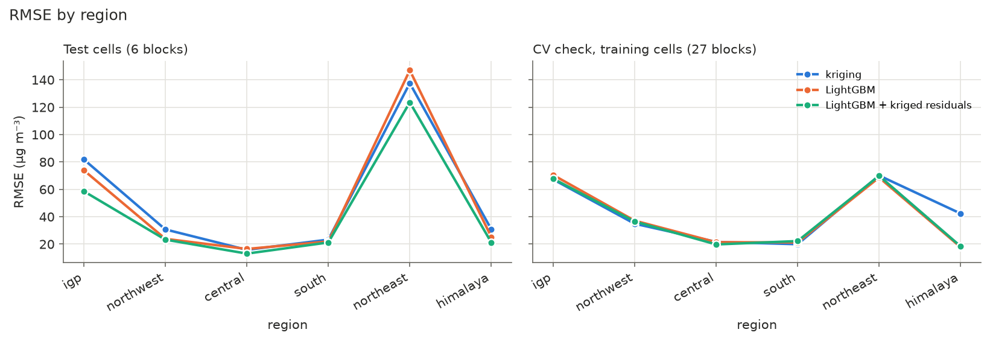
RMSE by region
- Central India is easiest, the northeast hardest (R² 0.23–0.53): pre-monsoon fire plumes are local and not described by the predictors.
- Seasons: best in the monsoon (CV R² 0.77), worst in the pre-monsoon (0.47).
- Hours: errors are 4–5 × larger at night (02:30 IST, RMSE ~58) than in the afternoon (14:30 IST, 12–17), following the daily cycle of PM2.5 itself.
- Pollution level: every method under-predicts “severe” hours (≥ 250 µg m⁻³, ~3% of rows): bias −116 (kriging), −121 (LightGBM), −62 (hybrid).
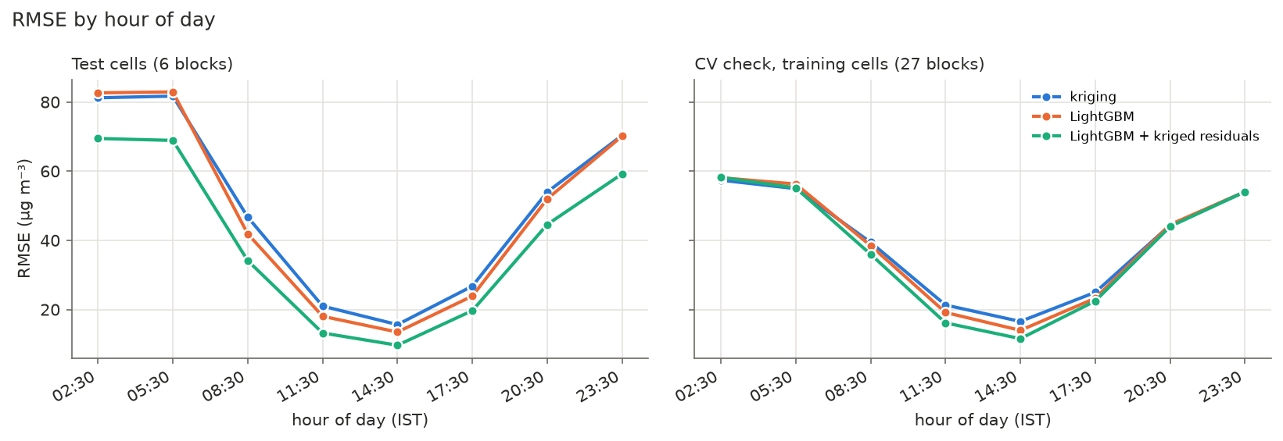
RMSE by hour of day
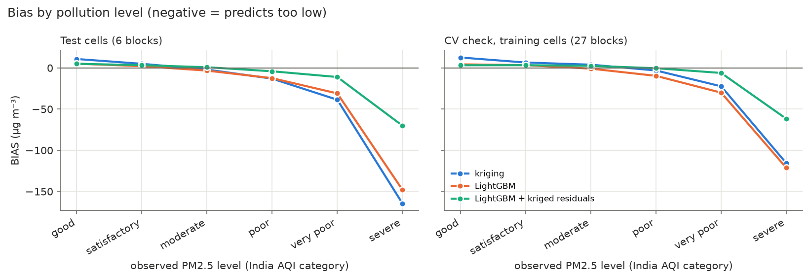
Bias by pollution level

4.4 Feature importance (RQ3)
Feature group | mean |SHAP| (log units) | RMSE increase when shuffled (µg m⁻³)
aerosol (AOD) | 0.35 | 11.4 (largest MAE increase, +12.5)
hour of day | 0.22 | 13.9
day of year | 0.17 | 14.5
location (lat, lon) | 0.17 | 18.8
surface pressure (altitude) | 0.15 | 10.2
temperature & humidity | 0.15 | 7.5
wind | 0.08 | 5.5
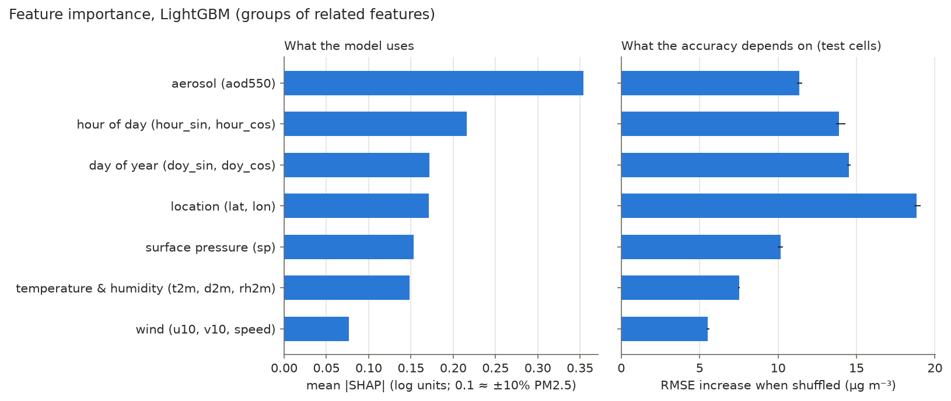
Feature importance
- AOD is what the model uses most (typical effect ±35–40%), rising steeply and then flattening with AOD.
- Location matters most for accuracy at new places: lat/lon carry large-scale emission patterns no other feature describes (removing them: test R² 0.59 → 0.48).
- Daily and seasonal cycles: predictions are ~30% higher at local night and ~25% lower around noon (boundary layer), ~20% higher in winter and lower in the monsoon.
- Altitude: surface pressure lowers predictions by up to ~55% at 600 hPa (~4,000 m); with AOD it dominates the Himalaya. Cold raises PM2.5 only in winter and post-monsoon. In the pre-monsoon, weather explains least (fires).
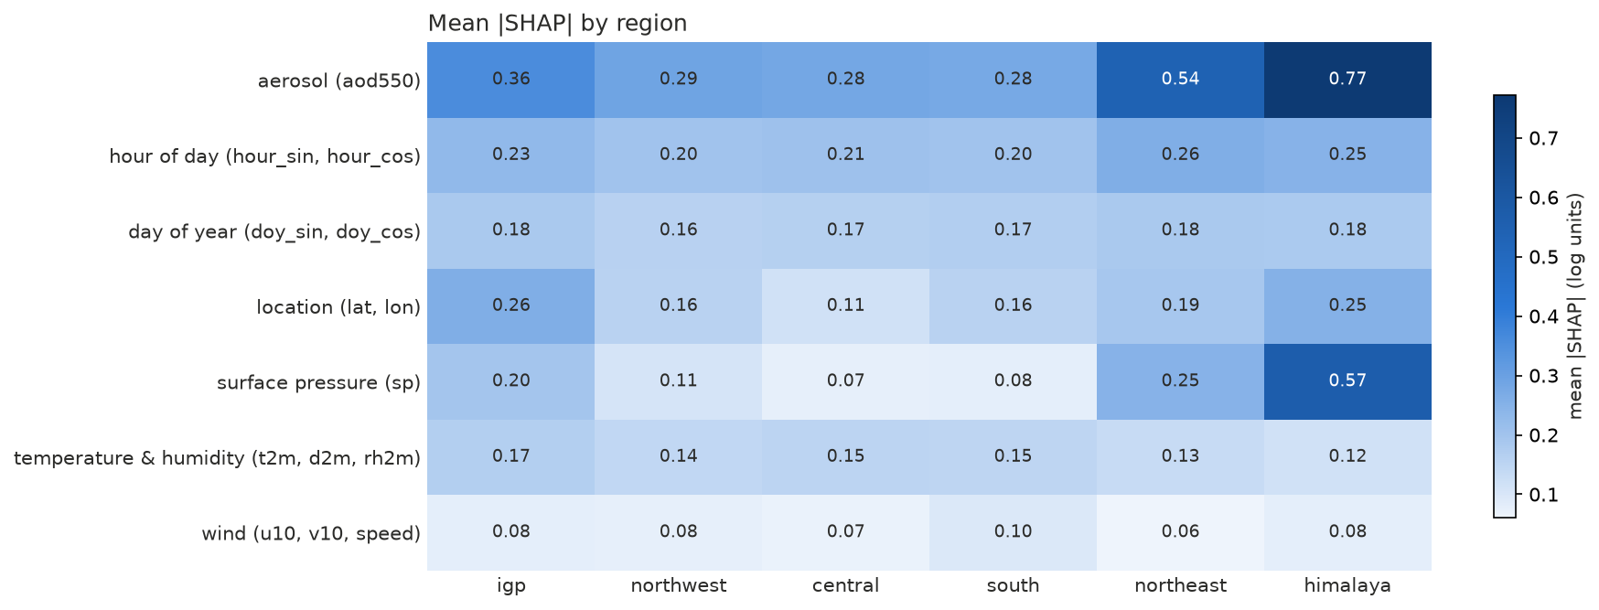
SHAP by region
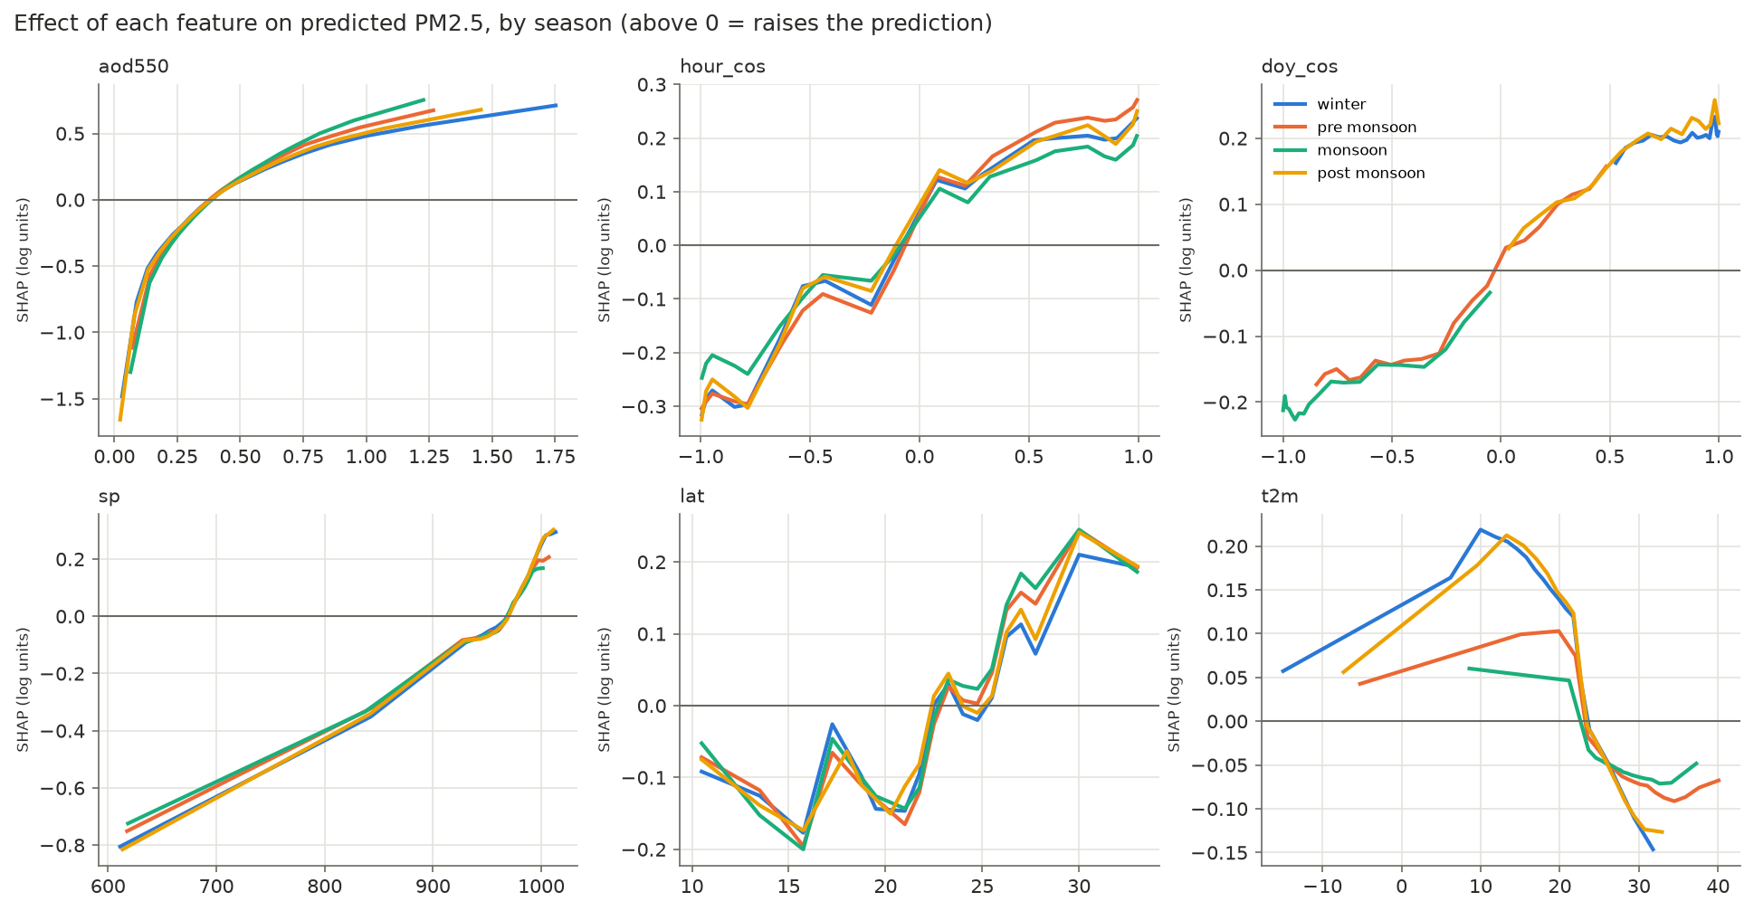
SHAP dependence

4.5 Spatially enhanced maps (RQ6)
Seasonal means at 0.25°; hatched areas (PoK, Aksai Chin, excluded coastal cells) are inside India’s official boundary but outside the area the models were trained and evaluated on.
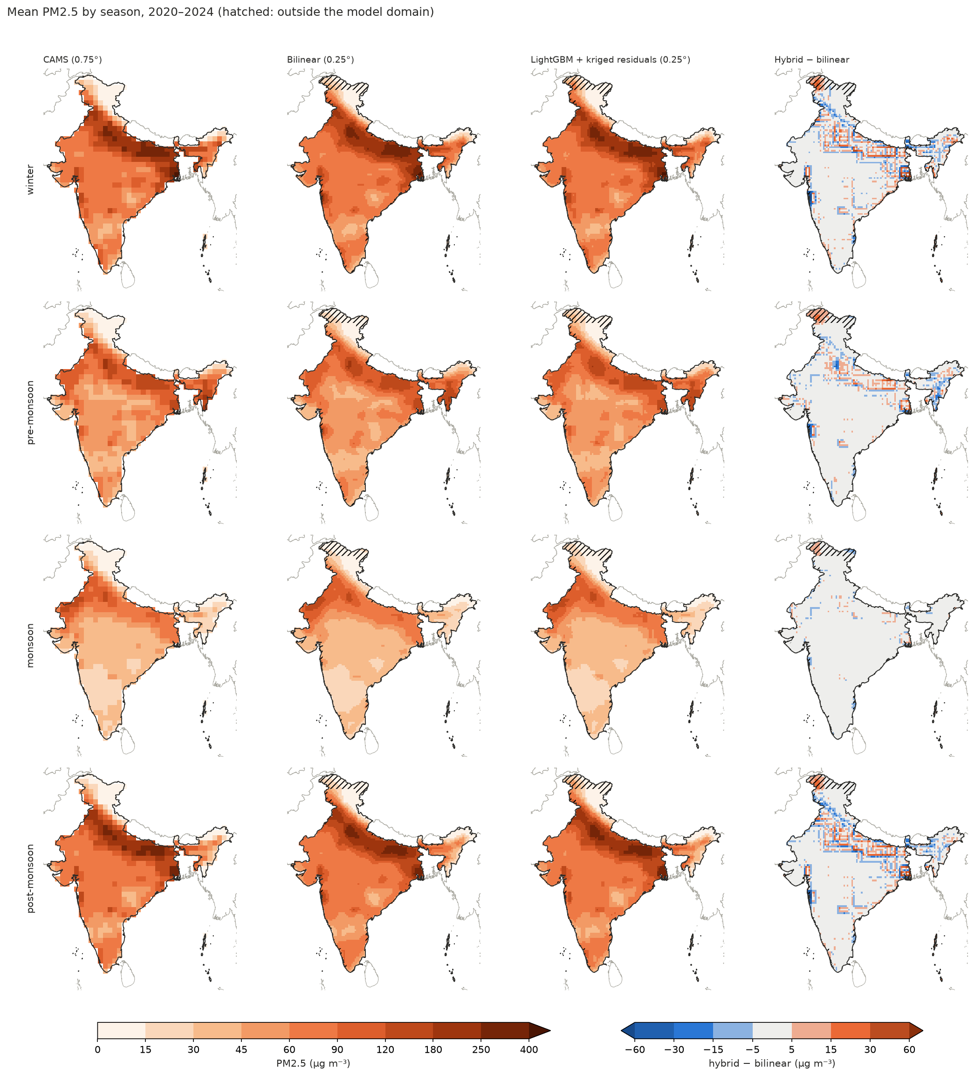
Seasonal mean maps
Fine map averaged back to 0.75° vs CAMS | RMSE | R² | bias
bilinear | 8.9 | 0.985 | −0.3
LightGBM + kriged residuals | 10.5 | 0.979 | −0.2
kriging | 15.8 | 0.952 | −0.3
LightGBM alone | 28.9 | 0.841 | −3.5
- All methods show the same large-scale picture: the IGP hotspot in winter and post-monsoon, a clean Himalaya and south, a clean monsoon except the desert northwest.
- The hybrid stays almost as faithful to CAMS as bilinear regridding and differs from it by 2–6 µg m⁻³ on average (most in the IGP, Himalayan foothills, northeast). It adds some plausible detail at the plain-to-Himalaya transition (steepest gradients 11–14% sharper than bilinear) but keeps a visible imprint of the 0.75° grid (it equals CAMS at every CAMS cell centre).
- LightGBM alone is not a good mapping method (drifts from CAMS, biased low).
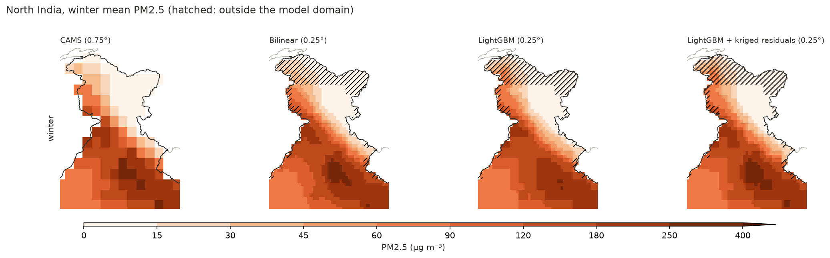
North India, winter

5. Discussion and limitations
- CAMS is not ground truth. All accuracies are agreement with a model reanalysis, not with measured air quality. CAMS is known to overestimate PM2.5 over the IGP.
- AOD and PM2.5 come from the same simulated aerosol field in CAMS, so the strong AOD → PM2.5 link (and AOD’s top importance) is partly built in. With satellite AOD and station PM2.5 the task would be harder and meteorology would likely matter more.
- Small test set. 6 test blocks with mostly one block per region make per-region test results anecdotal; the CV check (27 blocks) is the more reliable basis for comparisons. It slightly favours LightGBM, whose settings were tuned on the same folds.
- No validation below 0.75°. The fine maps can only be checked for consistency with CAMS. Their extra detail comes from the model’s learned response to interpolated predictors; real enhancement would need fine-resolution inputs (elevation model, satellite AOD at 1–10 km, emission or population maps) and fine-resolution reference data.
- Domain choices. Cells less than 50% inside India (incl. Mumbai and Chennai) and the island territories are excluded from training and evaluation. The region mask follows the de facto boundary; the maps use India’s official boundary, with the difference hatched.
- Reproducibility across machines. The project was run on two machines (Fedora, macOS). Tree models and interpolation give identical results; the MLP does not (test R² 0.545 vs 0.528 with the same seed). An IDW tie-breaking difference between machines was found and fixed (stable sort). Reported numbers are from the macOS re-run.

6. Conclusions
- From CAMS atmospheric and aerosol variables, PM2.5 at unseen locations can be estimated with R² ≈ 0.7 and a typical error of ~19 µg m⁻³; errors concentrate in severe-pollution hours, at night, in the northeast and in the fire season.
- Gradient boosting (LightGBM) is the best of the ML models tested.
- AOD, the daily and seasonal cycles, location and altitude drive the predictions.
- ML and interpolation are complementary: ML wins where neighbours are not representative (mountains, far from data), interpolation close to known cells. Their combination removes the ML model’s bias and reduces peak under-prediction, but its average accuracy gain over the best single method is small and location-dependent.
- Evaluation with only a few held-out blocks can badly over- or under-state such gains; a block bootstrap and a cross-validation check over many blocks are needed before drawing conclusions.

7. Reproducing the results
Environment: conda env create -f environment.yml (env pm25), ADS credentials in ~/.cdsapirc. Run from the repository root:
Step | Command | Time (macOS, 16 GB)
01 Download | conda run -n pm25 python scripts/download_eac4.py | ~6 h (ADS queue)
02 Region mask | conda run -n pm25 python scripts/build_region_mask.py | seconds
03 Preprocessing | conda run -n pm25 python scripts/preprocess_eac4.py | ~1 min
04 Exploration | conda run -n pm25 python scripts/explore_eac4.py | ~30 s
05 Splits | conda run -n pm25 python scripts/make_splits.py | seconds
06 Baselines | conda run -n pm25 python scripts/run_baselines.py | ~15 s
07 ML models | conda run -n pm25 python scripts/train_models.py --n-iter 8 --cv-time-frac 0.05 | ~40 min (or --cv-from results/07_models/all/cv_results.csv: ~4 min)
08 Hybrid | conda run -n pm25 python scripts/run_hybrid.py | ~9 min
09 Evaluation | conda run -n pm25 python scripts/evaluate.py | ~25 min
10 Feature importance | conda run -n pm25 python scripts/feature_importance.py | ~20 min
11 Maps | conda run -n pm25 python scripts/make_maps.py | ~11 min
12 Report figures | conda run -n pm25 python scripts/report_figures.py | ~10 s
Tests: conda run -n pm25 python -m pytest (73 tests). Data, .nc prediction files and fitted models are not in git; every script writes its settings and results to results/logs/<script>.log and results/<step>/config.json.

