**CONCEPCION HOLY CROSS COLLEGE, INC.**

**COMPUTER STUDIES DEPARTMENT**

Minane, Concepcion, Tarlac

**First Semester A.Y. 2024 – 2025**

**CASESTUDY**

**IN**

**APPLICATION**

**DEVELOPMENTAND**

**EMERGING**

**TECHNOLOGIES**

Submitted by:

**Dines Basco**

*Bachelor of Science in Computer Science Students*

BSCS2C

Submitted to:

**Mr. Arjay D. Balberan**

*Instructor*

October 12, 2024

# Table of Contents

1. **Introduction ----------------------------------------------------------------------------------------** Page 3
   1. Background of the website **------------------------------------------------------------------** Page 3
   2. Importance of a Website -------**-------------------------------------------------------------** Page 4
   3. Objectives of the Website **-------------------------------------------------------------------** Page 4
      1. General objective **--------------------------------------------------------------------** Page 4
      2. Specific objectives **-------------------------------------------------------------------** Page

5

1. **Literature Review --------------------------------------------------------------------------------** Page 6
   1. Existing Website related to Title -----------------------------**------------------------------** Page 6
   2. Relevant Technologies **----------------------------------------------------------------------** Page 7
2. **System Requirements and Design --------------------------------------------------------------** Page 8
   1. System Requirements **------------------------------------------------------------------------**Page8
      1. Hardware Requirements **---------------------------------------------------------------** Page 8
      2. Software Requirements **----------------------------------------------------------------** Page 8
      3. Network Requirements **----------------------------------------------------------------** Page

9

* 1. Functional Requirements **---------------------------------------------------------------------** Page 9
  2. Database Design **-----------------------------------------------------------------------------** Page 11
     1. Entity-Relationship Diagram (ERD) **-----------------------------------------------** Page 11
     2. Data Flow Diagram (DFD) **----------------------------------------------------------** Page

11

* 1. Database Tables **------------------------------------------------------------------------------**Page 13
  2. System Architecture **-------------------------------------------------------------------------** Page 15

1. **Development Process -----------------------------------------------------------------------------**Page

16

* 1. Planning **---------------------------------------------------------------------------------------**Page 18
  2. Analysis **---------------------------------------------------------------------------------------**Page 18
  3. Design **-----------------------------------------------------------------------------------------**Page 19
  4. Implementation **-------------------------------------------------------------------------------**Page

19

* 1. Testing **----------------------------------------------------------------------------------------** Page 19
  2. Deployment **----------------------------------------------------------------------------------** Page 19

1. **User Testing and Feedback ---------------------------------------------------------------------**Page 20
   1. Testing Procedures **---------------------------------------------------------------------------**Page

20

* 1. Issues Identified **------------------------------------------------------------------------------**Page 20 5.3 Solutions Implemented **----------------------------------------------------------------------** Page 20
  2. Feedback from Users **-------------------------------------------------------------------------**Page 21
  3. Final Adjustments **----------------------------------------------------------------------------**Page

21

1. **Grades ----------------------------------------------------------------------------------------------** Page

22

1. **References** ------------------------------------------------------------------------------------------Page

23

# Introduction

*Background of Daily Grind Coffee Shop*

The growth of coffee house in Manado motivate the owner of Decade Coffee Shop to open a coffee shop that offers a calm and comfortable for the gathering of consumers with friends or relatives or just want to relax enjoying coffee. Revisit intention is described as the willingness of customer to come back to the same place or probability of them to repurchase a product from the same place. Revisit intention can be affected by so many factors, include lifestyle, service scape, and food quality. The purpose of this study is to know the simultaneous and partial influence of lifestyle, servicescape, and food quality on customer revisit intention at Decade Coffee Shop. This research used multiple regression analysis with sample of 100 respondents. The result shows that lifestyle, servicescape, and food quality are simultaneously influence customer revisit intention. Service scape and food quality have significant influence on customer revisit intention partially, meanwhile lifestyle has not have a significant influence on customer revisit intention. Based on the result, researcher suggest that the place should be always clean, well arranged, and have a good atmosphere to retaining the customers. The owner should keep their employees current performance like give a bonus or other reward that can be motivate the employee to work harder because it shows that they already done their job well by serving a delicious and well-presentation food for the customers. The last, Decade Coffee Shop should think about how to attract and drive the customers to spend their free time at Coffee Shop.

The issues is about increasing phenomenon in contemporary cities is to work in multiple places, such as home, offices, and coffee shops, while simultaneously using ICT devices and networks. However, little attention has been paid to the new socio-spatial demands facing city services. This phenomenon has been empirically studied through a comparative case study in the city of Helsinki, Finland, by conducting observations of one public library (Library 10) and one coffee shop, as well interviews with the multi-local workers and managers of the two places. This comparative case study shows that multi-local workers with different profiles (age, level of education, contract of employment) and varied socio-spatial working practices use the library and coffee shop for several working purposes, such as individual or collective informal offices, or as temporary workplaces of a larger city network with urban ambiance.

*Importance of Daily Grind Coffee Shop*

Daily Grind Coffee Shop have become essential hubs in modern society, serving as more than just places to grab a cup of coffee. They are social spaces that foster community, provide environments for work or study, and support local economies. These establishments offer a casual and comfortable atmosphere, making them ideal for social gatherings, business meetings, or individual reflection. Moreover, coffee shops often support sustainable sourcing of coffee, contributing to global trade. In today's fast-paced world, they are critical in blending relaxation, productivity, and culture.

*General Objectives*

The main objectives of a Daily Grind Coffee Shop are to provide a welcoming

environment where customers can enjoy high-quality coffee and other beverages while fostering social interaction. Key goals include delivering excellent customer service, maintaining a comfortable and aesthetically pleasing atmosphere, and ensuring a consistent and diverse menu. Additionally, coffee shops aim to build a loyal customer base through community engagement and to operate sustainably, often by sourcing ethically produced coffee. Profitability and business growth, supported by efficient operations and marketing, are also essential objectives.

*Specific Objectives*

A *Daily Grind Coffee Shop* specific focus on enhancing both the customer experience and business efficiency. These include offering a wide variety of coffee blends, teas, and specialty drinks to cater to diverse tastes, alongside light snacks or meals. Another key objective is creating a cozy, inviting space that encourages both quick visits and extended stays, supporting customer satisfaction and retention. Additionally, coffee shops aim to provide fast, friendly, and personalized service, fostering a sense of community. Financially, they seek to increase sales through promotions, loyalty programs, and seasonal offerings while maintaining cost-effective operations to ensure long-term profitability.

# Literature Review

*Existing Website related to Daily Grind coffee shop*

According to **Ardekani R. & Rath J. (2019)**. Coffee shops have been described as ‘third places’ in urban lives separate from the work and home, providing places for people to meet, relax and develop connections. However, the growing presence of coffee shops in the urban landscape has meant that they increasingly take on a wider range of roles, becoming spaces of both leisure and work but also providing spaces of sociality in which people can develop connections, and potentially communities. The roles of coffee shops in five cities in England are explored in order to consider how they can be understood not only as spaces of consumption, but spaces which facilitate connection in increasingly isolated urban lives, and generate the potential for communities to develop. By understanding the varied ways in which businesses and consumers co-create these spaces, it may be possible to increase their potential as ‘spaces of community’. Today, with the development of the Internet, people spend a great amount of time online carrying out searches, checking social media, and shopping online. Customers surf the Internet to look for products and services that they are interested in. A company may risk losing its prospects if it does not have an online presence. Understanding the importance of digital marketing, having an interest in marketing, and having a passion for coffee, the author would like to develop a digital marketing plan for the author’s future coffee shop. The present study empirically explores the potential development of coffee shop tourism in Vietnam, a leading coffee producer and home to a vibrant coffee shop scene, focusing on the supply side. Semi-structured, face-to-face, and online interviews were conducted with 47 coffee shop owners/managers, complemented by observations and archival information. The analysis identifies various insightful dimensions. One of these, the ‘resource-based, image-related potential’, underscores the importance of intangible elements, including Vietnam’s existing coffee culture, and the experiential element supporting the potential for the nation’s coffee shop [industry](https://www.sciencedirect.com/topics/economics-econometrics-and-finance/industry) to become a tourist drawcard. The ‘resource-based involvement’ dimension highlights the need for stakeholder-based actions for the industry to develop further, while the ‘upstream-based issues’ dimension suggests factors currently preventing coffee shop tourism from achieving its full potential. The study discusses several theoretical and practical implications that emerge from the findings; in addition, a conceptual framework is developed.

*Relevant Technologies*

This is what we used to enhance our design for our website HTML, CSS, MYSQL and PHP. Several coffee shops have successfully implemented inventory management systems through their websites, leading to significant improvements in their operations. Introduced a digital system to manage their inventory, streamlining their stock replenishment process across multiple locations. This reduced waste and ensured a consistent supply of fresh ingredients. Another case, adopted a web-based inventory platform that provided real-time updates and detailed reporting, allowing them to make data-driven decisions and optimize their ordering process, ultimately improving efficiency and reducing human errors. These success stories demonstrate how digital solutions can transform the day-to-day operations of coffee shops, enhancing both productivity and customer satisfaction**,** so we noticed in the coffee shop is that the customer can't afford the high price that's why we thought of a low price to sell and have free WiFi while they are waiting for their order to those who walk in then also thought of going online to even if you're at home you can order using gadget and it can track our coffee shop because of its location.

# System Requirements and Design

*Hardware Requirements*

The Hardware Requirements used is Cellphone and Tablet to do research and a Laptop to create a Database to create a Website. It also needed a network for downloading large data sets, collaborating online and accessing cloud services. If conducting interviews or observation, you might need mobile devices smart phone on tablet for data collection and also external drives to back up data and documents.

*Software Requirements* The database we used HTML, CSS,MYSQL and PHP to make Website. *HTML* The HTML or HyperText Markup Language is the foundational language used to create web pages. It provides the structure and layout for content on the internet, allowing developers to organize text, images, links, and other multimedia elements effectively.*CSS* The control various aspects of a webpage, including colors, fonts, spacing, and positioning of elements. By utilizing CSS, developers can create responsive designs that adapt to different screen sizes and devices, enhancing user experience.*MYSQL*

The open-source relational database management system (RDBMS) that uses Structured Query Language (SQL) for managing and manipulating data. It is widely used for its reliability, scalability, and performance, making it a popular choice for web applications, including e-commerce sites and content management systems. *PHP* The PHP stands for "Hypertext Preprocessor," is a widely-used open-source server-side scripting language specifically designed for web development. It allows developers to create dynamic and interactive web pages by embedding PHP code within HTML.

*Network Requirements*

The Network I use is Cellular Data and WiFi Connection to do research and a Website.

*Functional Requirements*

The authentication process allows users, such as customers and staff, to create accounts, log in, and manage their profiles. This ensures that only authorized individuals can access specific features, such as order history, payment options, or staff management tools. Role management enables the system to define different user roles, such as administrators, baristas, and customers, each with tailored permissions and access levels.

The functional requirements for this system include the ability to automatically track stock levels of ingredients and supplies, such as coffee beans, milk, and pastries, ensuring accurate and timely information is available to staff.

The alerts can be triggered automatically through an integrated inventory management system that continuously monitors stock levels in real time. By providing timely notifications via email, SMS, or in-app messages, the coffee shop can facilitate prompt reordering of supplies, ensuring that popular menu items remain available and operational efficiency is maintained. This proactive approach not only enhances customer satisfaction but also helps in effective inventory management and cost control.

This system should allow the coffee shop to manage relationships with suppliers by tracking orders, deliveries, and payments. Key functions include creating and placing orders for ingredients (such as coffee beans, milk, and other supplies), receiving automated alerts for low stock levels, and maintaining a real-time inventory of products.

*Database Design*

*Entity-Relationship Diagram(ERD)*

Products refer to the items the coffee shop sells, including coffee, tea, pastries, and other consumables. These products are sourced from suppliers, who provide the necessary ingredients and goods. The coffee shop places orders with suppliers to replenish stock, and these orders are tracked to ensure timely delivery. Once the products arrive, they are added to the shop's inventory. As customers purchase items, transactions occur, reducing stock and generating sales

data.

**Data Flow Diagram(DFD)**

So the flow diagram that we made is when ordering coffee that uses an online application, a user who is a beginner registers and then buys a product when he has made a choice, he will go straight to the order processing then he will get his products.

**Database Tables**

*System Architecture*

The frontend refers to the user interface that customers and staff interact with. This includes a web or mobile application where customers can view the menu, place orders, and make payments. The user interface is designed to be intuitive, responsive, and visually appealing, ensuring a smooth and enjoyable experience for users. For staff, the frontend includes order management screens, point-of-sale (POS) systems, and inventory tracking tools.

The backend consists of the server-side logic and the database, which work behind the scenes. The backend processes customer orders, handles payments securely, and manages real-time inventory updates. The database (e.g., MySQL) stores essential data such as product details, supplier information, order history, and transaction records. The server-side (e.g., using PHP ) handles business logic, processes requests from the frontend, communicates with the database, and ensures data integrity and security. This architecture ensures efficient operations, smooth customer interactions, and streamlined internal processes for the coffee shop.

# Development Process

*System Development Life Cycle (SDLC) Overview*

The System Development Life Cycle (SDLC) is a structured process used to develop and maintain systems, ensuring they meet business requirements and function effectively. For a coffee shop, the SDLC can be applied to build or upgrade its digital systems, such as an online ordering platform, inventory management system, or POS system.

*Planning*

The Daily Grind Coffee Shop, offering a variety of coffee blends and preparations that attract consumers and coffee enthusiasts. It has become a favorite spot for young people to gather, socialize, or work on office and university assignments. The owner of Daily Grind Coffee

Shop in running the coffee shop business,

*Analysis:*

The Daily Grind Coffee Shop is a coffee producing country in with one of the best quality arabica beans in the world. The main goals include creating a coffee shop that not only serves specialty coffee, but also provides students with a quiet environment for studying as well as offering coffee beans to the intended target market.

*Design:*

The design of the Daily Grind Coffee Shop online platforms, such as its website or mobile app, focuses on user-friendly interfaces. The digital design showcases the menu, offers easy navigation for placing orders, and provides secure payment options. Consistency in branding across both physical and digital platforms is key, using the same color schemes, logos, and typography to reinforce the coffee shop’s identity.

*Implementation*

The Daily Grind Coffee Shop involves the integration of both physical operations and digital technologies to create a seamless experience for customers and staff. Technologically, the development includes building the coffee shop's website and mobile app using HTML**,** CSS, and for a responsive and user-friendly interface. The backend, using technologies such as PHP , will handle order processing, inventory management, and customer data. MySQL or another relational database system will store essential data such as menu items, transactions, and supplier information.

*Testing*

This involves systematically verifying both the frontend (customer interface) and backend (server-side operations) to identify and fix any bugs or issues. The process includes unit testing, where individual components such as the online ordering system, payment gateway, and inventory management are tested separately for proper functionality.

# User Testing and Feedback

*Testing Procedures*

The testing procedures for Daily Grind Coffee Shop involve a systematic approach to ensure the functionality, security, and performance of all systems. The process begins with unit testing, where individual components like the menu display, ordering system, and payment processing are tested in isolation to ensure they work correctly. Following this, integration testing is conducted to verify that different systems, such as inventory management, point-of-sale (POS), and supplier management, interact seamlessly.

*Issues Identified*

The development and testing phases of the Daily Grind Coffee Shop systems, several issues may be identified. Common challenges include slow system performance, particularly during peak hours, which can result in delays in order processing and customer frustration. Integration issues between the point-of-sale (POS) system and inventory management could lead to inaccurate stock tracking or order fulfillment errors. Payment gateway glitches might disrupt secure transactions, leading to failed or delayed payments.

*Solutions Implemented*

The payment gateway glitches, a more robust and secure payment system was integrated, with backups in place to prevent transaction failures. Usability concerns were addressed by refining the user interface, making it more intuitive for both customers and staff through simplified navigation and clearer design elements.

*Feedback From Users*

Customers appreciated the improved online ordering platform, which made it easier to place orders and make payments securely, reducing wait times and enhancing their overall

experience.

*Final Adjustment*

The review of security protocols is conducted to ensure that data protection measures are robust and compliant with industry standards.

# References

Abbasi, M., Shirazi, M., Torkmandi, H., Homayoon, S., & Abdi, M. (2023). Impact of teaching, learning, and assessment of medical law on cognitive, affective and psychomotor skills of medical students: a systematic review. BMC Medical Education, 23(1), 703. [**https://www.academic-pub.org/ojs/index.php/ijecs/article/view/1729**](https://www.academic-pub.org/ojs/index.php/ijecs/article/view/1729)

Ardekani R. & Rath J. (2019). Coffee people in Tehran, Glasgow, and Amsterdam. Journal of

Customer Culture, 20(1), 122–140. [**https://journals.sagepub.com/doi/abs/10.1177/09732586211005880**](https://journals.sagepub.com/doi/abs/10.1177/09732586211005880)

Al-Alak B. A. (2019). Impact of marketing activities on relationship quality in the Malaysian banking sector. Journal of Retailing and Consumer Services, 21(3), 347-356. <https://doi.org/10.1016/j.jretconser.2013.07.001>

# Grades

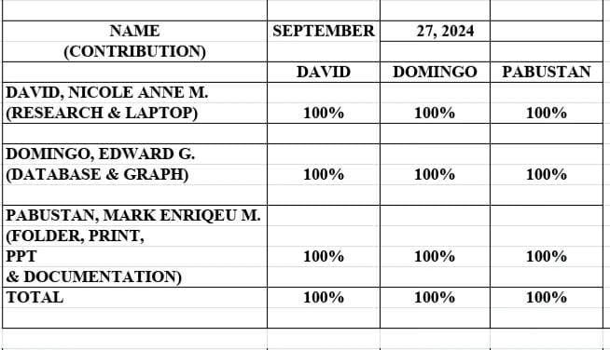

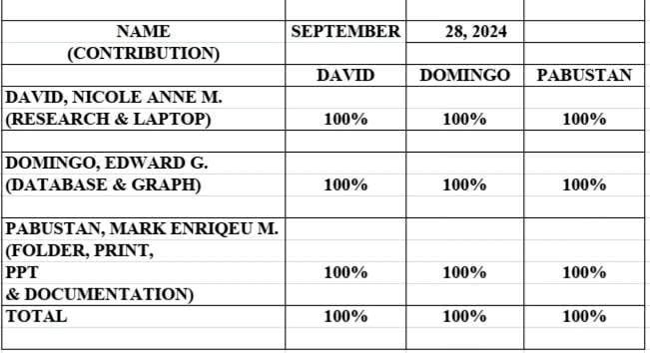

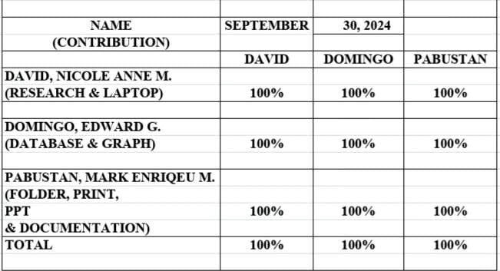

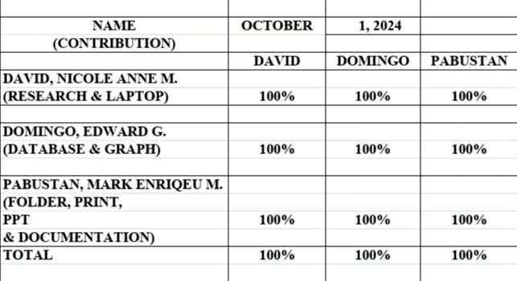

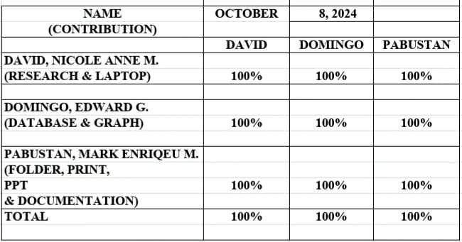

22 | MIDTERM