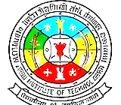
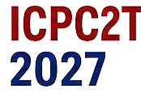




2027 IEEE International Conference on
Power, Control and Computing Technologies (ICPC2T 2027)
NIT Raipur, Chhattisgarh, India | 3–5 March 2027
National Institute of Technology Raipur — An Institute of National Importance

Special Session (SS) Proposal
ICPC2T 2027

1. Special Session Title
2. A Brief Description of the Area of Concern and Objectives (Approx. 300 words)

3. Scope and Topics of Interest

4. Details of Session Chairs / Organisers
Organizer Name | Essential Information | Photo

Submitted for consideration as a Special Session at ICPC2T 2027, NIT Raipur.

