|  |
| --- |
| **Lab 1: MS-DOS command Related to System and batch processing** |

* DOS stands for disk operating system. It provides cli interface.
* To open a Microsoft DOS command prompt shell window, first click the Start menu at the lower-left of your computer's desktop and select "Run...". Then if you are using Windows XP/Vista/7/8 or 10, type "cmd" (without the quotation marks) into the Run box and click "OK" (Fig. 1).

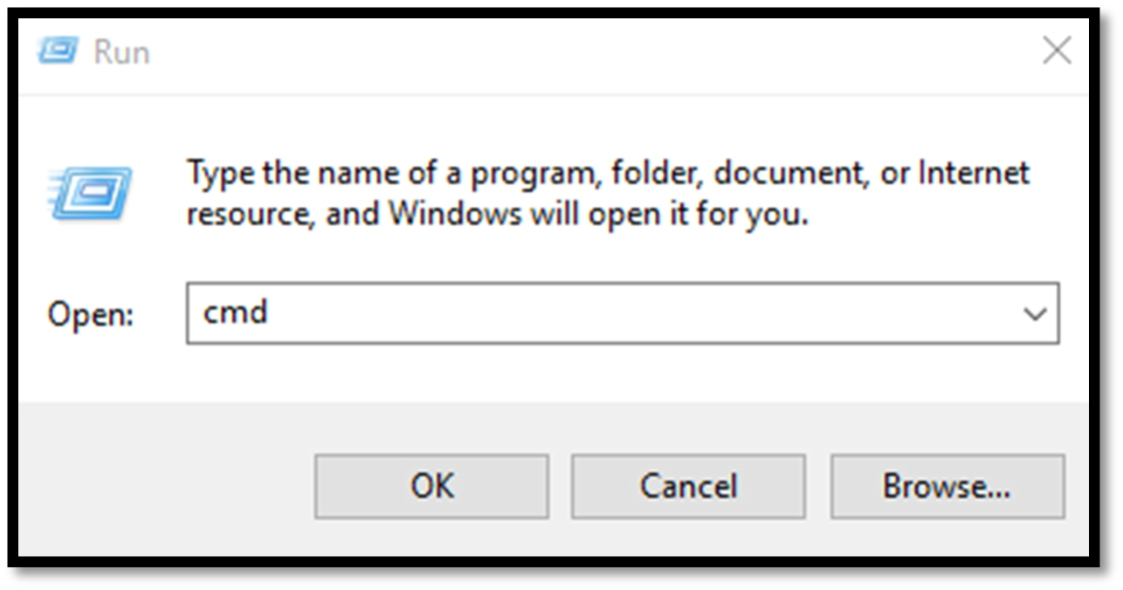

**DOS Commands**

* When you are using a Microsoft DOS command prompt shell window, you can type the following commands into the window.

1. **cd** : Change directory or display current directory path.

|  |  |
| --- | --- |
| Syntax | example |
| Cd directory_name | Cd newfolder |

1. **cls** : Clear the window.

|  |  |
| --- | --- |
| Syntax | example |
| Cls | cls |

1. **dir** : Display list of contents of current directory.

|  |  |
| --- | --- |
| Syntax | example |
| Dir | dir |

1. **help** : Display list of commands or help about a command.

|  |  |
| --- | --- |
| **Syntax** | **example** |
| Help command_name | Help dir |

1. **notepad** : Run the Windows Notepad text editor.

|  |  |
| --- | --- |
| **Syntax** | **example** |
| Notepad | Notepad, notepad filename |

1. **type** : Displays the contents of a text file.

|  |  |
| --- | --- |
| **Syntax** | **Example** |
| Type file_name | Type first.txt |

1. **attrib** : Displays or changes file attributes.

|  |  |
| --- | --- |
| **Syntax** | **Example** |
| Attrib [attribute] filename | Attrib +R first.txt |

1. **assoc** : Displays or modifies file extension associations.

|  |  |
| --- | --- |
| **Syntax** | **Example** |
| Assoc filename | Assoc first.txt |

1. **chkdsk** : Checks a disk and displays a status report.

|  |  |
| --- | --- |
| **Syntax** | **Example** |
| Chkdsk [volume][filename][option] | Chkdsk D: /F |

1. **color** : Sets the default console text and background colors.

|  |  |
| --- | --- |
| **Syntax** | **Example** |
| COLOR[attribute] | COLOR [hex color]  COLOR 5 |

1. **comp** : Compares the contents of two files or sets of files byte by byte.

|  |  |
| --- | --- |
| **Syntax** | **Example** |
| Comp file1 file2 option | Comp first.txt text.txt /A |

1. **copy** : Copies one or more files to another location.

|  |  |
| --- | --- |
| **Syntax** | **Example** |
| COPY [option] source [option] destination file | Copy first.txt third.txt |

1. **date** : Displays or sets the computer's date and prompts you to enter a new date.

|  |  |
| --- | --- |
| **Syntax** | **Example** |
| date [/t | <month-day-year>] | date |

1. **del (or erase)** : Deletes one or more files.

|  |  |
| --- | --- |
| **Syntax** | **Example** |
| Delete file_name | Del first.txt |

1. **echo** : Displays messages, or turns command echoing on/off.

|  |  |
| --- | --- |
| **Syntax** | **Example** |
| Echo | Echo message |

1. **exit** : Closes the DOS window.

|  |  |
| --- | --- |
| **Syntax** | **Example** |
| Exit | exit |

1. **find** : Searches for a text string in a file or files.

|  |  |
| --- | --- |
| **Syntax** | **Example** |
| Find “string” filename | Find “hi” first.txt |

1. **md** (or mkdir) : Creates a directory.

|  |  |
| --- | --- |
| **Syntax** | **Example** |
| Mkdir directory_name | Mkdir ncit |

1. **more** : Displays the contents of a file one screen at a time.

|  |  |
| --- | --- |
| **Syntax** | **Example** |
| More file_name | More first.txt |

1. **move** : Moves one or more files from one directory to another directory.

|  |  |
| --- | --- |
| **Syntax** | **Example** |
| Move filename destination directory | Move first.txt d:/ncit |

1. **rd (or rmdir)** : Removes a directory.

|  |  |
| --- | --- |
| **Syntax** | **Example** |
| Rmdir directory name | Rmdir /s ncit |

1. **ren** (or rename) : Renames a file or files.

|  |  |
| --- | --- |
| **Syntax** | **Example** |
| Rename oldfile_name new_name | Rename first.txt second.txt |

1. **sort** : Reads input, sorts data, and writes the results to the screen, to a file, or to another device.

|  |  |
| --- | --- |
| **Syntax** | **Example** |
| Sort file_name | Sort first.txt |

1. **time** : displays the current system time and prompts you to enter a new time.

|  |  |
| --- | --- |
| **Syntax** | **Example** |
| Time | time |

1. **tree** : Graphically displays the directory structure of a drive or directory.

|  |  |
| --- | --- |
| **Syntax** | **Example** |
| Tree | tree |

1. **xcopy** : Copies files and directories, including subdirectories.

|  |  |
| --- | --- |
| **Syntax** | **Example** |
| Xcopy source destination | Xcopy ncit d:/new |

1. **hostname**

|  |  |
| --- | --- |
| **Syntax** | **Example** |
| hostname |  |

1. shutdown

|  |  |
| --- | --- |
| **Syntax** | **Example** |
| Shutdown /s  To cancel :  Shutdown -a |  |

1. Start

|  |  |
| --- | --- |
| **Syntax** | **Example** |
| Start notepad.exe |  |

1. Tasklist

|  |  |
| --- | --- |
| **Syntax** | **Example** |
| Tasklist  Sort the list of processes by name:  C:\> tasklist /NH | sort  Filter the list of processes by a process name (case insensitive):  C:\> tasklist /NH | findstr /I *myProcess* | |  |  | | --- | --- | | /NH | Hide column names (header)  from result set output | |

1. Taskkill

|  |  |
| --- | --- |
| **Syntax** | **Example** |
| Taskkill pid  Taskkill –im pid |  |

1. Ver

|  |  |
| --- | --- |
| **Syntax** | **Example** |
|  |  |

1. defrag defragment media

network related command:

1. ftp

|  |  |
| --- | --- |
| **Syntax** | **Example** |
|  |  |

1. getmac

|  |  |
| --- | --- |
| **Syntax** | **Example** |
|  |  |

1. ipconfig

|  |  |
| --- | --- |
| **Syntax** | **Example** |
| **Ip config**has a number of switches the most common are**:**  **ipconfig /all** – displays more information about the network setup on your systems including the MAC address.  **ipconfig /release –**release the current IP address  **ipconfig /renew –**renew IP address  **ipconfig /?** -shows help |  |

1. netsh

|  |  |
| --- | --- |
| **Syntax** | **Example** |
|  |  |

1. nslookup

|  |  |
| --- | --- |
| **Syntax** | **Example** |
| Nslookup ncit.edu.np |  |

1. ping

|  |  |
| --- | --- |
| **Syntax** | **Example** |
| Ping ip –t  Ping –a ip  Ping –r count  Ping –l size |  |

1. route

|  |  |
| --- | --- |
| **Syntax** | **Example** |
| Route print |  |

1. systeminfo

|  |  |
| --- | --- |
| **Syntax** | **Example** |
| systeminfo |  |

1. telnet

|  |  |
| --- | --- |
| **Syntax** | **Example** |
| telnet ip address |  |

1. tracert

|  |  |
| --- | --- |
| **Syntax** | **Example** |
| Tracert ip_address |  |

1. call

|  |  |
| --- | --- |
| **Syntax** | **Example** |
| Call batfile_name |  |

1. cipher

|  |  |
| --- | --- |
| **Syntax** | **Example** |
| cipher | The cipher command, however, wipes a directory by writing random data to it. To wipe your C drive, for example, you'd use the **cipher /w:d** command, which will wipe free space on the drive. |

1. netstat

|  |  |
| --- | --- |
| **Syntax** | **Example** |
| netstat | **netstat -an** will provide you with a list of currently open ports and related IP addresses |

1. pathping

|  |  |
| --- | --- |
| **Syntax** | **Example** |
| Pathping ip | if there are multiple routers between your PC and the device you're testing |

1. sfc

|  |  |
| --- | --- |
| **Syntax** | **Example** |
| Sfc  Sfc/scannow | If SFC finds any corrupt or missing files, it will automatically replace them using cached copies kept by Windows for this purpose alone. |

1. call

|  |  |
| --- | --- |
| **Syntax** | **Example** |
| Call batfile_name |  |

1. **Create a batch file which include different command and execute it .**
2. **Create a batch file , which may display** 
   1. **your name , address ,**
   2. **display your ip address,**
   3. **display your routing information**
   4. **and reboot your system by giving message , “your system is down”**
3. **create a batch file that repeatedly ask for command and execute it.**

**@echo off**

**break off**

**title C:\Windows\system32\cmd.exe**

**cls**

**:cmd**

**set /p cmd=C:\Enter Command:**

**%cmd%**

**echo.**

**goto cmd**