Tribhuvan University
Faculty of Humanities and Social Sciences



LAB REPORT on
Scripting Language Lab Assignment 1:
Form Validation with HTML & Javascript

Submitted to
Mr. Diwas K.C.
Department of Computer Application,
Himalaya College of Engineering
Chyasal, Lalitpur

Submitted by
Sujal Gurung
Roll no. 34
BCA 4th Sem
May 2023

Objectives
Learn to use the features of HTML 5 and Javascript to create input forms with validation

Assignment
You are going to create an input form using HTML5 and Javascript. This input form will not submit any database to the server (you learn to do this in the next lab). It will validate and collect information from the user and go to a confirm page that displays the information entered and allows the user to confirm that the information is correct. Below are all the input form fields and the validation required.
It is up to you (the designer) how you present the information request. For example in entering a date you can have a single text box, or you can have multiple boxes with drop down choices. You do, however, have to validate the data to make sure it meets all validation rules.
Field | Validation
Name | The user must enter a first and last names. These cannot be blank. You may use a single text box, but must check for 2 names, or use 2 text boxes.
Address | The user must enter a valid mailing address that follows address rules. A city, state, and zip code must also be included as part of the address. You can use multiple text boxes – or a single one. You must still validate all elements.
Phone Number | A full 10 digit phone number must be entered.
Email Address | User must enter a correctly formatted email address name@domain.extension –
Birth Date | User must enter a valid birthday, make sure to check format and also date – if dates are unreasonable (like in the future) give a warning.
Message | The user will enter a free text message, you should have a multi-line text entry area for the message
Once the user enters all this information in the form and hits submit, you will present the information and allow the user to confirm that it is all correct. The user should not be able to enter invalid data or leave fields blank.

Lab Work
- index.html:
1 <!DOCTYPE html>
2 <html lang=" en">
3 <head>
4 <title></title>
5 <meta charset="UTF-8">
6 <meta name="viewport" content="width=device-width, initial-scale=1">
7 <link rel="preconnect" href="https://fonts.googleapis.com">
8 <link rel="preconnect" href="https://fonts.gstatic.com" crossorigin>
9 <link href="https://fonts.googleapis.com/css2?family=JetBrains+Mono:wght@400;700&display=swap" rel="stylesheet">
10 <link href="./style.css" rel="stylesheet">
11 </head>
12 <body>
13 <a href="./index.html">Home</a>
14 <form id="mainForm">
15 <fieldset>
16 <legend>Form Validation</legend>
17
18 <label>Name:
19 <input name="fullName" type="text" autofocus autocomplete required placeholder="FirstName LastName">
20 </label>
21
22 <label>Address:
23 <input name="address" type="text" autocomplete required placeholder="City, State, ZIP Code">
24 </label>
25
26 <label>Phone Number:
27 <input name="phone" type="tel" autocomplete required>
28 </label>
29
30 <label>Email address:
31 <input name="email" type="email" autocomplete required placeholder="name@domain.extension">
32 </label>
33
34 <label>Birth date:
35 Output <input name="birthDate" type="date" autocomplete required title="">
36 </label>
37
38 <label>Message:
39 <textarea name="message" rows="17" spellcheck="true" autocomplete required></textarea>
40 </label>
41
42 <button id="submit" type="submit" onclick="event.preventDefault(); validate();">Submit</button>
43 </fieldset>
44 </form>
45
46 <div id="confirmDialog" class="hidden">
47 <h2>Confirm details</h2>
48 <button type="" id="close" onclick="hideConfirmDialog()">
49 <img src="./assets/iconmonstr-x-mark-lined-240.png">
50 </button>
51 <span>If there are any mistakes close this dialog & resolve them</span>
52 <table border="2">
53 </table>
54 <a href="./valid.html">Confirm</a>
55 </div>
56 <script src="./script.js"></script>
57
58 </body>
59 </html>

- valid.html:
1 <!DOCTYPE html>
2 <html lang="en">
3 <head>
4 <title></title>
5 <meta charset="UTF-8">
6 <meta name="viewport" content="width=device-width, initial-scale=1">
7 <link href="./style.css" rel="stylesheet">
8 </head>
9 <body>
10 <h1>Congrats. All inputs valid.</h1>
11 </body>
12 </html>

- script.js:

1 // input's name attribute is used as key
2 // value is initially empty & later set to user input
3 const inputs = {
4 fullName: {
5 value: '',
6 pattern: /^[a-zA-Z]+\s[a-zA-Z]+$/,
7 errorMsg: 'First & last name must be letters'
8 },
9 address: {
10 value: '',
11 pattern: /^[a-zA-Z]+,\s?[a-zA-Z]+,\s?\d{5}(-\d{4})?$/,
12 errorMsg: 'City & State must be words. ZIPcode must be valid. Split them with comma'
13 },
14 phone: {
15 value: '',
16 pattern: /^\d{10}$/,
17 errorMsg: 'Must be a 10-digit number'
18 },
19 email: {
20 value: '',
21 pattern: /^\w+@[a-zA-Z]+.\w{3}$/,
22 errorMsg: 'Must be name@domain.extenstion with extension of 3 letters'
23 },
24 birthDate: {
25 value: '',
26 pattern: /^\d{4}-\d?\d-\d?\d$/,
27 errorMsg: 'Must be in format & must not be in the future'
28 },
29 message: {
30 value: '',
31 pattern: /^\S+[\s\S]*$/,
32 errorMsg: 'Must not be empty'
33 },
34 };
35
36 const mainForm = document.querySelector('#mainForm'); // returns an HTMLFormElement object
37 const confirmDialog = document.querySelector('#confirmDialog');
38 function validate(event) {
39
40 // hide errors if previously shown
41 document.querySelectorAll('.invalidMessage').forEach((message) => message.classList.add('hidden'))
42
43 // TODO 1: get inputs & put them in objects
44 for (let i=0, formControl; i < mainForm.length; i++) {
45 formControl = mainForm[i];
46 if (formControl.nodeName==='INPUT' || formControl.nodeName==='TEXTAREA') {
47 // input values are stored as strings regardless of type attribute.
48 // thus, we can use trim() on all
49 inputs[formControl.name]['value'] = formControl.value.trim();
50 }
51 }
52
53 // TODO 2: match regex
54 let valid = true; // boolean to keep track if any input is invalid;
55 // loop through input values & match them with regex
56 // here, name variable will hold one key at a time
57 for (const name in inputs) {
58 if (!inputs[name]['pattern'].test(inputs[name]['value'])) {
59 valid = false;
60 addInvalidMessage(name);
61 }
62 }
63
64 // additional validation for birthDate
65 if (checkUnreasonablDate()){
66 valid = false;
67 addInvalidMessage('birthDate');
68 }
69
70 if (valid) formConfirm(mainForm);
71 }
72
73 function checkUnreasonablDate() {
74 // get today's date & compare
75 let timestamp = {
76 today: Date.now(),
77 input: Date.parse(inputs['birthDate']['value'])
78 }
79 // both today & formattedDate are in timestamp format (i.e. milliseconds since UNIX epoch)
80 return timestamp['input'] >= timestamp['today'] ;
81 }
82
83 function addInvalidMessage(name) {
84 const invalidMessage = document.createElement('p');
85 invalidMessage.classList.add('invalidMessage');
86 invalidMessage.classList.remove('hidden');
87 invalidMessage.innerHTML = `${inputs[name]['errorMsg']}`;
88 if (name === 'message') document.querySelector(`label:has(textarea)`).append(invalidMessage); // for the sole textarea
89 else document.querySelector(`label:has(input[name="${name}"])`).append(invalidMessage);
90 }
91
92 function formConfirm(form) {
93 mainForm.classList.add('hidden');
94 confirmDialog.classList.remove('hidden');
95
96 let confirmValues = confirmDialog.querySelectorAll('td');
97 console.log(confirmValues);
98 let confirmTable = confirmDialog.querySelector('table');
99 let row;
100 for (const name in inputs) {
101 // important to assign row to a domNode inside loop rather than outside
102 row = document.createElement('tr');
103 row.innerHTML = `<th>${name}</th><td>${inputs[name]['value']}</td>`;
104 confirmTable.append(row);
105 console.log(name);
106 }
107 }
108
109 function hideConfirmDialog() {
110 confirmDialog.classList.add('hidden');
111 mainForm.classList.remove('hidden');
112 // clear contents of table
113 confirmDialog.querySelector('table').innerHTML = '';
114 }

Output
- errors:
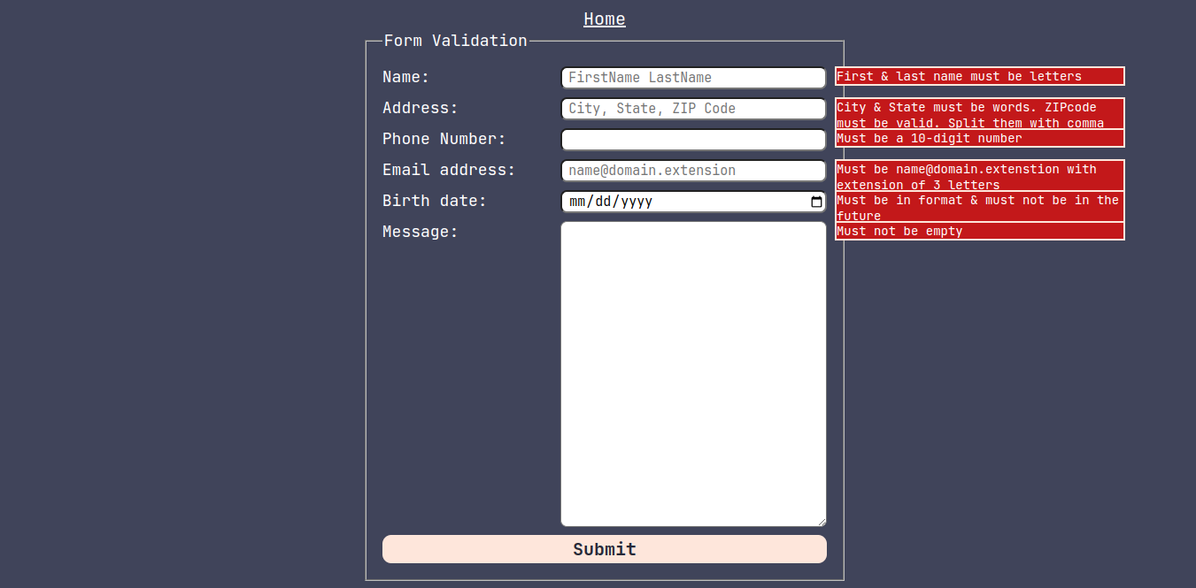
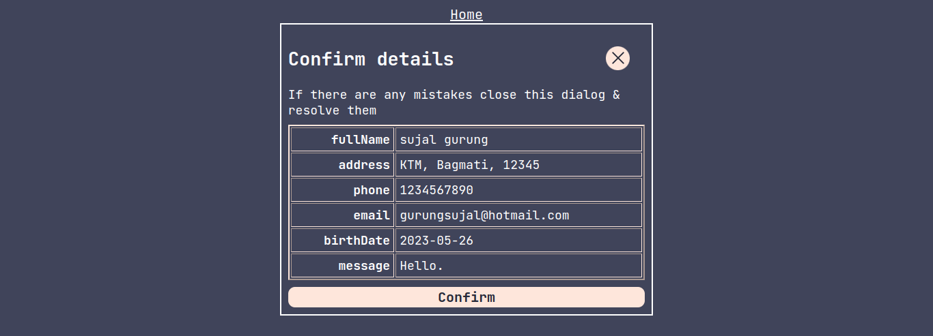
- confirm dialog:

- valid page:
Conclusion
Thus, we were able to apply everything we’d learned in class to build an html form & validate it using JavaScript & RegEx.

------- The End -------

