My Process for Analyzing Indian Agriculture Data with Power BI

**Start with Canvas:** I open Power BI and go to the "Canvas" screen. From there, I click "Get Data" and select the file type of the dataset I want to upload.

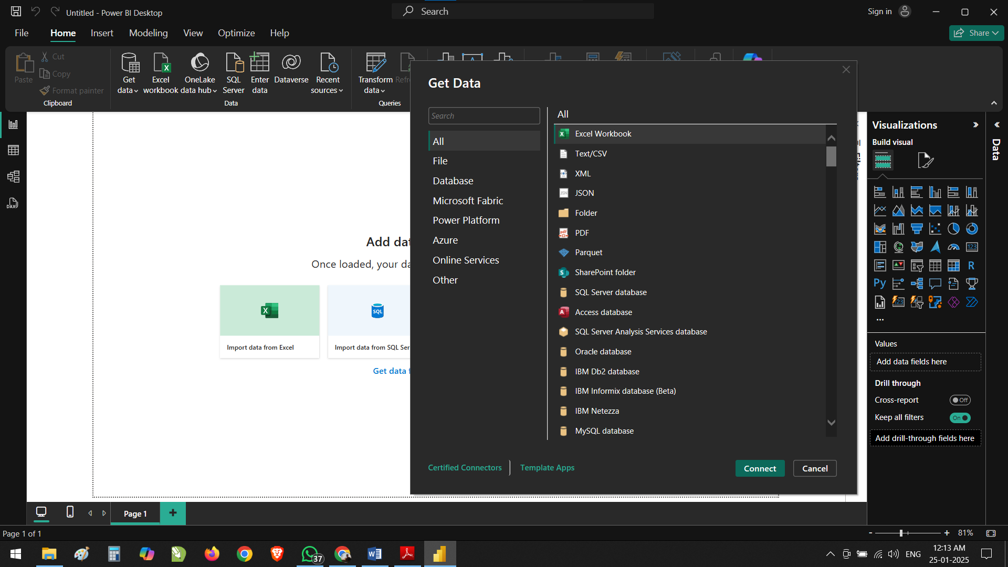

**Load or Transform Data:** Once I select my file, I decide between:

* **Load:** To quickly add the data to Power BI.
* **Transform:** To open Power Query Editor for cleaning and organizing the data.

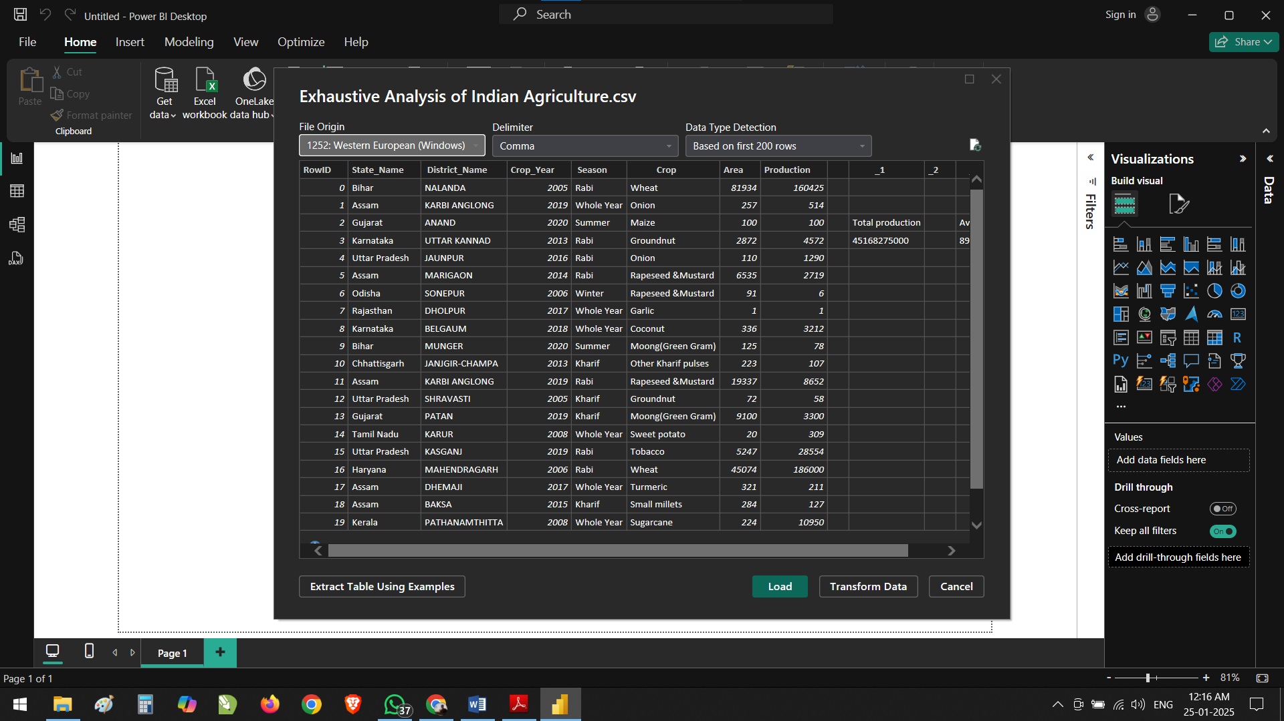

**Clean the Data:** In Power Query Editor, I:

* Check for any errors or empty cells by enabling "Column Quality" in the "View" tab.
* Delete unnecessary columns by selecting them and clicking "Remove Columns." These changes show up in the "Applied Steps" section.

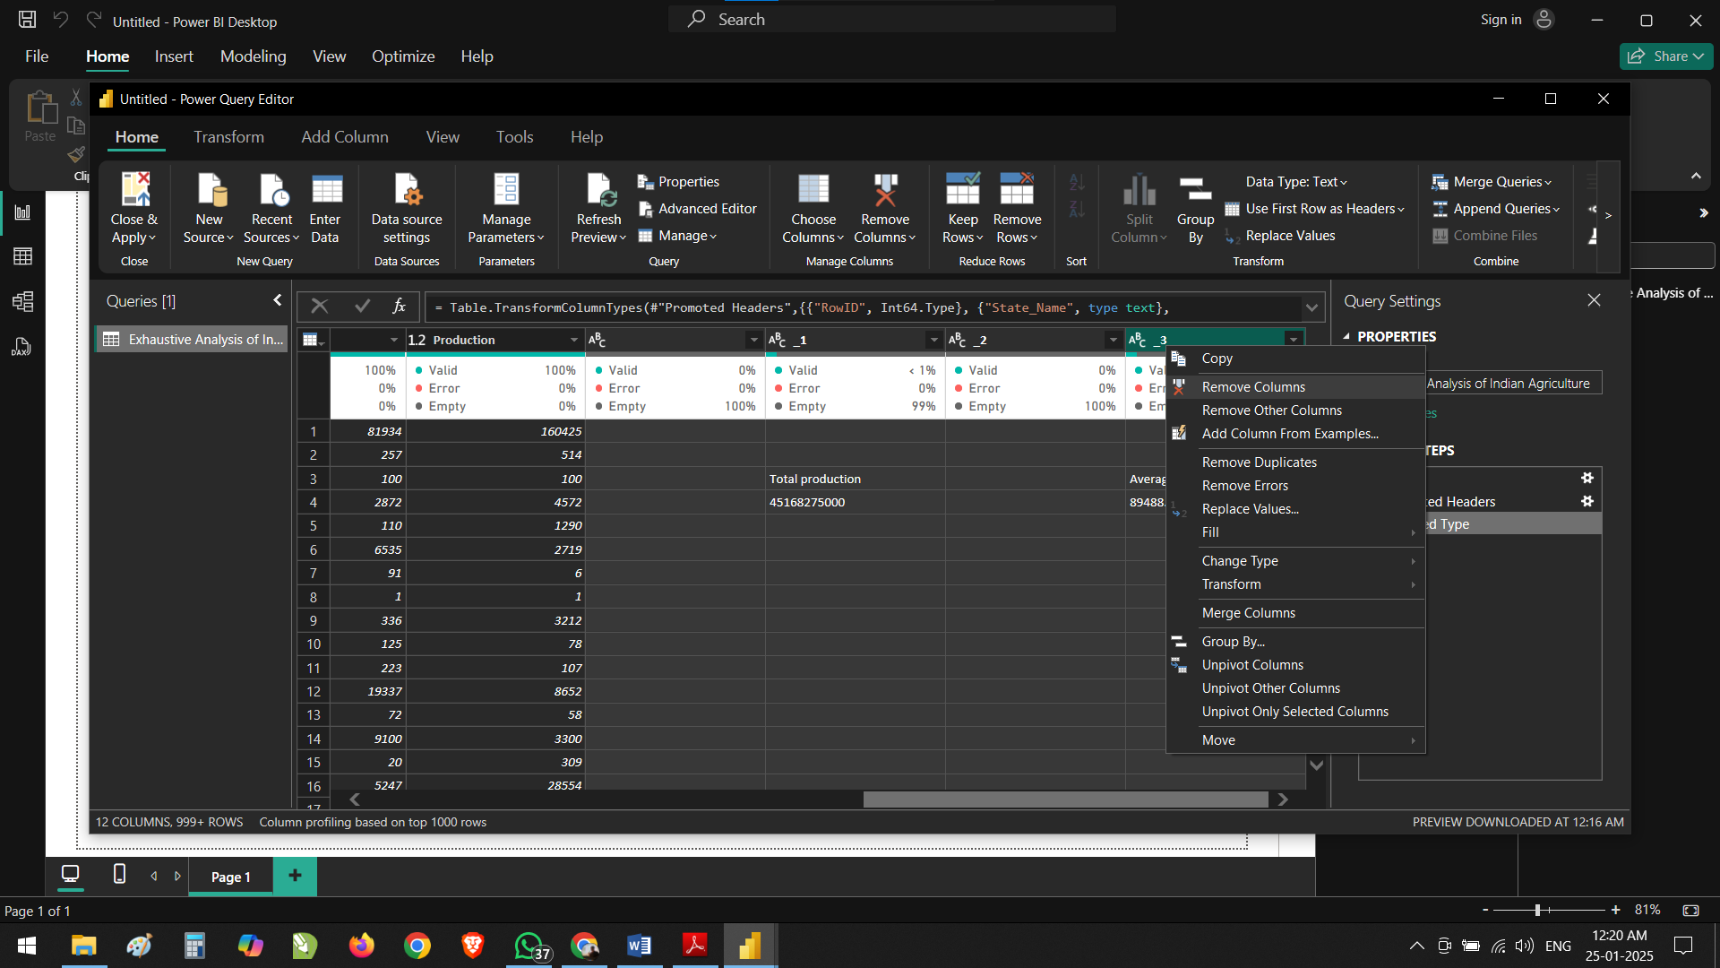

**Apply Changes:** After cleaning, I click "Close & Apply" to save my changes and return to Power BI Desktop.

**Visualize Data:** Finally, I use the "Table View" to see my data in a tabular format or the "Model View" to connect tables and create insightful visuals.

