Name: Dinesh Ku. Mallick

1. Creating and Renaming Files/Directories
Mkdir= to create a new directory test_dir
touch= to create a file example.txt
mv= to rename example.txt to renameed_example.txt

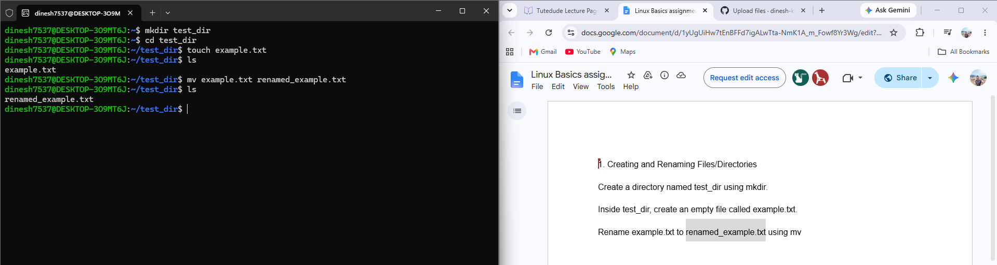

2. Viewing File Contents
cat= show the complete content of any particular file
Head -5 ____= to show top 5 line
Tail -5 _____= ttttto show bottom’s 5 lines

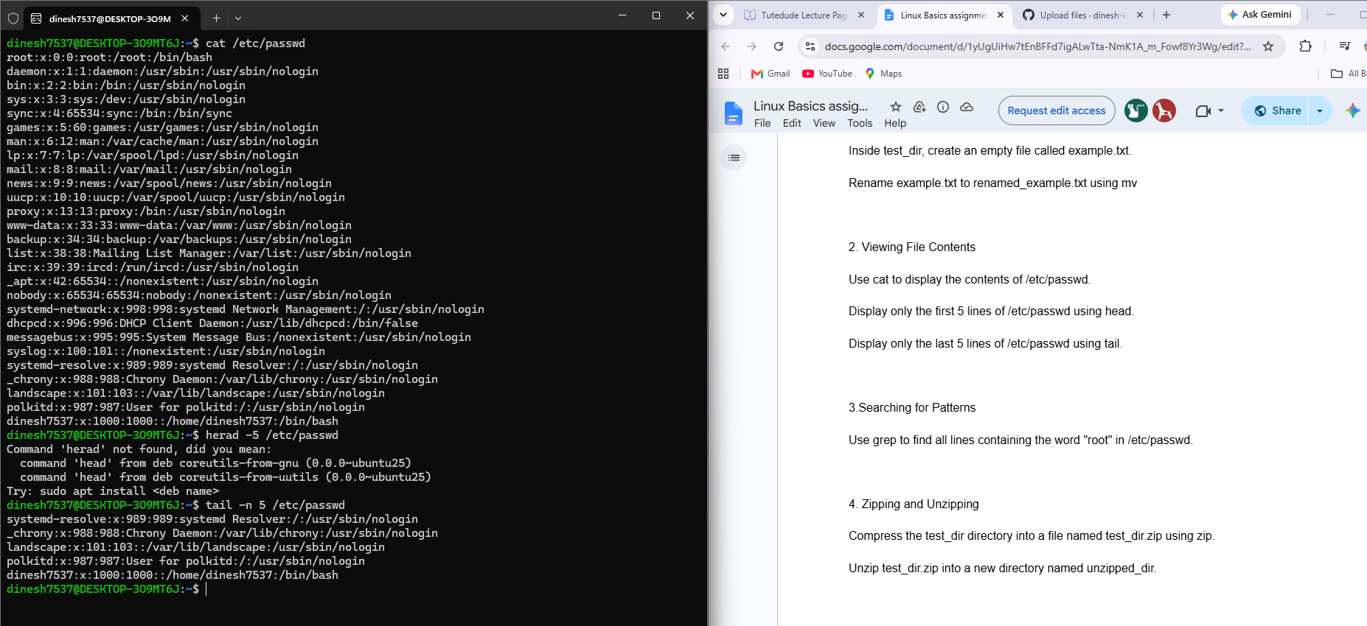
3.Searching for Patterns
cat= show the complete content of any particular file
grep= search a particular string within the output

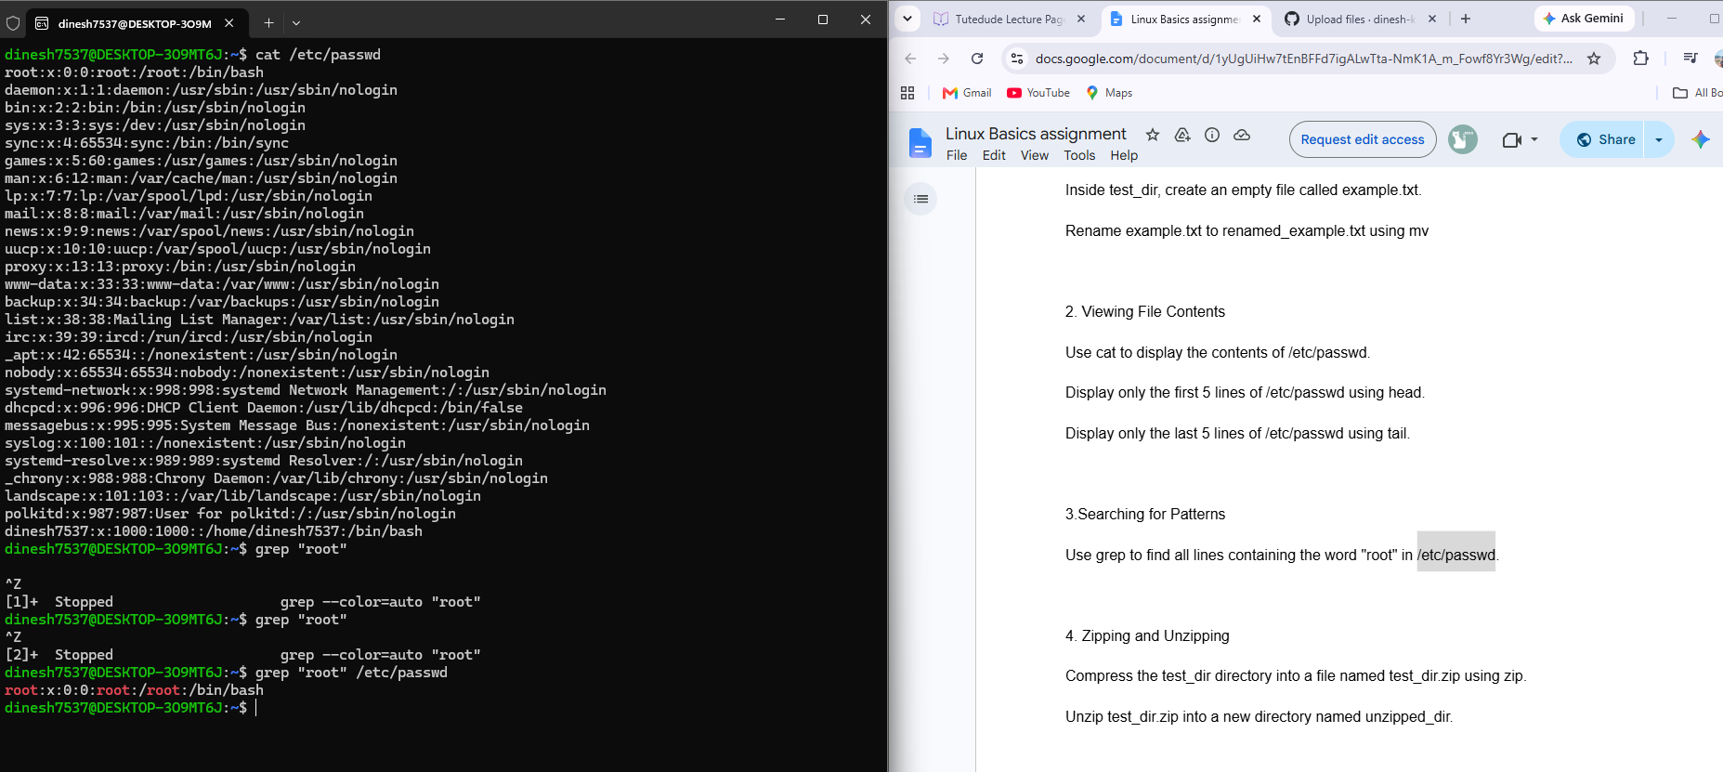

4. Zipping and Unzipping
zip ir test_dir.zip test_dir= to compress the directory into test_dir.zip
unzip test_dir.zip -d unzipped_dir

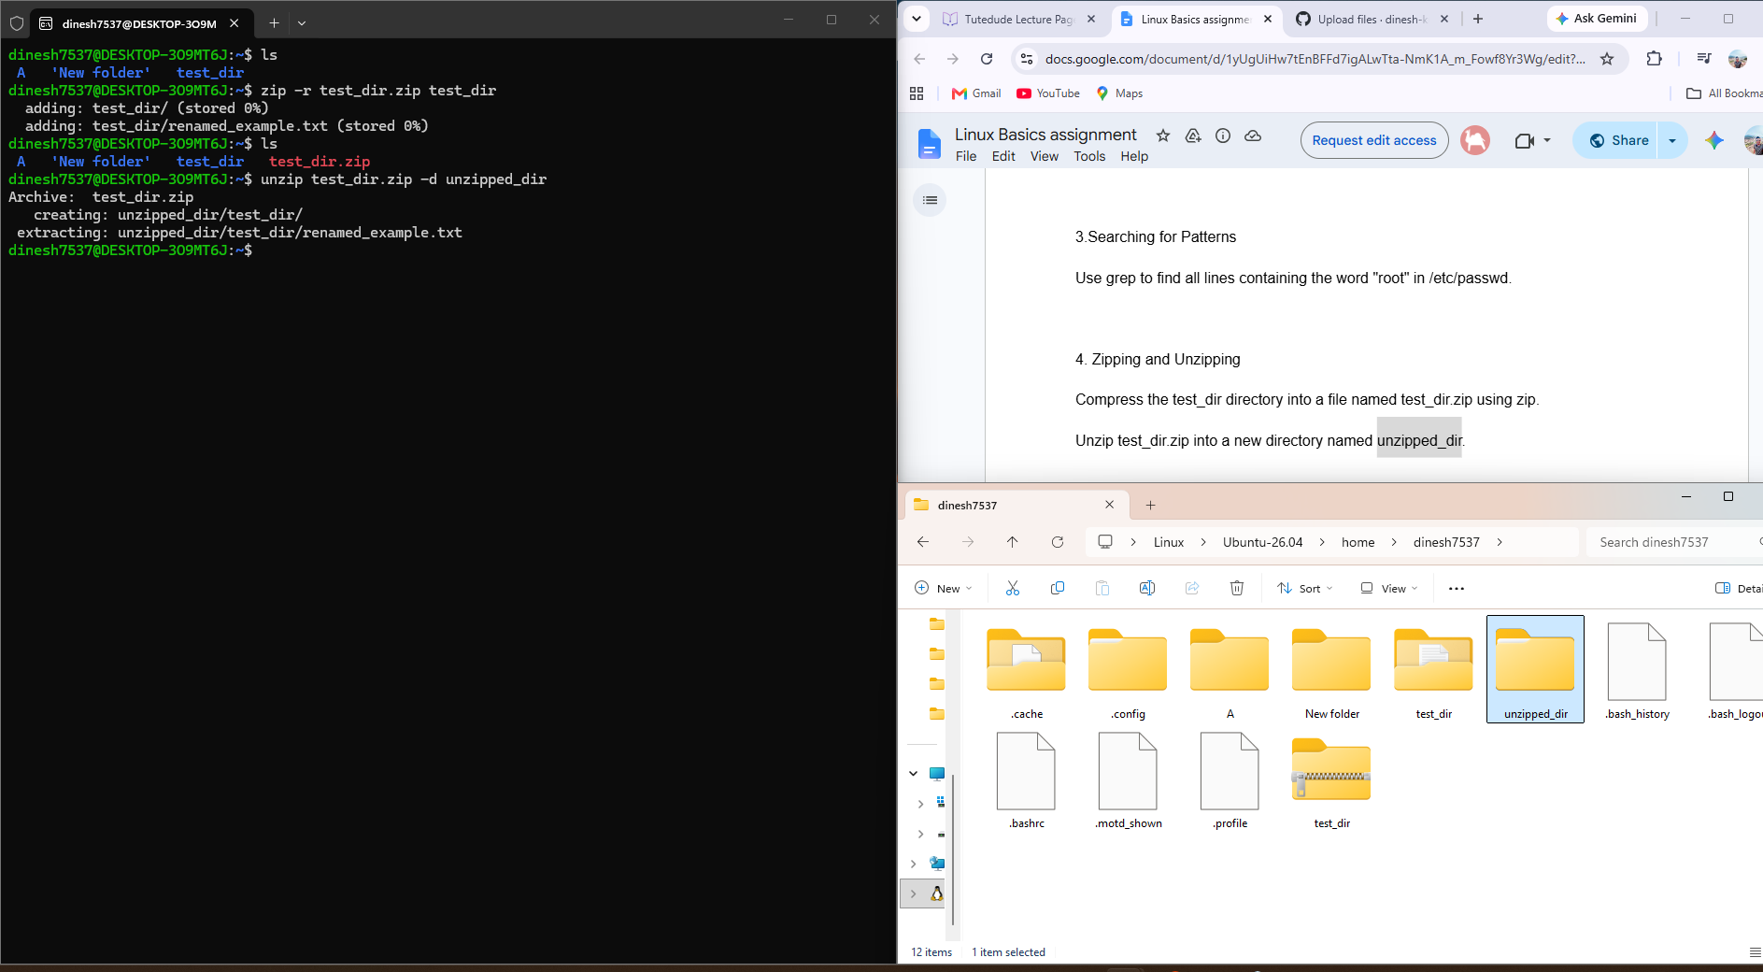

5. Downloading Files
Wget specified url = to download dat as a file from specified url

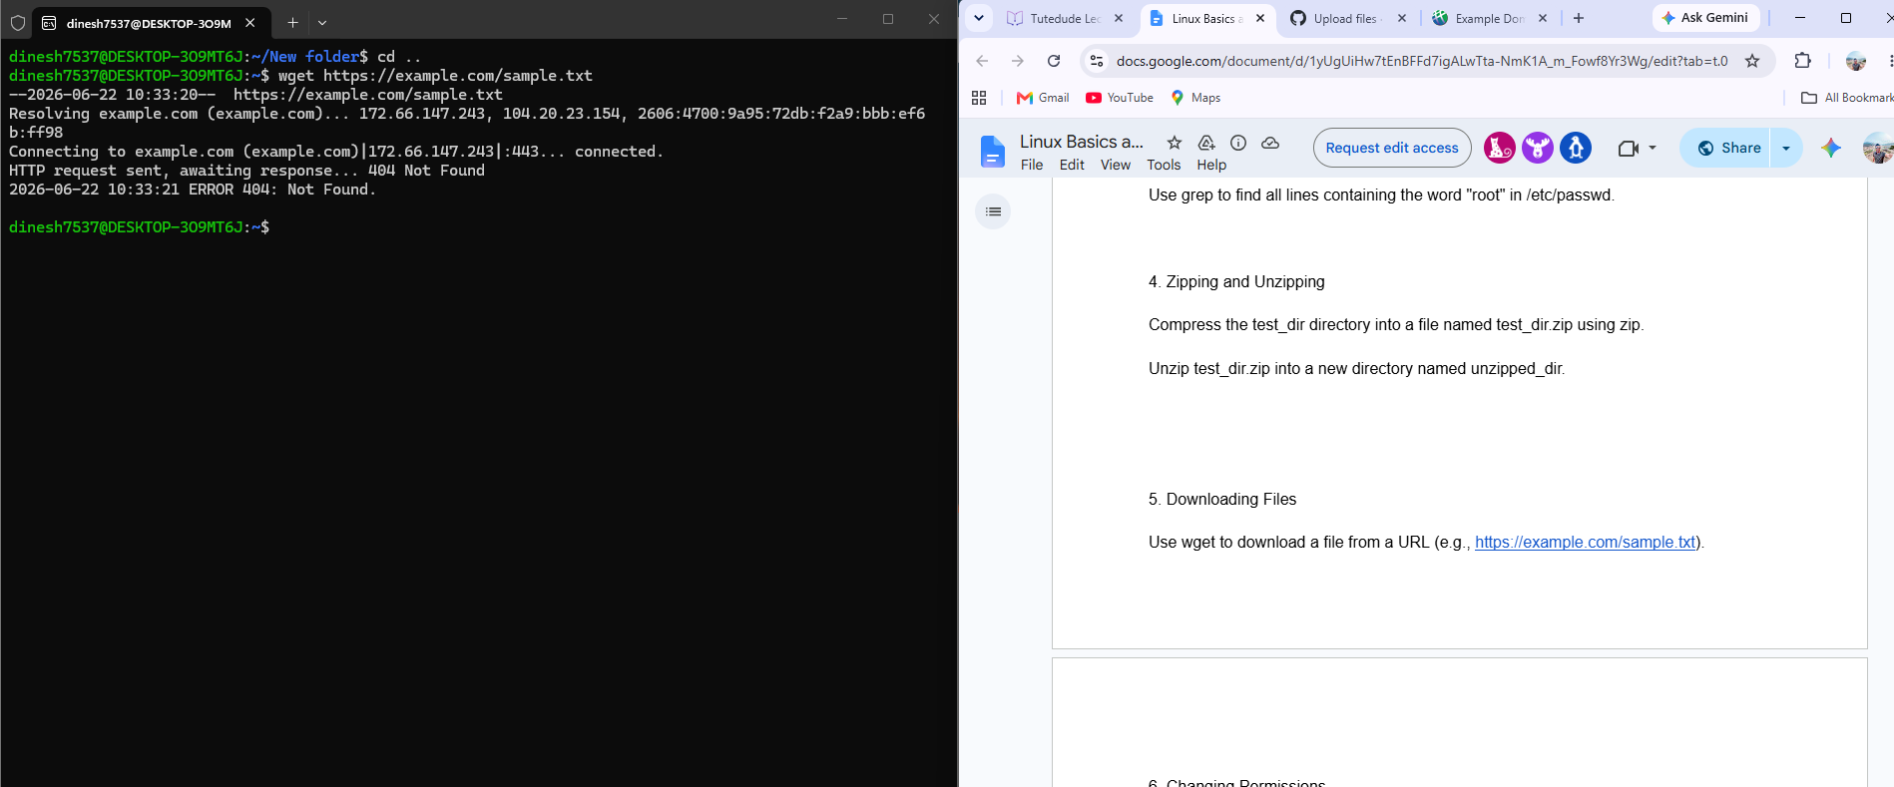

6. Changing Permissions
Chmod 444= permissions to read-only for everyone

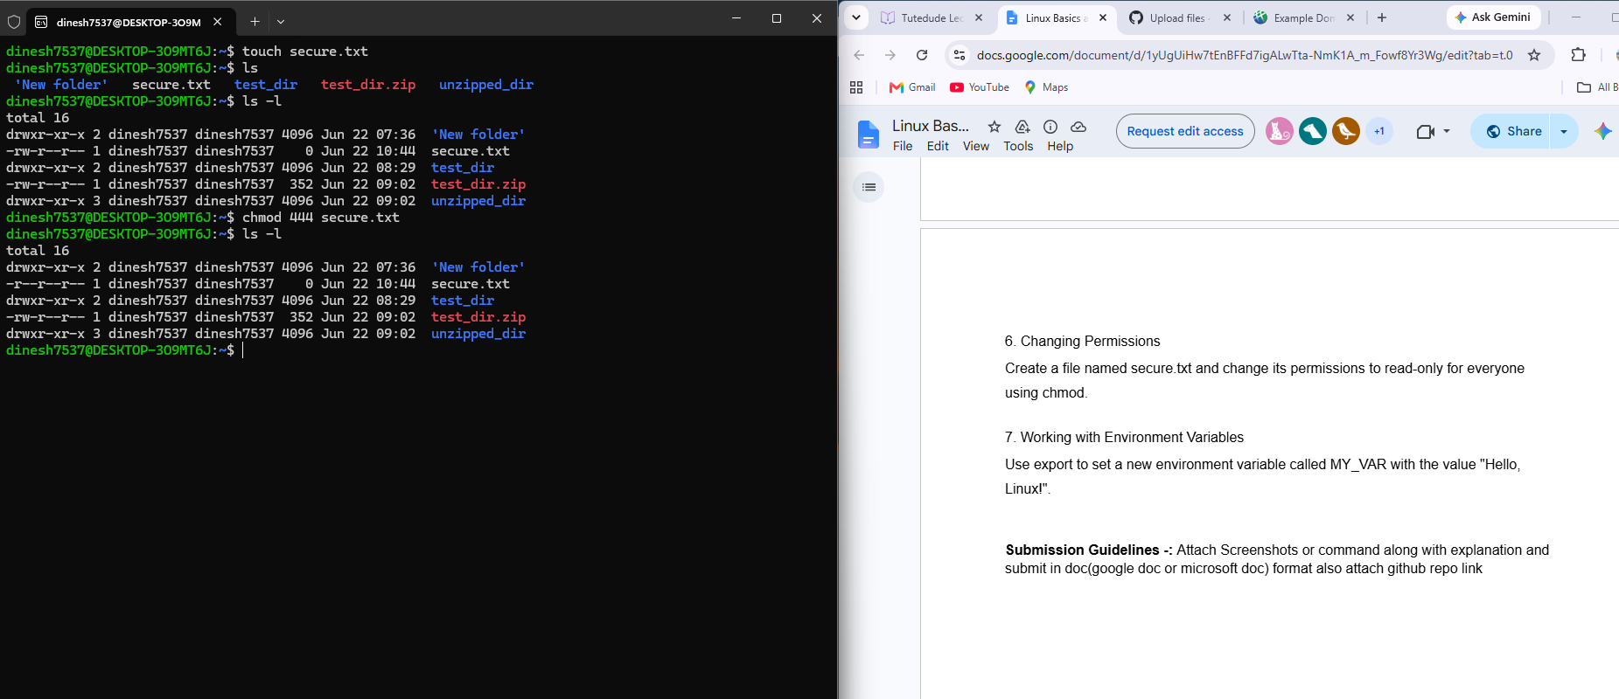

7. Working with Environment Variables
export= export enviroment variable with the value
echo= yo show the value

