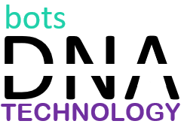

Project Code: SDCT1922

Developer Contact: 9123789067

Manager Contact: 8657893347

Project Description: A project description is a high-level overview of why you’re doing a project. The document explains a project’s objectives and its essential qualities. Think of it as the elevator pitch that focuses on what and why without delving into how. You typically draft a project description early on, during the project initiation phase of the project management lifecycle.he project manager often writes the project description. However, if you are working for an agency that seeks grant funding or writing a research proposal, you might need to learn how to write a project description in a project proposal.