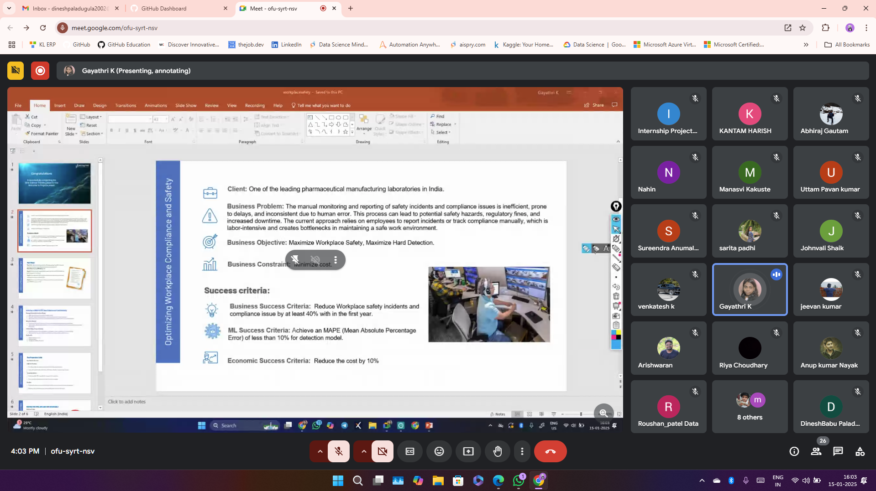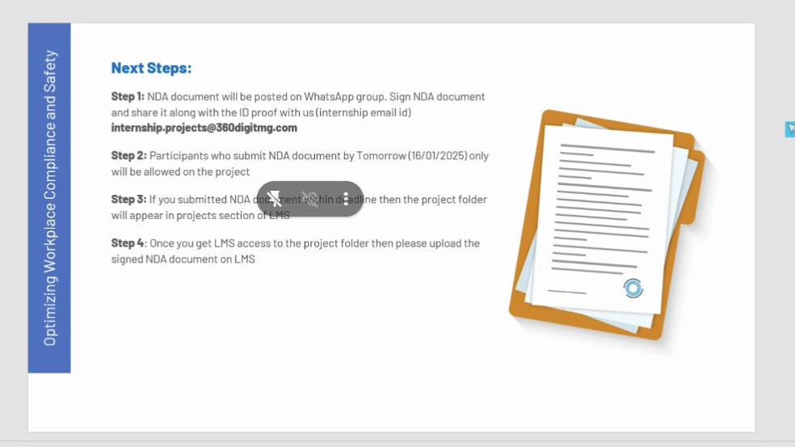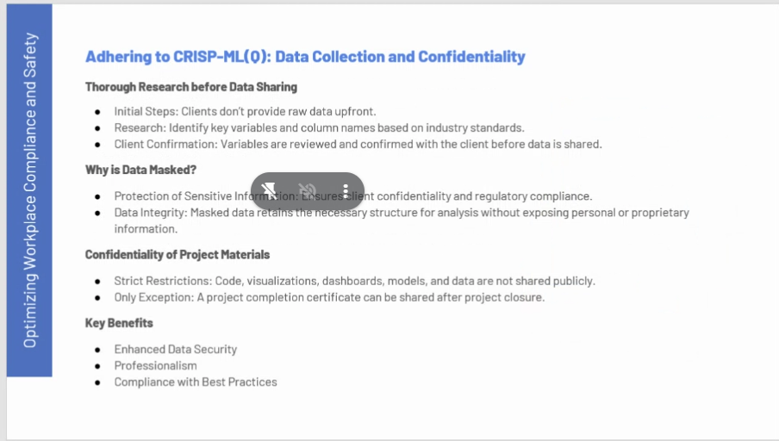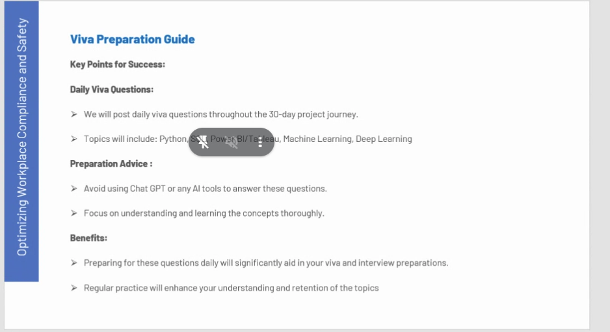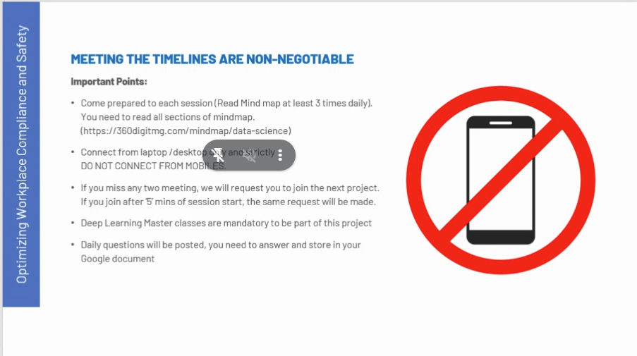

**Problem:**

Imagine a pharmaceutical company where workers handle hazardous chemicals and operate complex machinery. The current process for reporting safety incidents and compliance issues is manual. Employees fill out paper forms whenever there's a safety issue, such as a chemical spill or equipment malfunction. This manual process is slow and inefficient, leading to delayed responses and potentially dangerous situations. Additionally, managing these paper records is cumbersome and prone to errors.

**Objective:**

The goal is to create an automated system that detects safety incidents and compliance issues in real-time. This system will help reduce safety incidents and ensure regulatory compliance, ultimately leading to a safer workplace.

**Constraints:**

The company wants to minimize costs while implementing this solution. They can't afford to spend excessively on new equipment or software.

**Success Criteria:**

The company wants to achieve the following:

* **Business Success:** Reduce safety incidents and compliance issues by at least 40% within the first year.
* **ML Success:** Develop a machine learning model that can detect safety incidents with a Mean Absolute Percentage Error (MAPE) of less than 10%.
* **Economic Success:** Reduce overall costs by 10%.

**Example:**

1. **Current Scenario:**
   * An employee accidentally spills a hazardous chemical.
   * The employee fills out a paper form and submits it to the safety officer.
   * The safety officer processes the form and takes action to clean up the spill and ensure safety measures are followed.
   * This process takes several hours, during which other employees might be exposed to the hazard.
2. **Optimized Scenario:**
   * An employee accidentally spills a hazardous chemical.
   * Sensors and cameras in the lab detect the spill and automatically send an alert to the safety officer.
   * The safety officer receives the alert instantly and takes immediate action to clean up the spill and ensure safety measures are followed.
   * This process takes only a few minutes, minimizing the risk to other employees and preventing further incidents.

By implementing an automated system with sensors and machine learning, the company can achieve its business, ML, and economic success criteria while creating a safer work environment.

Here’s a detailed overview of the tools, techniques, and libraries you can use to accomplish your project:

**1. Tools for Data Collection and Annotation**

**Tools:**

* **Cameras/Video Equipment**: For capturing images and video in the lab.
* **Annotation Tools**:
  + **LabelImg**: For bounding box annotations (PPE detection).
  + **COCO Annotator**: For pose estimation and keypoints.
  + **CVAT (Computer Vision Annotation Tool)**: A web-based annotation tool supporting bounding boxes, polygons, and keypoints.

**2. Libraries and Frameworks for Development**

**Programming Language:**

* **Python**: The primary language for AI/ML development due to its extensive library support.

**Computer Vision Libraries:**

* **OpenCV**: For preprocessing images, video handling, and real-time processing.

**Deep Learning Frameworks:**

1. **For PPE Detection**:
   * **YOLOv8** (Ultralytics): Easy to use for object detection tasks.
   * **Detectron2**: Meta’s framework for advanced object detection and segmentation.
   * **TensorFlow** or **PyTorch**: For custom model training.
2. **For Pose Estimation**:
   * **OpenPose**: A state-of-the-art library for detecting body keypoints.
   * **MediaPipe**: Lightweight and efficient for real-time applications.
   * **HRNet**: For high-resolution pose estimation.
3. **Integration Tools**:
   * **Flask** or **FastAPI**: To build APIs for alert systems.
   * **Twilio**: For sending SMS or email alerts.

**3. Data Processing Techniques**

**Image Preprocessing:**

* Resize, crop, and normalize images for model compatibility.
* Data augmentation: Use libraries like **Albumentations** to apply random rotations, flips, and brightness adjustments.

**Keypoint Annotation for Pose Estimation:**

* Annotate datasets using COCO format or pre-built pose estimation datasets (e.g., MPII, COCO).

**4. Model Training and Optimization**

**Training Platforms:**

* **Local GPU Machine**: Use a system with NVIDIA GPUs (e.g., RTX 3060 or higher).
* **Cloud Platforms**:
  + **Google Colab**: Free tier with GPUs, suitable for prototyping.
  + **AWS SageMaker**, **Azure ML**, or **Paperspace** for scalable training.

**Hyperparameter Optimization Tools:**

* **Optuna** or **Ray Tune**: For automated hyperparameter tuning.

**Model Evaluation:**

* Use libraries like **scikit-learn** to calculate metrics such as MAPE, precision, recall, and F1-score.
* For pose estimation, compute keypoint detection accuracy using OKS (Object Keypoint Similarity).

**5. Integration and Deployment**

**Real-Time Video Processing:**

* Use **OpenCV** for video stream handling.
* Use **GStreamer** or **FFmpeg** for low-latency video streams.

**Deployment Tools:**

1. **Edge Devices**:
   * **NVIDIA Jetson Nano/AGX Xavier**: For on-premise, low-latency deployment.
   * **Raspberry Pi** (with Coral Edge TPU): For cost-effective edge solutions.
2. **Cloud-Based Deployment**:
   * Use **AWS Lambda**, **Azure Functions**, or **Google Cloud Functions** to host models and process video streams.
3. **Containerization**:
   * Use **Docker** to containerize the application for scalability and portability.

**6. Alert System Tools**

**For Notifications:**

* **Twilio**: Send SMS or email alerts.
* **Pushover**: Mobile push notifications.

**Visualization:**

* **Flask/Django**: Build a web dashboard for real-time monitoring.
* **Matplotlib/Plotly**: Generate charts for safety reports and model performance.

**7. Post-Deployment Monitoring and Maintenance**

**Logging and Monitoring:**

* Use **TensorBoard** for monitoring model performance during training.
* Use **ELK Stack (Elasticsearch, Logstash, Kibana)** or **Grafana** for tracking system metrics after deployment.

**Summary of Libraries and Tools:**

| **Category** | **Tools/Libraries** |
| --- | --- |
| Data Annotation | LabelImg, CVAT, COCO Annotator |
| Object Detection | YOLOv8, Detectron2, TensorFlow, PyTorch |
| Pose Estimation | OpenPose, MediaPipe, HRNet |
| Preprocessing | OpenCV, Albumentations |
| Training Platforms | Google Colab, AWS, Azure ML |
| Deployment | Docker, Flask, Jetson Nano, AWS Lambda |
| Notifications | Twilio, Pushover |
| Monitoring | TensorBoard, Grafana, ELK Stack |

Let me know if you’d like step-by-step instructions for any of these!