**Project Submission Details**

Name : Koneti Naga Dinesh Reddy

Company : Cisco

IDE used : Visual Studio

Language : Java

**Flowchart:**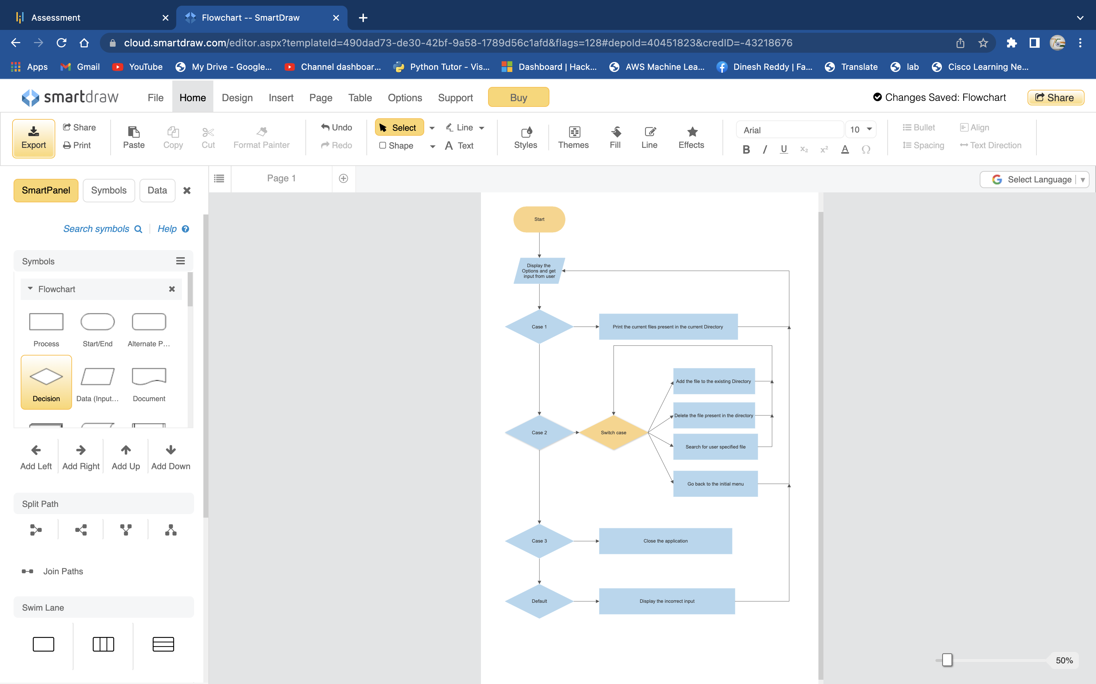

**Code:**

import java.io.File;

import java.util.Arrays;

import java.util.Scanner;

public class java_project {

public static void main(String[] args) {

File folder = new File("java");

folder.mkdirs();

try (Scanner scan = new Scanner(System.in)) {

while(true){

System.out.println("Prototype of the Application for Lokers Pvt.Ltd");

System.out.println("The following functions are :- ");

System.out.println("1. To display the files in ascending order");

System.out.println("2. Here are some User Enabled Operations");

System.out.println("3. Close Program");

System.out.println("Choice of Your Option");

int choice = scan.nextInt();

switch(choice)

{

case 1:

File arr[] = folder.listFiles();

Arrays.sort(arr);

for(int i=0;i<arr.length;i++)

System.out.println(arr[i]);

break;

case 2:

Boolean temp = true;

while(temp) {

System.out.println("Option 1 :- To Add a file in the Directory");

System.out.println("Option 2 :- To Delete a file from the Directory. ");

System.out.println("Option 3 :- To Search a user specified file from the Directory");

System.out.println("Option 4 :- Back to the previous menu");

int choice2 = scan.nextInt();

switch (choice2) {

case 1:

System.out.println("Enter a file name");

String name = scan.next();

if(new File(folder,name).exists()){

System.out.println("file already exist");

}else {

File folder1 = new File(folder, name);

folder1.mkdir();

if (new File(folder, name).exists()) {

System.out.println("file added successfully");

}

}

break;

case 2:

System.out.println("Enter a file name");

String name1 = scan.next();

boolean folder2 = new File(folder, name1).exists();

System.out.println(folder2);

if (folder2 == true) {

File folder3 = new File(folder, name1);

folder3.delete();

System.out.println("File successfully deleted");

} else {

System.out.println("file does not exist");

}

/*folder2.delete();*/

break;

case 3:

System.out.println("Enter a keyword to search");

String search = scan.next();

File arr1[] = folder.listFiles();

for(int a=0;a<arr1.length;a++){

if(arr1[a].getName().startsWith(search)){

System.out.println(arr1[a]);

}else{

System.out.println("No file found");

}

}

break;

case 4:

temp = false;

break;

default:

System.out.println("Input correct value and retry");

}

}

break;

case 3:

System.out.println("Program Terminated Successfully");

System.exit(0);

default:

System.out.println("Input correct value and retry");

break;

}

}

}

}

}