MIDDLEWARE LAB ASSIGNMENT 2

1. signup for the AWS Account

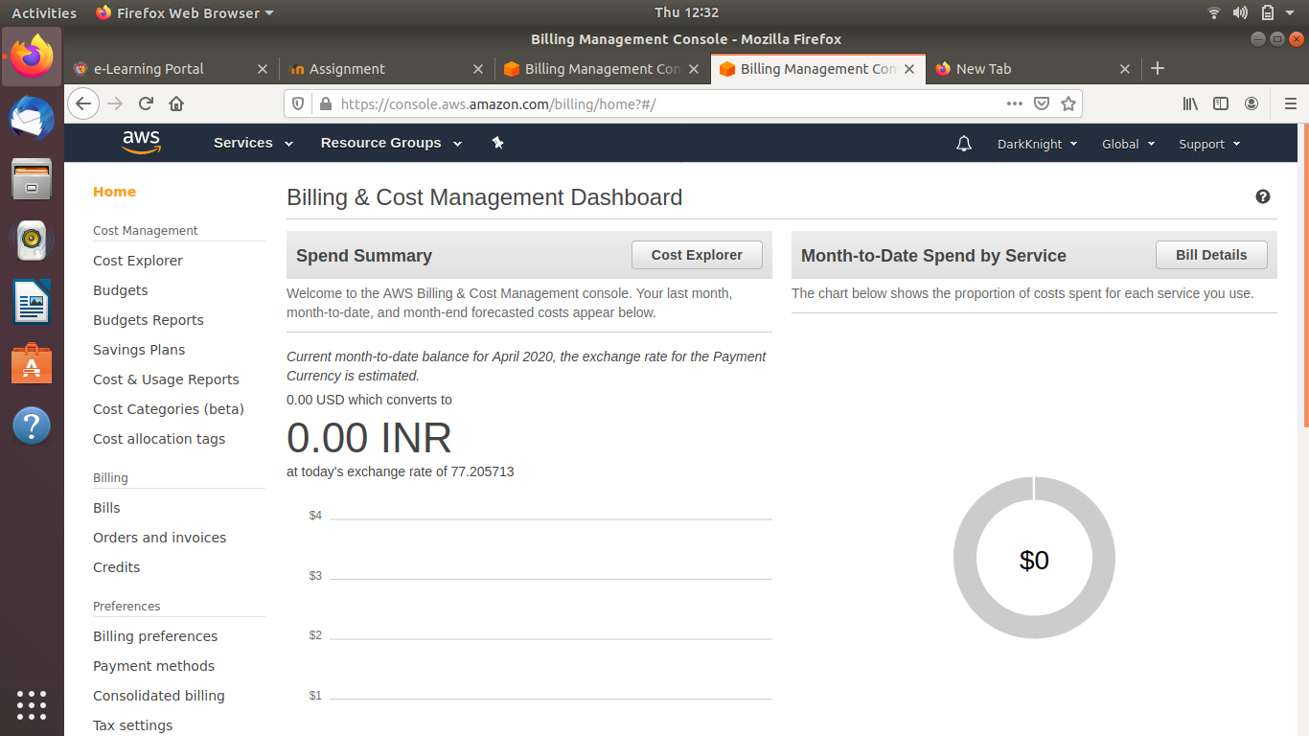

2.Launch a Linux and Windows Ec2 Instance

Compute – Ec2 – Lauchinstacnce – choose AMI

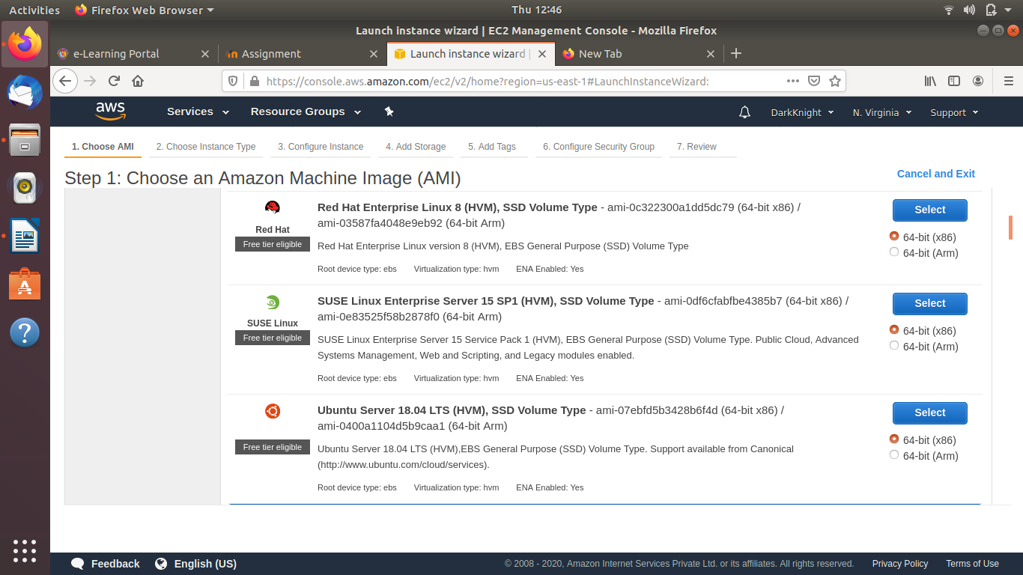

Red Hat Enterprise Linux 8 (HVM), SSD Volume Type - ami-0c322300a1dd5dc79 (64-bit x86) / ami-03587fa4048e9eb92 (64-bit Arm) - SELECT

Instance-Type:

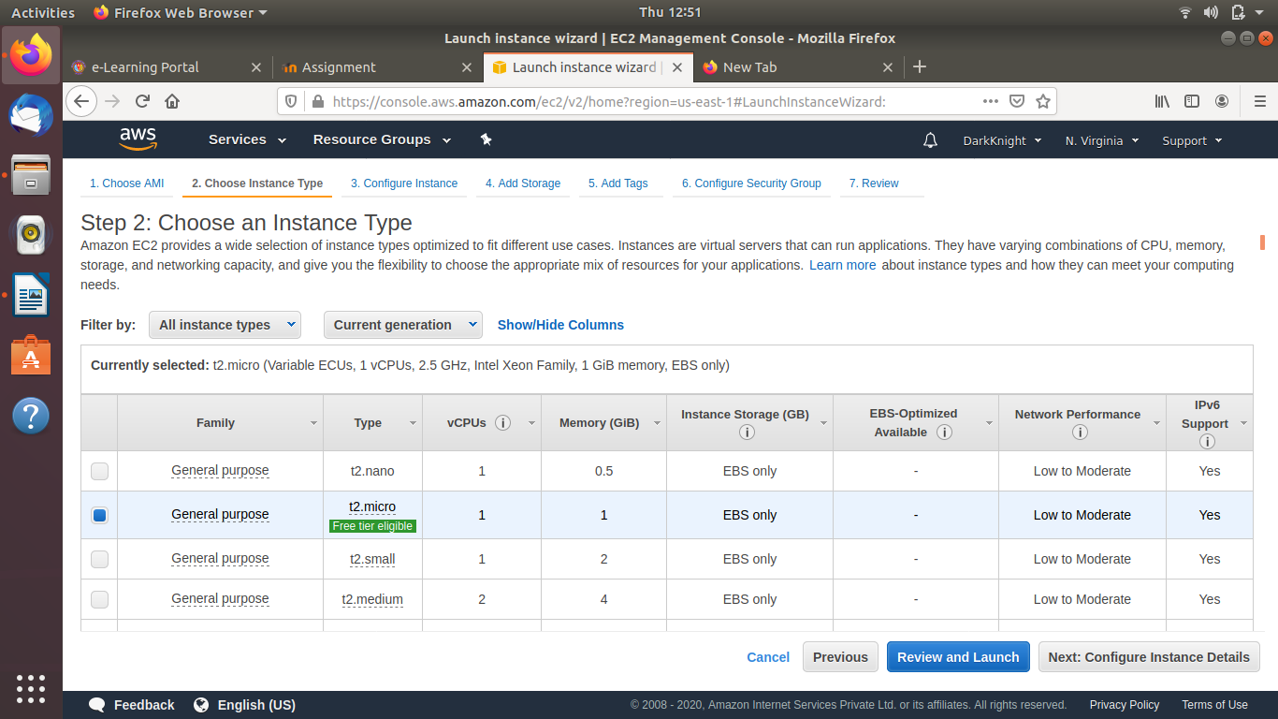

Configure Instance:

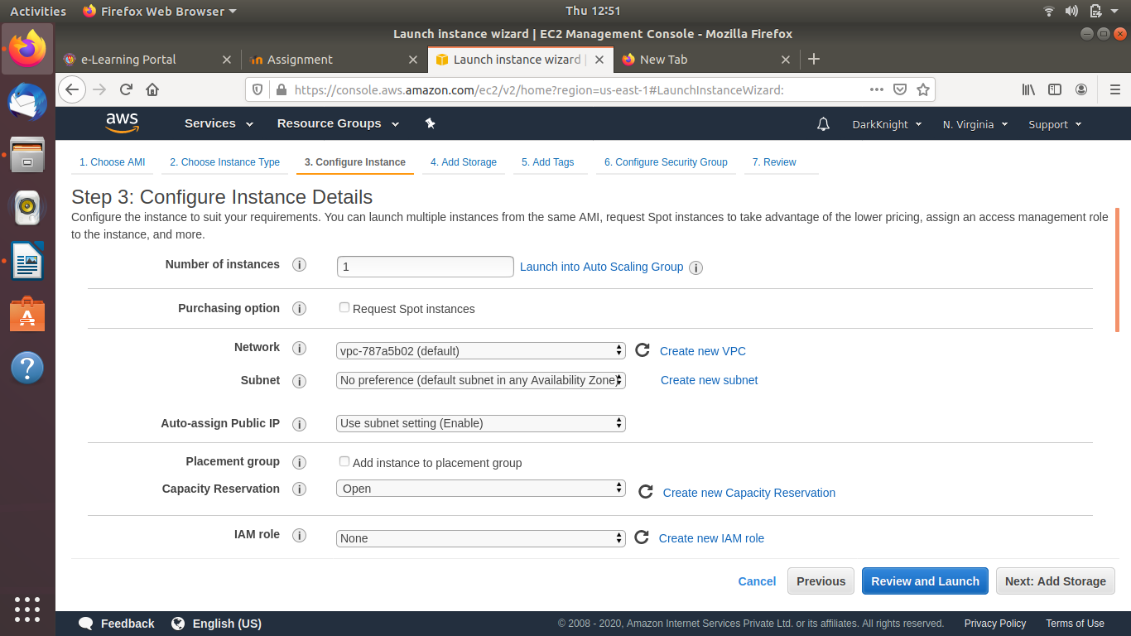

Add Storage:

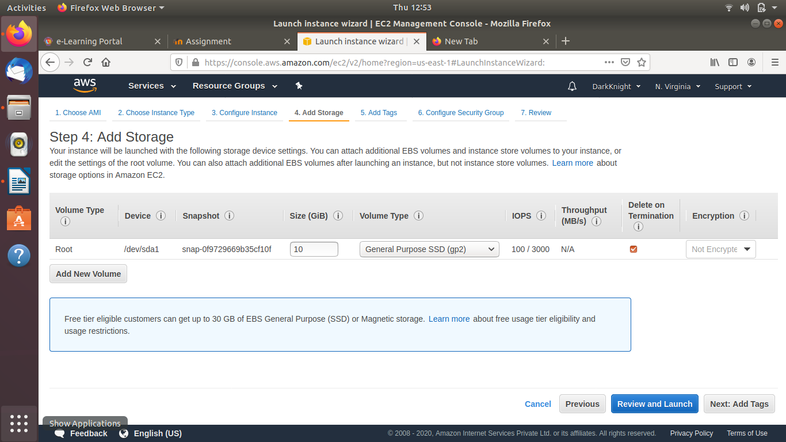

Add Tags:

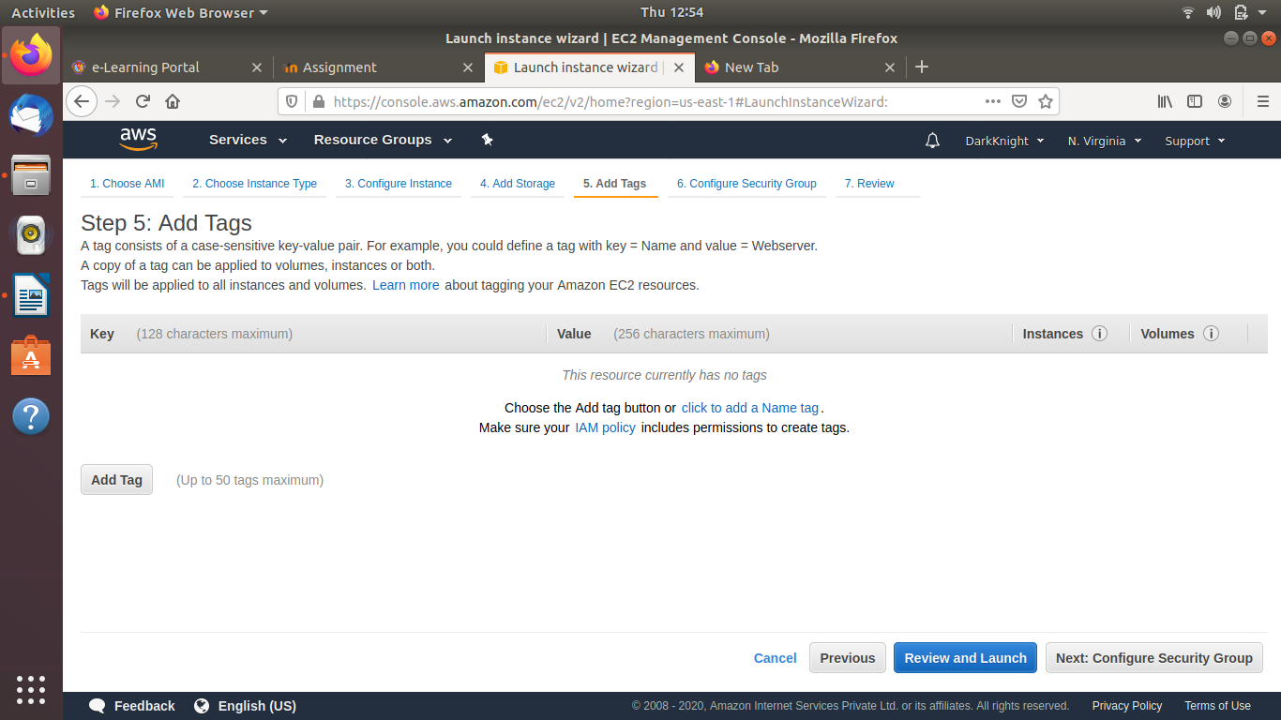

Configure Security Group:

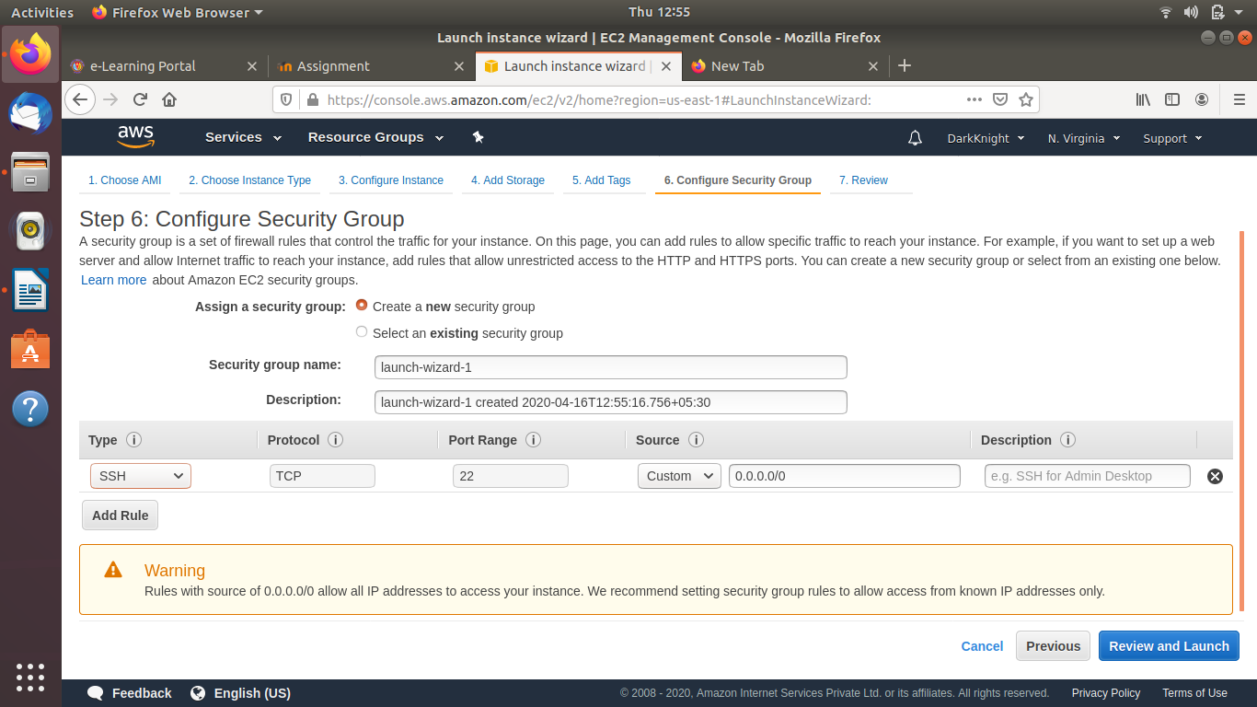

Review

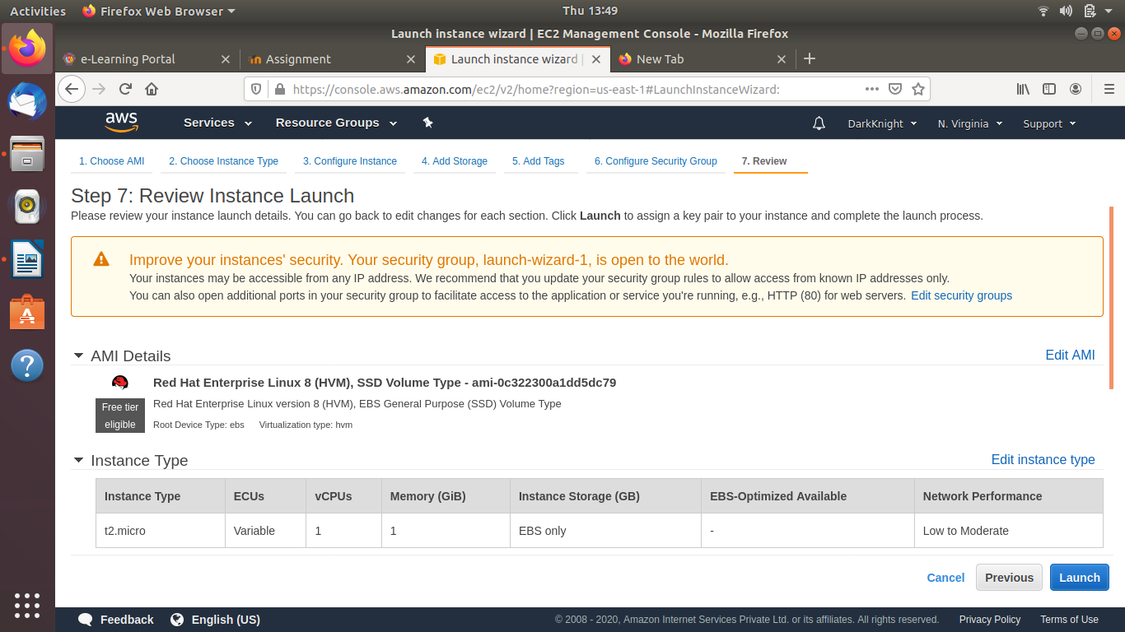

RHEL Instance has been launched

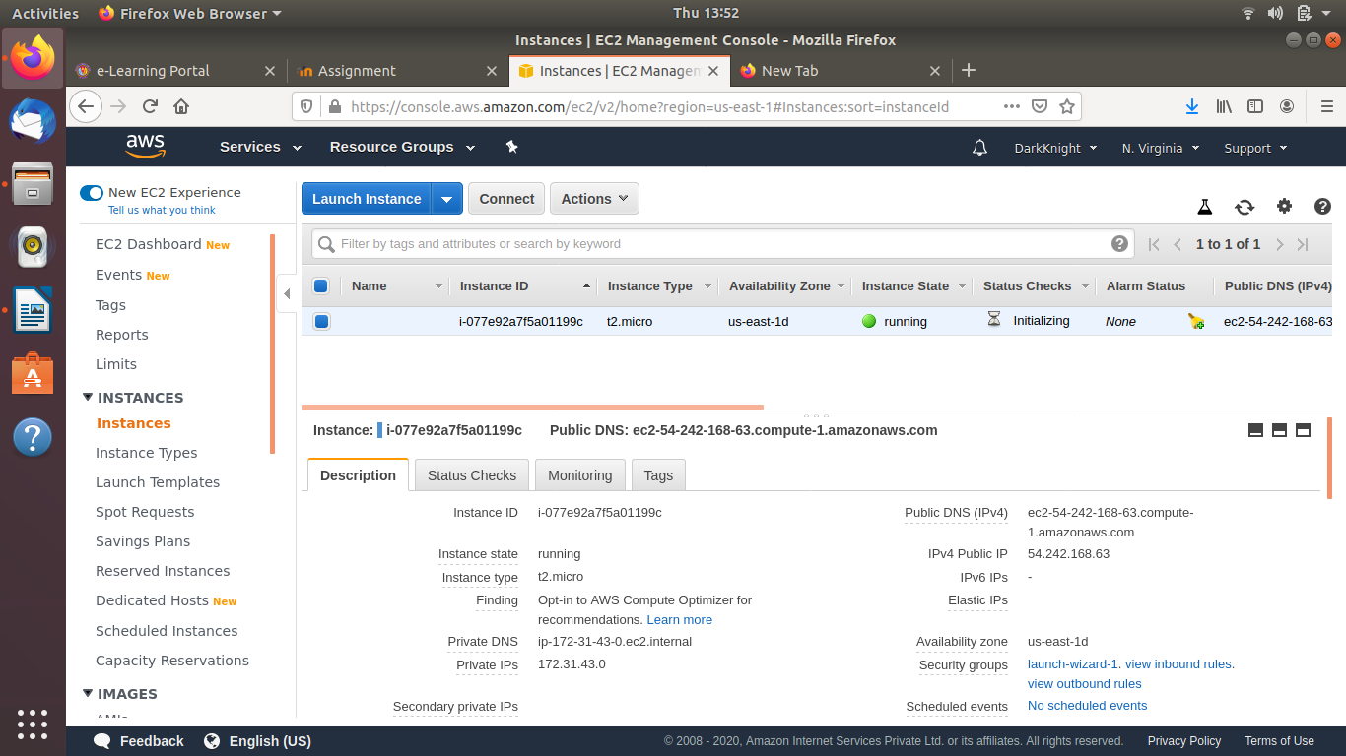

(3)Connection to RHEL Instance (public IP: 54.242.168.63)

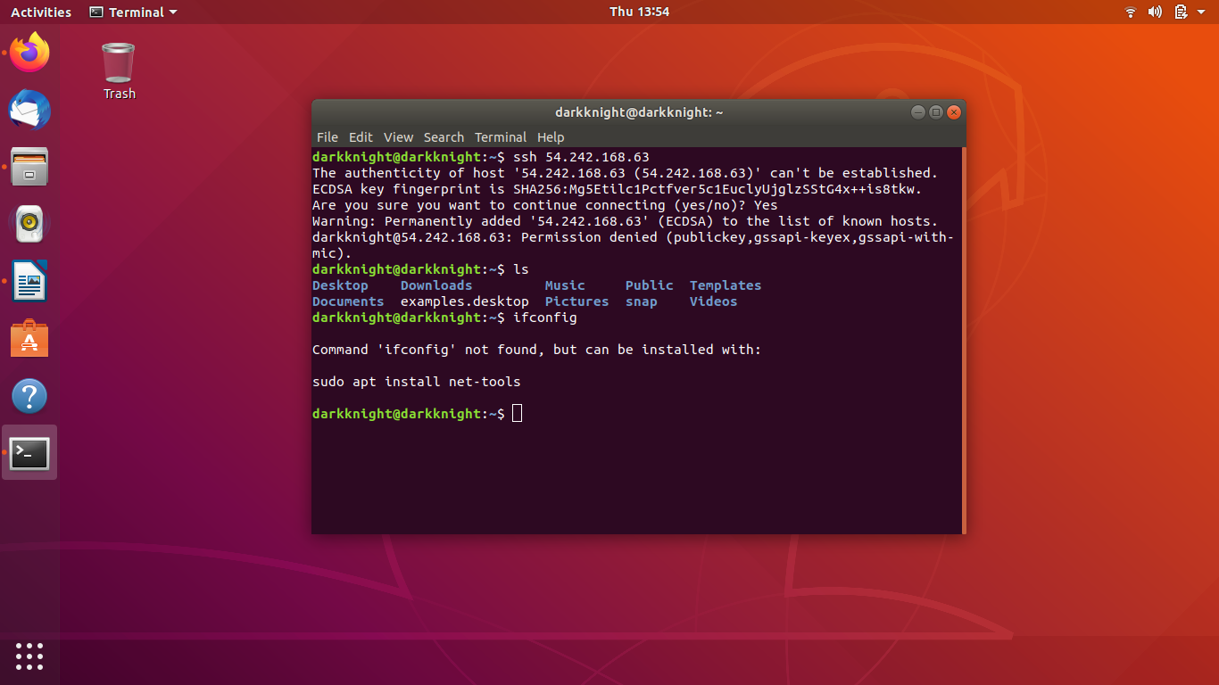

Creating Windows Ec2 Instance:

chose Microsoft Windows Server 2019 Base – ami-09d496c26aa745869 – Select

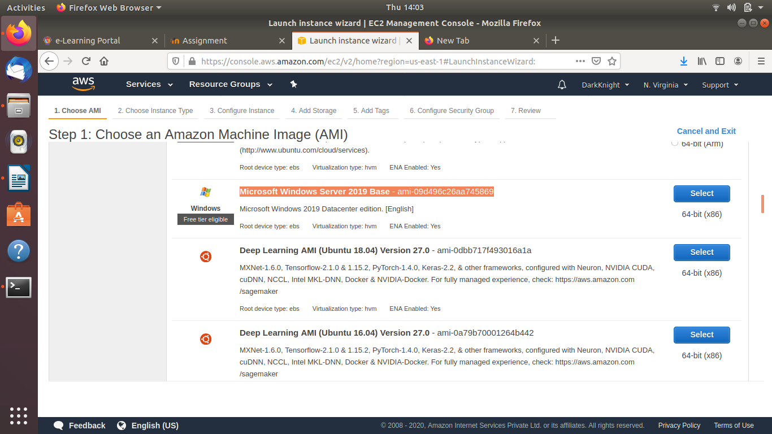

By following the exact same steps as RHEL linux installation we can create windows instance too.

Key Pair:

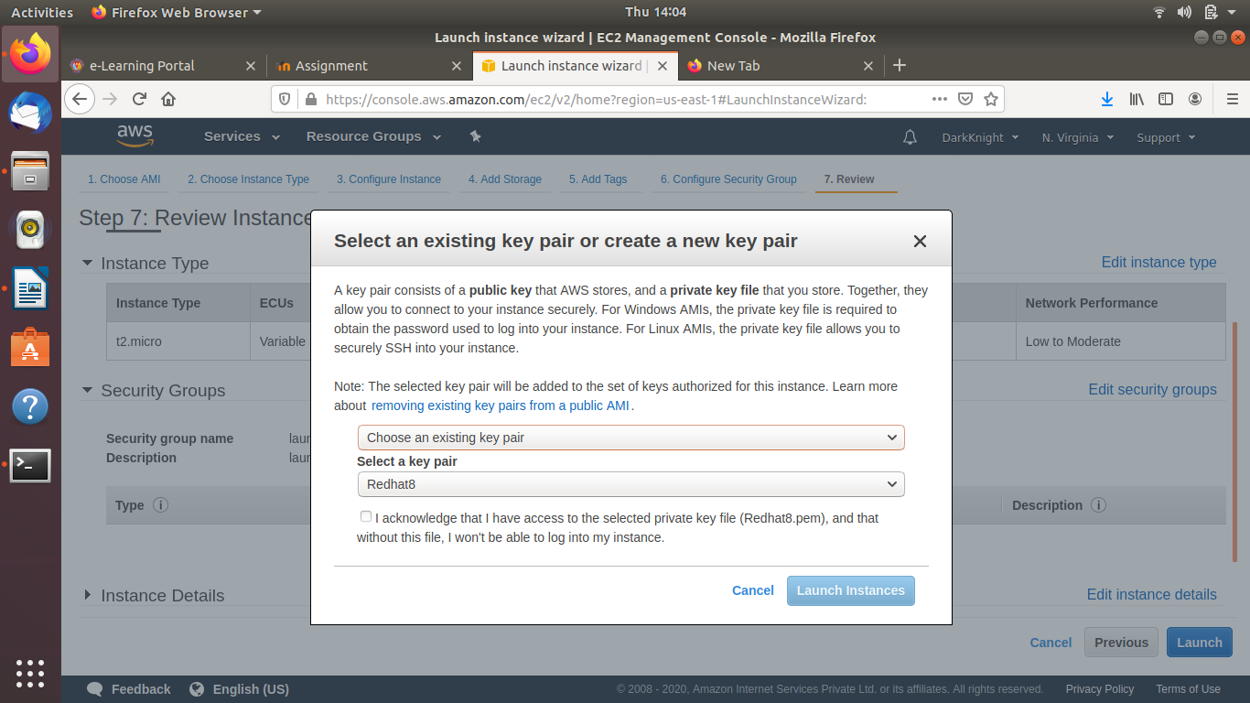

Windows Instance has been launched

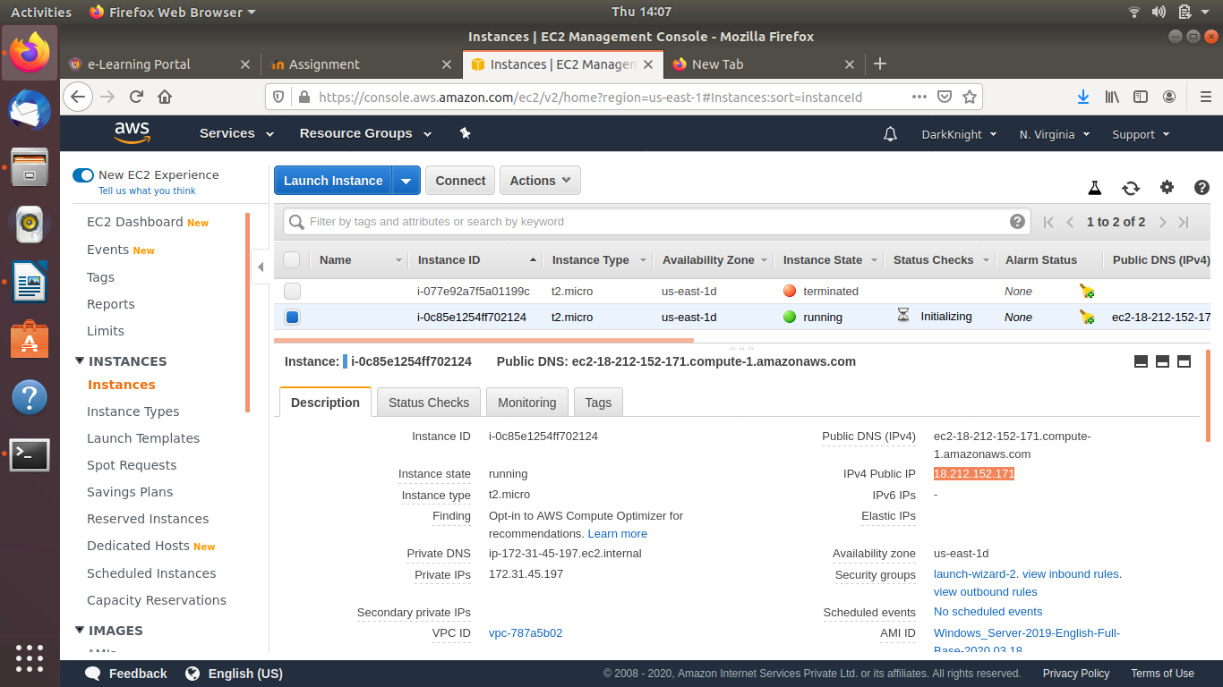

(3)Connecting to windows Instance:

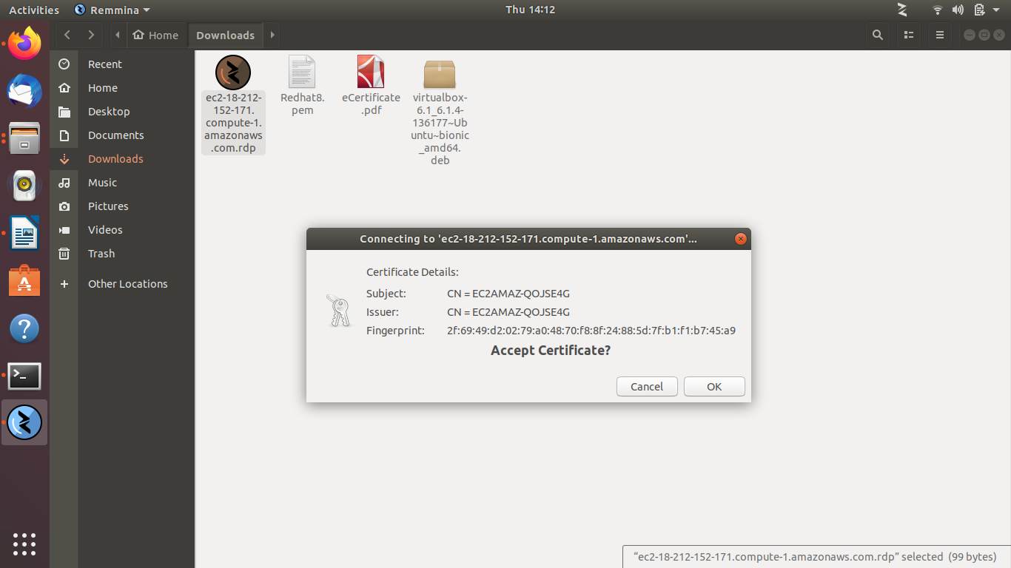

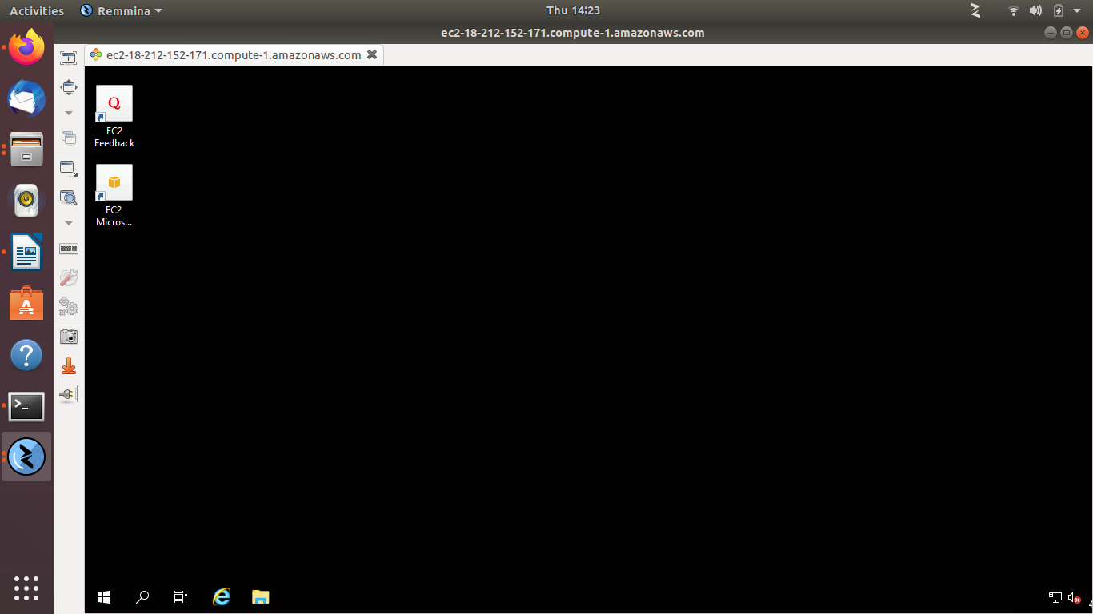

(4)Create an AMI and launch an EC2 instance with the new AMI:

Select an existing EC2 instance – Actions – Image – Create Image
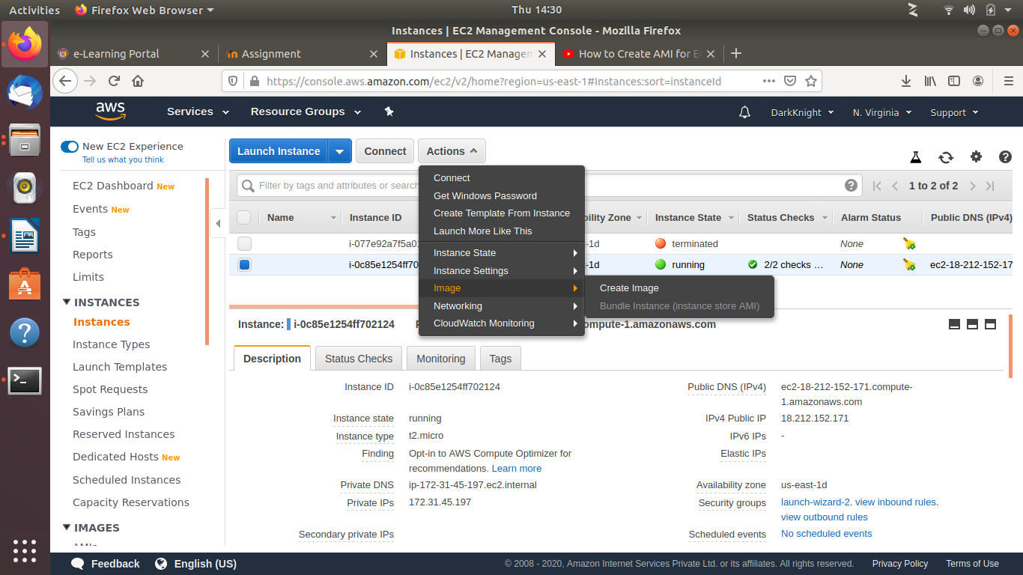

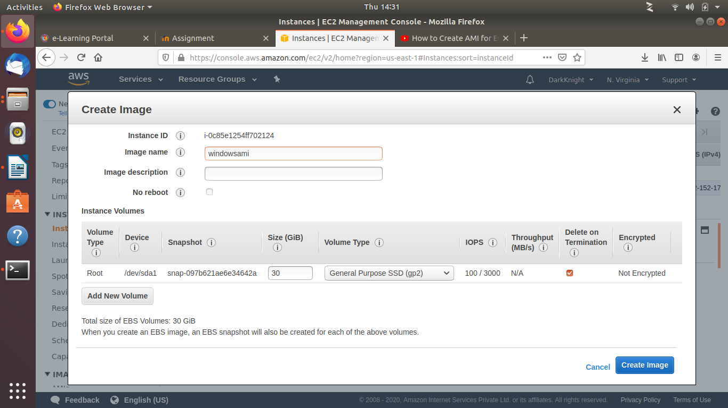

AMI is getting ready

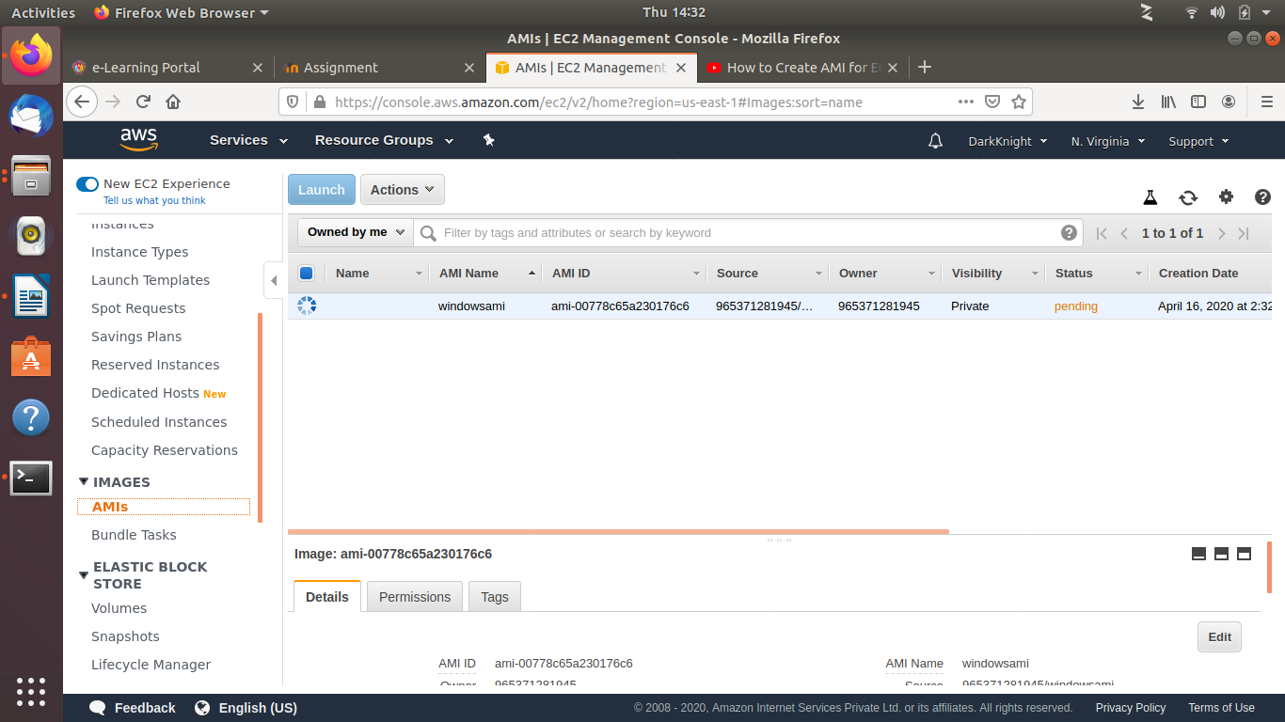

Creating EC2 instance from AMI we created.

Go to AMI – Click windowsAMI(name whcih we created)

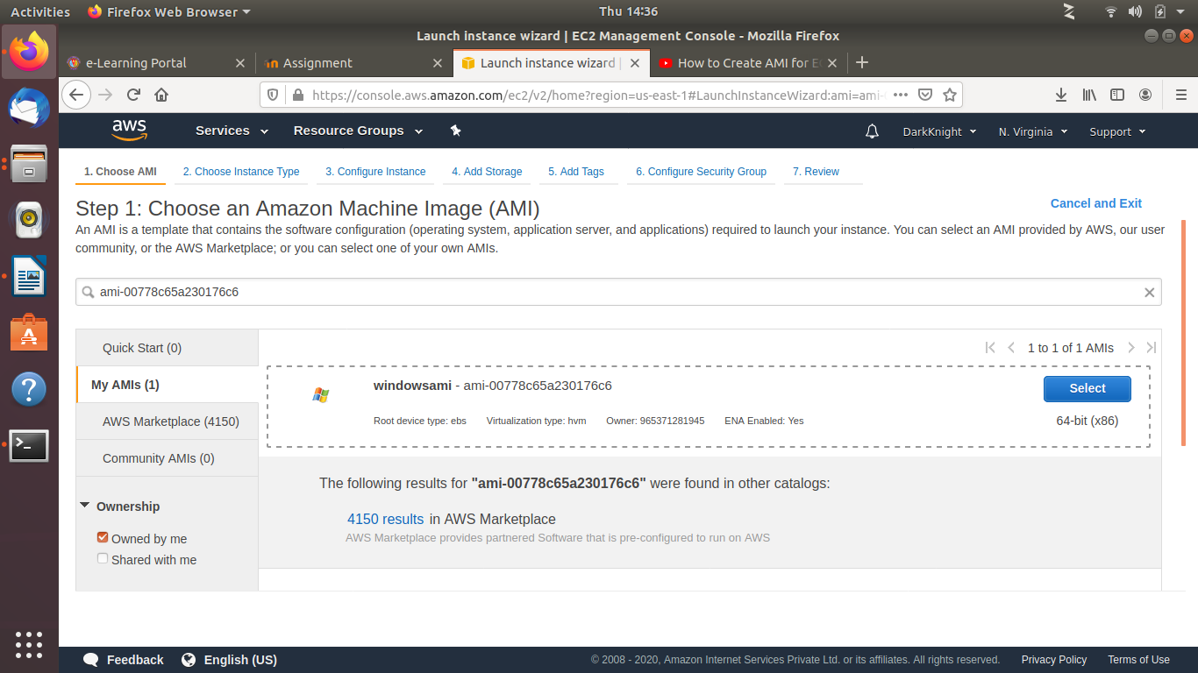

Review:

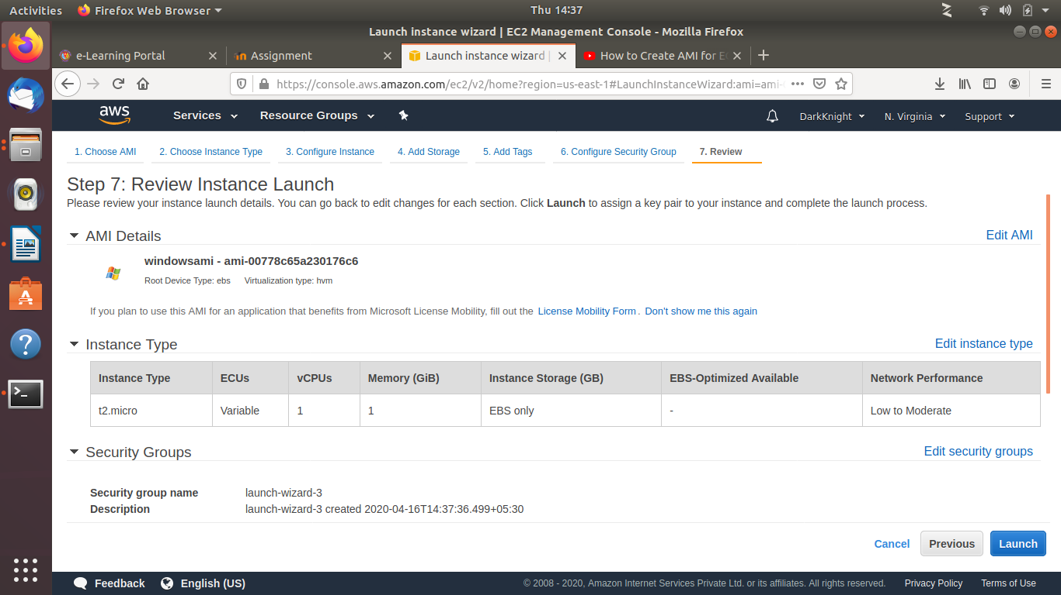

(5) Create an EBS volume and attach it to an EC2 instance:

Go to EBS – Volumes – Create Volume

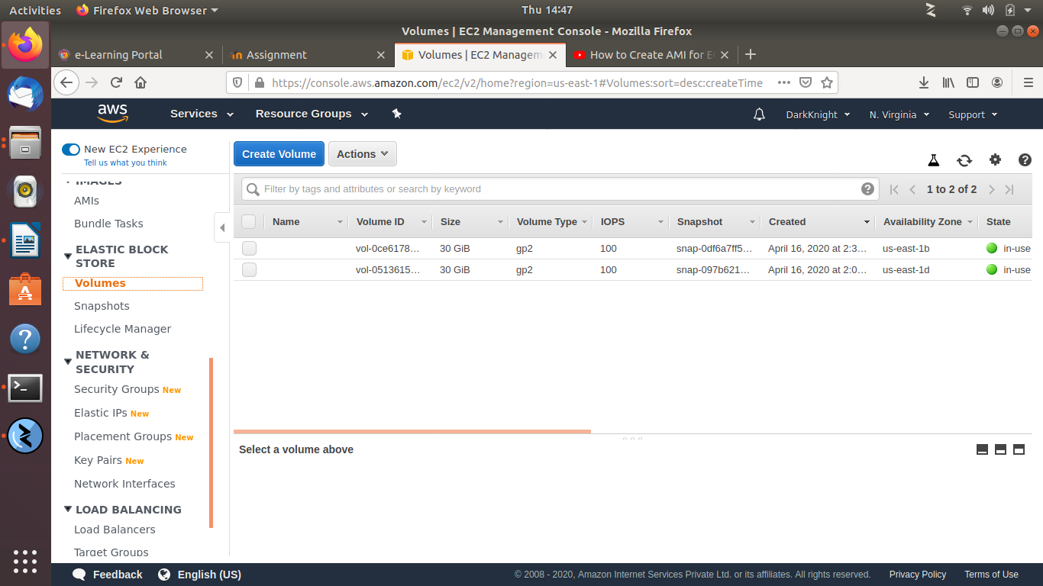

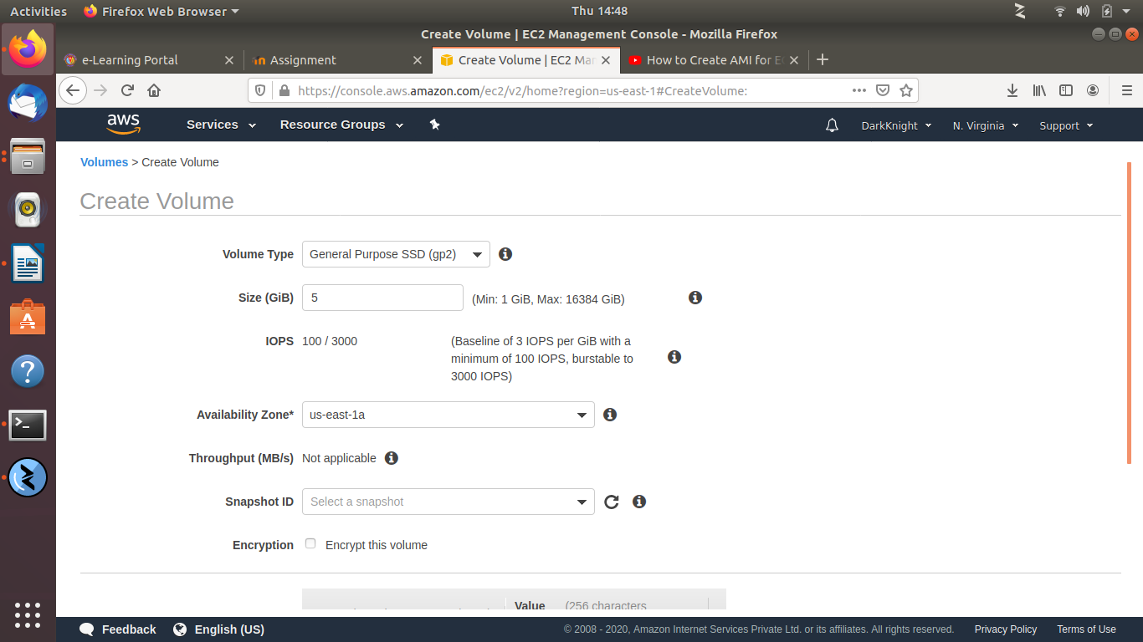

Volume created:

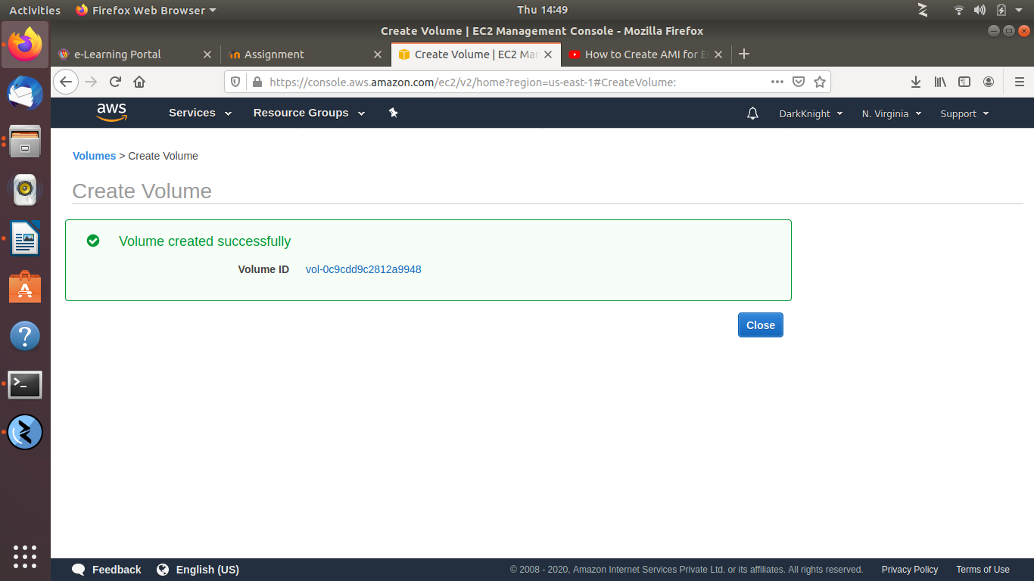

Attaching Volume to EC2 Instance:

Actions – AttachVolume

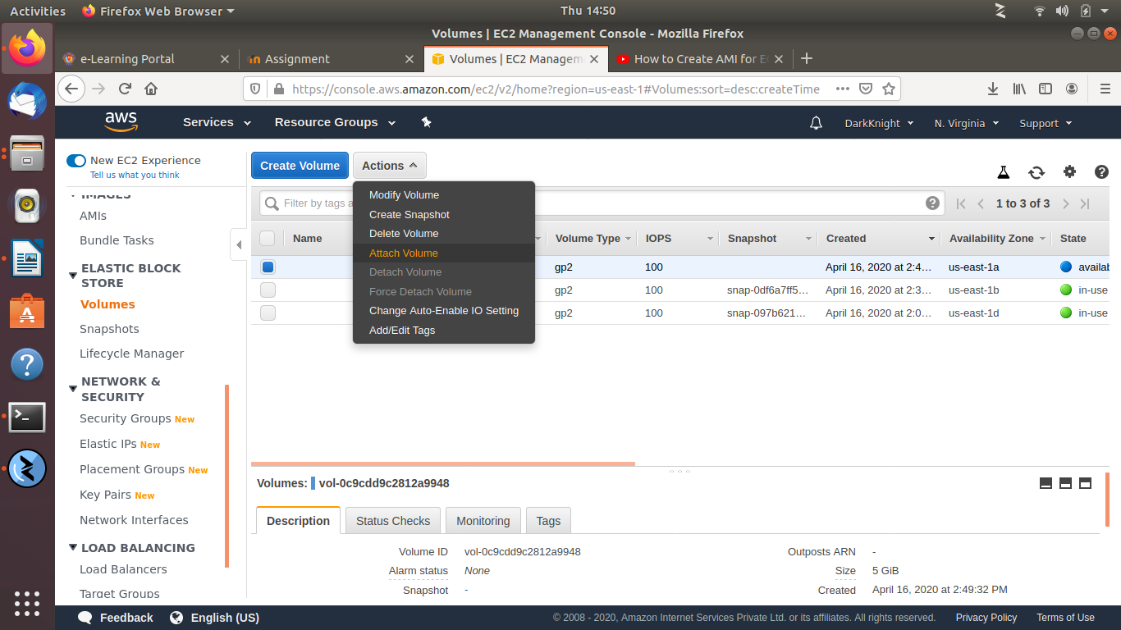

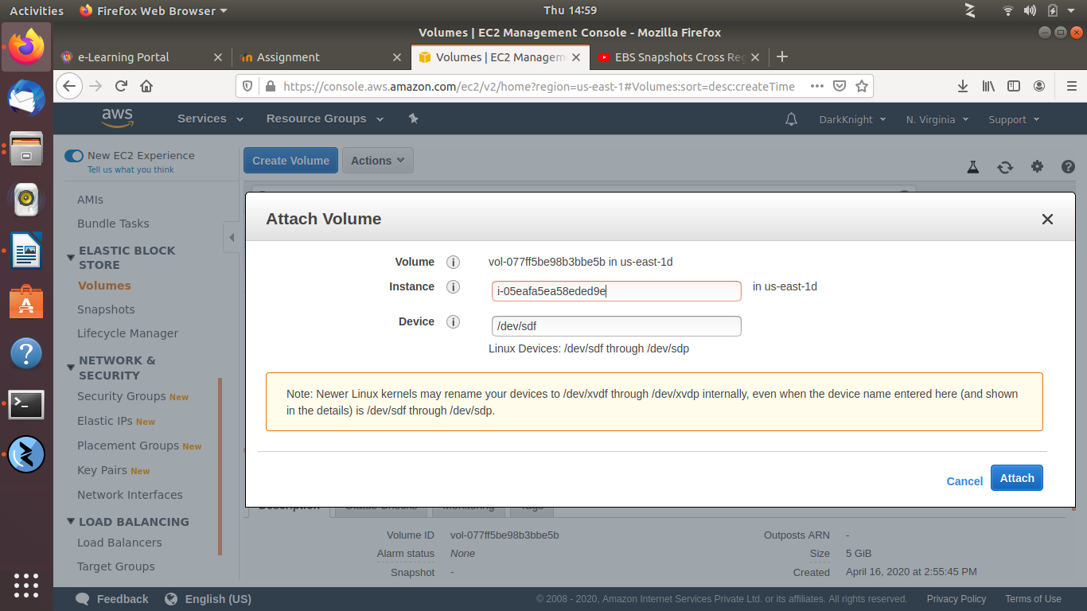

(6) Copy a volume from one region to another:

Select the Volume which needs to be copied to other region and create a snapshot of it.

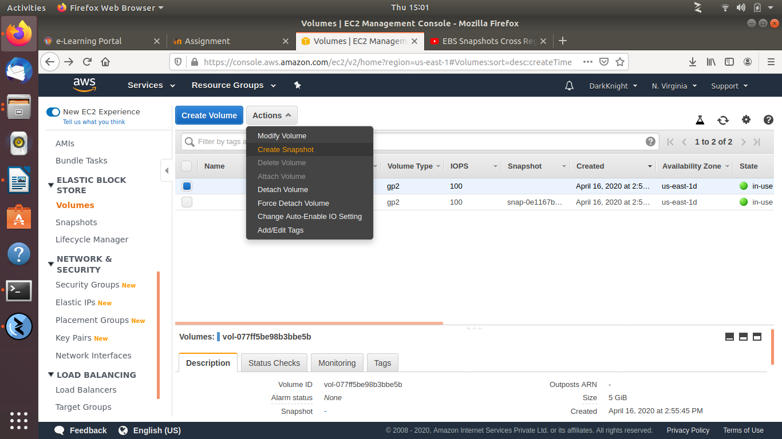

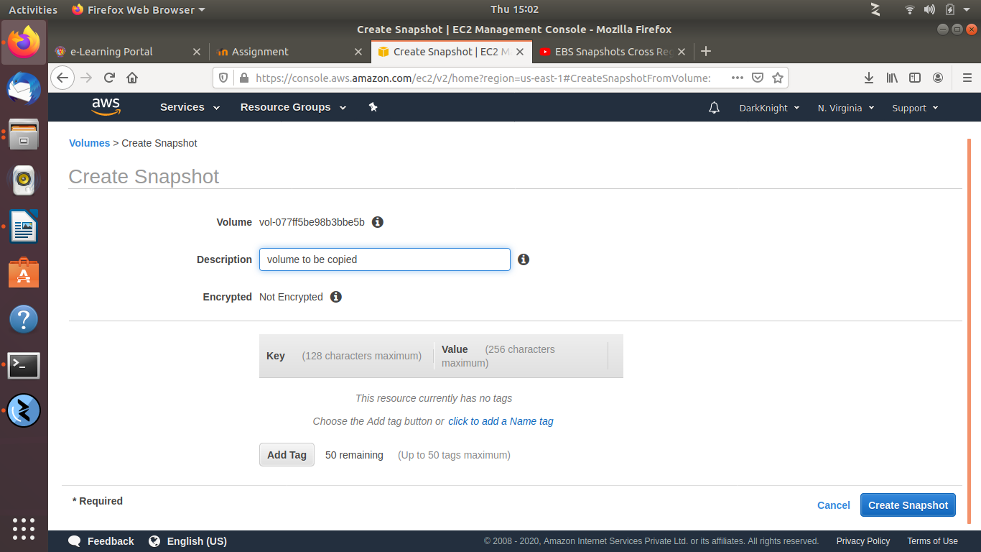

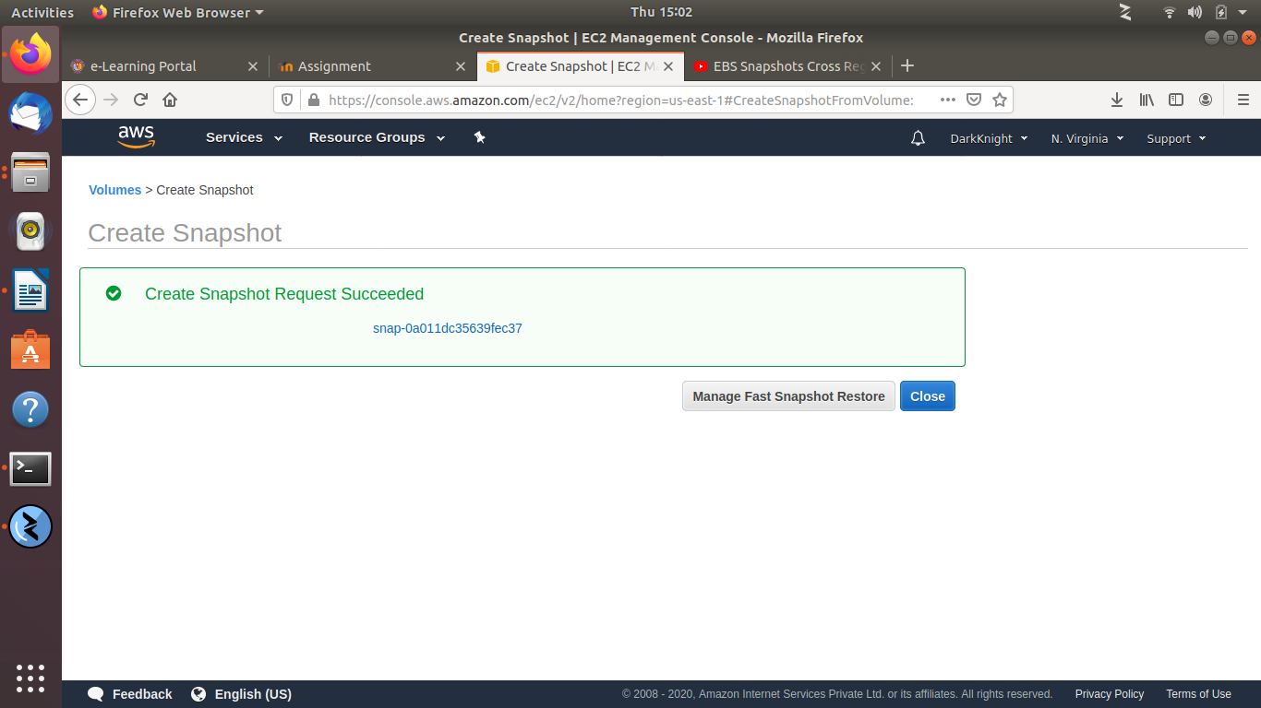

Now go to EBS – Snapshots – Actions – Copy Snapshot

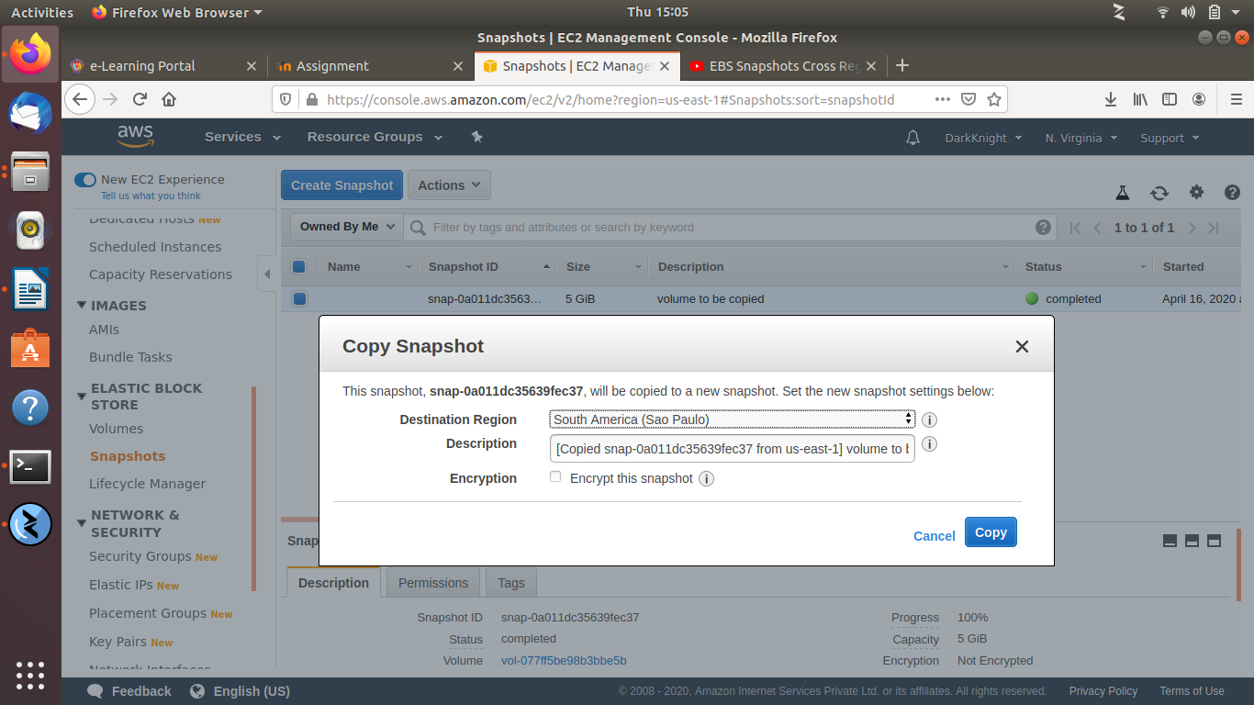

Select the region to want to copy the volume, I have selected South America(Sao Paulo)

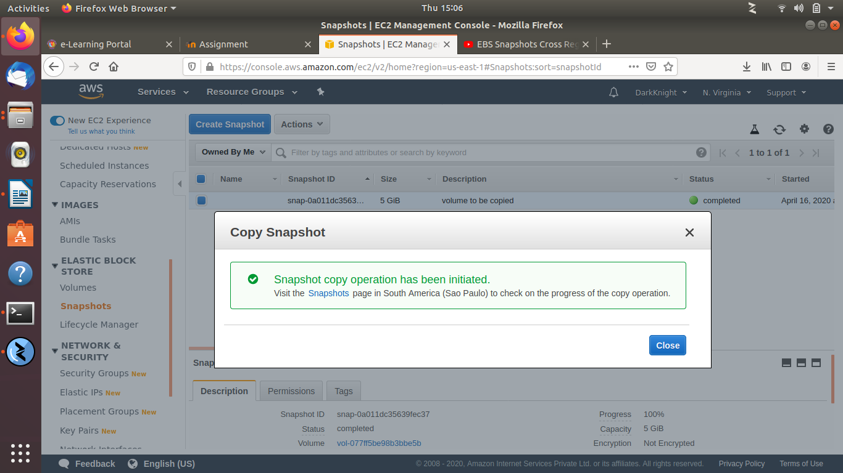

Voulme has been copied to other region successfully.

7. Attach an elastic IP to an EC2 instance:

Go to Ec2 Instance – Actions – Manage IP Addresses

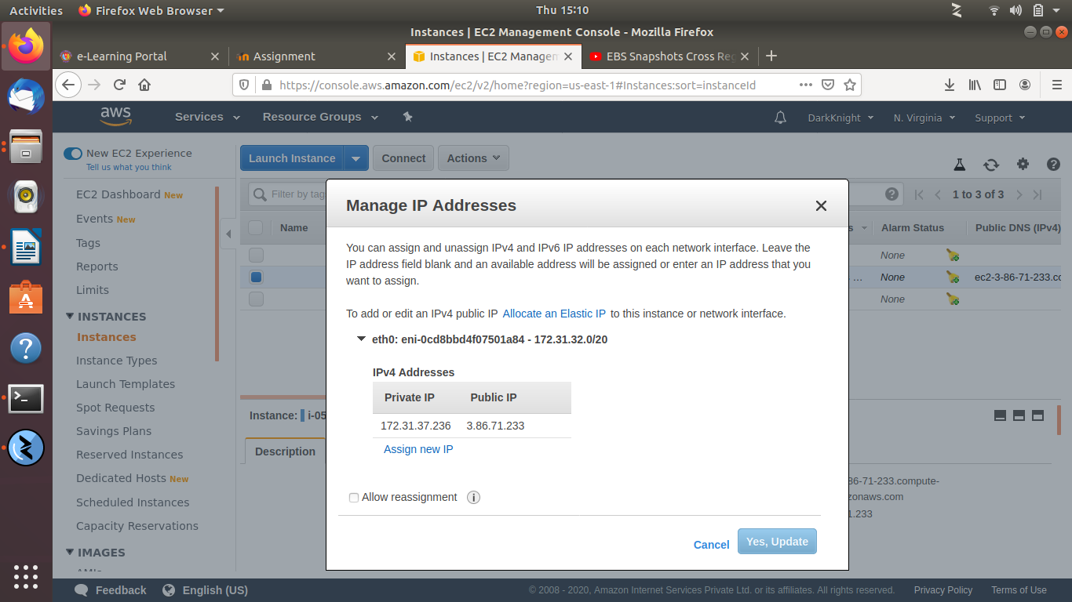

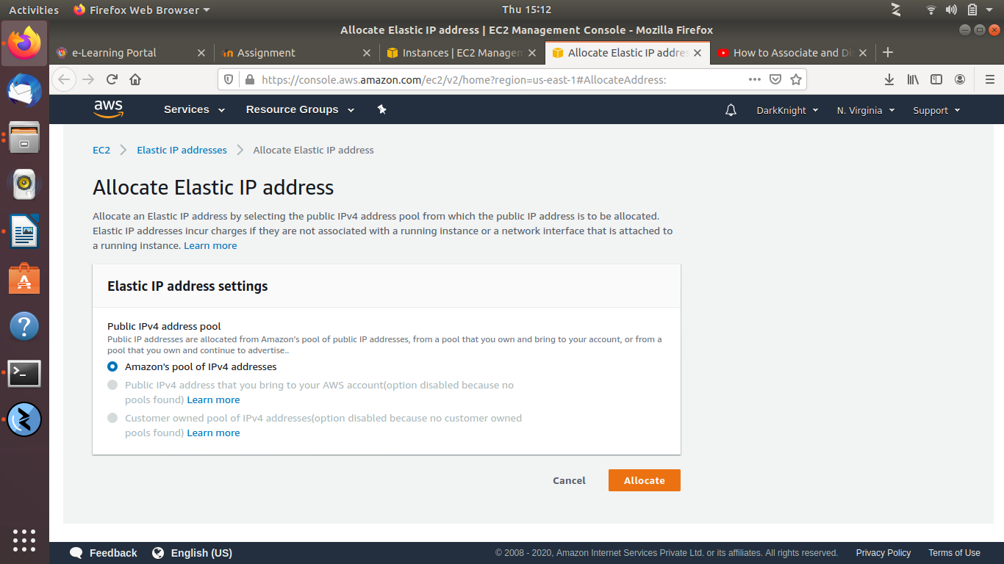

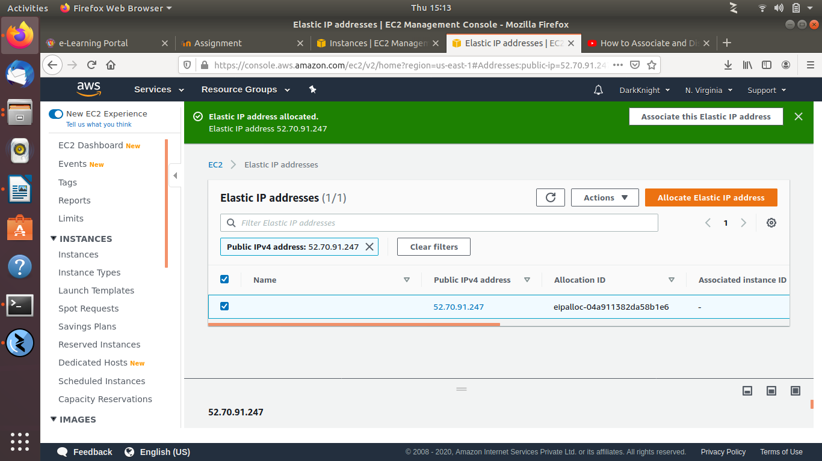

Associate the Elastic IP address to instance.

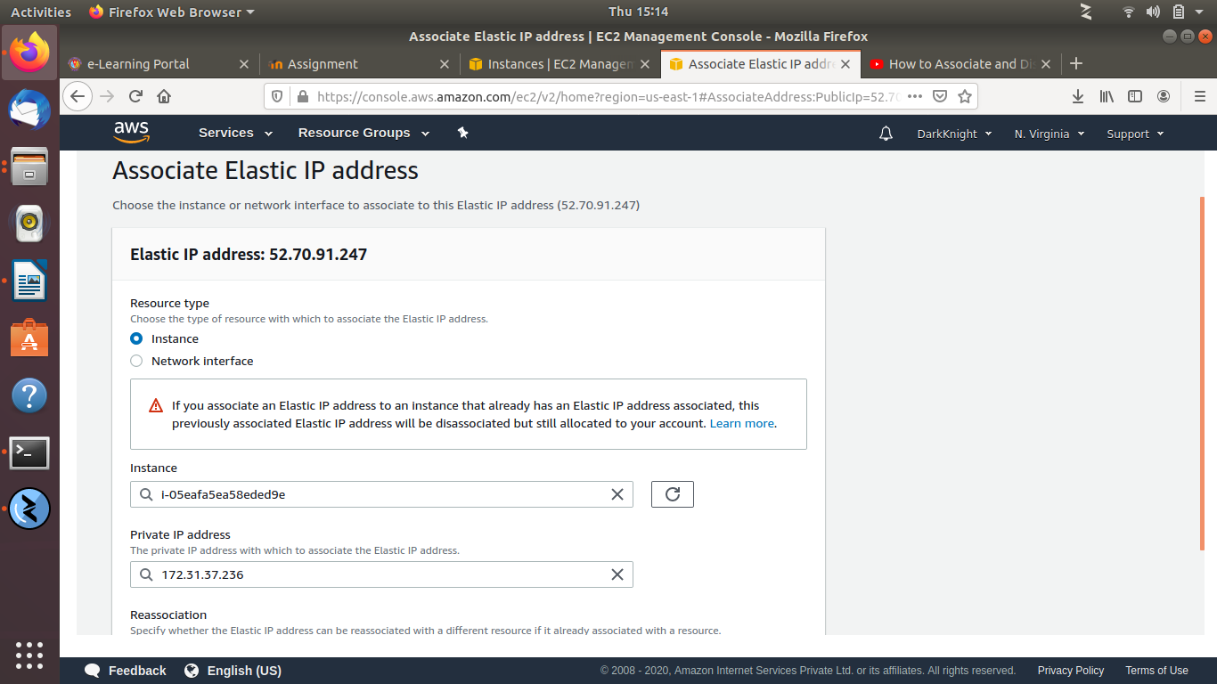

Elastic IP associated



