# Properties

hbase.regionserver.handler.count= 50

hbase.ipc.server.callqueue.scan.ratio=0.8

hbase.ipc.server.callqueue.read.ratio=0.8

hbase.ipc.server.callqueue.handler.factor=0.2

# Estimated Handlers & Queues

* Scan handlers=32
* scan RPC queue=6
* Get handlers=8
* Get RPC queue=2
* Put Handlers=10
* RPC queue=2

# Verify Logs

2023-10-28 06:37:24,006 INFO [main] **ipc.RWQueueRpcExecutor: default.RWQ.Fifo writeQueues=2 writeHandlers=10 readQueues=2 readHandlers=8 scanQueues=6 scanHandlers=32**

2023-10-28 06:37:24,008 INFO [main] ipc.RpcExecutor: Instantiated priority.FPBQ.Fifo with queueClass=class java.util.concurrent.LinkedBlockingQueue; numCallQueues=4, maxQueueLength=500, handlerCount=20

2023-10-28 06:37:24,010 INFO [main] ipc.RpcExecutor: Instantiated replication.FPBQ.Fifo with queueClass=class java.util.concurrent.LinkedBlockingQueue; numCallQueues=1, maxQueueLength=500, handlerCount=3

# Put (Write/Mutate) Handlers & Queue

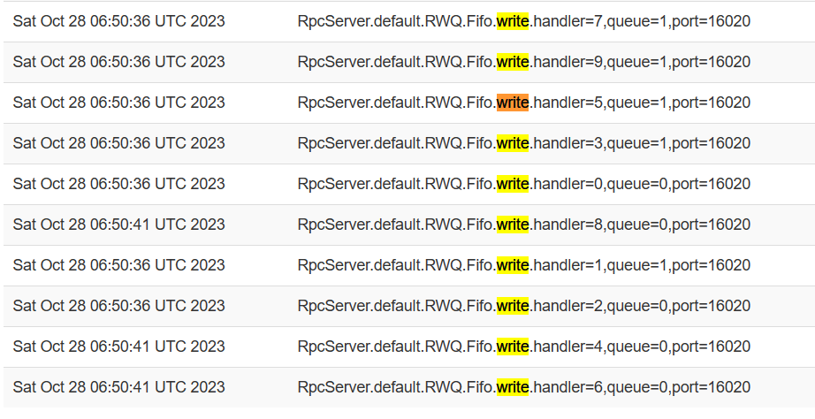

Logs-



# Get/Scan (Short Time) Read

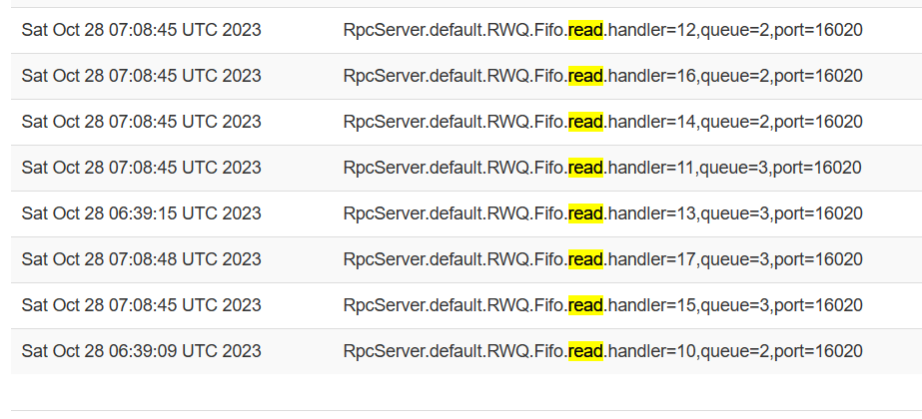

Logs-



# Scan (Long Time) Read

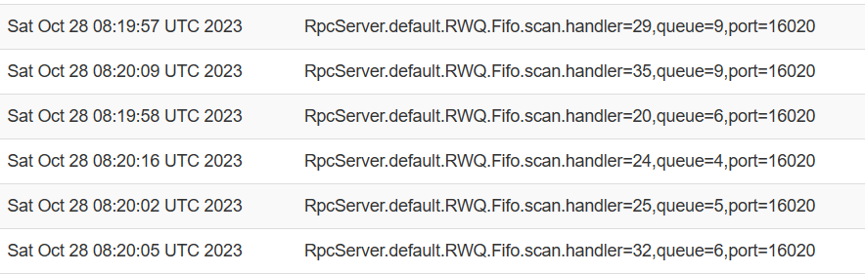

Handler Json



Logs-

