Grenoble INP / UJF
MOSIG2 – PDES
January 20nd, 2014

Distributed Systems

Final examination

Duration: 3 hours
All hand-written documents allowed, no electronic devices, no books

Answers can be written in English or French.

Please be mindful of the entire question before you start writing down your answer. In particular, use a similar wording and notations when possible. Be reminded that the length of a question is no testimony of its difficulty.

The given number of points per question is only there to give you an idea of the importance of a question, we reserve the right to change the exact number of points, but we will respect the relative importance amongst questions.

You must respect the following instructions:
- Indicate your name on each sheet and number it if you use several sheets for each part

Question 1 (3 points):

Explain the difference between a “reliable broadcast protocol” and a “uniform reliable broadcast protocol”. Use examples to illustrate your answer.

Question 1 (7 points):

Design an algorithm that implements the following specification under the following assumptions (start with a plain-text explanation, followed by pseudo-code).

- Asynchronous communications
- Perfect point-to-point links
- Crash faults
- Perfect failure detector

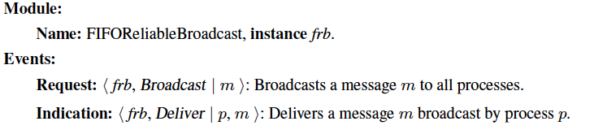
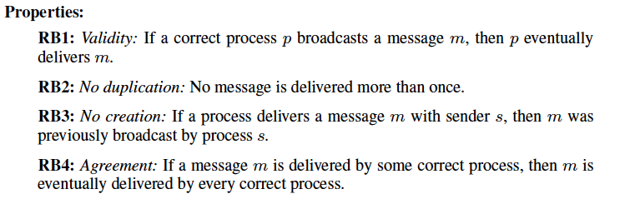
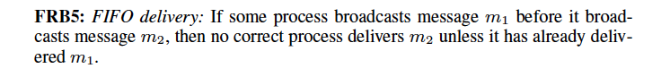

Question 2 (2 points):

Explain what you would change to the previous algorithm if the assumptions were:

- Asynchronous communications
- Perfect point-to-point links
- Crash faults
- A majority of processes are correct (i.e. do not crash)

Question 3 (8 points):

This question is about consensus. In short, processes use consensus to agree on a common value out of values they initially propose. We have studied the Paxos protocol, which is an example of a consensus protocol designed under the assumption that a majority of processes are correct. In this question, we use a different assumption: the availability of a perfect failure detector. Design an algorithm that implements consensus under this assumption (start with a plain-text explanation, followed by pseudo-code). We recall below the set of assumptions and the definition of interfaces and properties of a consensus protocol.

Assumptions:
- Asynchronous communications
- Perfect point-to-point links
- Crash faults
- Perfect failure detector

Specification of interfaces and properties of a consensus protocol.

