Layout structure details

1) parse_config.[h&c]
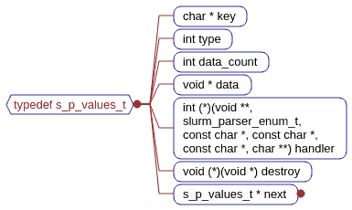
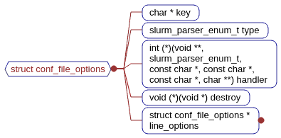
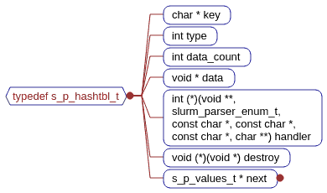
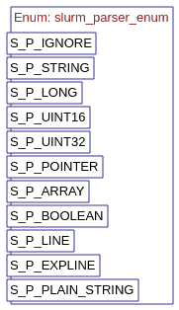

typedef struct slurm_parser_enum slurm_parser_enum_t;
typedef struct s_p_values s_p_values_t;
typedef s_p_values_t * s_p_hashtbl_t;
typedef struct conf_file_options *s_p_options_t;
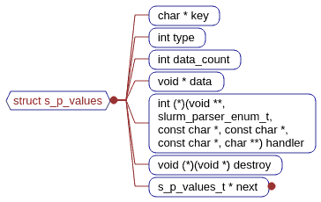

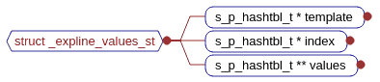

2) xtree.[h&c]
typedef struct xtree_node_st xtree_node_t;
typedef struct xtree_st xtree_t;

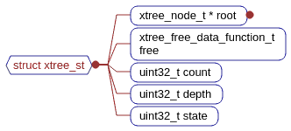

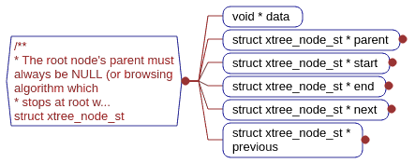

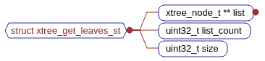

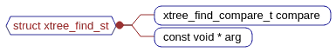

/** see function prototype for xtree_walk for description */
#define XTREE_PREORDER 1 #define XTREE_INORDER 2 #define XTREE_ENDORDER 4
#define XTREE_LEAF 8 #define XTREE_GROWING 16 /*XTREE_LEAF indicates the node being visited is a leaf and receive consequently only one visit.
* XTREE_GROWING is called before any other calls, allowing a node to add childs. */
#define XTREE_LEVEL_MAX UINT32_MAX
#define XTREE_STATE_DEPTHCACHED 1
#define XTREE_PREPEND 1 /** prepend to child list */
#define XTREE_APPEND 2 /** append to child list */
#define XTREE_REFRESH_DEPTH 4 /** default: don't refresh at insertion */
#define xtree_node_get_data(node) ((node) ? (node)->data : NULL)
#define xtree_get_root(tree) ((tree) ? (tree)->root : NULL)
#define XTREE_GET_PARENTS_FIRST_SIZE 64

3) xhash.[h&c]
typedef struct xhash_st xhash_t;
typedef struct xhash_item_st xhash_item_t;
#if 0 /* undefine default allocators */
#undef uthash_malloc #undef uthash_free/* re-define them using slurm's ones */ #define uthash_malloc(sz) xmalloc(sz) #define uthash_free(ptr, sz) xfree(ptr) #endif

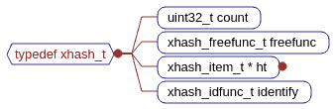

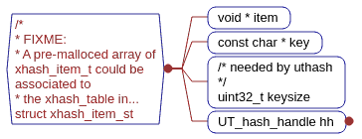

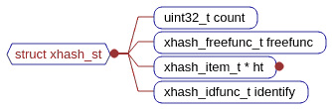

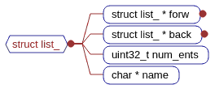
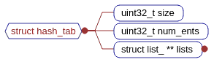
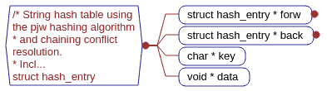

4) entity.h
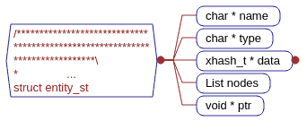
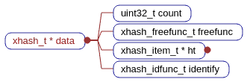

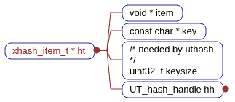

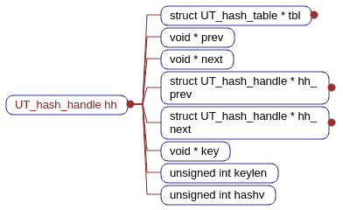
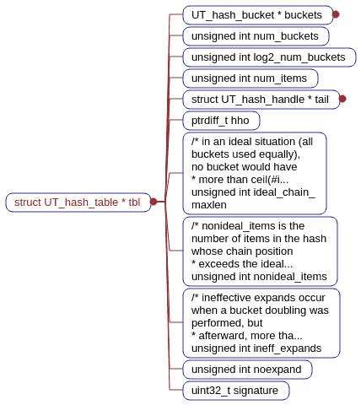
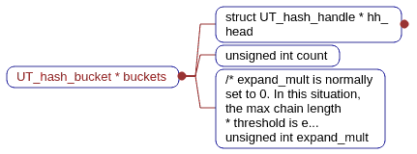
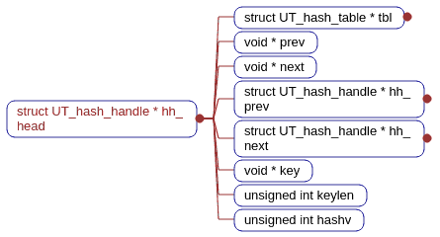

/* definition of the entity itself, main structure of this file. */
typedef struct entity_st entity_t;
/* definition of the key-value structure used internaly by entities */
typedef struct entity_data_st entity_data_t;
/* definition of the entity node structure used internaly by entities * to represent the layout nodes that are linked to them */
typedef struct entity_node_st entity_node_t;

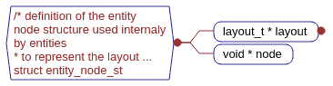
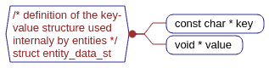
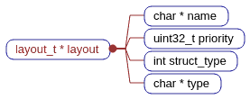

5) entity.c
typedef struct _entity_nodes_walkstruct_st _entity_nodes_walkstruct_t;
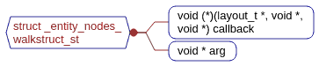

6)layout.h
typedef struct layout_st layout_t;
#define LAYOUT_STRUCT_TREE 1
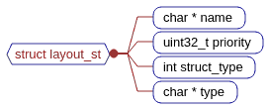

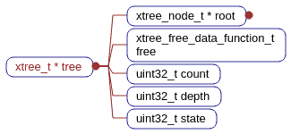
xtree_t *tree
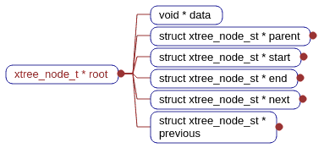

7)layouts_mgr.h
typedef enum layouts_keydef_types_en layouts_keydef_types_t;
typedef struct layouts_keyspec_st layouts_keyspec_t;
typedef struct layouts_plugin_spec_st layouts_plugin_spec_t;
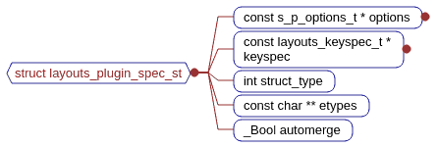
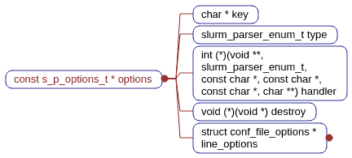
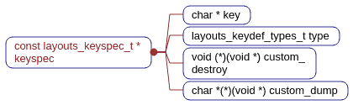
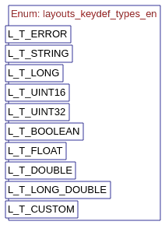

8)Layout_mgr.c
typedef struct layout_ops_st layout_ops_t;
typedef struct layouts_conf_spec_st layouts_conf_spec_t;
typedef struct layout_plugin_st layout_plugin_t;
typedef struct layouts_keydef_st layouts_keydef_t;
typedef struct layouts_mgr_st layouts_mgr_t;

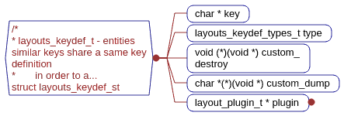

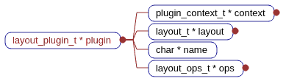

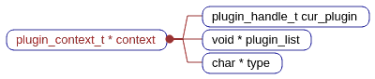

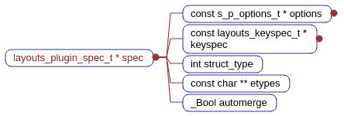
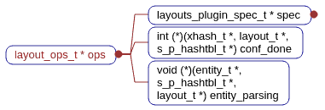

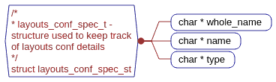

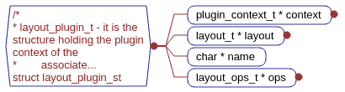
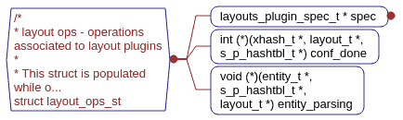

#define PATHLEN 256
void free(void*);
/* * layout plugin symbols - must be synchronized with ops structure definition * as previously detailed, that's why though being a global constant, * it is placed in this section. */
const char *layout_syms[] = {
"plugin_spec", /* holds constants, definitions, ... */
"layouts_p_conf_done", /* */
"layouts_p_entity_parsing", };

