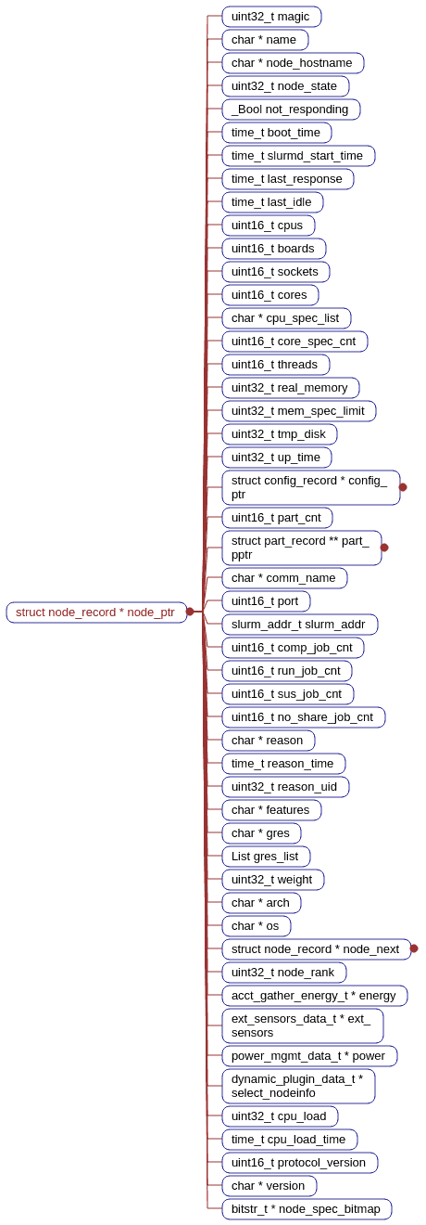
Structure(User defined type or Data Structure)

- Node usage and details for every nodes
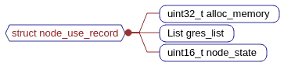

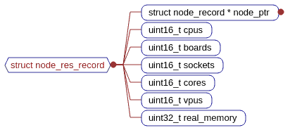

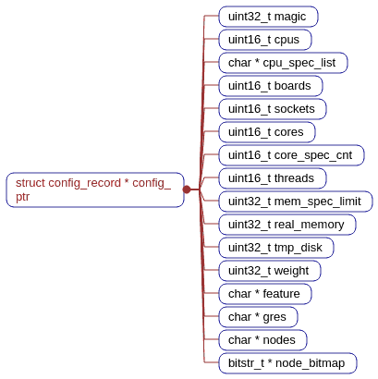

2) Partition and Job_resources details
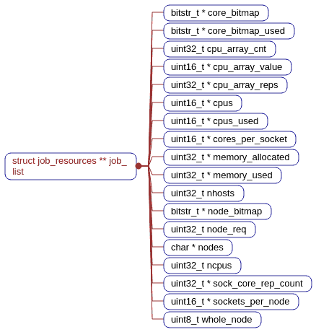
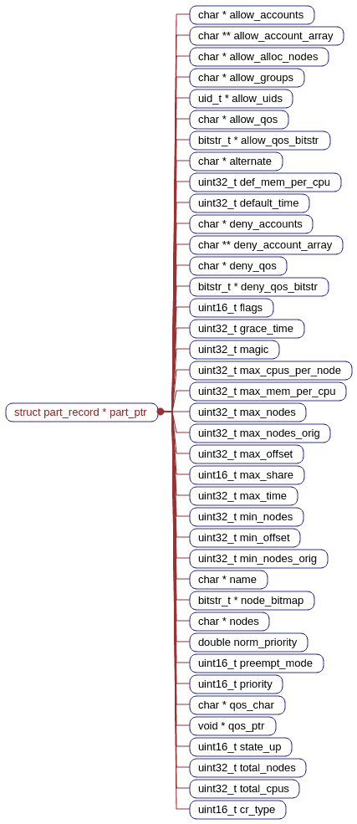

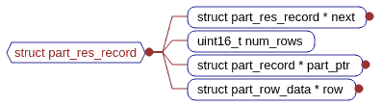
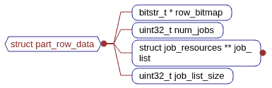

/* struct job_resources defines exactly which resources are allocated
* to a job, step, partition, etc.
*
* core_bitmap - Bitmap of allocated cores for all nodes and sockets
* core_bitmap_used - Bitmap of cores allocated to job steps
* cores_per_socket - Count of cores per socket on this node, build by
* build_job_resources() and insures consistent
* interpretation of core_bitmap
* cpus - Count of desired/allocated CPUs per node for job/step
* cpus_used - For a job, count of CPUs per node used by job steps
* cpu_array_cnt - Count of elements in cpu_array_* below
* cpu_array_value - Count of allocated CPUs per node for job
* cpu_array_reps - Number of consecutive nodes on which cpu_array_value
* is duplicated. See NOTES below.
* memory_allocated - MB per node reserved for the job or step
* memory_used - MB per node of memory consumed by job steps
* nhosts - Number of nodes in the allocation. On a
* bluegene machine this represents the number
* of midplanes used. This should always be
* the number of bits set in node_bitmap.
* node_bitmap - Bitmap of nodes allocated to the job. Unlike the
* node_bitmap in slurmctld's job record, the bits
* here do NOT get cleared as the job completes on a
* node
* node_req - NODE_CR_RESERVED|NODE_CR_ONE_ROW|NODE_CR_AVAILABLE
* nodes - Names of nodes in original job allocation
* ncpus - Number of processors in the allocation
* sock_core_rep_count - How many consecutive nodes that sockets_per_node
* and cores_per_socket apply to, build by
* build_job_resources() and insures consistent
* interpretation of core_bitmap
* sockets_per_node - Count of sockets on this node, build by
* build_job_resources() and insures consistent
* interpretation of core_bitmap
* whole_node - Job allocated full node (used only by select/cons_res)
*
* NOTES:
* cpu_array_* contains the same information as "cpus", but in a more compact
* format. For example if cpus = {4, 4, 2, 2, 2, 2, 2, 2} then cpu_array_cnt=2
* cpu_array_value = {4, 2} and cpu_array_reps = {2, 6}. We do not need to
* save/restore these values, but generate them by calling
* build_job_resources_cpu_array()
*
* Sample layout of core_bitmap:
* | Node_0 | Node_1 |
* | Sock_0 | Sock_1 | Sock_0 | Sock_1 |
* | Core_0 | Core_1 | Core_0 | Core_1 | Core_0 | Core_1 | Core_0 | Core_1 |
* | Bit_0 | Bit_1 | Bit_2 | Bit_3 | Bit_4 | Bit_5 | Bit_6 | Bit_7 |
*
* If a job changes size (reliquishes nodes), the node_bitmap will remain
* unchanged, but cpus, cpus_used, cpus_array_*, and memory_used will be
* updated (e.g. cpus and mem_used on that node cleared).
*/
struct job_resources

Node-0 |  |  |  | Node-1
Sock-0 |  | Sock-1 |  | Sock-2 |  | Sock-3
Core-0 | Core-1 | Core-2 | Core-3 | Core-4 | Core-5 | Core-6 | Core-7

/*
* node_res_record.node_state assists with the unique state of each node.
* When a job is allocated, these flags provide protection for nodes in a
* Shared=NO or Shared=EXCLUSIVE partition from other jobs.
*
* NOTES:
* - If node is in use by Shared=NO part, some CPUs/memory may be available
* - Caution with NODE_CR_AVAILABLE: a Sharing partition could be full.
*
* - these values are staggered so that they can be incremented as multiple
* jobs are allocated to each node. This is needed to be able to support
* preemption, which can override these protections.
*/
enum node_cr_state {
NODE_CR_AVAILABLE = 0, /* The node may be IDLE or IN USE (shared) */
NODE_CR_ONE_ROW = 1, /* node is in use by Shared=NO part */
NODE_CR_RESERVED = 64000 /* node is in use by Shared=EXCLUSIVE part */
};

/* job_details - specification of a job's constraints,
* can be purged after initiation */
struct job_details {
char *acctg_freq; /* accounting polling interval */
uint32_t argc; /* count of argv elements */
char **argv; /* arguments for a batch job script */
time_t begin_time; /* start at this time (srun --begin),
* resets to time first eligible
* (all dependencies satisfied) */
char *ckpt_dir; /* directory to store checkpoint
* images */
uint16_t contiguous; /* set if requires contiguous nodes */
uint16_t core_spec; /* specialized core count */
char *cpu_bind; /* binding map for map/mask_cpu - This
* currently does not matter to the
* job allocation, setting this does
* not do anything for steps. */
uint16_t cpu_bind_type; /* see cpu_bind_type_t - This
* currently does not matter to the
* job allocation, setting this does
* not do anything for steps. */
uint32_t cpu_freq_min; /* Minimum cpu frequency */
uint32_t cpu_freq_max; /* Maximum cpu frequency */
uint32_t cpu_freq_gov; /* cpu frequency governor */
uint16_t cpus_per_task; /* number of processors required for
* each task */
List depend_list; /* list of job_ptr:state pairs */
char *dependency; /* wait for other jobs */
char *orig_dependency; /* original value (for archiving) */
uint16_t env_cnt; /* size of env_sup (see below) */
char **env_sup; /* supplemental environment variables
* as set by Moab */
bitstr_t *exc_node_bitmap; /* bitmap of excluded nodes */
char *exc_nodes; /* excluded nodes */
uint32_t expanding_jobid; /* ID of job to be expanded */
List feature_list; /* required features with
* node counts */
char *features; /* required features */
uint32_t magic; /* magic cookie for data integrity */
uint32_t max_cpus; /* maximum number of cpus */
uint32_t max_nodes; /* maximum number of nodes */
multi_core_data_t *mc_ptr; /* multi-core specific data */
char *mem_bind; /* binding map for map/mask_cpu */
uint16_t mem_bind_type; /* see mem_bind_type_t */
uint32_t min_cpus; /* minimum number of cpus */
uint32_t min_nodes; /* minimum number of nodes */
uint16_t nice; /* requested priority change,
* NICE_OFFSET == no change */
uint16_t ntasks_per_node; /* number of tasks on each node */
uint32_t num_tasks; /* number of tasks to start */
uint8_t open_mode; /* stdout/err append or trunctate */
uint8_t overcommit; /* processors being over subscribed */
uint16_t plane_size; /* plane size when task_dist =
* SLURM_DIST_PLANE */
/* job constraints: */
uint32_t pn_min_cpus; /* minimum processors per node */
uint32_t pn_min_memory; /* minimum memory per node (MB) OR
* memory per allocated
* CPU | MEM_PER_CPU */
uint32_t pn_min_tmp_disk; /* minimum tempdisk per node, MB */
uint8_t prolog_running; /* set while prolog_slurmctld is
* running */
uint32_t reserved_resources; /* CPU minutes of resources reserved
* for this job while it was pending */
bitstr_t *req_node_bitmap; /* bitmap of required nodes */
uint16_t *req_node_layout; /* task layout for required nodes */
time_t preempt_start_time; /* time that preeption began to start
* this job */
char *req_nodes; /* required nodes */
uint16_t requeue; /* controls ability requeue job */
char *restart_dir; /* restart execution from ckpt images
* in this dir */
uint8_t share_res; /* set if job can share resources with
* other jobs */
char *std_err; /* pathname of job's stderr file */
char *std_in; /* pathname of job's stdin file */
char *std_out; /* pathname of job's stdout file */
time_t submit_time; /* time of submission */
uint16_t task_dist; /* task layout for this job. Only
* useful when Consumable Resources
* is enabled */
uint32_t usable_nodes; /* node count needed by preemption */
uint8_t whole_node; /* job requested exclusive node use */
char *work_dir; /* pathname of working directory */
};

typedef struct job_array_struct {
uint32_t task_cnt; /* count of remaining task IDs */
bitstr_t *task_id_bitmap; /* bitmap of remaining task IDs */
char *task_id_str; /* string describing remaining task IDs,
* needs to be recalcuated if NULL */
uint32_t array_flags; /* Flags to control behavior (FUTURE) */
uint32_t max_run_tasks; /* Maximum number of running tasks */
uint32_t tot_run_tasks; /* Current running task count */
uint32_t min_exit_code; /* Minimum exit code from any task */
uint32_t max_exit_code; /* Maximum exit code from any task */
uint32_t tot_comp_tasks; /* Completed task count */
} job_array_struct_t;

/*
* NOTE: When adding fields to the job_record, or any underlying structures,
* be sure to sync with _rec_job_copy.
*/
struct job_record {
char *account; /* account number to charge */
char *alias_list; /* node name to address aliases */
char *alloc_node; /* local node making resource alloc */
uint16_t alloc_resp_port; /* RESPONSE_RESOURCE_ALLOCATION port */
uint32_t alloc_sid; /* local sid making resource alloc */
uint32_t array_job_id; /* job_id of a job array or 0 if N/A */
uint32_t array_task_id; /* task_id of a job array */
job_array_struct_t *array_recs; /* job array details,
* only in meta-job record */
uint32_t assoc_id; /* used for accounting plugins */
void *assoc_ptr; /* job's assoc record ptr, it is
* void* because of interdependencies
* in the header files, confirm the
* value before use */
uint16_t batch_flag; /* 1 or 2 if batch job (with script),
* 2 indicates retry mode (one retry) */
char *batch_host; /* host executing batch script */
char *burst_buffer; /* burst buffer specification */
check_jobinfo_t check_job; /* checkpoint context, opaque */
uint16_t ckpt_interval; /* checkpoint interval in minutes */
time_t ckpt_time; /* last time job was periodically
* checkpointed */
char *comment; /* arbitrary comment */
uint32_t cpu_cnt; /* current count of CPUs held
* by the job, decremented while job is
* completing (N/A for bluegene
* systems) */
uint16_t cr_enabled; /* specify if if Consumable Resources
* is enabled. Needed since CR deals
* with a finer granularity in its
* node/cpu scheduling (available cpus
* instead of available nodes) than the
* bluegene and the linear plugins
* 0 if cr is NOT enabled,
* 1 if cr is enabled */
uint32_t db_index; /* used only for database
* plugins */
uint32_t derived_ec; /* highest exit code of all job steps */
struct job_details *details; /* job details */
uint16_t direct_set_prio; /* Priority set directly if
* set the system will not
* change the priority any further. */
time_t end_time; /* time execution ended, actual or
* expected. if terminated from suspend
* state, this is time suspend began */
bool epilog_running; /* true of EpilogSlurmctld is running */
uint32_t exit_code; /* exit code for job (status from
* wait call) */
front_end_record_t *front_end_ptr; /* Pointer to front-end node running
* this job */
char *gres; /* generic resources requested by job */
List gres_list; /* generic resource allocation detail */
char *gres_alloc; /* Allocated GRES added over all nodes
* to be passed to slurmdbd */
char *gres_req; /* Requested GRES added over all nodes
* to be passed to slurmdbd */
char *gres_used; /* Actual GRES use added over all nodes
* to be passed to slurmdbd */
uint32_t group_id; /* group submitted under */
uint32_t job_id; /* job ID */
struct job_record *job_next; /* next entry with same hash index */
struct job_record *job_array_next_j; /* job array linked list by job_id */
struct job_record *job_array_next_t; /* job array linked list by task_id */
job_resources_t *job_resrcs; /* details of allocated cores */
uint16_t job_state; /* state of the job */
uint16_t kill_on_node_fail; /* 1 if job should be killed on
* node failure */
char *licenses; /* licenses required by the job */
List license_list; /* structure with license info */
uint16_t limit_set_max_cpus; /* if max_cpus was set from
* a limit false if user set */
uint16_t limit_set_max_nodes; /* if max_nodes was set from
* a limit false if user set */
uint16_t limit_set_min_cpus; /* if max_cpus was set from
* a limit false if user set */
uint16_t limit_set_min_nodes; /* if max_nodes was set from
* a limit false if user set */
uint16_t limit_set_pn_min_memory; /* if pn_min_memory was set from
* a limit false if user set */
uint16_t limit_set_time; /* if time_limit was set from
* a limit false if user set */
uint16_t limit_set_qos; /* if qos_limit was set from
* a limit false if user set */
uint16_t mail_type; /* see MAIL_JOB_* in slurm.h */
char *mail_user; /* user to get e-mail notification */
uint32_t magic; /* magic cookie for data integrity */
char *name; /* name of the job */
char *network; /* network/switch requirement spec */
uint32_t next_step_id; /* next step id to be used */
char *nodes; /* list of nodes allocated to job */
slurm_addr_t *node_addr; /* addresses of the nodes allocated to
* job */
bitstr_t *node_bitmap; /* bitmap of nodes allocated to job */
bitstr_t *node_bitmap_cg; /* bitmap of nodes completing job */
uint32_t node_cnt; /* count of nodes currently
* allocated to job */
uint32_t node_cnt_wag; /* count of nodes Slurm thinks
* will be allocated when the
* job is pending and node_cnt
* wasn't given by the user.
* This is packed in total_nodes
* when dumping state. When
* state is read in check for
* pending state and set this
* instead of total_nodes */
char *nodes_completing; /* nodes still in completing state
* for this job, used to insure
* epilog is not re-run for job */
uint16_t other_port; /* port for client communications */
char *partition; /* name of job partition(s) */
List part_ptr_list; /* list of pointers to partition recs */
bool part_nodes_missing; /* set if job's nodes removed from this
* partition */
struct part_record *part_ptr; /* pointer to the partition record */
uint8_t power_flags; /* power management flags,
* see SLURM_POWER_FLAGS_ */
time_t pre_sus_time; /* time job ran prior to last suspend */
time_t preempt_time; /* job preemption signal time */
bool preempt_in_progress; /* Premption of other jobs in progress
* in order to start this job,
* (Internal use only, don't save) */
uint32_t priority; /* relative priority of the job,
* zero == held (don't initiate) */
uint32_t *priority_array; /* partition based priority */
priority_factors_object_t *prio_factors; /* cached value used
* by sprio command */
uint32_t profile; /* Acct_gather_profile option */
uint32_t qos_id; /* quality of service id */
void *qos_ptr; /* pointer to the quality of
* service record used for
* this job, it is
* void* because of interdependencies
* in the header files, confirm the
* value before use */
uint8_t reboot; /* node reboot requested before start */
uint16_t restart_cnt; /* count of restarts */
time_t resize_time; /* time of latest size change */
uint32_t resv_id; /* reservation ID */
char *resv_name; /* reservation name */
struct slurmctld_resv *resv_ptr;/* reservation structure pointer */
uint32_t requid; /* requester user ID */
char *resp_host; /* host for srun communications */
char *sched_nodes; /* list of nodes scheduled for job */
dynamic_plugin_data_t *select_jobinfo;/* opaque data, BlueGene */
uint8_t sicp_mode; /* set for inter-cluster jobs */
char **spank_job_env; /* environment variables for job prolog
* and epilog scripts as set by SPANK
* plugins */
uint32_t spank_job_env_size; /* element count in spank_env */
uint16_t start_protocol_ver; /* Slurm version step was
* started with */
time_t start_time; /* time execution begins,
* actual or expected */
char *state_desc; /* optional details for state_reason */
uint32_t state_reason; /* reason job still pending or failed
* see slurm.h:enum job_wait_reason */
List step_list; /* list of job's steps */
time_t suspend_time; /* time job last suspended or resumed */
time_t time_last_active; /* time of last job activity */
uint32_t time_limit; /* time_limit minutes or INFINITE,
* NO_VAL implies partition max_time */
uint32_t time_min; /* minimum time_limit minutes or
* INFINITE,
* zero implies same as time_limit */
time_t tot_sus_time; /* total time in suspend state */
uint32_t total_cpus; /* number of allocated cpus,
* for accounting */
uint32_t total_nodes; /* number of allocated nodes
* for accounting */
uint32_t user_id; /* user the job runs as */
uint16_t wait_all_nodes; /* if set, wait for all nodes to boot
* before starting the job */
uint16_t warn_flags; /* flags for signal to send */
uint16_t warn_signal; /* signal to send before end_time */
uint16_t warn_time; /* when to send signal before
* end_time (secs) */
char *wckey; /* optional wckey */

/* Request number of switches support */
uint32_t req_switch; /* Minimum number of switches */
uint32_t wait4switch; /* Maximum time to wait for minimum switches */
bool best_switch; /* true=min number of switches met */
time_t wait4switch_start; /* Time started waiting for switch */
};

/*****************************************************************************\
* PARTITION parameters and data structures
\*****************************************************************************/
#define PART_MAGIC 0xaefe8495

struct part_record {
char *allow_accounts; /* comma delimited list of accounts,
* NULL indicates all */
char **allow_account_array; /* NULL terminated list of allowed
* accounts */
char *allow_alloc_nodes;/* comma delimited list of allowed
* allocating nodes
* NULL indicates all */
char *allow_groups; /* comma delimited list of groups,
* NULL indicates all */
uid_t *allow_uids; /* zero terminated list of allowed user IDs */
char *allow_qos; /* comma delimited list of qos,
* NULL indicates all */
bitstr_t *allow_qos_bitstr; /* (DON'T PACK) assocaited with
* char *allow_qos but used internally */
char *alternate; /* name of alternate partition */
uint32_t def_mem_per_cpu; /* default MB memory per allocated CPU */
uint32_t default_time; /* minutes, NO_VAL or INFINITE */
char *deny_accounts; /* comma delimited list of denied accounts */
char **deny_account_array; /* NULL terminated list of denied accounts */
char *deny_qos; /* comma delimited list of denied qos */
bitstr_t *deny_qos_bitstr; /* (DON'T PACK) associated with
* char *deny_qos but used internallly */
uint16_t flags; /* see PART_FLAG_* in slurm.h */
uint32_t grace_time; /* default preempt grace time in seconds */
uint32_t magic; /* magic cookie to test data integrity */
uint32_t max_cpus_per_node; /* maximum allocated CPUs per node */
uint32_t max_mem_per_cpu; /* maximum MB memory per allocated CPU */
uint32_t max_nodes; /* per job or INFINITE */
uint32_t max_nodes_orig;/* unscaled value (c-nodes on BlueGene) */
uint32_t max_offset; /* select plugin max offset */
uint16_t max_share; /* number of jobs to gang schedule */
uint32_t max_time; /* minutes or INFINITE */
uint32_t min_nodes; /* per job */
uint32_t min_offset; /* select plugin min offset */
uint32_t min_nodes_orig;/* unscaled value (c-nodes on BlueGene) */
char *name; /* name of the partition */
bitstr_t *node_bitmap; /* bitmap of nodes in partition */
char *nodes; /* comma delimited list names of nodes */
double norm_priority; /* normalized scheduling priority for
* jobs (DON'T PACK) */
uint16_t preempt_mode; /* See PREEMPT_MODE_* in slurm/slurm.h */
uint16_t priority; /* scheduling priority for jobs */
char *qos_char; /* requested QOS from slurm.conf */
void *qos_ptr; /* pointer to the quality of
* service record attached to this
* partition, it is void* because of
* interdependencies in the header
* files, confirm the value before use */
uint16_t state_up; /* See PARTITION_* states in slurm.h */
uint32_t total_nodes; /* total number of nodes in the partition */
uint32_t total_cpus; /* total number of cpus in the partition */
uint32_t max_cpu_cnt; /* max # of cpus on a node in the partition */
uint32_t max_core_cnt; /* max # of cores on a node in the partition */
uint16_t cr_type; /* Custom CR values for partition (if supported by select plugin) */
};

extern List part_list; /* list of part_record entries */
extern time_t last_part_update; /* time of last part_list update */
extern struct part_record default_part; /* default configuration values */
extern char *default_part_name; /* name of default partition */
extern struct part_record *default_part_loc; /* default partition ptr */
extern uint16_t part_max_priority; /* max priority in all partitions */

struct config_record {
uint32_t magic; /* magic cookie to test data integrity */
uint16_t cpus; /* count of processors running on the node */
char *cpu_spec_list; /* arbitrary list of specialized cpus */
uint16_t boards; /* count of boards configured */
uint16_t sockets; /* number of sockets per node */
uint16_t cores; /* number of cores per CPU */
uint16_t core_spec_cnt; /* number of specialized cores */
uint16_t threads; /* number of threads per core */
uint32_t mem_spec_limit; /* MB real memory for memory specialization */
uint32_t real_memory; /* MB real memory on the node */
uint32_t tmp_disk; /* MB total storage in TMP_FS file system */
uint32_t weight; /* arbitrary priority of node for
* scheduling work on */
char *feature; /* arbitrary list of node's features */
char *gres; /* arbitrary list of node's generic resources */
char *nodes; /* name of nodes with this configuration */
bitstr_t *node_bitmap; /* bitmap of nodes with this configuration */
};
extern List config_list; /* list of config_record entries */

extern List front_end_list; /* list of slurm_conf_frontend_t entries */

struct node_record {
uint32_t magic; /* magic cookie for data integrity */
char *name; /* name of the node. NULL==defunct */
char *node_hostname; /* hostname of the node */
uint32_t node_state; /* enum node_states, ORed with
* NODE_STATE_NO_RESPOND if not
* responding */
bool not_responding; /* set if fails to respond,
* clear after logging this */
time_t boot_time; /* Time of node boot,
* computed from up_time */
time_t slurmd_start_time; /* Time of slurmd startup */
time_t last_response; /* last response from the node */
time_t last_idle; /* time node last become idle */
uint16_t cpus; /* count of processors on the node */
uint16_t boards; /* count of boards configured */
uint16_t sockets; /* number of sockets per node */
uint16_t cores; /* number of cores per CPU */
char *cpu_spec_list; /* node's specialized cpus */
uint16_t core_spec_cnt; /* number of specialized cores on node*/
uint16_t threads; /* number of threads per core */
uint32_t real_memory; /* MB real memory on the node */
uint32_t mem_spec_limit; /* MB memory limit for specialization */
uint32_t tmp_disk; /* MB total disk in TMP_FS */
uint32_t up_time; /* seconds since node boot */
struct config_record *config_ptr; /* configuration spec ptr */
uint16_t part_cnt; /* number of associated partitions */
struct part_record **part_pptr; /* array of pointers to partitions
* associated with this node*/
char *comm_name; /* communications path name to node */
uint16_t port; /* TCP port number of the slurmd */
slurm_addr_t slurm_addr; /* network address */
uint16_t comp_job_cnt; /* count of jobs completing on node */
uint16_t run_job_cnt; /* count of jobs running on node */
uint16_t sus_job_cnt; /* count of jobs suspended on node */
uint16_t no_share_job_cnt; /* count of jobs running that will
* not share nodes */
char *reason; /* why a node is DOWN or DRAINING */
time_t reason_time; /* Time stamp when reason was
* set, ignore if no reason is set. */
uint32_t reason_uid; /* User that set the reason, ignore if
* no reason is set. */
char *features; /* node's features, used only
* for state save/restore, DO NOT
* use for scheduling purposes */
char *gres; /* node's generic resources, used only
* for state save/restore, DO NOT
* use for scheduling purposes */
List gres_list; /* list of gres state info managed by
* plugins */
uint32_t weight; /* orignal weight, used only for state
* save/restore, DO NOT use for
* scheduling purposes. */
char *arch; /* computer architecture */
char *os; /* operating system now running */
struct node_record *node_next; /* next entry with same hash index */
uint32_t node_rank; /* Hilbert number based on node name,
* or other sequence number used to
* order nodes by location,
* no need to save/restore */
#ifdef HAVE_ALPS_CRAY
uint32_t basil_node_id; /* Cray-XT BASIL node ID,
* no need to save/restore */
time_t down_time; /* When first set to DOWN state */
#endif /* HAVE_ALPS_CRAY */
acct_gather_energy_t *energy; /* power consumption data */
ext_sensors_data_t *ext_sensors; /* external sensor data */
power_mgmt_data_t *power; /* power management data */
dynamic_plugin_data_t *select_nodeinfo; /* opaque data structure,
* use select_g_get_nodeinfo()
* to access contents */
uint32_t cpu_load; /* CPU load * 100 */
time_t cpu_load_time; /* Time when cpu_load last set */
uint16_t protocol_version; /* Slurm version number */
char *version; /* Slurm version */
bitstr_t *node_spec_bitmap; /* node cpu specialization bitmap */
};
extern struct node_record *node_record_table_ptr; /* ptr to node records */
extern int node_record_count; /* count in node_record_table_ptr */
extern xhash_t* node_hash_table; /* hash table for node records */
extern time_t last_node_update; /* time of last node record update */

extern uint16_t *cr_node_num_cores;
extern uint32_t *cr_node_cores_offset;

/*
* bitmap2node_name_sortable - given a bitmap, build a list of comma
* separated node names. names may include regular expressions
* (e.g. "lx[01-10]")
* IN bitmap - bitmap pointer
* IN sort - returned ordered list or not
* RET pointer to node list or NULL on error
* globals: node_record_table_ptr - pointer to node table
* NOTE: the caller must xfree the memory at node_list when no longer required
*/
char * bitmap2node_name_sortable (bitstr_t *bitmap, bool sort);

/*
* bitmap2node_name - given a bitmap, build a list of comma separated node
* names. names may include regular expressions (e.g. "lx[01-10]")
* IN bitmap - bitmap pointer
* RET pointer to node list or NULL on error
* globals: node_record_table_ptr - pointer to node table
* NOTE: the caller must xfree the memory at node_list when no longer required
*/
char * bitmap2node_name (bitstr_t *bitmap);

/*****************************************************************************\
* Consumable Resources parameters and data structures
\*****************************************************************************/

/*
* Define the type of update and of data retrieval that can happen
* from the "select/cons_res" plugin. This information needed to
* support processors as consumable resources. This structure will be
* useful when updating other types of consumable resources as well
*/
enum select_plugindata_info {
SELECT_CR_PLUGIN, /* data-> uint32 1 if CR plugin */
SELECT_BITMAP, /* Unused since version 2.0 */
SELECT_ALLOC_CPUS, /* data-> uint16 alloc cpus (CR support) */
SELECT_ALLOC_LPS, /* data-> uint32 alloc lps (CR support) */
SELECT_AVAIL_MEMORY, /* data-> uint32 avail mem (CR support) */
SELECT_STATIC_PART, /* data-> uint16, 1 if static partitioning
* BlueGene support */
SELECT_CONFIG_INFO /* data-> List get .conf info from select
* plugin */
} ;

job_resource.h,node_conf.h,slurmctld.h,

