From Brownfield to Governed AI: CTO Briefing
Logistics Ops Repo 2.0: an evidence-backed transformation of shipment, fleet, routing and exception operations
Team Delta, presented by Dinesh Naik
13 October 2026 (version 2.1)
Field | Value
Purpose | One readable account of the whole engagement for the CTO: what we inherited, what we changed, how we proved it, what is still open, and what we need
Version | v2.1 (v2.0 earlier on 2026-10-13; v1.0 was 2026-10-08)
Date | 2026-10-13
Team | Team Delta: Dinesh Naik (presenter), Hardik Trivedi, Nachiket Bordekar, Rama Vedula, Sudhir Kulkarni
Author / Agent | Claude Code agent, operator Dinesh Naik
Status | Final draft for CTO review
Evidence sources | Every figure below is taken from a file in the repository; the evidence register (03-Evidence-Register.xlsx) lists all 146 hashed evidence files
Companion files | 02-CTO-Presentation-v2.1.pptx (slides), 03-Evidence-Register.xlsx (evidence), diagrams/ (editable diagrams), semantic-layer-rebuild-comparison/COMPARISON.md (rebuild test)
What changed in v2.1 | Repo 3.0 (the repository rebuilt from the semantic layer alone) added as a third column to the tables in sections 1 and 4.1
What changed in v2.0 | New section 7: a blind rebuild from the semantic layer alone, compared with the original. Team Delta named. Sections renumbered
Tags used in the source documents: [VF] verified fact, [INF] inference, [ASM] assumption, [UNK] unknown.
Team Delta
Name | Email | Role
Dinesh Naik | Dinesh.Naik@Birlasoft.Com | Presenter
Hardik Trivedi | Hardik.Trivedi@Birlasoft.Com | Team member
Nachiket Bordekar | Nachiket.Bordekar@Birlasoft.Com | Team member
Rama Vedula | Rama.Vedula@Birlasoft.Com | Team member
Sudhir Kulkarni | Sudhir.Kulkarni@Birlasoft.Com | Team member

1. The answer in one page
We were handed a logistics operations repository (Repo 1.0) whose own quick-start failed. It let any caller claim any role through a request header, and its AI endpoint answered with no authorisation and no guardrail. A missed lookup returned a different record, and its audit trail could not say who did what.
We froze that behaviour in tests, found and ranked 62 problems, replaced the unsafe paths with tested controls (Repo 2.0), and proved the change:
Measure | Repo 1.0 (as delivered) | Repo 2.0 (as built) | Repo 3.0 (rebuilt from the semantic layer)
The same 12 attacks | 10 succeed | 0 succeed | full suite not re-run; the 8 equivalent probes are all refused
Tests passing | 3 (0 collected without httpx) | 181 (plus 7 that pin old behaviour on purpose) | 175 (plus 1 expected failure)
Test coverage, application and ETL | 45% | 97% | 95% (application)
CI | never run | green on Python 3.11 and 3.14 | none (not described in the layer)
Evidence | none | 146 hashed files; 203 of 203 document citations verified | gap report, comparison report and raw probe results; builder audited (57 actions); not hash-registered
Behaviour against Repo 2.0 | n/a | reference | same status code on 29 of 30 probes; 41 of 41 AI decisions agree on the same data
Ingests the original data | yes (counts only) | 349 of 354 shipment rows kept | 0 of 354 (the layer’s intake rule is stricter than Repo 2.0’s code)
Repo 3.0 is the repository a separate agent rebuilt blind from the 21 semantic-layer files only; section 7 explains how. The 8 equivalent probes are:
- no token;
- a role header with no token;
- a forged alg: none token;
- a persona from another domain;
- an unknown record;
- the colliding key REC-0001;
- a non-key value;
- the rate limit.
Decision (recommendation, not an approval):
- NO-GO for production on real data. 5 of 12 readiness gates fail, and closing them needs people and a platform, not more code.
- CONDITIONAL GO for a controlled pilot on synthetic data, in a local or test environment.
Not proven, stated up front:
- No real AI model was ever called.
- Nothing is deployed.
- No business KPI moved.
- One operator and one agent built, tested and graded everything; there was no independent review.
New in v2.0: can the knowledge travel? A separate agent rebuilt the application from the semantic layer alone. It behaved the same as the original on 29 of 30 checks and matched every AI recommendation on the same data (41 of 41). But it accepted none of the original’s 354 shipment rows, because one data rule lives only in the original code (section 7).

2. The journey from start to goal
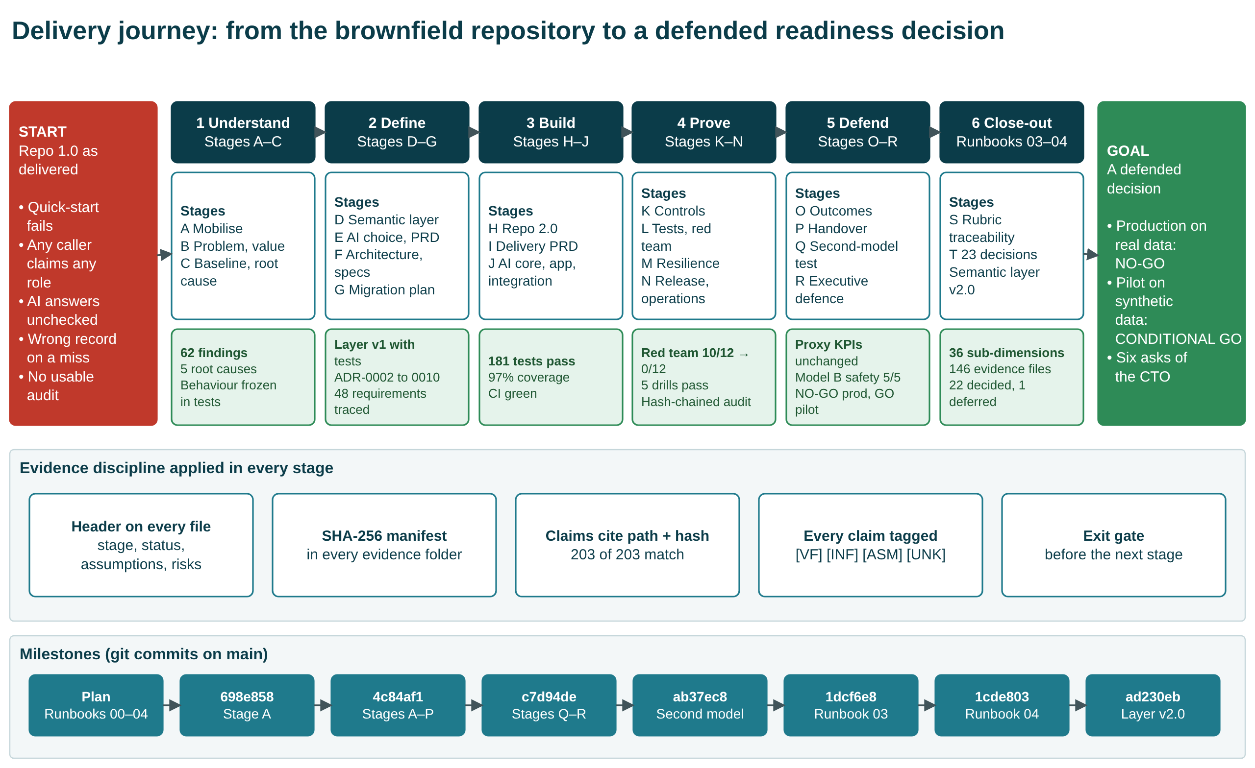
Delivery journey
The work followed a written runbook of 18 stages (A to R), plus two close-out stages: S, rubric traceability, and T, the 23 open decisions. The stages fall into six phases. Every stage ended at an exit gate before the next began.
Every artifact carries a header block (stage, status, assumptions, risks). Every evidence file is hashed in its folder’s manifest, and every claim in a document cites a file path and its hash. The milestone row shows the git commits that recorded each step.

3. What we inherited: Repo 1.0
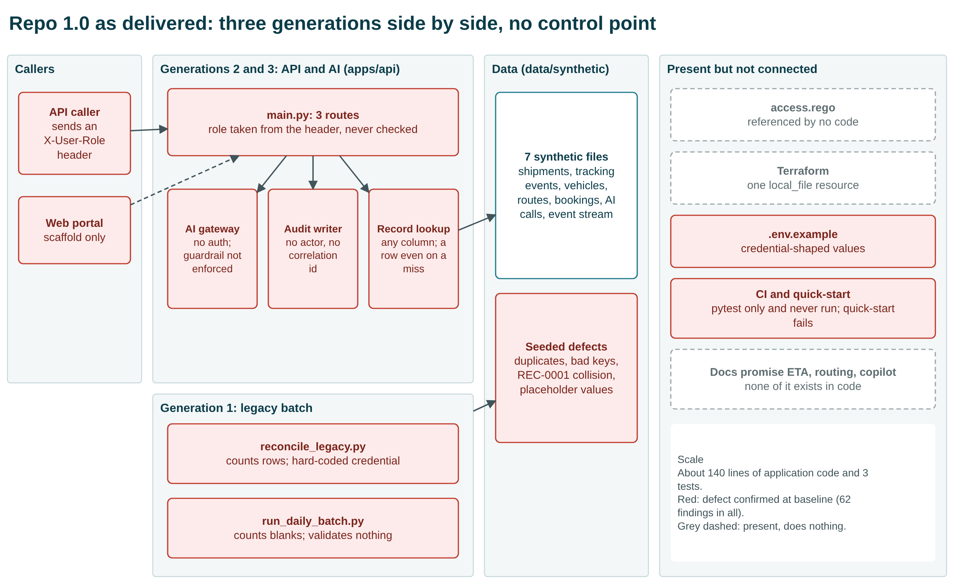
Repo 1.0 architecture
Three engineering generations sat side by side with no control point between caller and data:
- Legacy batch scripts.
- A partly modernised FastAPI service.
- An AI gateway.
Files for policy, Terraform and CI existed but did nothing. The documentation promised ETA prediction, route optimisation and an exception copilot, none of which existed in code. The system was about 140 lines of application code with 3 tests.

3.1 Findings and root causes
Final disposition | Count
Fixed | 43
Fixed in the tree (credentials stay in git history) | 4
Partial | 10
Changed by decision | 2
Deferred | 2
Proposed for acceptance | 1
Total (25 of them severity S1) | 62
Five root causes explain why the defects existed:
- RC-1 No governance by design: the old decision to keep legacy code beside the API (ADR-0001) was never revisited. This one is plausible but unconfirmed until an owner is interviewed.
- RC-2 Identity not modelled.
- RC-3 No data contracts.
- RC-4 AI unguarded by design.
- RC-5 No evidence produced as a by-product.
The full list of findings is the Findings sheet of the evidence register.

4. What we built: Repo 2.0
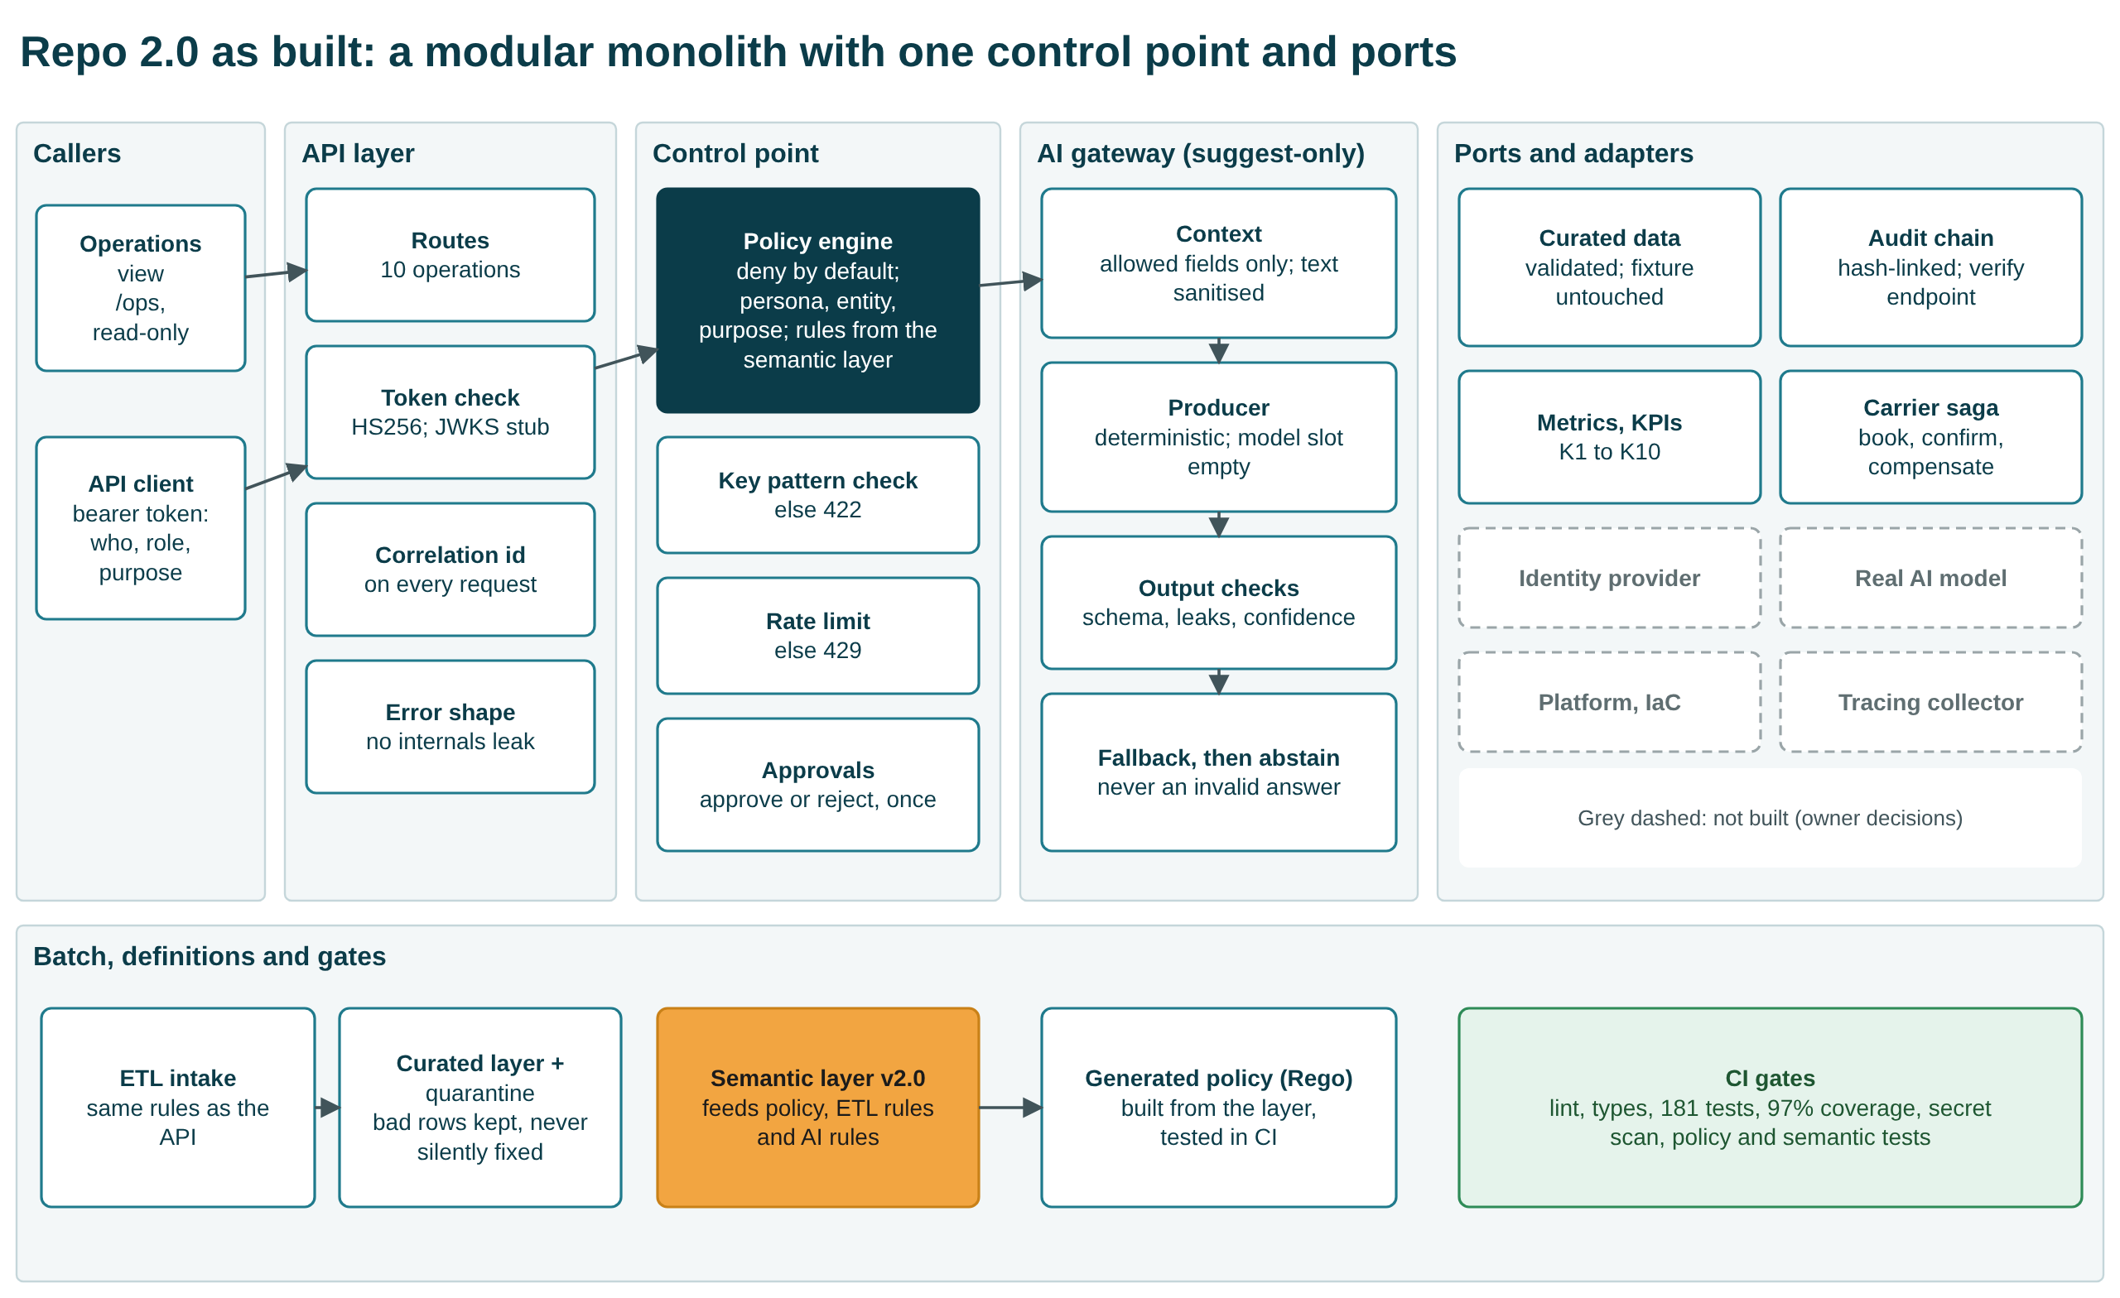
Repo 2.0 architecture
Repo 2.0 is a modular monolith with ports. We chose it over hardening the old monolith or splitting it into services, because the system is too small for network boundaries to pay for themselves. Its main features:
- One control point. Every request passes a token check and a deny-by-default policy engine. The engine reads its rules from the semantic layer (persona, entity, purpose, field mask) and generates the Rego policy that CI tests.
- An AI gateway that only suggests. It sees allow-listed fields only, checks its own output, and falls back or abstains rather than return an invalid answer. A person must approve or reject every suggestion, once.
- Validated data. Data goes through the same validation rules as the API. Bad rows are quarantined, never silently fixed, and the synthetic fixture stays byte-identical.
- Hash-chained audit. Every event records actor, correlation id, tenant and the policy decision, and a verify endpoint detects tampering.
Grey dashed boxes in the diagram are not built because they need owner decisions: identity provider, real model, platform and infrastructure, tracing collector.

4.1 Repo 1.0, Repo 2.0 and Repo 3.0
Area | Repo 1.0 (as delivered) | Repo 2.0 (as built) | Status | Repo 3.0 (rebuilt from the semantic layer)
Quick-start and tests | Test command fails; 3 tests; 45% coverage | Works; 181 tests; 97% coverage; CI green | Fixed | 175 tests pass, 1 expected failure; 95% coverage
Identity | Role taken from a request header | Signed token, forged tokens rejected; no identity provider yet | Fixed (interim) | Same: signed token; forged and alg-none tokens rejected
Authorisation | Flat allow-list; policy file unused | Deny by default; persona, entity, purpose; policy generated and tested; scope narrowing declared but not enforced | Fixed (scope partial) | Same decisions on every probe; scope not enforced; no policy file
Record lookup | Any column; wrong record on a miss | Key pattern enforced; 404 on a miss; colliding rows quarantined | Fixed | Same: 422 for a malformed key, 404 on a miss
AI endpoint | No auth; guardrail off; no schema | Authorised, rate-limited, allow-listed context, checked output, suggest-only | Fixed (no model) | Same 19 response fields; 41 of 41 AI decisions agree
Human approval | None | Approve or reject once; self-approval still possible | Fixed (no four-eyes) | Same: once only, 409 on repeat
Audit | Time and action only | Hash-chained; who, purpose, decision; tampering detected; still a local file | Partial | Same: hash-chained, tampering detected, local file
Data quality | Defects counted, then discarded | Validated, quarantined, curated layer | Fixed | Gap: rejects all 354 original shipment rows (layer rule stricter than Repo 2.0)
Observability | Notes only | Correlation id, metrics, KPI endpoint; no tracing | Partial | Correlation id, metrics and KPI endpoint; no tracing
CI and change control | Never run | Green on two Python versions; PR template, CODEOWNERS; branch protection not enabled | Partial | None (not described in the layer)
Secrets | In source and .env.example | Removed from the tree; history kept; repository private; values treated as compromised | Fixed in tree | No credentials in the tree; a dev-only default signing secret in code; no secret scan
Infrastructure | Terraform writes one local file | Container recipe; nothing provisioned; platform-neutral by decision | Deferred | None (not described in the layer)
Repo 3.0 entries come from the rebuild’s own tests and the probe comparison in section 7. The workbook’s Repo 1.0 vs 2.0 sheet has all 20 areas, with the findings and evidence file for each. Its File Inventory sheet compares the two versions: 51 files and 197 code lines in Repo 1.0, against 158 files and 9,281 code lines in Repo 2.0, counted with git.

5. How we proved it

5.1 The same 12 attacks, before and after
Ten of twelve attacks succeeded against Repo 1.0; none succeed against Repo 2.0. Two attacks did not succeed even against Repo 1.0: smuggling text through a category field (RT-08), and actioning a suggestion with no approval step, which failed because the route did not exist (RT-10). The Red Team sheet of the evidence register lists each attack and the HTTP status it returned. This was our own red team, not an independent one.

5.2 One AI request, before and after
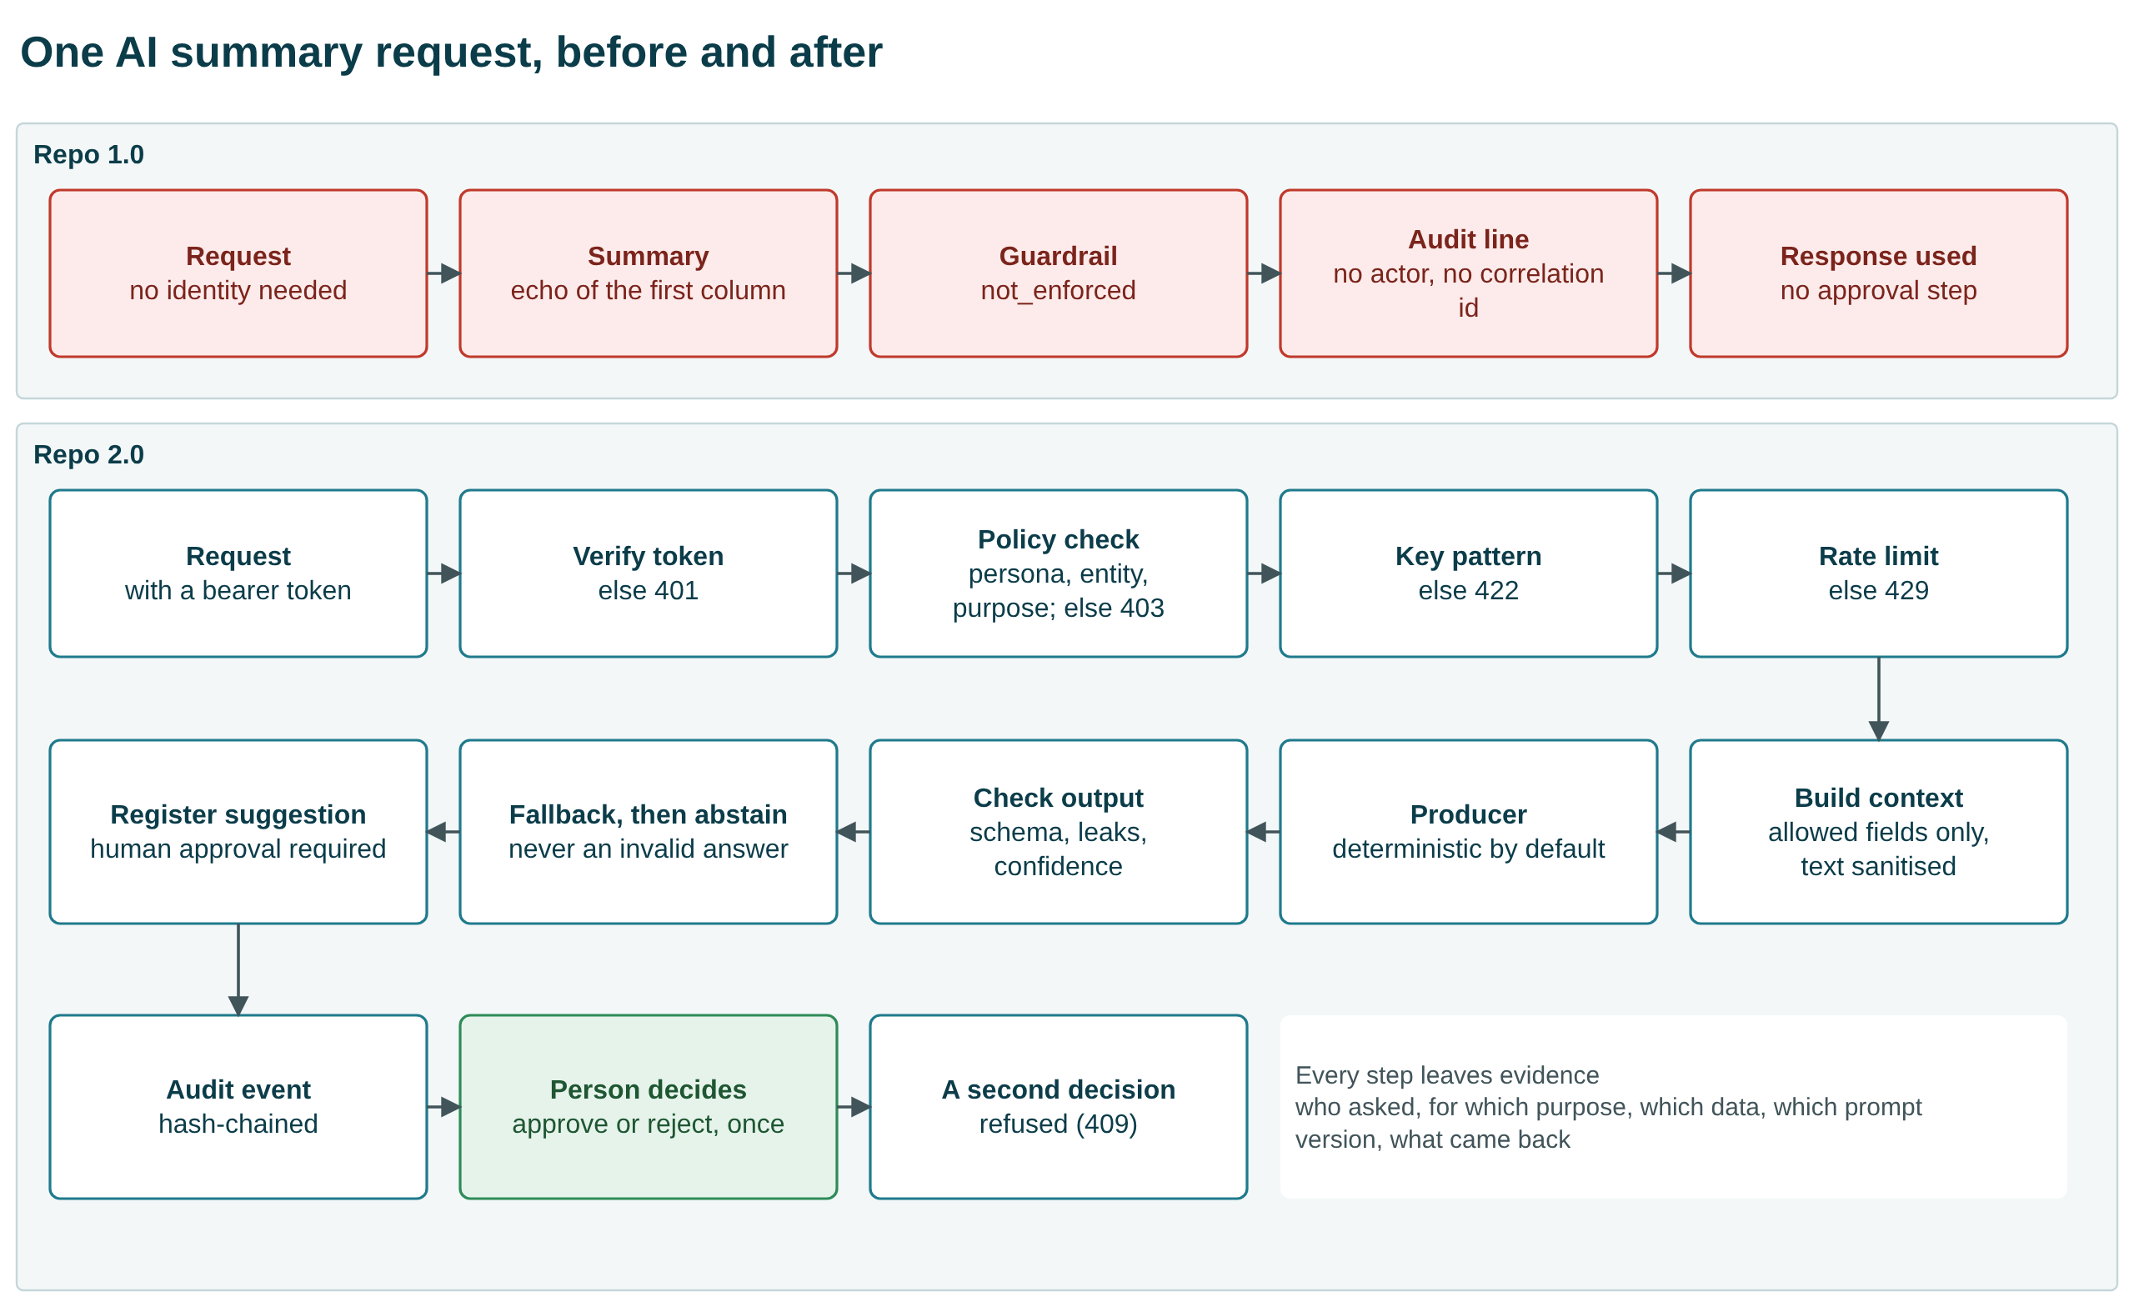
AI request path

5.3 Other proof
- 5 failure drills pass:
  - missing correlation ids
  - AI gateway timeout
  - duplicate replay
  - stale master data
  - partial batch failure
- A backup was restored on the synthetic fixture.
- One business event was reconstructed end to end from the audit trail.
- Supply chain: 0 known dependency vulnerabilities, and an SBOM of 21 runtime and 58 development components.
- AI evaluation: 192 cases, 0 failures, on the deterministic provider only.

5.4 Business KPIs did not move, and could not
KPIs K1 to K8 are computed from a static synthetic fixture that the intervention does not touch. They are identical before and after, which is the honest and expected result. Only engineering health improved (K9 tests, K10 coverage). No monetary benefit is verified. In the benefit model, which is expressed in analyst-hours, the expected net value at fixture volume is negative.

6. The semantic layer and the second-model test
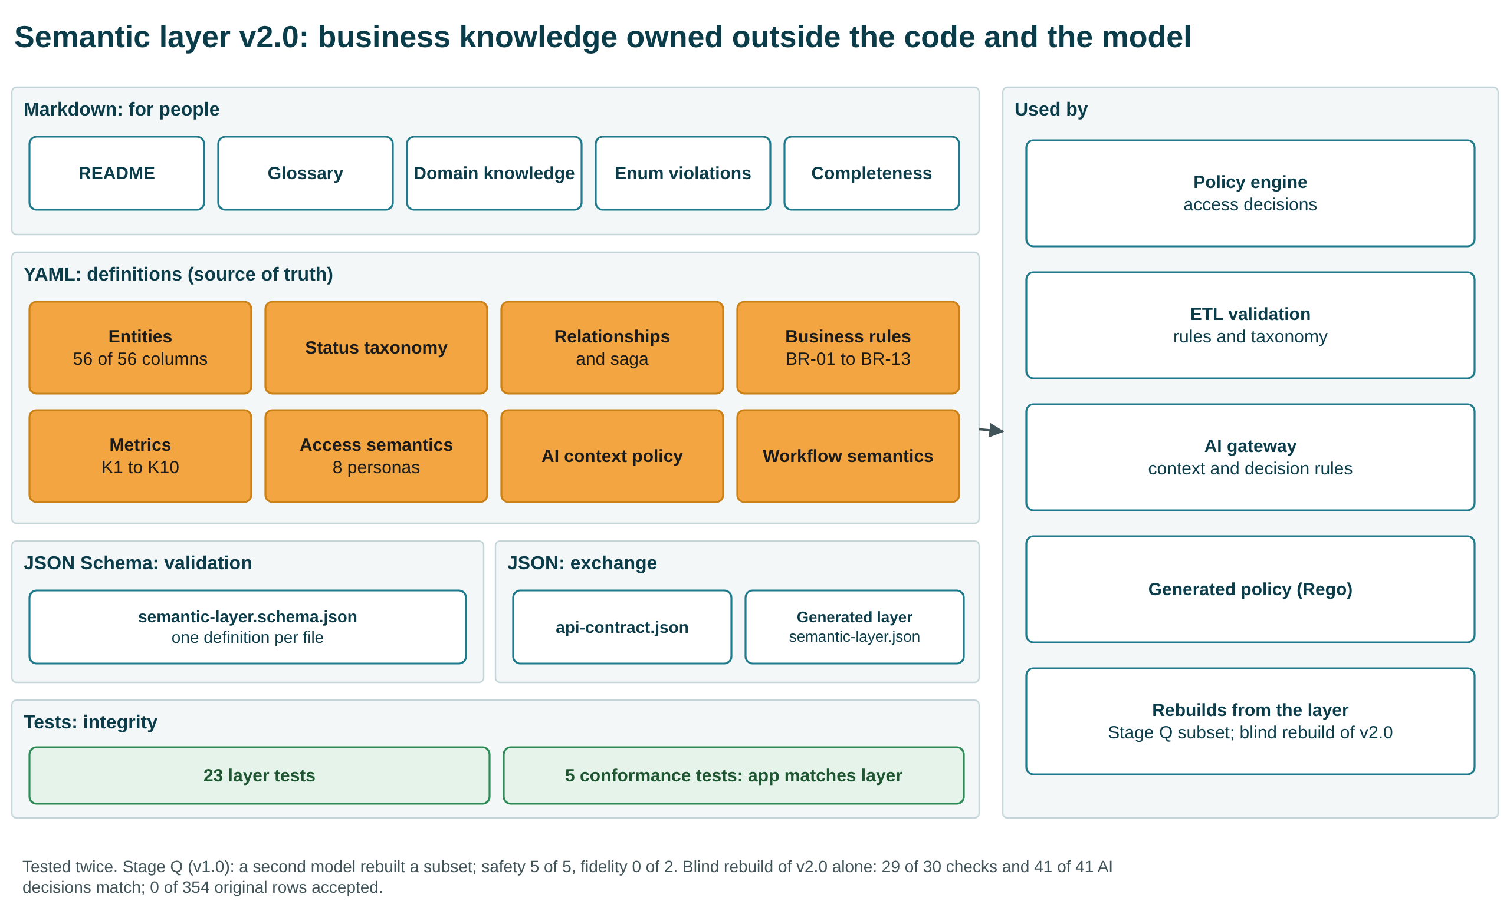
Semantic layer
The business meaning of the system is held in portable files, independent of both the code and any AI model:
- Markdown for people.
- YAML definitions: entities, taxonomy, relationships, business rules (BR-01 to BR-13, plus 12 key and pattern rules), 10 metrics, access for 8 personas, AI context policy, workflow semantics.
- A JSON Schema for validation.
- JSON for exchange.
- 28 tests: 23 for the layer itself and 5 that check the application against it.
Version 2.0 was aligned to the capstone requirement (semantic-layer-build.txt) after the transformation, as the requirement asks.
To test portability, a second, smaller model of the same vendor family rebuilt part of the system in one blind attempt.
What it was given:
- the semantic layer
- the PRD and the specifications
- a build brief
What it produced:
- Scope: a four-behaviour subset of the application.
- Safety: it matched the original on the safety behaviours this harness measures: 5 of 5 safety gates passed, and none of the 12 attacks succeeded. That attack result is partly vacuous. With the token used, three AI-path attacks (RT-08, RT-09, RT-12) never reached the AI path, and they passed only in an extra run with an ai_agent token that was not pre-registered. It passed 21 of 24 black-box API checks. It also left scope narrowing and tenant filtering unenforced.
- AI output: it did not match. Only 8 of 192 evaluation cases passed every strict check, against 192 of 192 for the original. It passed 0 of 2 fidelity gates: abstention scored 0.875 and recommendation class 0.1667, against a required 1.0.
The differences traced to eight places where the specification was silent. Version 2.0 now specifies all eight, and section 7 reports the blind rebuild that then tested v2.0. The result is therefore partly supported, not a demonstration of model independence.

7. Can the knowledge travel? A blind rebuild from the semantic layer
The capstone asks whether the semantic layer carries enough business knowledge to recreate the system without the original code or model. We tested that directly.
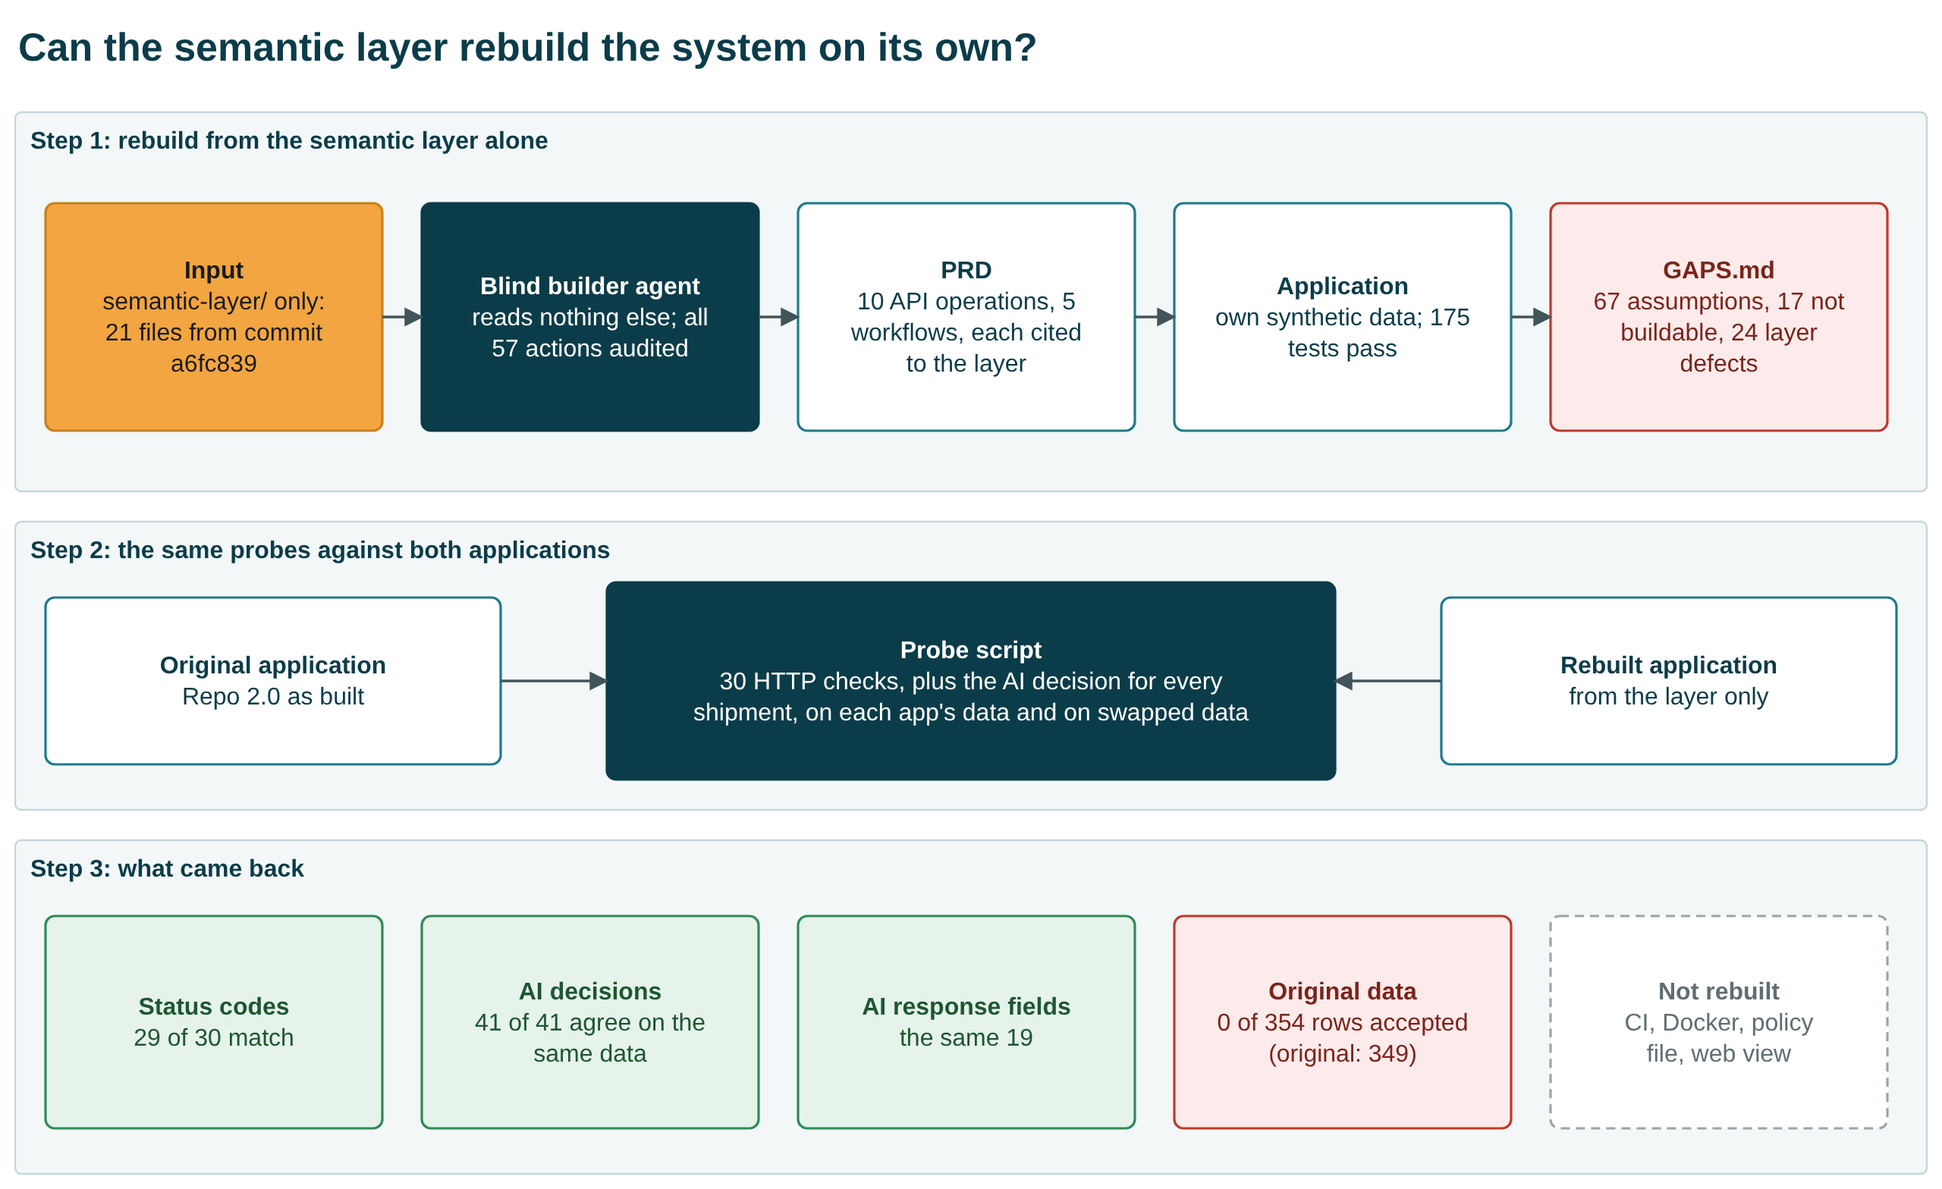
Semantic-layer rebuild

7.1 How the test was run
- Input: only the 21 files of semantic-layer/ were copied into an empty folder. They came from the repository at commit a6fc839, and the original repository was not changed.
- Builder: a separate agent (claude-opus-5-5) was told to read nothing but that folder. We checked all 57 of its actions, and none read anything else.
- What it built, in the order the capstone requires:
  - a PRD: 13 API requirements and 5 workflow requirements, each cited to a layer file and key;
  - the application;
  - its own synthetic data, because the layer contains none;
  - 175 passing tests;
  - a gap report: 67 assumptions, 17 items it could not build, and 24 inconsistencies inside the layer.
- Comparison: the same probe script was run against both applications in four pairings:
  - each on its own data;
  - the rebuild on the original’s data;
  - the original on the rebuild’s data.

7.2 What came back
Check | Original | Rebuild
30 black-box requests: same status code | n/a | 29 of 30 (an unknown suggestion id returns 404 in the original, 422 in the rebuild)
Security behaviour: tokens, roles, purposes, masking, approval once, audit, rate limit | as designed | the same
AI response fields | 19 | the same 19
AI recommendation per shipment, both on the same data | n/a | 41 of 41 agree
Shipment rows accepted from the original dataset (354 rows) | 349 | 0
The last row is the main gap.
- Layer: says a value outside its allowed list is rejected at intake.
- Rebuild: followed that literally, so it rejected every row.
- Original: flags most of these values and keeps the row, and it downgrades rule BR-04 from block to flag. That behaviour exists only in its code (etl/validation.py), not in the layer. [VF]

7.3 The six comparison areas from the capstone requirement
Area | Finding | Verdict
PRD generation | A PRD came from the layer alone, every requirement cited to the layer | Yes
Application generation | Same behaviour on the 10 operations; intake rejects the original data; no CI, Docker, policy file or web view | Partial
Context completeness | 67 assumptions, 17 items not buildable, 24 inconsistencies in the layer | Partial
Model independence | One builder, one run, same vendor family; not shown across vendors | Partial
Repository dependency | Original code not needed to build; the layer’s own tests still need the original data and KPI dictionary | Partial
Knowledge-transfer quality | High for access rules, AI decisions and the domain model; low for wire formats, intake severity and entity relationships | Partial

7.4 What the layer needs for an identical rebuild
- Intake severity per rule: which violations quarantine a row and which only flag it, including the BR-04 override and how placeholder references are handled. This alone would have let the rebuild accept the original data.
- A wire-level API schema: nested response shapes, every status code per operation, error types, headers and rate-limit numbers.
- Token and audit formats: algorithm, required claims and expiry, plus the audit record schema and how the hash chain is computed.
- Data the layer stands on:
  - a small canonical dataset or a generator specification;
  - the definition of the event stream;
  - the KPI dictionary, held inside the layer.
- Relationships: shipments linked to routes and vehicles, or a statement that no link exists.
- Numbers in keys, not prose: thresholds and status lists as keys, one version number, and the contradictions resolved.
Proposed next step: add these to the layer, then run the blind rebuild again to see whether the result becomes identical.
Limits:
- One run and one builder model.
- The comparison was run by an agent that also helped build the original, and it was not independently reviewed.
The full report, probe script and raw results are in semantic-layer-rebuild-comparison/. The rebuilt repository is in semantic-layer-rebuild/.

8. How any claim traces to proof
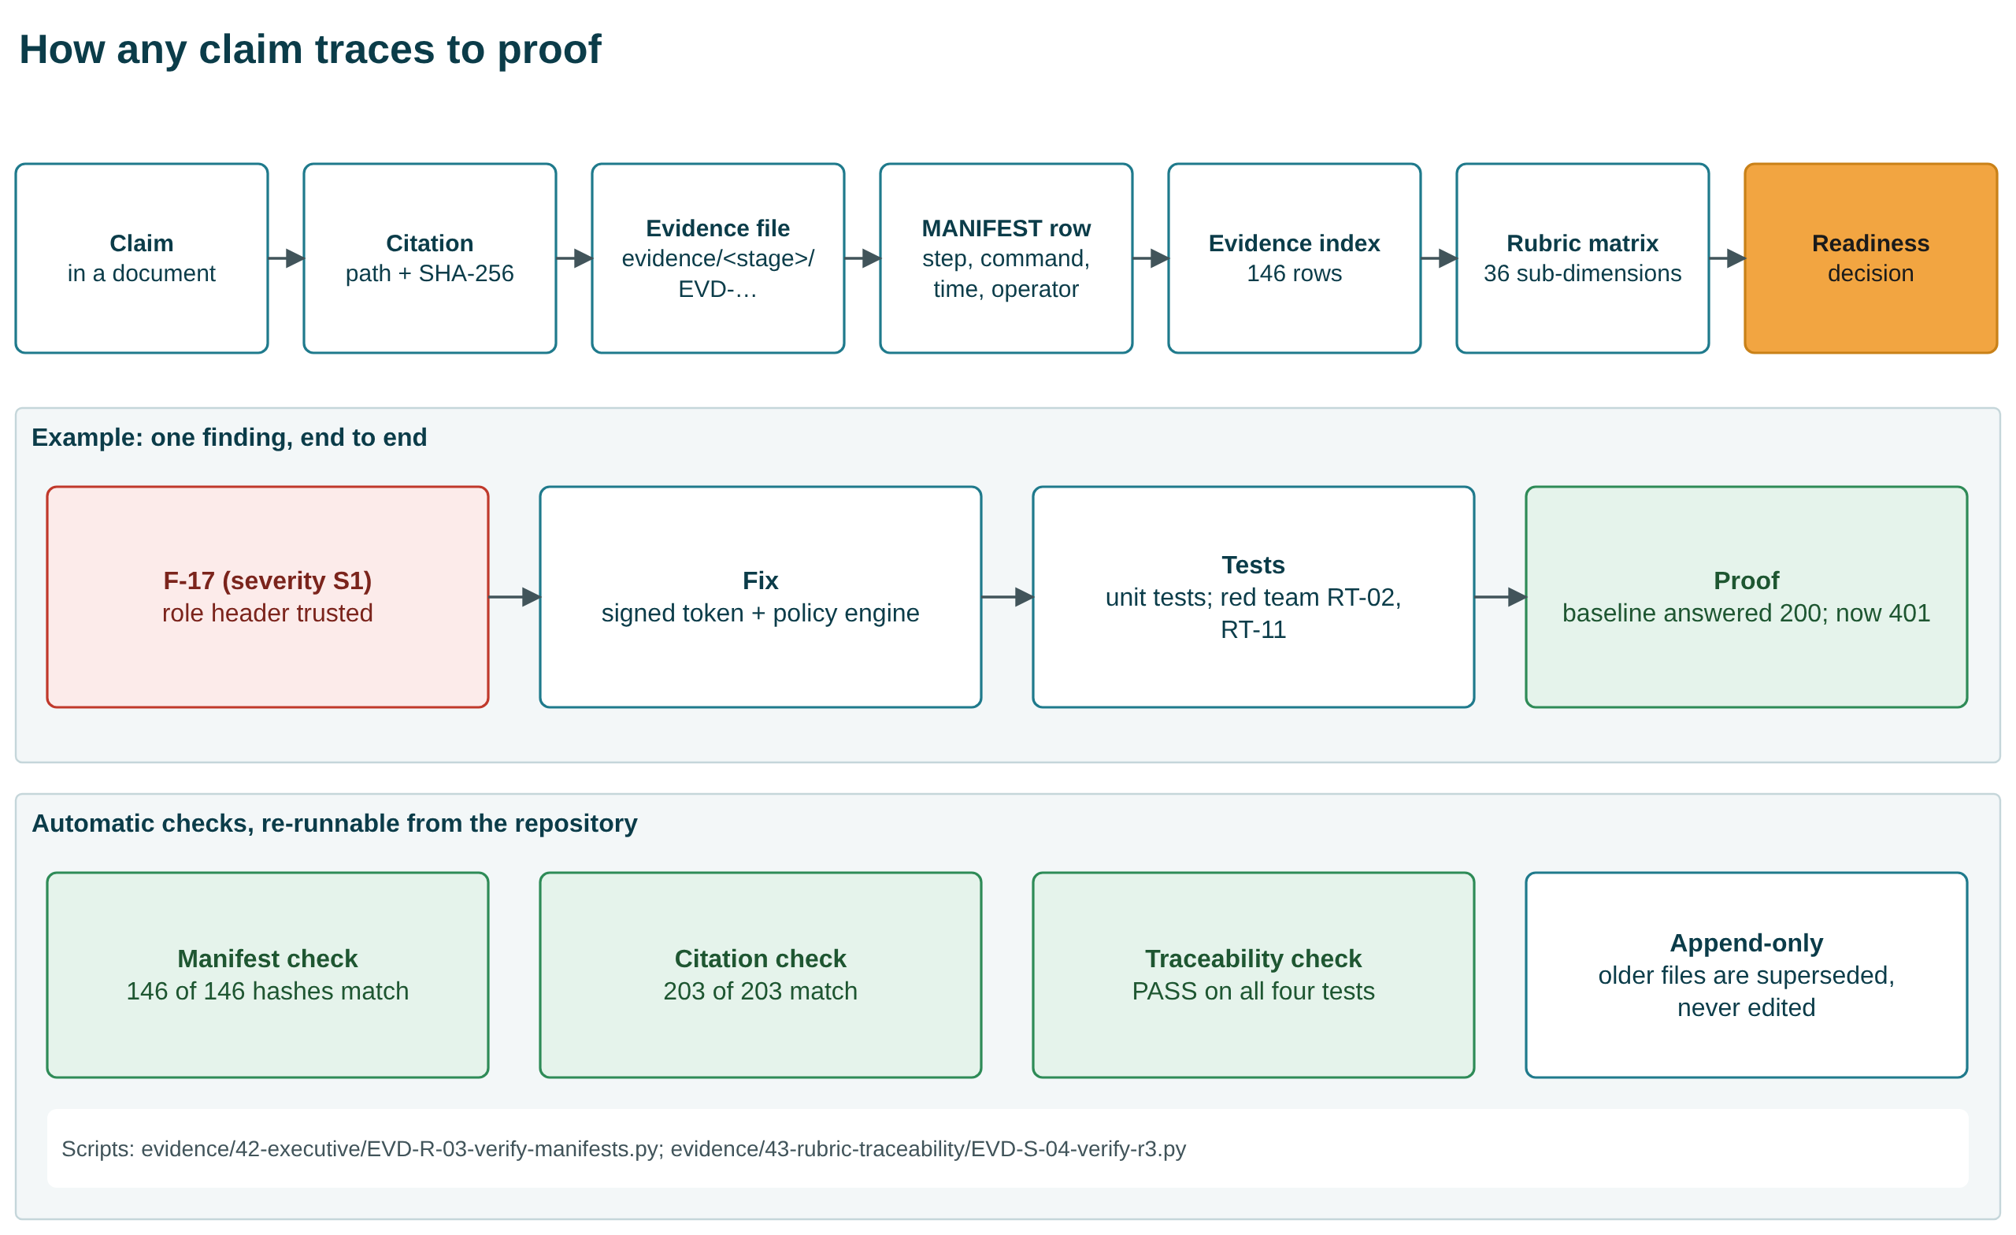
Evidence chain
Three scripts re-check the whole chain from the repository:
- Manifest check: 146 of 146 hashes match.
- Citation check: 203 of 203 citations match.
- Traceability check: PASS.
Evidence is append-only: an older file is superseded by a newer one, never edited.

9. Rubric evidence coverage
Criterion | Marks | MET | PARTIAL | NOT MET | BLOCKED | Coverage index
R1 As-Is understanding | 20 | 6 | 1 | 0 | 0 | 0.93
R2 Repo 2.0 design | 25 | 5 | 4 | 0 | 0 | 0.78
R3 Governance, risk, security | 20 | 5 | 2 | 1 | 1 | 0.67
R4 PRD and working application | 25 | 4 | 1 | 0 | 1 | 0.75
R5 Presentation and defence | 10 | 4 | 1 | 0 | 0 | 0.90
The index measures how complete the evidence is, not how many marks an evaluator will give. In our judgement [INF], R3 and R4 are held back by missing people and a missing model, not by missing work.

10. Readiness decision
Gate | Criterion | State
G1 | Tests pass, coverage at or above floor | PASS
G2 | Evaluation at thresholds | PASS (deterministic provider only)
G3 | No original defect re-exploitable | PASS
G4 | No critical or high dependency vulnerability | PASS
G5 | Audit tamper-evident; reconstruction shown | PASS (author-run)
G6 | Backup restore shown | PASS (repository level)
G7 | Rollback defined and rehearsed | PARTIAL
G8 | Alerts routed to named people | FAIL
G9 | Named approver and risk owners | FAIL
G10 | Platform and identity provider exist | FAIL
G11 | Independent evidence review | FAIL
G12 | Compliance resolved for real data | FAIL
A pilot needs G1 to G7; production needs all twelve. The gates were fixed before the decision was made. G7 is only partial: rollback is defined, but there is no cutover to rehearse. Even the pilot recommendation therefore rests on conditions.
Conditions for the pilot (from the readiness decision):
- A sponsor accepts that the operator fills every role.
- The repository visibility is decided and the credentials in history are revoked or confirmed fake. The repository is now private and the values are treated as compromised.
- Branch protection and required CI checks are turned on. This cannot be done today: GitHub requires a paid plan for branch protection on a private repository.
- No real personal data and no hosted model are used until the regulatory scope and model questions are closed.
- One independent reviewer reads this pack.
All 23 open questions now have a dated decision from the operator (15 decided, 7 ratified, 1 deferred). Because one person holds every role, those decisions are provisional. No risk acceptance is signed by a named person (0 of 12).

11. What is not proven
- No real AI model. All AI evidence uses the deterministic provider, and its thresholds are valid only for that provider.
- Nothing deployed. The platform-neutral decision means Terraform provisions nothing, and the container image was never built.
- No business value measured.
- No independent review. The red team and the gates were self-run.
- Portability partly shown. Two rebuilds were attempted:
  - The first second-model test kept safety but not AI-output fidelity.
  - The blind rebuild from the layer alone matched behaviour and AI decisions, but could not ingest the original data, and it is not an identical repository.
- Credentials remain in git history. The repository is private and the values are treated as compromised.
- Branch protection is not enabled on main. GitHub reports that it needs a Pro plan for a private repository.
- Other open risks of medium severity. These are all in docs/42-executive/residual-risks.md:
  - Identity uses HS256 shared-secret tokens, and the JWKS verifier is a stub.
  - The audit chain detects edits but cannot prevent deletion of its newest entry.
  - Approvals never expire.
  - The rate limit is held in memory.
  - Business rule BR-04 is violated by 354 of 354 rows.
  - 1,992 of 3,000 historical events have no usable correlation id.

12. Six asks of the CTO
# | Ask | Why only the CTO can give it | Time
1 | Ratify the write authorisation (OQ-11) | The operator gave it to themselves | minutes
2 | Name approvers; sign or reject the 12 risk acceptances (OQ-05) | 0 of 12 signed; the only NOT MET rubric row | about an hour
3 | Confirm the platform, model and egress decisions (OQ-01 to OQ-03) | They decide whether infrastructure and a working AI model can ever be met | a conversation
4 | Name a regulatory regime or confirm none applies (OQ-04, OQ-21) | Validates the candidate obligations | a day of review
5 | Confirm the proxy KPIs; say whether real figures exist (OQ-08, OQ-09) | The sponsor owns the value argument | minutes
6 | Appoint one independent reviewer (GOV-10) | Every gate and grade was self-run | a few hours
The signature block is in docs/44-decisions/cto-signoff-pack.md.

13. How to present this
The v2.0 deck has 29 slides:
- a 22-slide main talk, including four section dividers and a closing slide;
- a 7-slide appendix.
The full main talk takes about 15 minutes. For the agreed 10-minute slot (OQ-12), skip the two architecture diagrams (slides 6 and 9) and the semantic-layer overview (slide 13), and talk only to the headline tiles on slide 15.
Minute | Slides | Message
0:00 | 1 to 3 | Team Delta; the four questions; the answer: NO-GO production, CONDITIONAL GO pilot
1:30 | 4 | The journey: six phases, one evidence discipline
2:30 | 5 to 7 | 01 The starting point: what we inherited; 62 findings, five root causes
4:00 | 8 to 11 | 02 What we built and proved: Repo 2.0, the three-way comparison with Repo 3.0 (slide 10), the red team
6:30 | 12 to 17 | 03 Can the knowledge travel? The semantic layer, the blind rebuild, results, six areas, what the layer needs
10:30 | 18 to 21 | 04 Decision and asks: gates, what is not proven, six asks
13:30 | 22 | Thank you, questions
any | 23 to 29 | Appendix: AI request path, KPIs, earlier second-model test, evidence chain, rubric, where to find things
Every slide has speaker notes. Every diagram is drawn with native PowerPoint shapes, so boxes and arrows can be moved or reworded in PowerPoint. The same diagrams are also available as draw.io files in diagrams/.

14. Sources
All figures come from these repository files (each is also listed, with its hash, in the evidence register):
- Decision and gates: docs/42-executive/production-readiness-decision.md, docs/30-release/go-no-go-criteria.md
- Red team: evidence/26-tevv/EVD-L-03-redteam-baseline.json, evidence/26-tevv/EVD-L-03-redteam-v2.json
- KPIs: docs/34-after-kpis/after-intervention-kpi-sheet.md, evidence/34-after-kpis/EVD-O-01-after-kpis.json
- Findings: evidence/13-traceability/EVD-F-04b-finding-disposition-final.csv
- Root causes: docs/06-root-cause/evidence-confidence-matrix.md
- Rubric: docs/43-rubric-traceability/readiness-assessment.md
- Decisions: docs/44-decisions/open-questions-register-v2.md, docs/44-decisions/cto-signoff-pack.md
- Second model: docs/40-scale/model-comparison.md
- Semantic layer: semantic-layer/SEMANTIC-COMPLETENESS.md
- Semantic-layer rebuild: semantic-layer-rebuild-comparison/COMPARISON.md and results/*.json; the rebuilt repository’s GAPS.md (both in the Deliverables folder, outside the repository)
- Tests and coverage: re-run on 2026-10-08 (181 passed, 1 skipped, 7 expected xfail; 97%)

