NEPATHYA COLLEGE
(Tribhuvan University)

Tilottama-5, Manigram, Rupandehi


Project Report: “Blood Donation Platform”
BCA, 4th Semester Tribhuvan University Kritipur Nepal

Submitted By
Name: Dinesh Poudel

Submitted to:
Shiva Bhattarai
Department of Computer Science and Information Technology Tilottama-5, Nepal

Contents
Chapter 1: Introduction 1
1.1 Introduction 1
1.2 Problem Statement 1
1.3 Objectives 1
1.4 Scope and Limitation 2
1.5 Report Organization 2
Chapter 2: Background Study and Literature Review 3
2.1 Background Study 3
2.2 Literature Review 4
Chapter 3: System Analysis and Design 5
3.1 System Analysis 5
3.1.1 Requirement Analysis 5
3.1.2 Feasibility Analysis 8
3.1.3 Data Modelling (ER-Diagram) 9
3.1.4 Process Modelling (DFD) 10
3.2 System Design 12
3.2.1 Architectural Design 12
Chapter 4: Conclusion and Future Recommendations 13
4.1 Conclusion 13
4.2 Future Recommendations 13
References 13

Chapter 1: Introduction

1.1 Introduction
Blood transfusion is a critical medical procedure essential for saving lives in emergencies, surgeries, trauma cases, and chronic illnesses such as thalassemia and cancer. In Nepal, despite efforts by the Nepal Red Cross Society and various hospitals, the demand for blood frequently exceeds supply, particularly during festivals, natural disasters, or in remote areas. The absence of a centralized, real-time donor registry forces families and healthcare providers to rely on fragmented social media groups, WhatsApp broadcasts, and phone calls, often leading to unverified information, significant delays, and preventable loss of life.
Sabaiko Blood Bank is a web-based application developed to overcome these challenges by providing a secure, centralized platform that connects verified donors with receivers (hospitals, blood banks, and organizations). The system enables donors to register and update availability, allows receivers to search compatible donors by blood group and precise location (province to ward level), The system ensures accessibility and brings much-needed transparency, speed, and trust to Nepal's blood donation process. By employing Spring Boot, a robust Java based framework, and Thyme leaf, a powerful templating engine for creating dynamic web pages, the system ensures a seamless user experience.

1.2 Problem Statement:
The blood donation ecosystem in Nepal remains highly fragmented and inefficient, posing significant risks during medical emergencies. Hospitals and blood banks typically maintain isolated donor databases with no standardized mechanism for inter-hospital data sharing or nationwide access. This silos information, making it extremely difficult for healthcare providers to quickly identify available donors when urgent needs arise, such as in trauma cases, surgeries, or natural disasters. Furthermore, the absence of a centralized registry means there is no reliable way to track donors' real-time availability status, blood group compatibility, or last donation date, forcing families and medical staff to rely on outdated lists or personal networks.
Compounding these issues, urgent blood requirements are frequently broadcast through informal channels like Facebook groups, WhatsApp messages, and social media posts. While these platforms enable rapid dissemination, they often spread unverified or inaccurate information, leading to misinformation, fake donor claims, and wasted time chasing unreliable leads. Manual verification of donor health eligibility—such as confirming recent donation history or medical fitness—adds further delays, consuming critical hours when minutes matter. In remote or rural areas, geographic barriers exacerbate the problem, as locating nearby donors becomes nearly impossible without structured location data.
These systemic gaps result in preventable delays and, tragically, loss of lives that could have been saved with timely transfusions. Sabaiko Blood Bank directly addresses these challenges by introducing a secure, centralized, real-time platform that verifies donors through admin oversight, enables precise location-based searching (down to ward level), tracks availability, and facilitates efficient matching between donors and receivers (hospitals or organizations), ultimately bringing transparency, speed, and reliability to Nepal's blood donation process.

1.3 Objectives (Make it 3-4 objectives)
- To develop a centralized and secure registration system for blood donors and receivers with mandatory admin verification to ensure authenticity and trust.
- To develop secured centralized registration system for blood donors.
- To create a searchable and filterable donor database that allows receivers to find donors by blood group, province, district, municipality (palika), ward, and real-time availability.
- To implement a structured donation tracking system that records donation history and supports a two-step verification process by receivers and administrators.
- To provide a robust administrative panel for approving users, managing roles and statuses, monitoring donations, and maintaining overall system integrity.
- To ensure strong security through role-based access control, encrypted authentication, and status-based login restrictions.
- To design a responsive, mobile-friendly, and user-friendly interface accessible across all regions of Nepal on various devices.

1.4 Scope and Limitation
Scope
- Covers donor registration, recipient request creation, automated matching, notification, and admin management.
- Supports all eight blood types (A+, A-, B+, B-, AB+, AB-, O+, O-).
- Location-based search at Provence to Ward level.
- Deployable on free-tier cloud services for initial nationwide use.
Limitation
- Does not integrate directly with blood-bank inventory systems of hospitals (future scope).
- SMS notification relies on third-party gateways (currently implemented via phone number only in prototype).
- Offline coordination between donor and recipient after matching is manual.
- Does not perform medical screening; donor self-declaration is used.

1.5 Report Organization
The report is organized into several key sections that together provide a clear and comprehensive understanding of the project. It begins with an introduction that outlines the project’s objectives, problem statement, scope, and limitations, establishing the foundation for the work. This is followed by a background study that explains the essential theories, terminologies, and related literature, helping to contextualize the project within existing research and similar systems. The next section focuses on system analysis and design, detailing both functional and non-functional requirements, along with system diagrams such as use case representations, feasibility studies, and the overall system design. Finally, the report concludes with a summary of the project’s outcomes, the challenges encountered during development, and practical recommendations for future improvements.

Chapter 2: Background Study and Literature Review

2.1 Background Study
Blood donation is a vital healthcare service that supports emergency treatment, surgeries, and management of chronic diseases. In Nepal, blood donation activities are mainly handled by the Nepal Red Cross Society and hospital-based blood banks. However, the existing system faces challenges such as the absence of a centralized donor database, difficulty in finding available donors quickly, geographic limitations, and lack of proper verification mechanisms. These issues often lead to delays, especially during emergencies and high-demand periods.
Traditional blood donation coordination relies heavily on manual processes, phone calls, and informal communication channels, which are inefficient and unreliable. There is no unified platform to systematically connect verified donors with hospitals or organizations in need, resulting in time-consuming searches and increased risk for patients.
Sabaiko Blood Bank is a web-based blood donation management platform developed to address these challenges. The system provides a centralized and secure platform where verified donors and receivers can connect efficiently. It enables donor search based on blood group and Nepal-specific address hierarchy, ensuring accurate location-based matching.
By implementing role-based access control, admin verification, and donation history tracking, the platform ensures trust, security, and transparency. Through the use of modern web technologies, Sabaiko Blood Bank aims to improve the efficiency, reliability, and accessibility of blood donation services in Nepal.

2.2 Literature Review
Several studies and institutional efforts have focused on improving blood donation and blood bank management through information systems. However, existing solutions often emphasize inventory management over donor–receiver connectivity and lack strong verification and location-based search mechanisms.
Sharma et al. [1] proposed a Blood Bank Management System using PHP and MySQL, primarily designed for hospital-level blood inventory management. While the system improves internal record keeping and stock monitoring, it does not support public donor search, real-time donor availability, or location-based filtering, which limits its effectiveness during emergency blood requirements.
The Ministry of Health and Population, Nepal [2], through the National Blood Transfusion Service Guidelines, emphasizes the importance of donor safety, traceability, and proper verification in blood transfusion services. However, these guidelines focus more on operational and regulatory aspects rather than providing a digital platform for donor discovery, tracking, and coordination.
The Nepal Red Cross Society Annual Report 2023–2024 [5] highlights ongoing challenges in meeting blood demand, particularly during emergencies and high-demand periods. Although the organization plays a central role in blood collection and distribution, the report indicates a need for improved digital systems to enhance coordination, accessibility, and timely donor identification.
From a technological perspective, modern web frameworks such as Spring Boot with Spring Security [3] and React [4] provide robust support for building secure, scalable, and user-friendly web applications. These technologies enable features such as role-based access control, secure authentication, and responsive interfaces, which are essential for healthcare-related systems handling sensitive user data.
Based on the limitations identified in existing systems and institutional reports, the present work, Sabaiko Blood Bank, aims to bridge the gap by providing a centralized, secure, and location-aware blood donation management platform. The system integrates strong admin verification, detailed Nepal-specific address filtering, and a modern web technology stack to better support real-world blood donation needs in Nepal.

Chapter 3: System Analysis and Design

3.1 System Analysis
System Analysis refers into the process of examining a system with the intent of improving it through better procedures and methods. It is the process of planning a new system to either replace or complement an existing system. It is therefore, the process of gathering and interpreting facts, diagnosing problems and using the information to re-comment improvements in the system.

3.1.1 Requirement Analysis

Requirement analysis involves refining and prioritizing the collected requirements to ensure they align with the project’s objectives and constraints. This process includes:
- Functional Requirements
Functional requirements define what a system should do. They describe the specific behavior, features, and functionalities that the system must provide. These requirements represent the actions the system performs in response to user inputs or system conditions. The functional requirements of the Blood Donation Platform include:
- User Authentication: The system shall allow users (donors, receivers, and admins) to register and log in using a username and password. The system shall validate login credentials and deny access if the credentials are incorrect or the user is not approved.
- Donor Registration and Profile Management: The system shall allow donors to register and manage their profile information, including blood group, address, medical details, and availability status.
- Receiver Registration: The system shall allow hospitals or receivers to register by providing organizational details and verification information.
- Donor Search Functionality: The system shall allow receivers to search for donors based on blood group, district, municipality, ward number, and availability status.
- Blood Donation Request Handling: The system shall allow receivers to search and contact suitable donors for urgent blood requirements.
- Admin Verification and User Management: The system shall allow the admin to verify donor and receiver documents, approve or reject user registrations, restrict users, and manage system users.
- Dashboard and Reporting: The system shall provide an admin dashboard displaying system statistics such as total donors, receivers, and pending approvals.
- Password Recovery: The system shall allow users to recover forgotten passwords through a secure email-based password reset process.

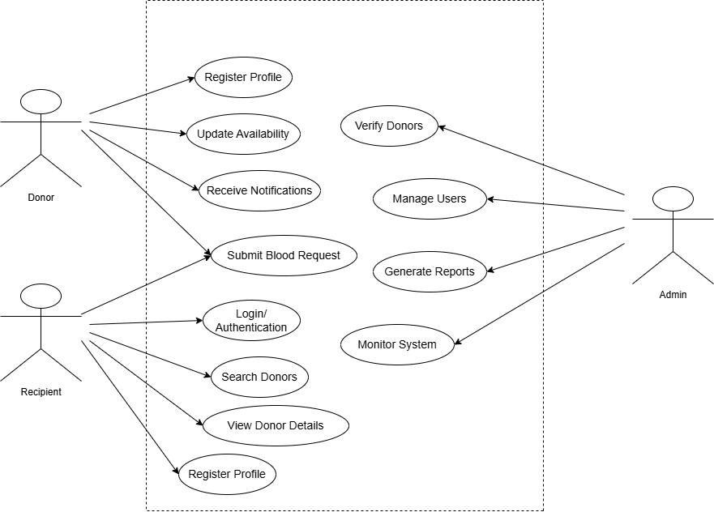
Figure-1: Use case diagram

- Non-Functional Requirements
Non-functional requirements define how the system performs a particular function, focusing on overall quality attributes such as performance, scalability, security, usability, and reliability. These requirements describe the operational characteristics of the system rather than specific behaviors. The non-functional requirements of the Blood Donation Platform include:
- Performance: The system shall respond to donor search queries and dashboard requests within 2 seconds under normal operating conditions.
- Scalability: The system shall support at least 500 concurrent users and allow future expansion in terms of users, data volume, and additional features without requiring major architectural changes.
- Security: User passwords shall be securely hashed using the BCrypt algorithm. Role-based access control shall be enforced to prevent unauthorized access to sensitive system resources.
- Availability: The system shall maintain at least 99% uptime when deployed on free-tier or entry-level hosting platforms, excluding scheduled maintenance periods.
- Usability: The system shall provide a responsive and user-friendly interface that is fully accessible on mobile and desktop web browsers, enabling users to perform basic operations with minimal learning effort.
- Maintainability: The system shall be designed using a modular architecture with proper documentation, allowing updates, bug fixes, and enhancements to be applied with minimal downtime.
- Compatibility: The system shall be compatible with major modern web browsers, including Google Chrome, Mozilla Firefox, Microsoft Edge, and Safari.

3.1.2 Feasibility Analysis
Technical Feasibility: The system is technically feasible using Spring Boot, PostgreSQL, and Thymeleaf, which are stable, well-documented, and widely used technologies. Free-tier platforms like Railway and Vercel support smooth deployment.
Operational Feasibility: The system is easy to use and requires minimal training. Its intuitive interface and support for Nepali-language labels make it suitable for quick adoption.
Economic Feasibility: The project is cost-effective as it uses open-source tools and free-tier hosting, resulting in zero development and deployment cost.
Schedule Feasibility: The Event Management System (EMS) project is schedule-feasible, as the development process is broken down into clearly defined phases. The project timeline is realistic, with the initial phases (requirement analysis and system design) estimated to take 3-4 weeks. The development phase, including both frontend and backend, is expected to take 4-6 weeks, followed by 1-2 weeks for testing and debugging. Deployment and go-live can be completed in 1-2 weeks. Given the familiarity with the chosen technologies (Spring Boot, PostgreSQL, and Thyme leaf, the project is expected to be completed within the planned schedule without significant delays.
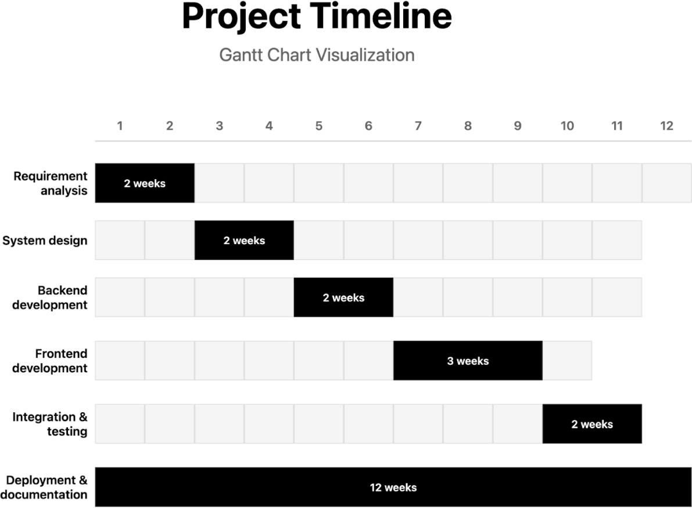
Figure-2: Gantt Chart for Blood Donation Platform

3.1.3 Data Modelling (ER-Diagram)

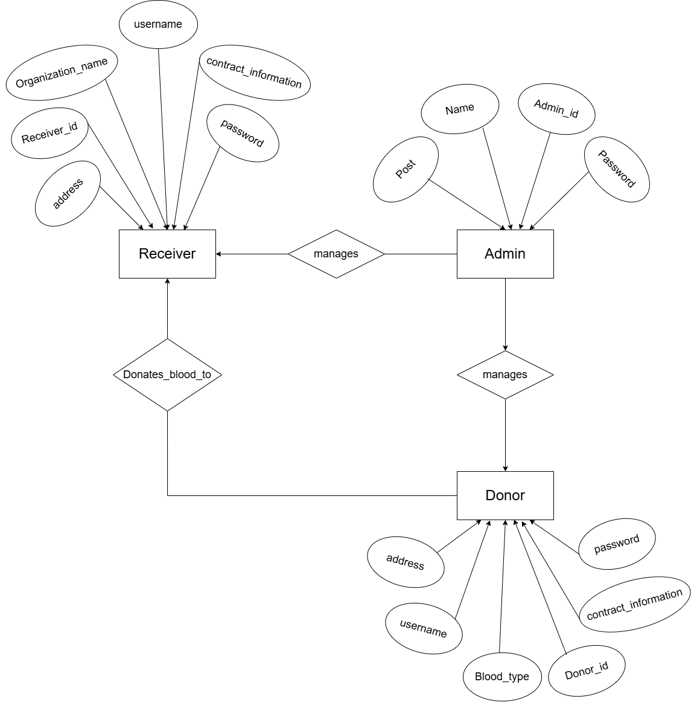
Figure-3: ER diagram

3.1.4 Process Modelling (DFD)
Process Modelling with DFDs visually represents data flow in a system, showing processes, data stores, and external entities. Level 0 gives a high-level overview, Level 1 breaks it into major processes, and Level 2 details each process. They help understand, design, and document systems effectively.

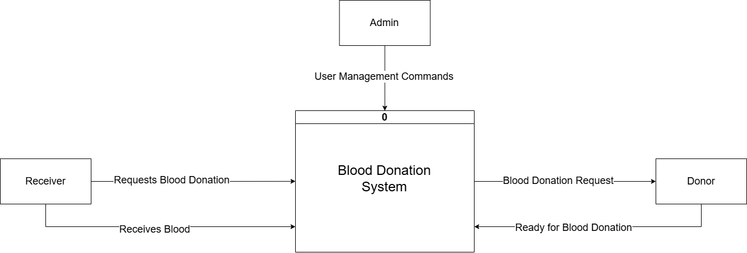
Figure-4: Context Level DFD

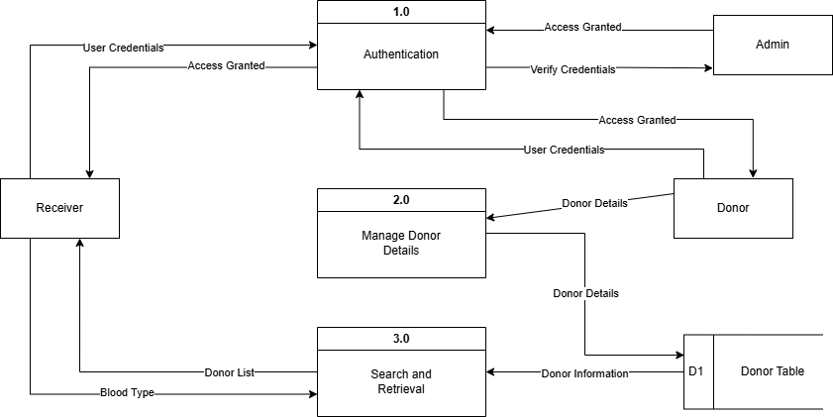
Figure-5: Level-1 DFD

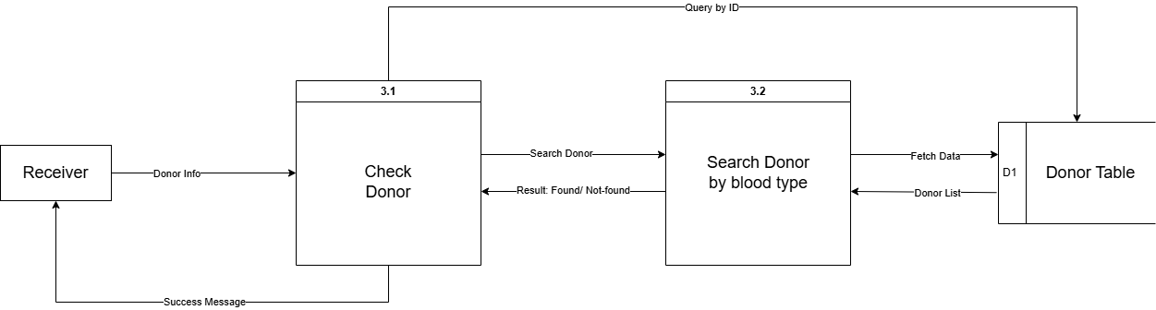
Figure-6: Level-2 DFD

3.2 System Design

3.2.1 Architectural Design

Architectural design is a process for identifying the sub-systems making up a system and the framework for sub-system control and communication.
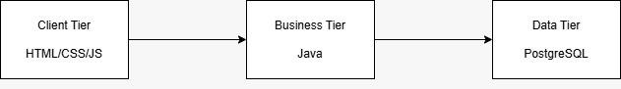
Figure-7: Architectural Design

Chapter 4: Conclusion and Future Recommendations

4.1 Conclusion
Sabaiko Blood Bank successfully demonstrates that a low-cost, open-source web platform can significantly reduce the time taken to locate compatible blood donors in Nepal. The implemented system is live, responsive, secure, and ready for pilot deployment.

4.2 Future Recommendations
- Integration with NRCS central database via API.
- Mobile applications (React Native) with push notifications.
- SMS gateway integration using local providers (Ncell/NTC API).
- AI-based prediction of blood demand during festivals/disasters.
- Blockchain-based immutable donation history for credibility.

References
[1] S. Sharma et al., “Blood Bank Management System using PHP,” Int. J. Eng. Res. Technol., vol. 10, no. 5, pp. 224–229, May 2021. [2] Ministry of Health and Population, Nepal, “National Blood Transfusion Service Guidelines,” 2023. [3] Spring Boot Documentation, “Spring Security Reference,” 2025. [Online]. Available: https://spring.io/projects/spring-security [4] React Documentation, “React v18,” 2025. [Online]. Available: https://react.dev [5] Nepal Red Cross Society, Annual Report 2023–2024.

