# ExNo:2 UML Class Diagram

**Aim:** To Identify the Conceptual Classes and to develop a domain model with UML class diagram for reservation and booking system.

# Description

A class diagram in the [Unified](http://en.wikipedia.org/wiki/Unified_Modeling_Language) [Modeling](http://en.wikipedia.org/wiki/Unified_Modeling_Language) [Language](http://en.wikipedia.org/wiki/Unified_Modeling_Language) (UML) is a type of static structure diagram that describes the structure of a system by showing the system's [classes](http://en.wikipedia.org/wiki/Class_(computer_science)), their attributes, and the relationships between the classes.

The class diagram is the main building block in [object](http://en.wikipedia.org/wiki/Object_oriented) [oriented](http://en.wikipedia.org/wiki/Object_oriented) modeling. They are being used both for general [conceptual](http://en.wikipedia.org/wiki/Conceptual_model) [modeling](http://en.wikipedia.org/wiki/Conceptual_model) of the systematic of the application, and for detailed modeling translating the models into [programming](http://en.wikipedia.org/wiki/Programming_code) [code](http://en.wikipedia.org/wiki/Programming_code). The classes in a class diagram represent both the main objects and or interactions in the application and the objects to be programmed .In the class diagram these classes are represented with boxes which contain three parts A class with three sections.

* The upper part holds the name of the class
* The middle part contains the attributes of the class
* The bottom part gives the methods or operations the class can take or undertake

In the system design of a system, a number of classes are identified and grouped together in a class diagram which helps to determine the statically relations between those objects. With detailed modeling, the classes of the conceptual design are often split in a number of subclasses.

# CLASS DIAGRAMS PECIFIC OOLS

Class diagrams are used for only one of the UML static structure diagrams, the class diagrams itself. Object diagrams are represented on the ArgoUML deployment diagram.

ArgoUML uses the class diagram to show model structure through the use of packages.

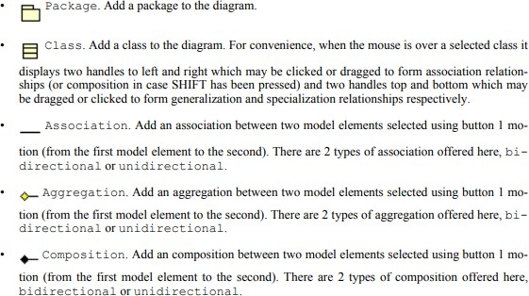

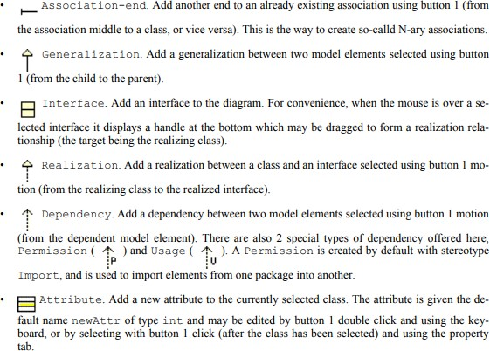

**Online Airline Ticket Reservation System:**

Online Airline ticket reservation is very useful nowadays. This is very important to design a good-working system software for ticket booking and related transactions.

The Reservation system should contain the following features:

1. If a passenger wants to reserve ticket(s), firstly, he/she has to log in to the Airline system with valid credentials. Then, the passenger has to provide his/her details with the date of the journey, names of the passengers and their details, origin airport details, destination airport details, and the class type of the required ticket(s).
2. The Airline Reservation System will provide the available Airline-list, and Seat-availability, via-details.
3. To book ticket passengers can pay through online/offline mode. After successful payment of the ticket fare the System will generate the ticket and PNR no. will be given to the passenger. The System also keeps the payment details and sends them to the system Admin.
4. The Passenger can check PNR status (confirmed) by entering the PNR no. into the Reservation system.
5. The Reservation system should store all Airline details, fare details (by zone, class, and date wise), PNR no, date of Flight, etc. This maintenance should be controlled by the Admin.
6. The System also has refund rules which have a date of reservation, ticket fare, and refundable percentage. The passenger can simply cancel the ticket(s) by entering the PNR no and a cancel ticket request. After cancelation, the Admin will pass the refundable amount to the System and the System will give the refundable amount to the passenger.

**Class Diagram:**

These diagrams describe the operation and attributes of a class with imposed constraints in the system. In this article the classes to be considered are ‘payment’, ‘Airline’, ‘passenger’, ‘ticket’, ‘Airline reservation system’, ‘admin’. The description of the classes is given below.

|  |  |  |
| --- | --- | --- |
| **Class** | **Attributes** | **Processes** |
| Payment | amount | ticketGeneration |
| Flight | Flight code, Flight name, frequency | — |
| passenger | PAX_id, name,age,sex | login, search Flight, modify the form,  pay charges, book tickets now ticket, cancel tickets |
| ticket | PNR_no, status, payment type, Flight code search train, date of journey | new Ticket, delete tickets |
| Airline reservation system | System | response |
| Admin | ID, name | formDetails, cancellationForm, refundAmt |

# 

Result :

Thus the class diagram of reservation and booking system was created successfully.