SELENIUM AUTOMATION – 10 TEST CASES

TC-1: Open Online Shopping Website
Testcase
Customer opens the online shopping website.
Program
import time
from selenium import webdriver
from selenium.webdriver.common.by import By
driver = webdriver.Chrome()
driver.get("https://www.saucedemo.com/inventory.html")
driver.find_element(By.ID,"user-name").send_keys("standard_user")
driver.find_element(By.ID,"password").send_keys("secret_sauce")
driver.find_element(By.ID,"login-button").click()
time.sleep(10)
driver.quit()
Output:
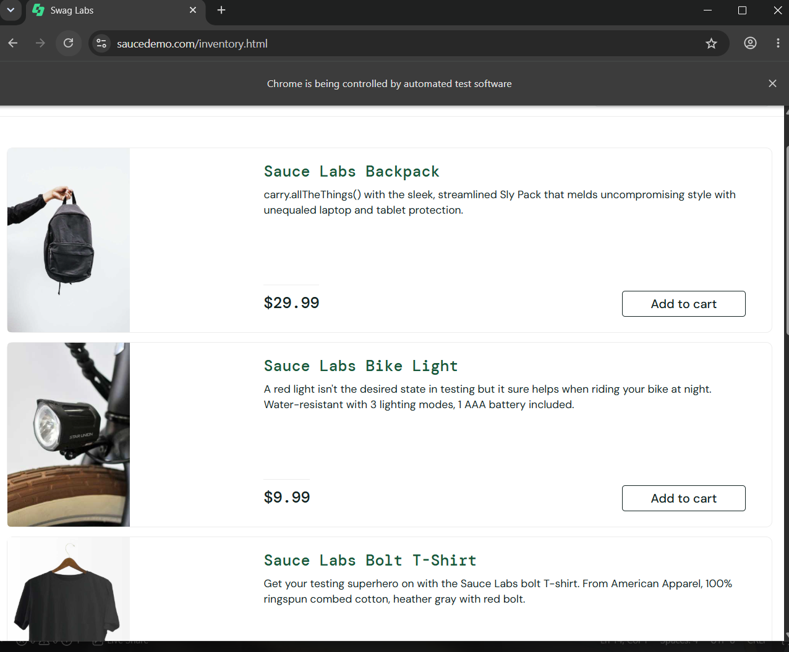

TC-2: Alert Accept
Testcase
Customer clicks Delete/Remove Product and the confirmation popup appears.
Program
import time
from selenium import webdriver
from selenium.webdriver.common.by import By
driver = webdriver.Chrome()
driver.get("https://www.tutorialspoint.com/selenium/practice/alerts.php")
driver.find_element(By.XPATH, "//button[@onclick='myDesk()']").click()
alert = driver.switch_to.alert
time.sleep(5)
alert.accept()
time.sleep(10)
driver.quit()
Output:
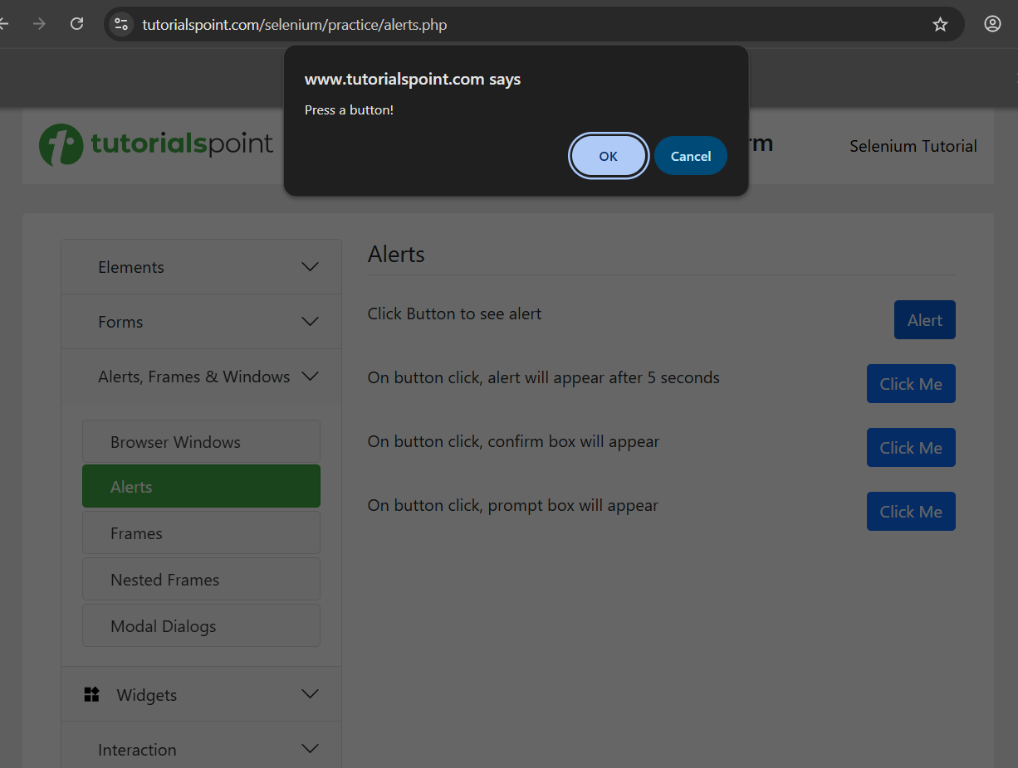
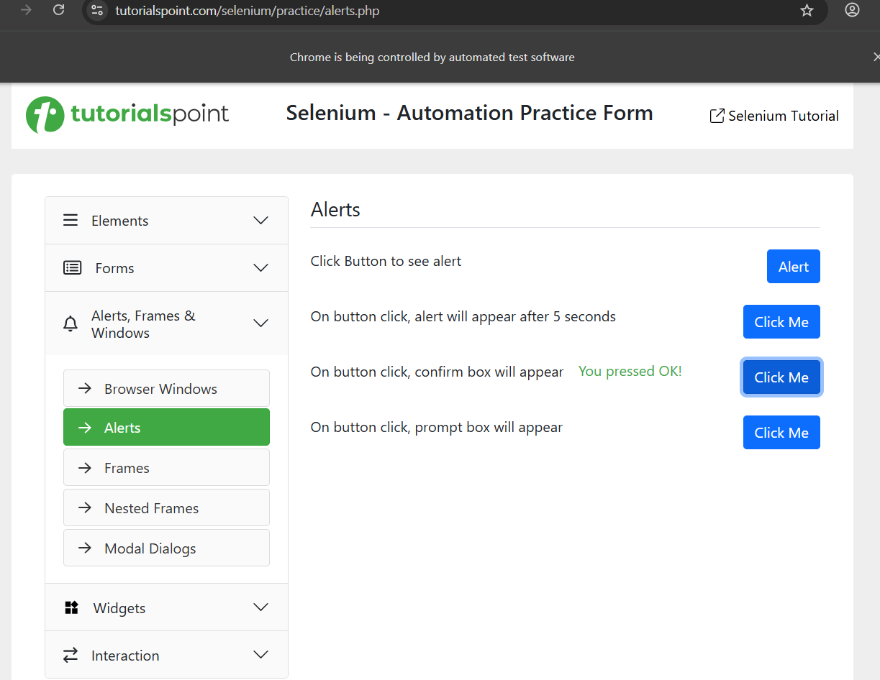

TC-3: Alert Dismiss
Testcase
Customer clicks Delete/Remove Product but chooses Cancel.
Program
import time
from selenium import webdriver
from selenium.webdriver.common.by import By
driver = webdriver.Chrome()
driver.get("https://www.tutorialspoint.com/selenium/practice/alerts.php")
driver.find_element(By.XPATH, "//button[@onclick='myDesk()']").click()
alert = driver.switch_to.alert
time.sleep(5)
alert.dismiss()
time.sleep(10)
driver.quit()

Output:
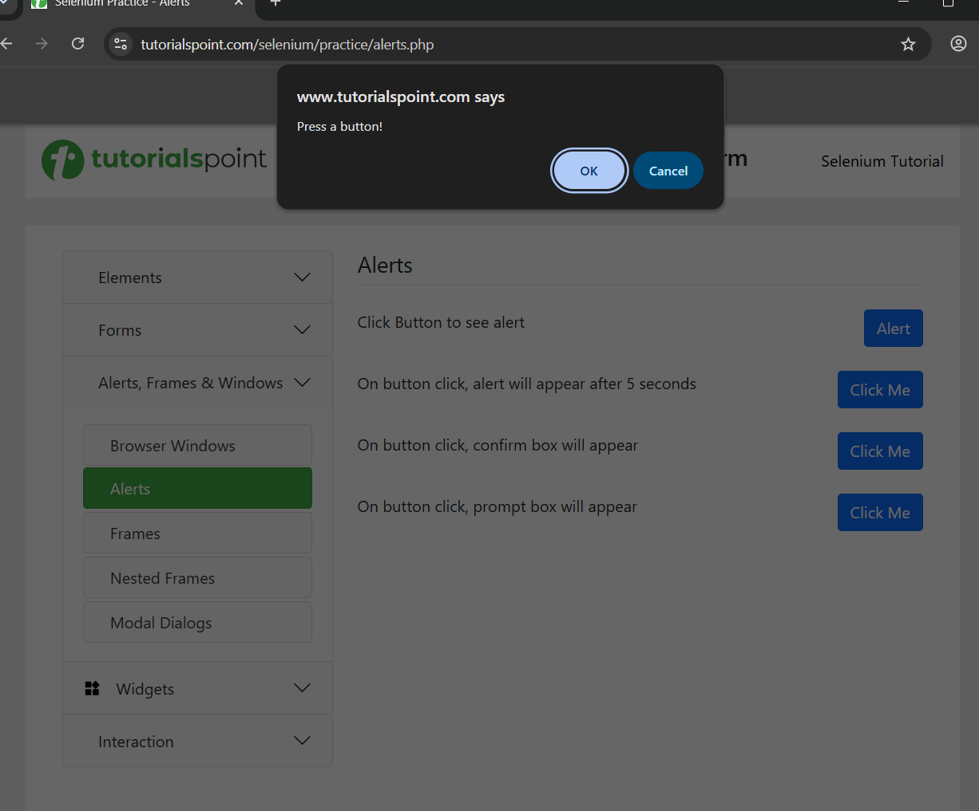
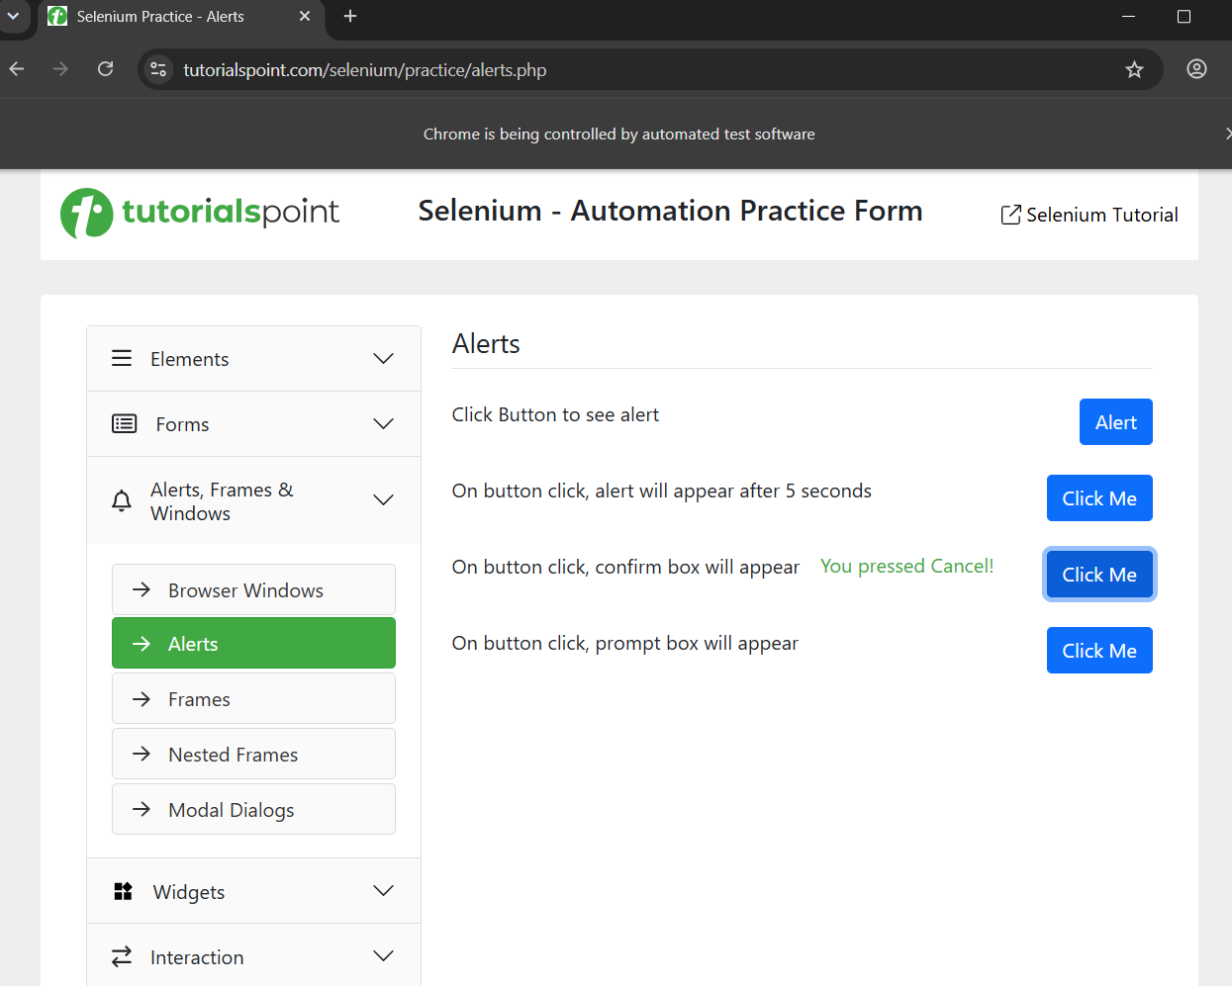
TC-4: Prompt Alert
Testcase
Customer enters a name/coupon/customer information in a prompt popup.
Program
import time
from selenium import webdriver
from selenium.webdriver.common.by import By
driver = webdriver.Chrome()
driver.get("https://www.tutorialspoint.com/selenium/practice/alerts.php")
driver.find_element(By.XPATH,"//button[@onclick='myPromp()']").click()
time.sleep(1)
alert = driver.switch_to.alert
alert.send_keys("DK")
time.sleep(10)
alert.accept()
time.sleep(2)
driver.quit()
Output:
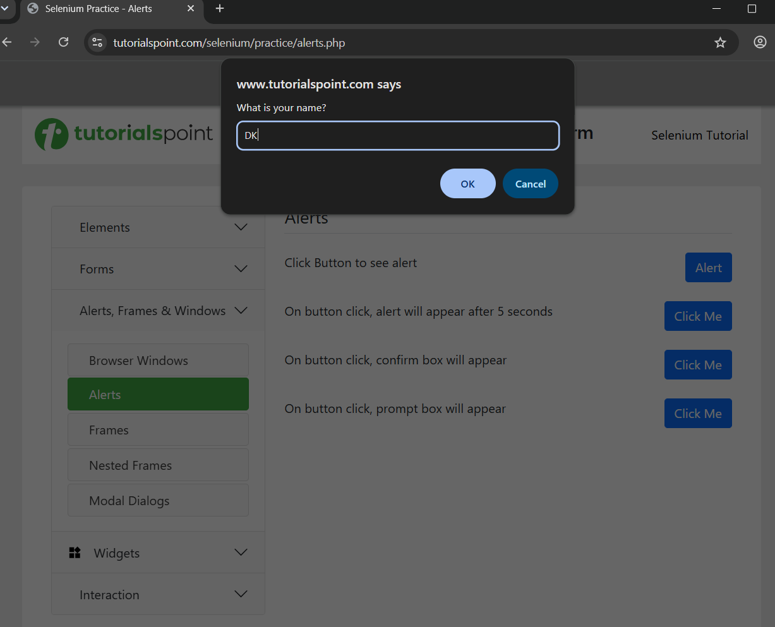
TC-5: Mouse Hover
Testcase
Customer moves the mouse over the Products/Category menu.
Program
import time
from selenium import webdriver
from selenium.webdriver.common.by import By
from selenium.webdriver.common.action_chains import ActionChains
driver = webdriver.Chrome()
driver.get("https://demoqa.com/menu/")
time.sleep(5)
menu = driver.find_element(By.XPATH, "//a[text()='Main Item 2']")
actions = ActionChains(driver)
time.sleep(2)
actions.move_to_element(menu).perform()
time.sleep(3)
driver.quit()
Output:
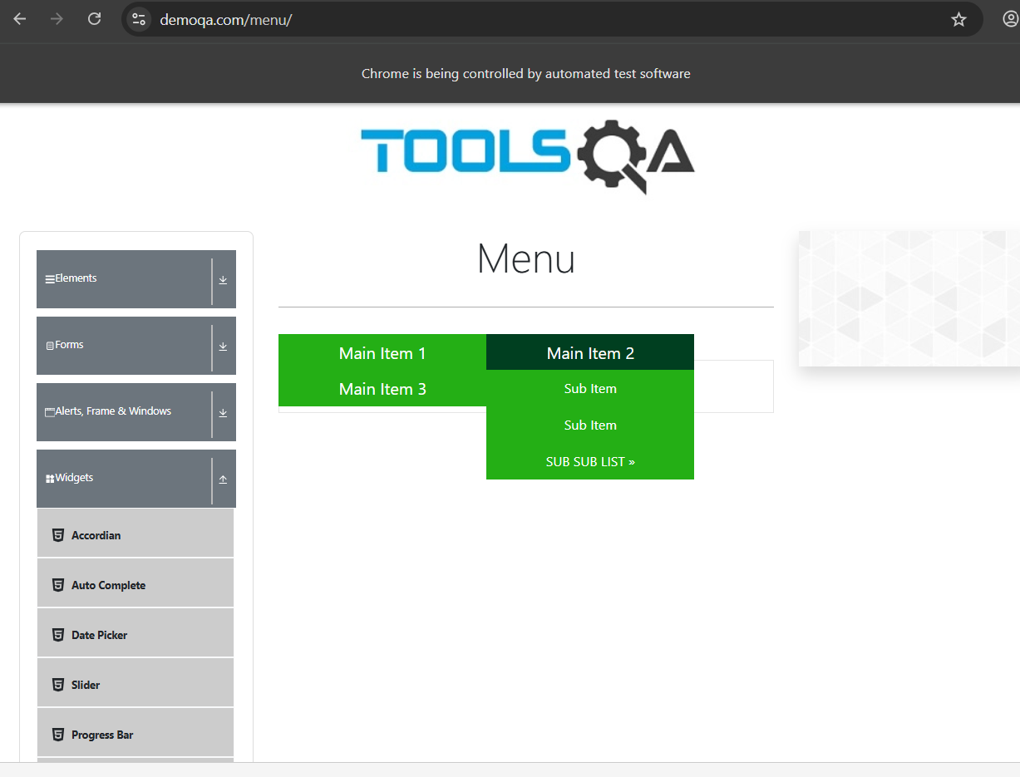

TC-6: Double Click
Testcase
Customer double-clicks a product/button.
Program
import time
from selenium import webdriver
from selenium.webdriver.common.by import By
from selenium.webdriver.common.action_chains import ActionChains
driver = webdriver.Chrome()
driver.get("https://demoqa.com/buttons")
time.sleep(10)
button = driver.find_element(By.ID,"doubleClickBtn")
ActionChains(driver).double_click(button).perform()
time.sleep(10)
driver.quit()
Output:
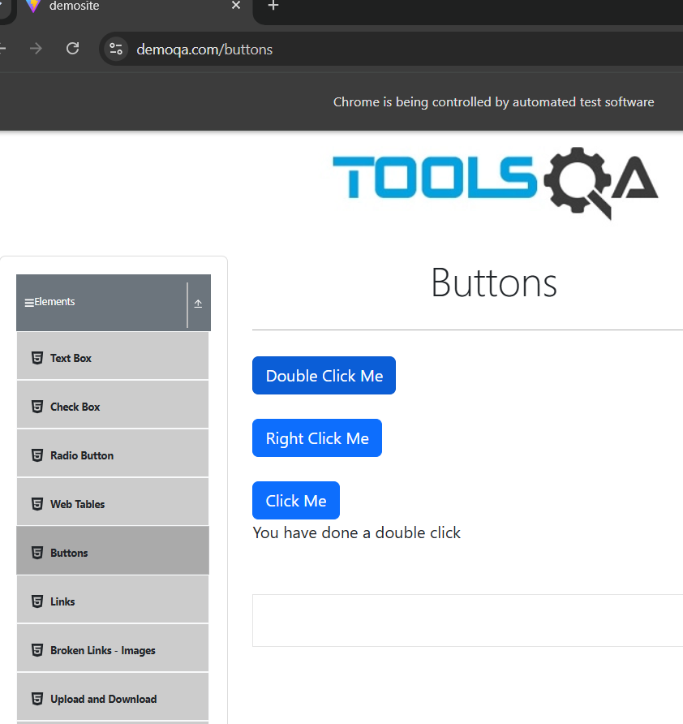

TC-7: Drag and Drop
Testcase
Customer drags a product/item into a shopping cart area.
Program
import time
from selenium import webdriver
from selenium.webdriver.common.by import By
from selenium.webdriver.common.action_chains import ActionChains
driver = webdriver.Chrome()
driver.get("https://demoqa.com/droppable")
driver.maximize_window()
time.sleep(2)
source = driver.find_element(By.ID, "draggable")
target = driver.find_element(By.ID, "droppable")
time.sleep(3)
actions = ActionChains(driver)
actions.click_and_hold(source)
actions.move_to_element(target)
actions.release()
actions.perform()
time.sleep(3)
driver.quit()
Output:
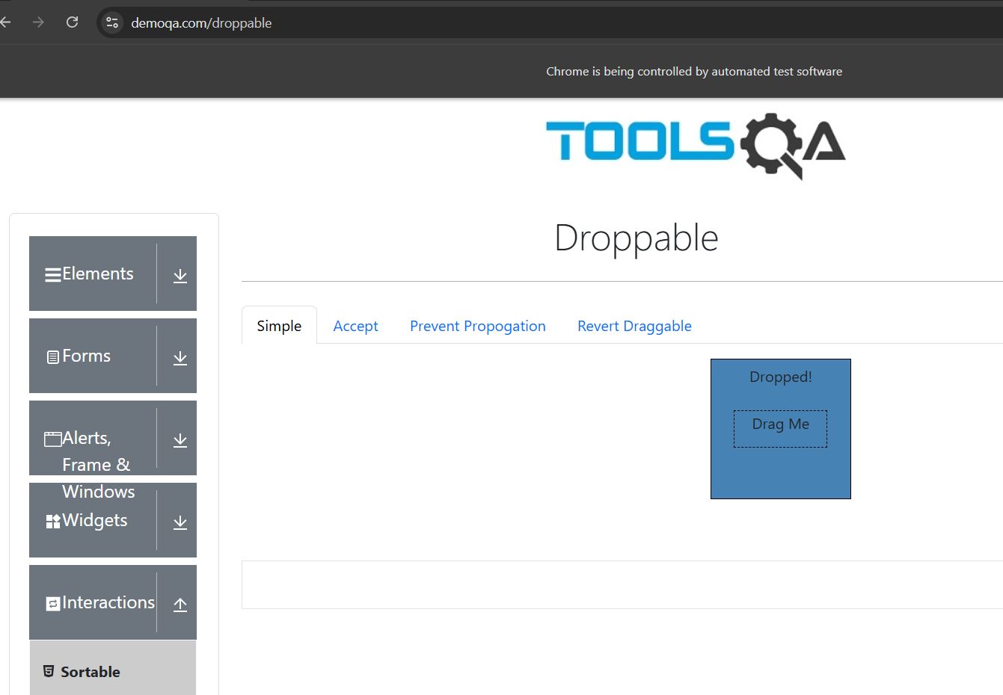
TC-8: Explicit Wait
Testcase
Customer searches for a product and waits for the product results to load.
Program
import time
from selenium import webdriver
from selenium.webdriver.common.by import By
from selenium.webdriver.support.ui import WebDriverWait
from selenium.webdriver.support import expected_conditions as EC
driver = webdriver.Chrome()
driver.get("https://www.saucedemo.com/")
driver.find_element(By.ID, "user-name").send_keys("standard_user")
driver.find_element(By.ID, "password").send_keys("secret_sauce")
driver.find_element(By.ID, "login-button").click()
wait = WebDriverWait(driver, 10)
product = wait.until(EC.visibility_of_element_located((By.XPATH, "//div[text()='Sauce Labs Backpack']"))).click()
time.sleep(10)
driver.quit()
Output:
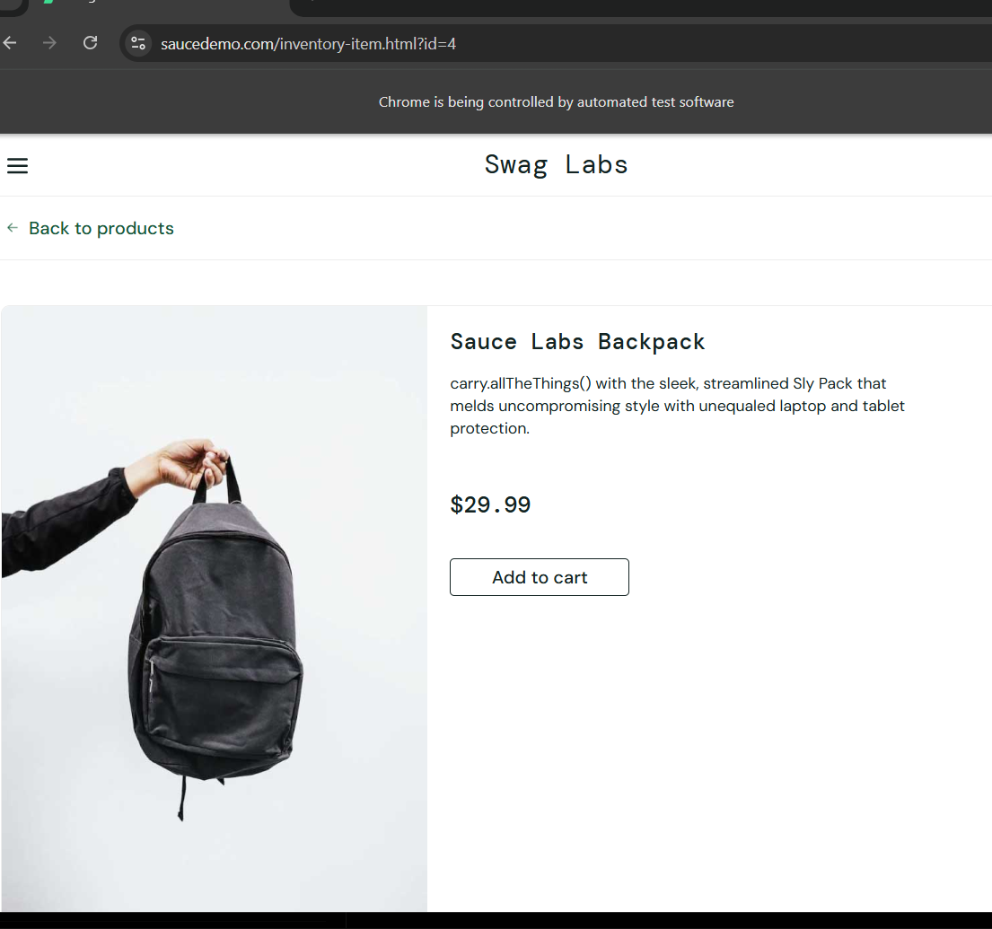
TC-9: Clickable Wait
Testcase
Customer completes checkout and waits until the Place Order/Finish button becomes clickable.
Program
import time
from selenium import webdriver
from selenium.webdriver.common.by import By
from selenium.webdriver.support.ui import WebDriverWait
from selenium.webdriver.support import expected_conditions as EC
driver = webdriver.Chrome()
driver.get("https://www.saucedemo.com/")
driver.find_element(By.ID, "user-name").send_keys("standard_user")
driver.find_element(By.ID, "password").send_keys("secret_sauce")
driver.find_element(By.ID, "login-button").click()
driver.find_element(By.ID, "add-to-cart-sauce-labs-backpack").click()
driver.find_element(By.CLASS_NAME, "shopping_cart_link").click()
driver.find_element(By.ID, "checkout").click()
time.sleep(5)
driver.find_element(By.ID, "first-name").send_keys("DK")
driver.find_element(By.ID, "last-name").send_keys("Test")
driver.find_element(By.ID, "postal-code").send_keys("600001")
driver.find_element(By.ID, "continue").click()
wait = WebDriverWait(driver, 10)
finish_button = wait.until(
EC.element_to_be_clickable(
(By.ID, "finish")
)
)
finish_button.click()
time.sleep(2)
driver.quit()

Output:
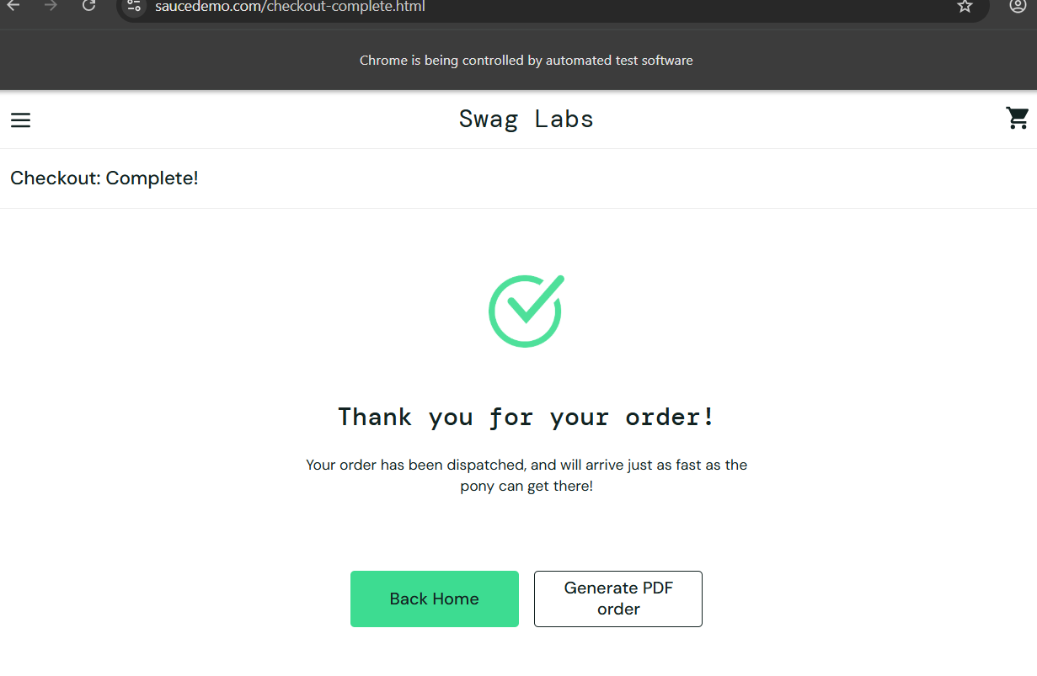

TC-10: Alert Wait
Testcase
Customer completes the purchase and waits for the order confirmation popup.
Program
import time
from selenium import webdriver
from selenium.webdriver.common.by import By
from selenium.webdriver.support.ui import WebDriverWait
from selenium.webdriver.support import expected_conditions as EC
driver = webdriver.Chrome()
driver.get("https://www.tutorialspoint.com/selenium/practice/alerts.php")
driver.find_element(By.XPATH,"//button[@onclick='myMessage()']").click()
wait = WebDriverWait(driver, 10)
alert = wait.until(EC.alert_is_present())
time.sleep(5)
alert.accept()
time.sleep(5)
driver.quit()
Output:
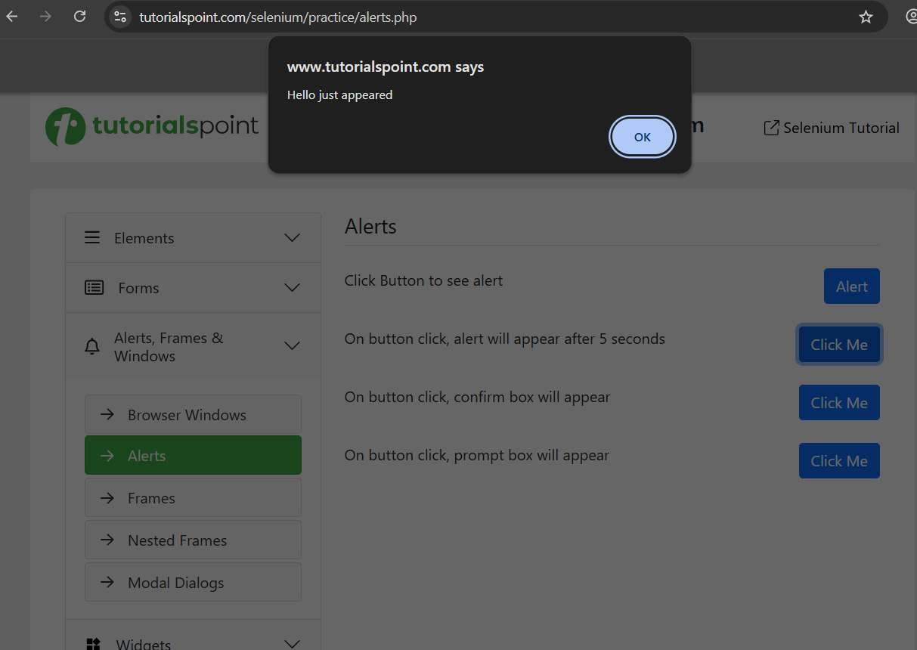

GitHub Link: https://github.com/dinesh2068/SELENIUM-10-test-cases-practice.git

