**Weeks 2, 4, 6, 8, 10, and 12**

**✅ Week 2:**

**Hadoop Installation & Monitoring**

1. Perform setting up and installing Hadoop in its three operating modes:
   * Standalone
   * Pseudo-distributed
   * Fully-distributed
2. Use web-based tools to monitor your Hadoop setup.

**✅ Week 4:**

**Word Count using MapReduce**

* Run a basic **Word Count** MapReduce program to understand the **MapReduce paradigm**.

**✅ Week 6:**

**Hive Operations**

1. Install the Hive framework.
2. Create, alter, and drop **databases** and **tables** in Hive.
3. Perform **Hive queries and joins** to display and retrieve data.

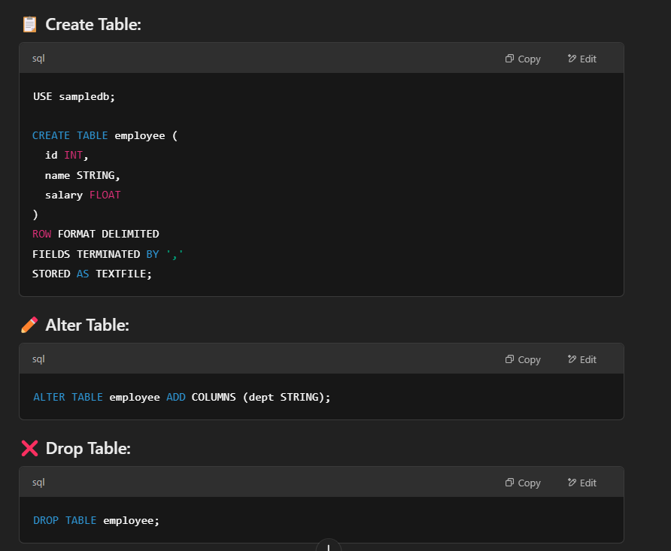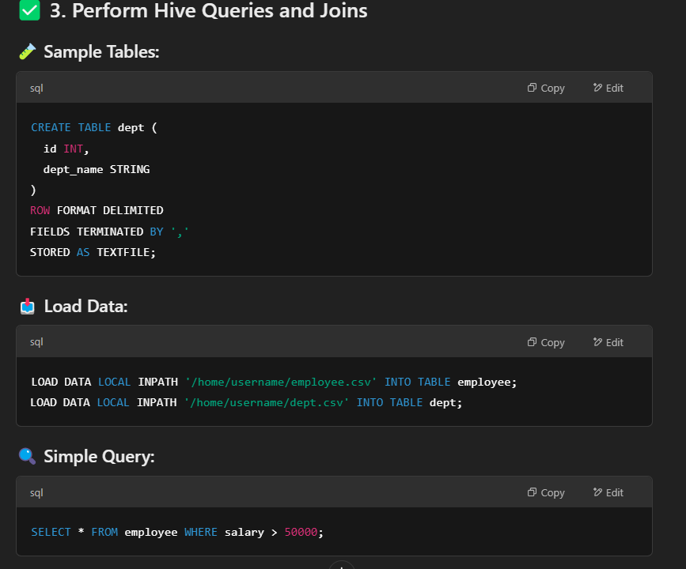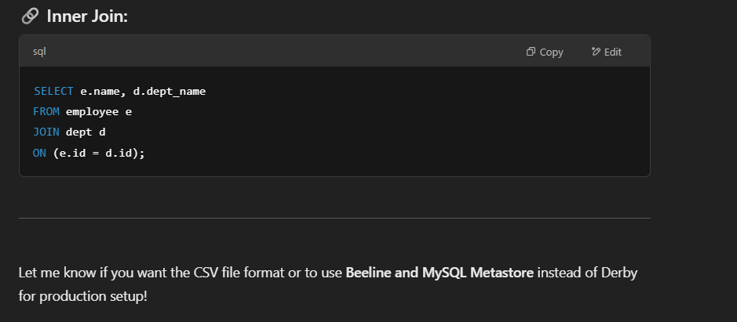

**✅ Week 8:**

**Sales Data Analysis using Spark**

1. Analyze sales data stored in Hadoop Data Lake.
2. Create a DataFrame and write Spark SQL queries to compute:
   * Average sale of every customer.
3. Store the output as a **Parquet** file.

**✅ Week 10:**

**Spark RDD Operations**

1. Write a Spark program to **count the number of occurrences** of each character in a text file.

from pyspark import SparkContext

sc = SparkContext("local", "Character Count")

text_file = sc.textFile("path_to_your_file.txt")

char_counts = (

text_file.flatMap(lambda line: list(line)) # Break each line into individual characters

.map(lambda char: (char, 1)) # Assign each character a count of 1

.reduceByKey(lambda a, b: a + b) # Aggregate counts for each character

)

# Display results

for char, count in char_counts.collect():

print(f"Character '{char}' occurs {count} times.")

output:

Character 'a' occurs 15 times.

Character 'b' occurs 8 times.

Character 'c' occurs 20 times.

Character ' ' occurs 50 times. # Space character count

Character '.' occurs 5 times.

**✅ Week 12:**

**Spark Joins**

* Join **Customer** and **Sales** datasets using a common key product_id.
* Print:
  + customer_id
  + customer_name
  + product_name
  + price

from pyspark.sql import SparkSession

spark = SparkSession.builder.appName("RetailDataJoin").getOrCreate()

customer_data = [(101, "Ravi", 1),

(102, "Keerth", 2),

(101, "Syam", 1),

(101, "Geetha", 1),

(103, "Dawn", 3)]

customer_schema = ["customer_id", "customer_name", "product_id"]

customer_df = spark.createDataFrame(customer_data, customer_schema)

sales_data = [(1, "Laptop", 50000),

(2, "Mobile", 20000),

(3, "Tablet", 15000)]

sales_schema = ["product_id", "product_name", "price"]

sales_df = spark.createDataFrame(sales_data, sales_schema)

joined_df = customer_df.join(sales_df, "product_id")

result_df = joined_df.select("customer_id", "customer_name", "product_name", "price")

result_df.show()

spark.stop()