Step 1 : access home page (<http://localhost:8080/todo/>)

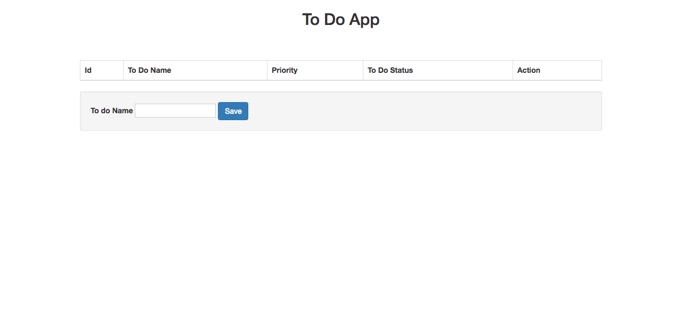

* Step 2 : add some todos

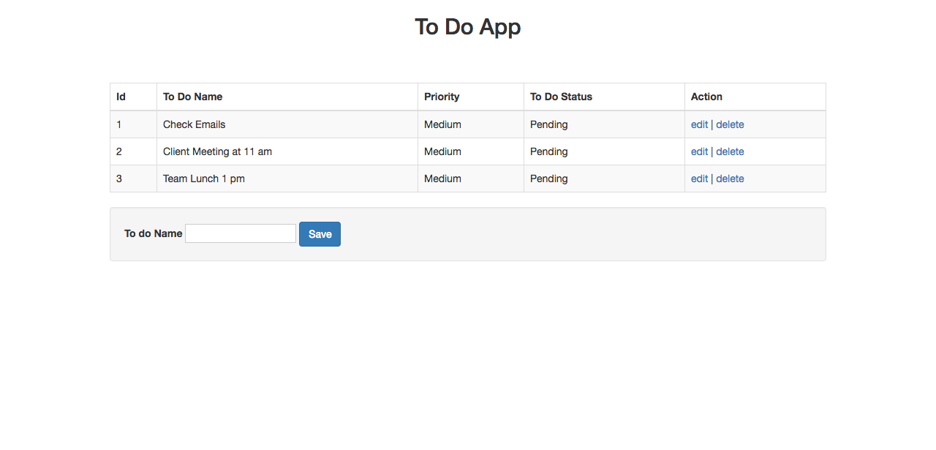

* Step 3 : update todo status or priority by clicking edit on action column.

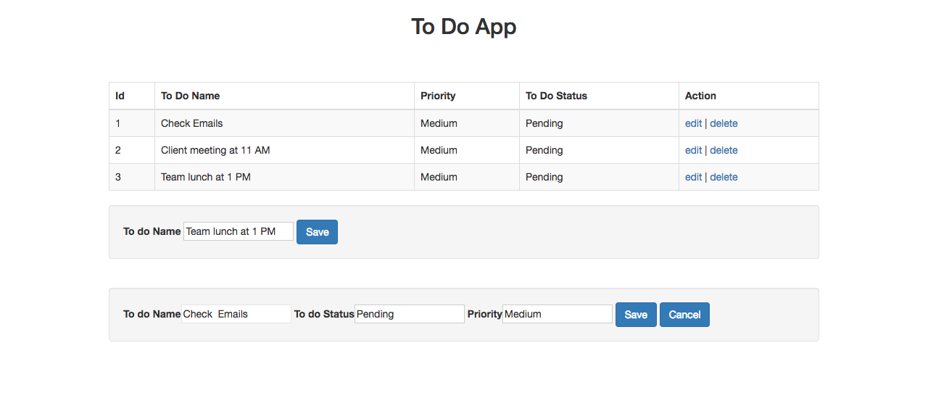

* Step 4 : delete todo as and when required by clicking delete on action column.