***ABSTRACT***

Our project Health care Management system includes registration of patients, storing their details into the system, and also booking their appointments with doctors. Our software has the facility to give a unique id for every patient and stores the details of every patient and the staff automatically. User can search availability of a doctor and the details of a patient using the id. The Health care Management System can be entered using a username and password. It is accessible either by an administrator or receptionist. Only they can add data into the database. The data can be retrieved easily. The interface is very user-friendly. The data are well protected for personal use and makes the data processing very fast. It is having mainly two modules. One is at Administration Level and other one is of user I.e., of patients and doctors. The Application maintains authentication in order to access the application. Administrator task includes managing doctor’s information, patient’s information. To achieve this aim a database was designed one for the patient and other for the doctors which the admin can access. The complaints which are given by user will be referred by authorities. The Patient modules include checking appointments, prescription.

**Introduction:**

The project Health care Management system includes registration of patients, storing their details into the system, and also computerized billing in the pharmacy, and labs. The software has the facility to give a unique id for every patient and stores the details of every patient and the staff automatically. It includes a search facility to know the current status of each room. User can search availability of a doctor and the details of a patient using the id. The Health care Management System can be entered using a username and password. It is accessible either by an administrator or receptionist. Only they can add data into the database. The data can be retrieved easily. The interface is very user-friendly. The data are well protected for personal use and makes the data processing very fast. Health care Management System is powerful, flexible, and easy to use and is designed and developed to deliver real conceivable benefits to hospitals. Health carel Management System is designed for multispecialty hospitals, to cover a wide range of hospital administration and management processes. It is an integrated end-to-end Health care Management System that provides relevant information across the hospital to support effective decision making for patient care, hospital administration and critical financial accounting, in a seamless flow. Health care Management System is a software product suite designed to improve the quality and management of hospital management in the areas of clinical process analysis and activitybased costing. Health care Management System enables you to develop your organization and improve its effectiveness and quality of work. Managing the key processes efficiently is critical to the success of the hospital helps you manage your processes.

**Problem Statement**: In this busy world we don’t have the time to wait in infamously long hospital queues. The problem is, queuing at hospital is often managed manually by administrative staff, then take a token there and then wait for our turn then ask for the doctor and the most frustrating thing - we went there by traveling a long distance and then we come to know the doctor is on leave or the doctor can’t take appointments. HMS will help us overcome all these problems because now patients can book their appointments at home, they can check whether the doctor they want to meet is available or not. Doctors can also confirm or decline appointments, this help both patient and the doctor because if the doctor declines’ appointment, then patient will know this in advance and patient will visit hospital only when the doctor confirms’ the appointment this will save time and money of the patient. HMS is essential for all healthcare establishments, be it hospitals, nursing homes, health clinics, rehabilitation centers, dispensaries, or clinics. The main goal is to computerize all the details regarding the patient and the hospital. The installation of this healthcare software results in improvement in administrative functions and hence better patient care, which is the prime focus of any healthcare unit**.**

**Benefits of implementing a health care management**

• Appointment booking o Helps patients cut the long queue and saves their time o Is equipped with features like automated email and text message reminders

• Role-Based Access Control o Allows employees to access only the necessary information to effectively perform their job duties o Increases data security and integrity

• Overall cost reduction o Cuts down paper costs as all the data are computerized o No separate costs for setting up physical servers

• Data accuracy o Removes human errors o Alerts when there’s a shortage of stock

• Data security o Helps to keep patients records private Restricts access through role-based access control

**REQUIREMENT SPECIFICATION**

**INTRODUCTION**: To be used efficiently, all computer software needs certain hardware components or the other software resources to be present on a computer. These pre-requisites are known as(computer) system requirements and are often used as a guideline as opposed to an absolute rule. Most software defines two sets of system requirements: minimum and recommended. With increasing demand for higher processing power and resources in newer versions of software, system requirements tend to increase over time. Industry analysts suggest that this trend plays a bigger part in driving upgrades to existing computer systems than technological advancements.

**HARDWARE REQUIREMENTS**:

The most common set of requirements defined by any operating system or software application is the physical computer resources, also known as hardware. A hardware requirements list is often accompanied by a hardware compatibility list (HCL), especially in case of operating systems. An HCL lists tested, compatibility and sometimes incompatible hardware devices for a particular operating system or application. The following sub-sections discuss the various aspects of hardware requirements.

**HARDWARE REQUIREMENTS FOR PRESENT PROJECT:**

PROCESSOR : Intel dual Core ,i3

RAM : 1 GB HARD DISK : 80 GB

**SOFTWARE REQUIREMENTS**: Software Requirements deal with defining software resource requirements and pre-requisites that need to be installed on a computer to provide optimal functioning of an application. These requirements or pre-requisites are generally not included in the software installation package and need to be installed separately before the software is installed.

**SOFTWARE REQUIREMENTS FOR PRESENT PROJECT:** OPERATING SYSTEM : Windows 7/ XP/8

FRONT END : HTML, CSS, JAVA SCRIPT.

DATABASE : MySQL

**SCHEMA**

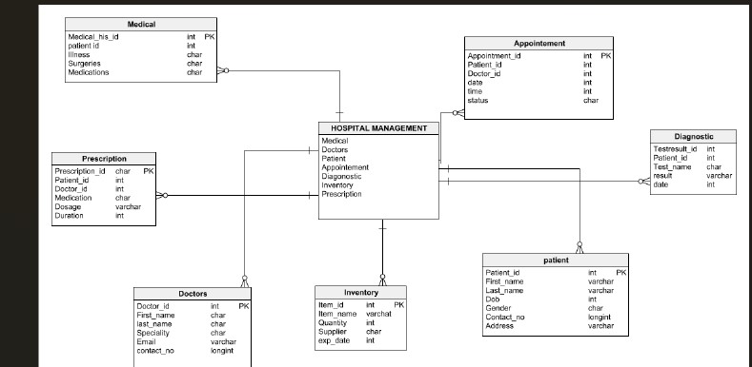

**SAMPLE OUTPUT**

