**UNIT-V: AC BRIDGES**:

**SYLLABUS:** Measurement of inductance- Maxwell’s bridge, Hay’s bridge, Anderson’s bridge. Measurement of capacitance and loss angle –Desaunty’s Bridge – Schering Bridge.

The bridge circuit can be operated with only AC voltage signal, then it is said to be AC bridge circuit or simply AC bridge. AC bridge are similar to D.C. bridge in topology(way of connecting).It consists of four arm AB,BC,CD and DA .Generally the impedance to be measured is connected between ‘A’ and ‘B’. A detector is connected between ‘B’ and ’D’. The detector is used as null deflection instrument. Some of the arms are variable element. By varying these elements, the potential values at ‘B’ and ‘D’ can be made equal. This is called balancing of the bridge.

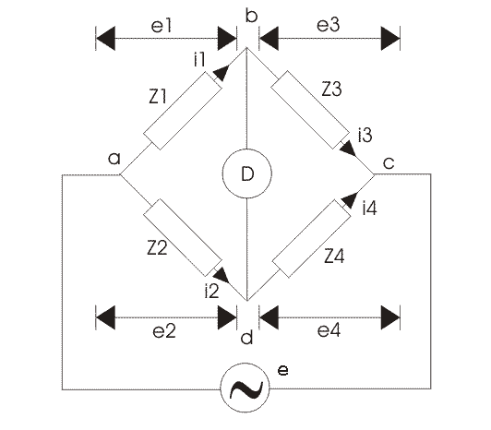

General form of A.C. bridge

At the balance condition, the current through detector is zero.

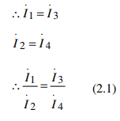

At balance condition,

Voltage drop across ‘AB’=voltage drop across ‘AD’.

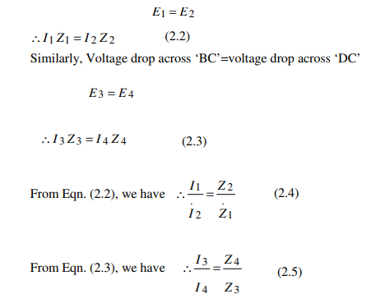

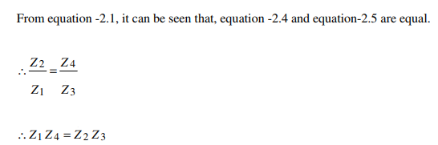

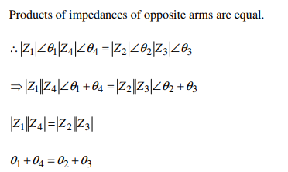

* For balance condition, magnitude on either side must be equal.
* Angle on either side must be equal.

**Types of detector**

The following types of instruments are used as detector in A.C. bridge.

• Vibration galvanometer

• Head phones (speaker)

• Tuned amplifier

**Vibration galvanometer**

Between the point ‘B’ and ‘D’ a vibration galvanometer is connected to indicate the bridge

balance condition. This A.C. galvanometer which works on the principle of resonance. The

A.C. galvanometer shows a dot, if the bridge is unbalanced.

**Head phones**

Two speakers are connected in parallel in this system. If the bridge is unbalanced, the

speaker produced more sound energy. If the bridge is balanced, the speaker do not produced

any sound energy.

**Tuned amplifier**

If the bridge is unbalanced the output of tuned amplifier is high. If the bridge is balanced,

output of amplifier is zero.

These bridges are very useful for the measurement of :

* Inductance (L)
* Capacitance (C)
* Frequency (F)
* Mutual inductance (M)
* Storage factor, Loss factor etc..

**Inductance (L) measurement:**

Inductance is measured by using the following bridges:

1. Maxwell’s bridge
2. Hay’s bridge
3. Anderson’s bridge

**MAXWELL’S BRIDGE:**

The bridge used for the measurement of self-inductance of the circuit is known as the Maxwell Bridge. It is the advanced form of the Wheatstone bridge. Two methods are used for determining the self-inductance of the circuit. They are

1. Maxwell’s Inductance Bridge
2. Maxwell’s inductance Capacitance Bridge

**MAXWELL INDUCTANCE BRIDGE:**



It is the simplest ratio AC Bridge for the determination of unknown medium inductance of an inductor. The four arms of this bridge encloses following components.

**AB arm:** inductor of unknown inductance Lx with a series internal resistance L1

**BC arm**: Fixed resistance R2

**AD arm**: Variable inductor of known inductance L0 with its series internal resistance R3

**DC arm**: Variable resistance R4

**Working:** The variable inductance L0 and resistance R4 are varied at fixed value of R2 , till no sound is heard in head phone. At no sound, bridge becomes balanced.

Let Z1, Z2, Z3 and Z4 are the impedances of the four arms of the bridge. Then,

Z1 = R1 + jωLX ; Z2 = R2

Z3 = R3 + jωL0 ; Z4 = R4

Under the balance condition of bridge**, Z1Z4=Z2Z3**



Putting values of impedances, we have





Comparing real part of eq.(2), we have



|  |
| --- |
|  |

Eq.(3) is the real part/dc balance condition of this bridge. By this, the series internal resistance of

Unknown inductor can be determined.

And comparing imaginary part of eq.(2), we have

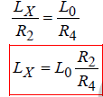

……(4)

The equation (4) is the formula for the determination of unknown inductance. On the knowledge of R2 and R4 in balance condition, the unknown inductance is calculated.

**Advantages:**

From eqs. (3) and (4), we can write,

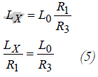

Thus balance condition is obtained when, Time constant of unknown inductor =time constant of known inductor

Hence, this bridge is the most suitable for the comparing inductances and in measurement of self

inductance in terms of known self inductance. This bridge is also used for measuring the iron

losses of the transformers at audio frequency.

**Disadvantage:**

The disadvantage of this bridge is that the both balance condition can not be satisfied independently because any change in L0 causes change in R3. Thus process of getting balance is

not easy.

**MAXWELL INDUCTANCE CAPACITANCE BRIDGE:**

This is an AC bridge it is modified Maxwell’s inductance bridge. By this bridge unknown inductance of an inductor is measured in terms of capacitance.

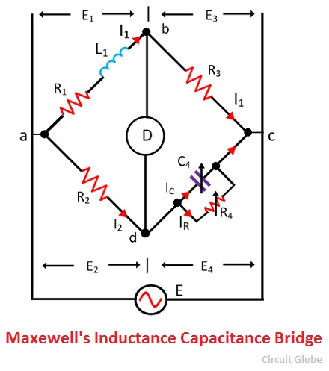

Let, L1 – unknown inductance of resistance R1.

R1 – unknown resistor

R2, R3-fixed resistors

R4-variable resistor

C4 – variable Capacitor

For balance condition,

Z1Z4=Z2Z3

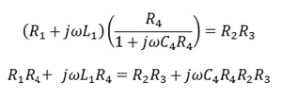

By separating the real part equation we get,



|  |
| --- |
|  |

separating the imaginary part equation we get,



|  |
| --- |
|  |

The above equation shows that the bridges have two variables R4 and C4 which appear in one of the two equations and hence both the equations are independent.

The circuit quality factor is expressed as

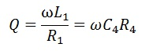

**Advantages of the Maxwell’s Bridges**

1. The balance equation of the circuit is free from frequency.
2. Both the balance equations are independent of each other.
3. The Maxwell’s inductor capacitance bridge is used for the measurement of the high range [inductance.](https://circuitglobe.com/what-is-a-inductance.html)

**Disadvantages of the Maxwell’s Bridge**

1. The Maxwell inductor capacitance bridge requires a variable capacitor which is very expensive. Thus, sometimes the standard variable capacitor is used in the bridges.
2. The bridge is only used for the measurement of medium quality coils.

Because of the following disadvantages, the Hays bridge is used for the measurement of circuit inductance which is the advanced form of the Maxwell’s Bridge.

**HAY’S BRIDGE:**

Hay’s bridge is used for determining the self-inductance of the circuit. The bridge is the advanced form of Maxwell’s bridge. The Maxwell’s bridge is only appropriate for measuring the medium quality factor. Hence, for measuring the high-quality factor the Hays bridge is used in the circuit.

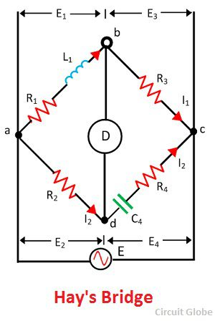

The unknown inductor L1 is placed in the arm ab along with the resistance R1. This unknown inductor is compared with the standard capacitor C4 connected across the arm cd. The resistance R4 is connected in series with the capacitor C4. The other two non-inductive resistor R2 and R3 are connected in the arm ad and bc respectively.

The C4 and R4 are adjusted for making the bridge in the balanced condition. When the bridge is in a balanced condition, no current flows through the detector which is connected to point b and c respectively. The potential drops across the arm ad and cd are equal and similarly, the potential across the arm ab and bc are equal.

Let,

L1 – unknown inductance having a resistance R1

R2, R3, R4 – known non-inductive resistance.

C4 – standard capacitor

At balance condition,

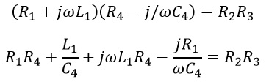

Separating the real and imaginary term, we obtain

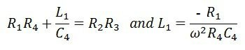

Solving the above equation, we have

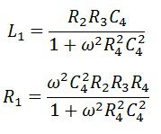

The quality factor of the coil is

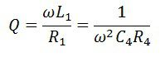

The equation of the unknown inductance and capacitance consists frequency term. Thus for finding the value of unknown inductance the frequency of the supply must be known. For the high-quality factor, the frequency does not play an important role.

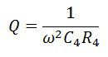

Substituting the value of Q in the equation of unknown inductance, we get

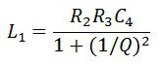

For greater value of Q the 1/Q is neglected and hence the equation become

|  |
| --- |
| https://circuitglobe.com/wp-content/uploads/2017/07/hay-equation-8.jpg |

**Advantages of Hay’s Bridge**

The following are the advantages of Hay’s Bridge.

1. The Hays bridges give a simple expression for the unknown inductances and are suitable for the coil having the quality factor greater than the 10 ohms.
2. It gives a simple equation for quality factor.
3. The Hay’s bridge uses small value resistance for determining the Q factor.

**Disadvantages of Hay’s Bridge**

The only disadvantage of this type of bridge is that it is not suitable for the measurement of the coil having the quality factor less than 10 ohms.

**ANDERSON’S BRIDGE:**

Anderson’s bridge gives the accurate measurement of self-inductance of the circuit. The bridge is the advanced form of Maxwell’s inductance capacitance bridge. In Anderson bridge, the unknown inductance is compared with the standard fixed capacitance which is connected between the two arms of the bridge.

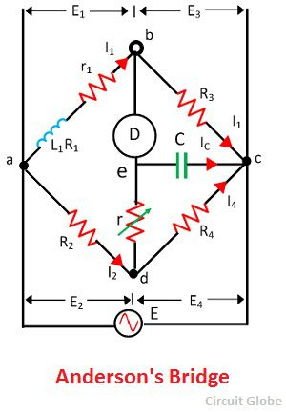

The bridge has fours arms ab, bc, cd, and ad. The arm ab consists unknown inductance along with the resistance. And the other three arms consist the purely resistive arms connected in series with the circuit.

The static capacitor and the variable resistor are connected in series and placed in parallel with the cd arm. The voltage source is applied to the terminal a and c.

Let, L1 – unknown inductance having a resistance R1.

R2, R3, R4 – known non-inductive resistance

C4 – standard capacitor

At balance Condition,

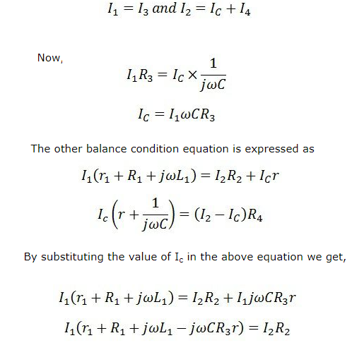

And





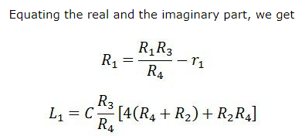

**Advantages of Anderson Bridge**

1. The balance point is easily obtained on the Anderson bridge as compared to Maxwell’s inductance capacitance bridge.
2. The bridge uses fixed capacitor because of which accurate reading is obtained.
3. The bridge measures the accurate capacitances in terms of inductances.

**Disadvantages of Anderson Bridge**

1. The circuit has more arms which make it more complex as compared to Maxwell’s bridge. The equation of the bridge is also more complex.
2. The bridge has an additional junction which arises the difficulty in shielding the bridge

**Capacitance (L) measurement:**

Capacitance is measured by using the following bridges:

1. Desaunty’s Bridge 2.Schering Bridge.

**DESAUNTY’S BRIDGE :**

This is the simplest method of finding out the value of a unknown capacitor in terms of a known standard capacitor.

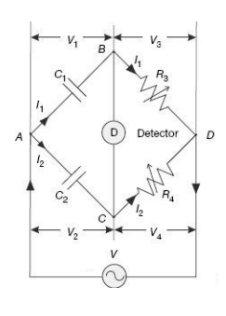

The unknown capacitor C1 in the branch AB is compared with the standard known standard capacitor C2 on arm AC. The bridge can be balanced by varying either of the non-inductive resistors R3 or R4 Under balanced condition, since no current flows through the detector, nodes B and C are at the same potential,

i.e., V1 = V2 and V3 = V4

At balance condition we have,

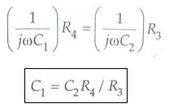

In order to make measurement in capacitors having inherent dielectric losses, the modified De Sauty’s bridge as suggested by Grover, can be used. This bridge is also called the series resistance-capacitance bridge.

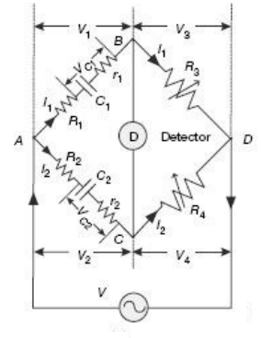

The unknown capacitor C1 with internal resistance r1 representing losses in the branch AB is compared with the standard known standard capacitor C2 along with its internal resistance r2 on arm AC. Resistors R1 and R2 are connected externally in series with C1 and C2 respectively. The bridge can be balanced by varying either of the non-inductive resistors R3 or R4 . Under balanced condition, since no current flows through the detector, nodes B and C are at the same potential, i.e., V1 = V2 and V3 = V4 .

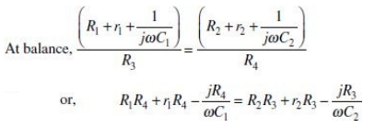

Equating real parts, we have

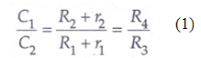

And equating imaginary parts

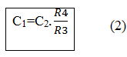

The modified De Sauty’s bridge can also be used to estimate dissipation factor for the

unknown capacitor as described below:

Dissipation factor for the capacitors are defined as

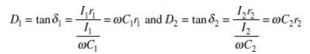

From Eq. (1), we have

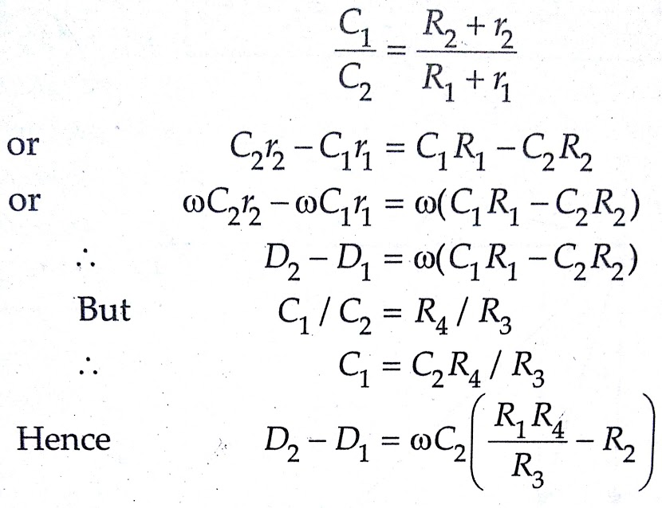

Thus, dissipation factor for one capacitor can be estimated if dissipation factor of the other capacitor is known.

**SCHERING BRIDGE.**

This is an ac bridge which is used for the determination of the most accurate value of the unknown capacitance of a capacitor and is used to define the quality of capacitor by determination of its power factor. This bridge is also used in measurement of dielectric constants of liquids, testing of cables and insulators at high voltages.



The four arms of this encloses following components.

**AB arm**: Capacitor of unknown capacitance C1with a series internal resistance R1

**BC arm**: Fixed resistance R2

**AD arm**: Standard Capacitor of known capacitance C0

**DC arm**: A variable capacitor of capacitance C4 in parallel combination with Variable resistance R4.

**Working**: The variable capacitor C4 and resistance R4 are varied at fixed value of R2 , till no sound is heard in head phone. At no sound, bridge becomes balanced. Let Z1, Z2, Z3 and Z4 are the impedances of the four arms of the bridge. Then,





Under the balance condition of bridge



Putting values of impedances, we have

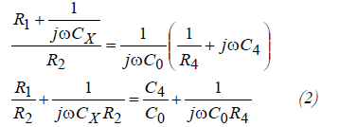

Comparing real part of eq.(2), we have   
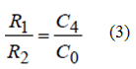

And comparing imaginary part of eq.(2), we have



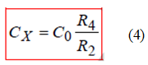

Eq.(3) is the first balance condition of this bridge.By this, the series internal resistance of unknown capacitor can be determined. This condition also indicates that the variation in C4 results this balance condition and is independent of R4 . The equation (4) is second balance condition and provides formula for the determination of unknown capacitance. On the knowledge of R2 and R4 in balance condition, the unknown capacitance is calculated with eq.(4). This equation also suggests that this balance is obtained by variation in R4 and is independent of C4 . Thus C4 and R4 are varied at fixed value of R2 for getting the balance condition. The power factor of unknown capacitor can be written as,



Power factor of unknown capacitor can be determined with eq.(5) by knowing the value of R1 and CX . Since the Both C4 and R4 are required for determination R1 and CX , thus power factor require both the variable quantity. If power factor is small then quality of capacitor is good otherwise not.

**Advantage:** This bridge provides Good/fine balance condition, most accurate result and is most sensitive. It is also useful in measurement of dielectric constants of liquids and testing of cables and insulators at high voltage