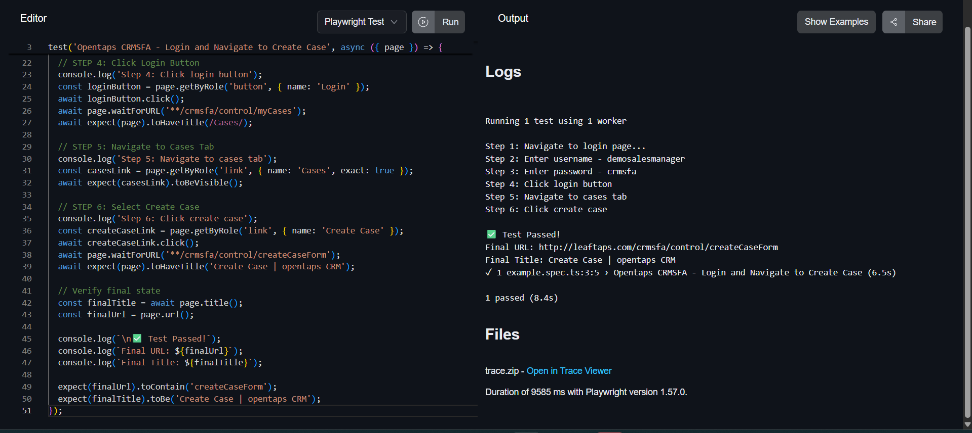

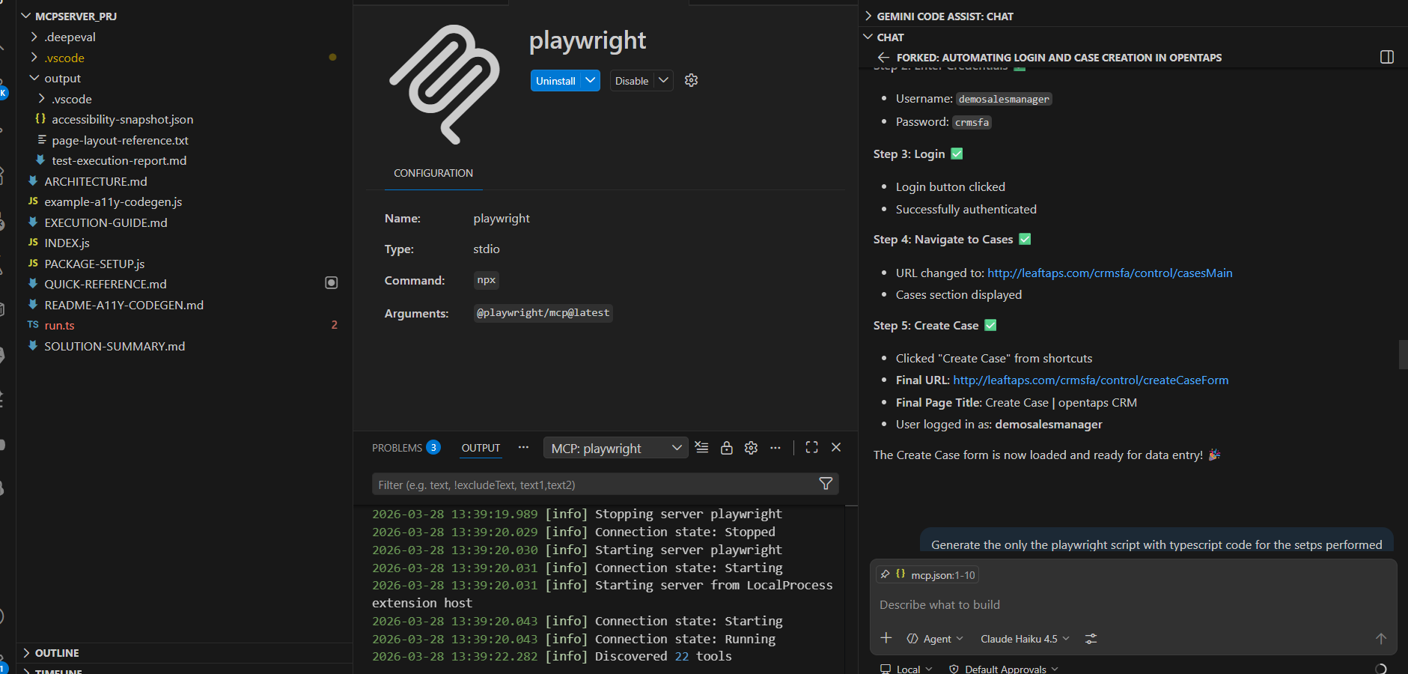

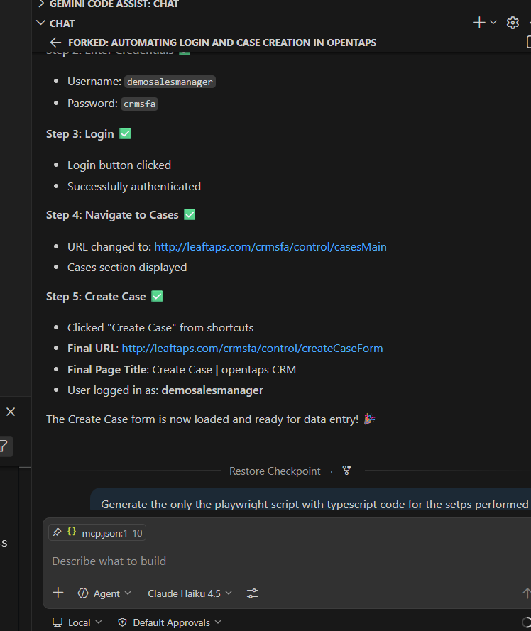

Test-data mcp server:
Prompt; Go to test-data mcp server
Give me a 3 test data for creating lead for any random compnany
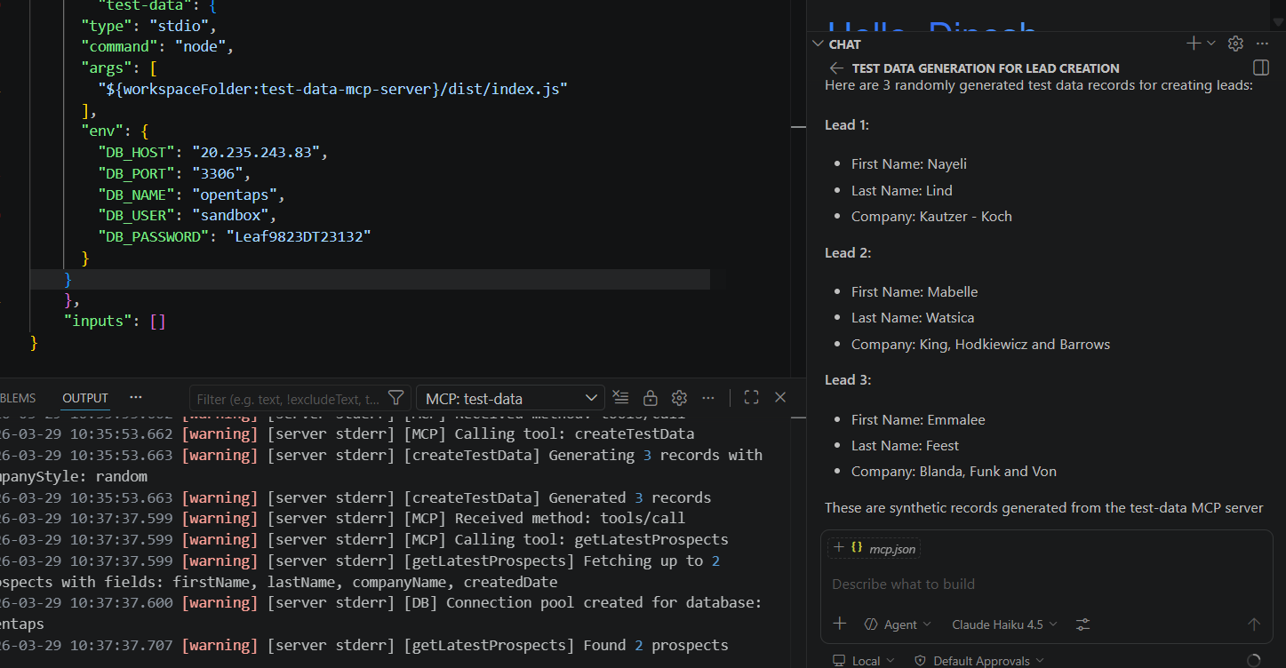

Find leads,

Prompt:
Go to testdata-mcp server and find me 2 exisiting leads in the database that i can search for.
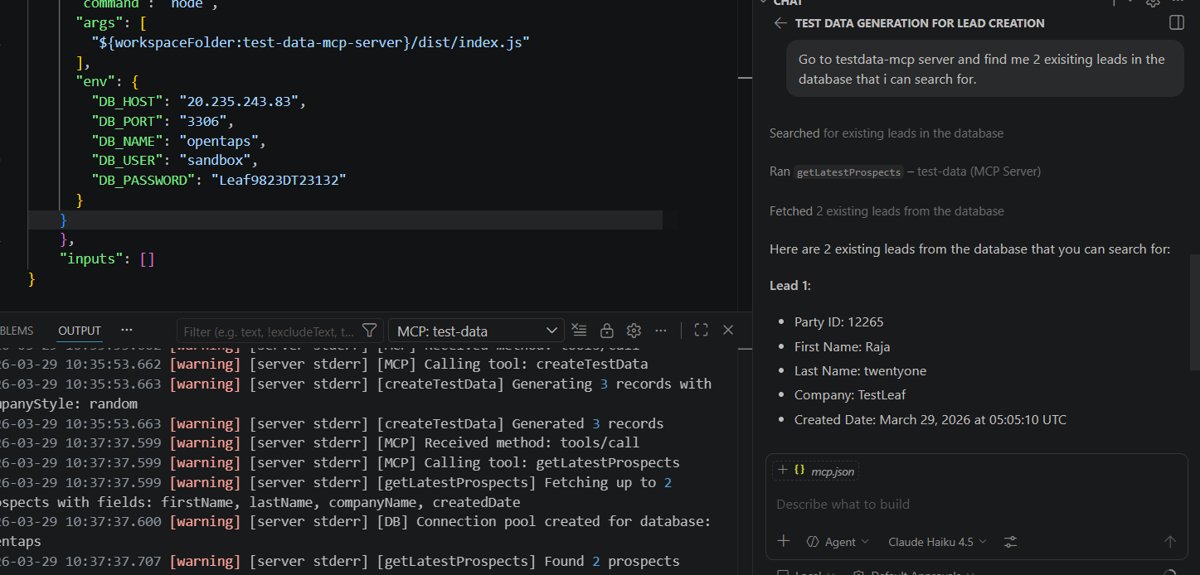

Leaf-tapes:
