HTML Quick Styler
Project Documentation & User Guide
Design and preview HTML element styles — instantly, visually, without writing code.

Version | 1.0
Platform | Web Browser (HTML / CSS / Vanilla JavaScript)
License | Open Source — MIT
Author | HTML Quick Styler Team

1. Project Overview
HTML Quick Styler is a browser-based styling tool that lets developers, designers, and learners visually configure CSS properties for HTML elements — and see the results update in real time without touching a line of code.
The tool is delivered as a single self-contained HTML file. No installation, no build step, and no server required. Open the file in any modern browser and start styling.

Key Highlights
Zero-dependency: Runs entirely in the browser as one .html file.
Live updates: Every control change is reflected in the preview instantly.
CSS export: Copy or download the generated CSS with one click.
Local persistence: Save and reload styles between sessions via localStorage.
Dark / Light themes: Switch themes at any time with the header toggle.
Responsive UI: Works on desktop, tablet, and mobile viewports.
Keyboard shortcuts: Ctrl+S to save, Ctrl+Shift+Z to reset, Esc to close modal.

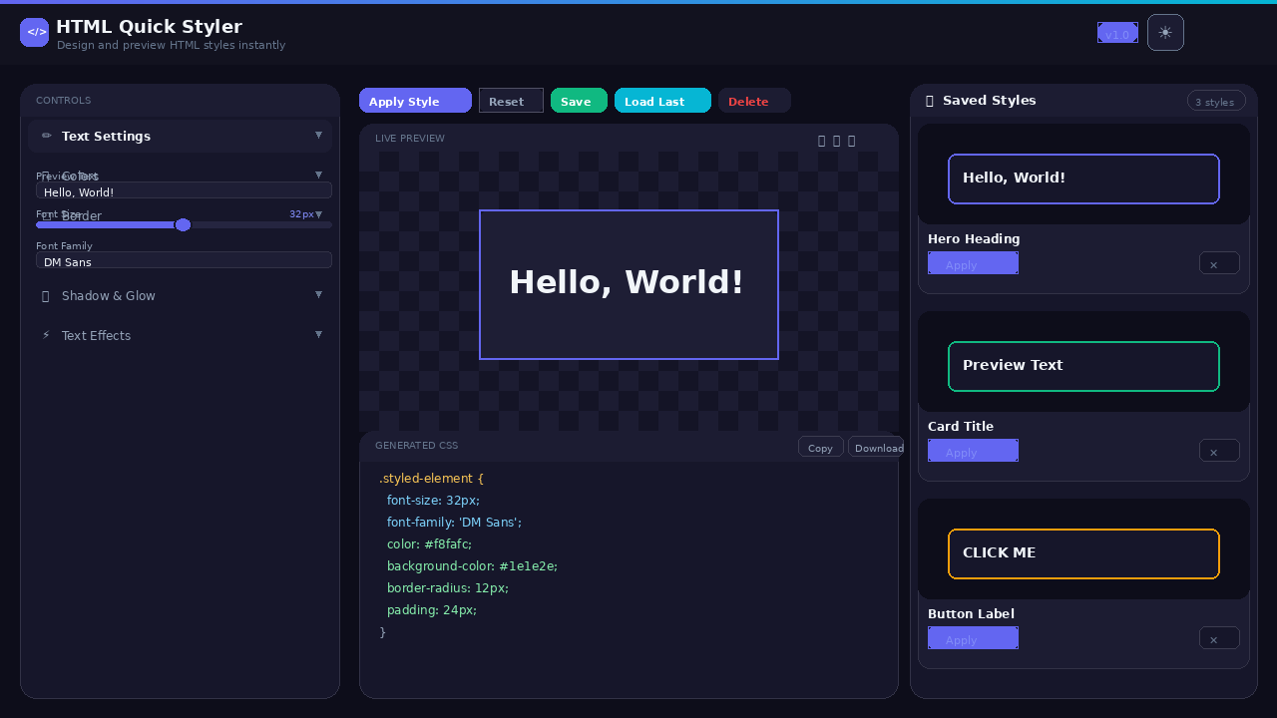
Figure 1 — Full application overview showing control panel, live preview, CSS output, and saved styles

2. How It Works
HTML Quick Styler follows a simple, reactive data flow. A single JavaScript state object acts as the source of truth. Every UI control reads from and writes to this state. Whenever the state changes, the preview box and CSS code block are both updated synchronously.
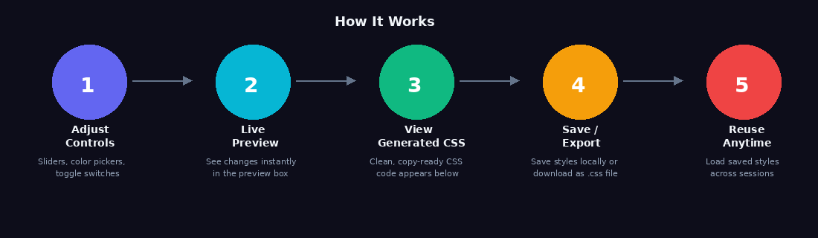
Figure 2 — Five-step workflow from adjusting controls to reusing saved styles

Data Flow
Step 1 — User adjusts a control: Any slider, color picker, select, checkbox, or text input fires an input/change event.
Step 2 — readControlsToState(): All control values are read and written into the central state object in one pass.
Step 3 — applyToPreview(): The state is converted to a CSS style object and applied directly to the preview box element.
Step 4 — renderCSSCode(): The same style object is serialised into a .styled-element { … } CSS rule with syntax highlighting.
Step 5 — Persistence (optional): Clicking Save serialises the full state to localStorage under a hqs_<timestamp> key.

3. Feature Reference

3.1 Control Panel
The sticky left-side panel contains six collapsible accordion sections. Every section can be expanded or collapsed independently by clicking its header.
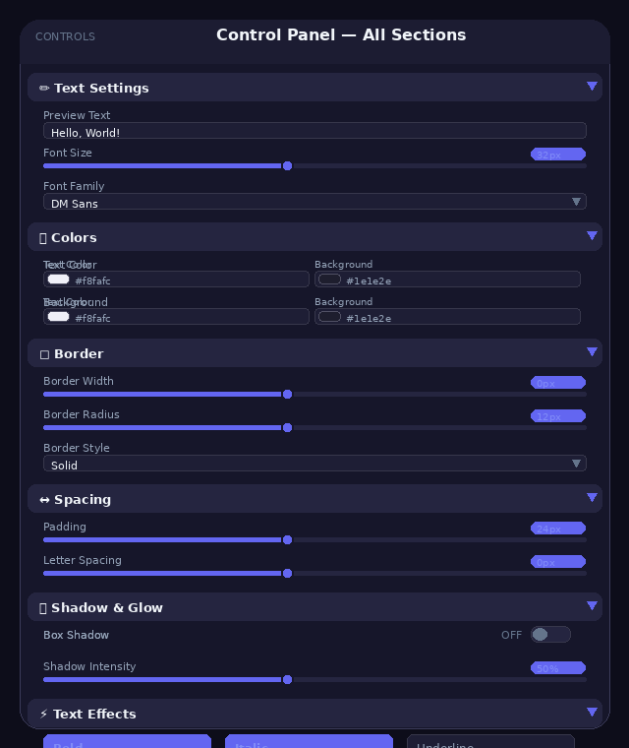
Figure 3 — Control panel with all six sections expanded

Text Settings
Sets the preview text, font size (10–100 px), and font family. Eight typefaces are included: DM Sans, Syne, JetBrains Mono, Arial, Georgia, Times New Roman, Courier New, and Verdana.

Colors
Dual colour pickers for text colour and background colour. The hex value is shown next to each picker and updates as you drag.

Border
Controls border width (0–20 px), border colour, border style (solid / dashed / dotted / double / groove), and border radius (0–60 px).

Spacing
Padding (0–80 px), margin (0–60 px), letter spacing (−5 to 20 px), and line height (1.0–3.0).

Shadow & Glow
Toggle switches for box-shadow and text-shadow. A Shadow Intensity slider (0–100 %) controls blur radius, spread, and alpha automatically. An Opacity slider adjusts the entire element's opacity.

Text Effects
Six toggle buttons: Bold, Italic, Underline, UPPERCASE, Strikethrough, and Skew (skewX −8°). Multiple effects can be active at the same time.

3.2 Action Bar
Button | Variant | Description
Apply Style | Primary | Re-applies all current control values to the preview box and refreshes the CSS output. Useful after manually editing the text field.
Reset | Secondary | Reverts all controls and the preview box to default values (32 px DM Sans, dark background).
Save | Success | Opens the Save Style modal. Enter a name, press Enter or click Save Style.
Load Last | Cyan | Silently loads the most recently saved style without opening any dialog.
Delete | Danger | Asks for confirmation, then removes all saved styles from localStorage.

3.3 Live Preview
The preview panel shows the styled element on a neutral checkerboard canvas. Three device-width modes are available:
Desktop: Full panel width (unrestricted)
Tablet: Max 768 px
Mobile: Max 375 px
The expand button (⤢) doubles the minimum preview height to 480 px for better visibility of large text or complex shadows.
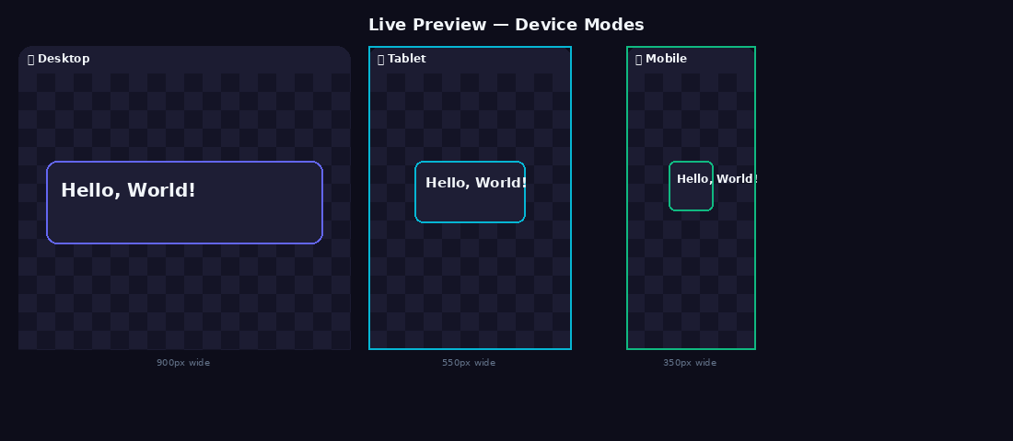
Figure 4 — Live preview shown in desktop, tablet, and mobile device modes

3.4 CSS Code Generator
Below the preview, the Generated CSS panel displays a complete .styled-element { } rule built from the current state. Only non-default properties are included to keep the output clean. Syntax highlighting uses four colour classes: selector (amber), property names (sky blue), values (green), and braces/punctuation (slate).
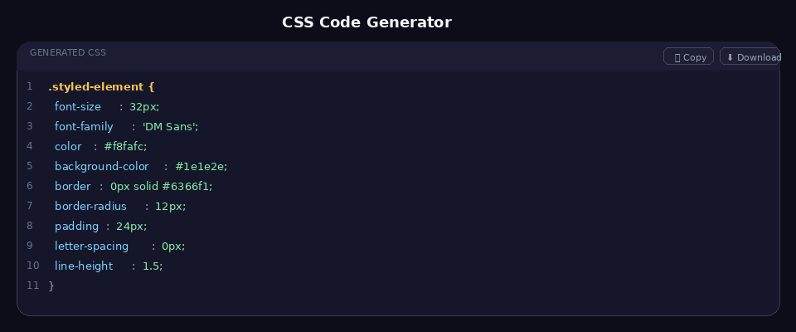
Figure 5 — Syntax-highlighted CSS output with Copy and Download buttons
Copy pastes the plain CSS to the clipboard. Download triggers a browser download of styled-element.css with a generation comment at the top.

3.5 Saved Styles
Styles are persisted in the browser's localStorage under keys prefixed with hqs_. Each record stores the style name, preview text, full state snapshot, and a Unix timestamp.
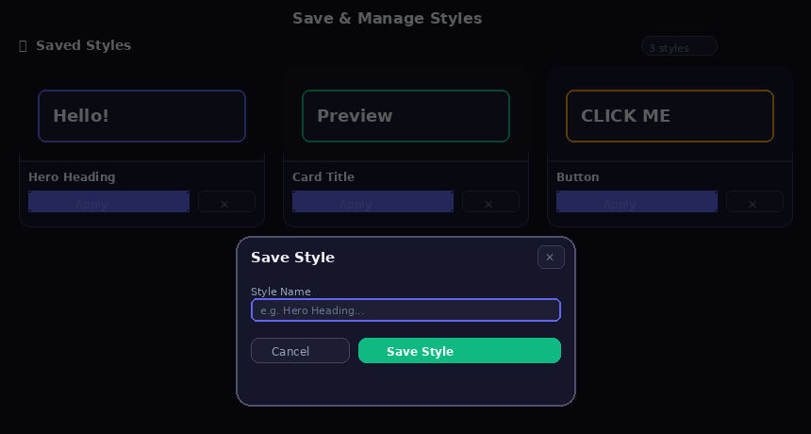
Figure 6 — Saved styles grid (left) and the Save Style modal (right, overlaid)
Each saved style card shows a mini preview rendered with the stored style values, the style name, an Apply button that restores the full state, and a delete (✕) button. Deleting animates the card out before removing the record.

4. File Structure
HTML Quick Styler ships as a single HTML file. All CSS and JavaScript are embedded inline. The logical structure is:
html-quick-styler.html | Root file — open this in a browser
<head>
<style> | All CSS (variables, layout, components, responsive)
Google Fonts link | JetBrains Mono, Syne, DM Sans
<body>
<header> | Sticky top bar with branding, theme toggle, mobile menu
<main> | Two-column grid: control panel + right panel
<aside> | Control panel with 6 accordion sections
<div.right-panel> | Action bar, live preview, CSS code block
<section.saved> | Saved styles grid (rendered dynamically)
<div.modal-overlay> | Save modal (hidden by default)
<div.toast-container> | Toast notification container
<script> | All JavaScript (state, events, persistence, UI helpers)

5. CSS Architecture
All styles live inside a single <style> block in the document head. The design system is token-based, using CSS custom properties (variables) defined on :root. A [data-theme='light'] selector block overrides the dark-theme tokens for light mode.

Design Tokens

Colors
--primary (#6366F1)
--cyan (#06B6D4)
--success (#10B981)
--danger (#EF4444)
--warning (#F59E0B)

Backgrounds
--bg-base
--bg-surface
--bg-panel
--bg-elevated
--bg-input
--bg-hover

Typography
--font-ui (DM Sans)
--font-mono (JetBrains Mono)
--font-brand (Syne)

Spacing
--radius-sm/md/lg/xl
--shadow-sm/md/lg
--shadow-glow

Layout
--panel-width (320px)
--header-h (64px)
--transition

6. JavaScript Architecture
The entire application logic is ~350 lines of modular vanilla JavaScript, structured around a single immutable-style state object.

State Management
defaultState defines 26 properties. state is always a deep copy. copyState() uses JSON.parse(JSON.stringify()) for a cheap deep clone.

readControlsToState()
Reads every DOM control value into state in one synchronous pass. Called before any save operation and on every live input event.

writeStateToControls()
The inverse — pushes state values back into all DOM controls. Called on reset and load.

buildStyleObject(s)
Pure function. Converts a state snapshot into a CSS property/value map. Handles compound values like box-shadow (intensity → blur/spread/alpha) and text-decoration (underline + strike).

applyToPreview()
Iterates the style object and sets element.style[camelProp] = value on the preview box.

generateCSS() / renderCSSCode()
generateCSS() serialises the style object to a .styled-element { } string, filtering out 'none', 'normal', and '1.00' to keep output minimal. renderCSSCode() injects the string into the code block with regex-based syntax highlighting.

localStorage Helpers
getStoredKeys() returns all hqs_* keys sorted by timestamp. loadStyleByKey() merges stored state over defaultState (safe fallback). deleteStyleByKey() removes the record and re-renders the grid.

Toast System
toast(icon, message, type) creates a div, appends it to the container, then auto-removes it after 2.8 s with a CSS out transition.

Accordion
section-header buttons toggle aria-expanded and add/remove the collapsed class on the sibling section-body. A CSS animation handles the expand effect.

7. Keyboard Shortcuts
Shortcut | Action
Ctrl / Cmd + S | Open the Save Style modal
Ctrl / Cmd + Shift + Z | Reset all controls to defaults
Escape | Close the Save Style modal
Enter (in modal) | Confirm and save the style

8. Browser Compatibility
Browser | Status
Chrome 88+ | ✓ Full support
Firefox 85+ | ✓ Full support
Safari 14+ | ✓ Full support
Edge 88+ | ✓ Full support
IE 11 | ✗ Not supported
Requires: CSS custom properties, CSS Grid, localStorage API, Clipboard API (copy), navigator.clipboard (HTTPS or localhost for Copy button).

9. Customisation Guide

Add a new font
Add a Google Fonts <link> in the <head>, then add a new <option> in the #fontFamily <select>.

Change the accent colour
Edit --primary and --primary-light in :root. All buttons, sliders, focus rings, and borders update automatically.

Add a new CSS property
Add the property to defaultState, add a control in the HTML, wire it in readControlsToState() and writeStateToControls(), then add the property to buildStyleObject().

Persist styles to a server
Replace localStorage.setItem / getItem in the storage helpers with fetch() calls to a REST API.

Embed in an iframe
The file is fully self-contained. Drop it in an <iframe src='html-quick-styler.html'> with no additional configuration.

10. Changelog & Roadmap

v1.0 — Initial Release
- Full control panel with 6 accordion sections
- Real-time live preview with device-width modes
- Syntax-highlighted CSS code generator
- Copy to clipboard and .css file download
- localStorage save / load / delete
- Dark and light theme
- Responsive layout with mobile menu
- Keyboard shortcuts
- Toast notification system
- Staggered entry animation on load

Planned for v1.1
- Gradient background builder
- CSS filter effects (blur, brightness, contrast)
- Animation / transition controls
- Multi-element comparison view
- Export as full HTML snippet (not just CSS)
- Import existing CSS to populate controls

HTML Quick Styler — Documentation v1.0 | Generated for Google Drive upload

