**User is not a sudoer**

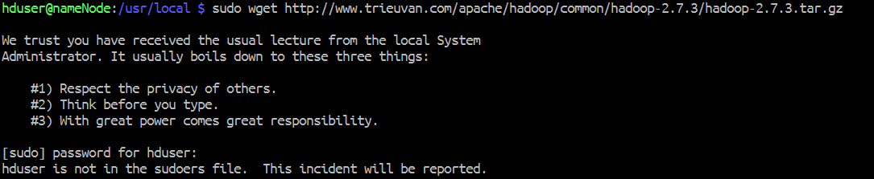

Solution:

The simplest way to add a user to sudoers file is run the command bellow as user with permission to execute gpasswd:

sudo gpasswd -a username sudo

**Location of Hadoop-env.sh**

/usr/local/hadoop/etc/hadoop

**Change the timezone**

sudo timedatectl set-timezone America/New_York

**java.io.IOException: Incompatible clusterIDs**

<http://hadooptutorial.info/incompatible-clusterids/>

