**TECHNICAL DESIGN DOCUMENT**



**PROJECT NAME:** Viman

**DEVELOPED BY:** Sagar Tejwani

**Introduction:**

Viman’s aim is to redefine air travel and to provide Indian travellers a seamless and personalized air ticket booking experience. The brand name ‘Viman’ is a hindi word that means ‘Airplane’. As it aims to transform the flying experience of travellers in India, Viman christens its brand tagline as ‘ Wings of India ’.

**Functional Requirements:**

The functional requirements of the project are:

* Login
* Register
* Search Flights
* Booking Flights
* Make Payment
* View Bookings
* Cancel Booking
* Give Feedback

**Services**

The different micro-services in which this project is divided into are:

* **User Registration :** User can register on website to use all the services.
* **User Login :** User will have to just enter email and password for validation.
* **Search Flight:** User can search flight by providing source, destination & date.
* **Book Flight:** User can book any flight from all the available flights.
* **View Bookings:** User can view the reservations made by me.
* **Cancel Booking:** User can cancel booking made by him.
* **Feedback:** User can provide feedback about the website.

**Overall Architecture Diagram:**

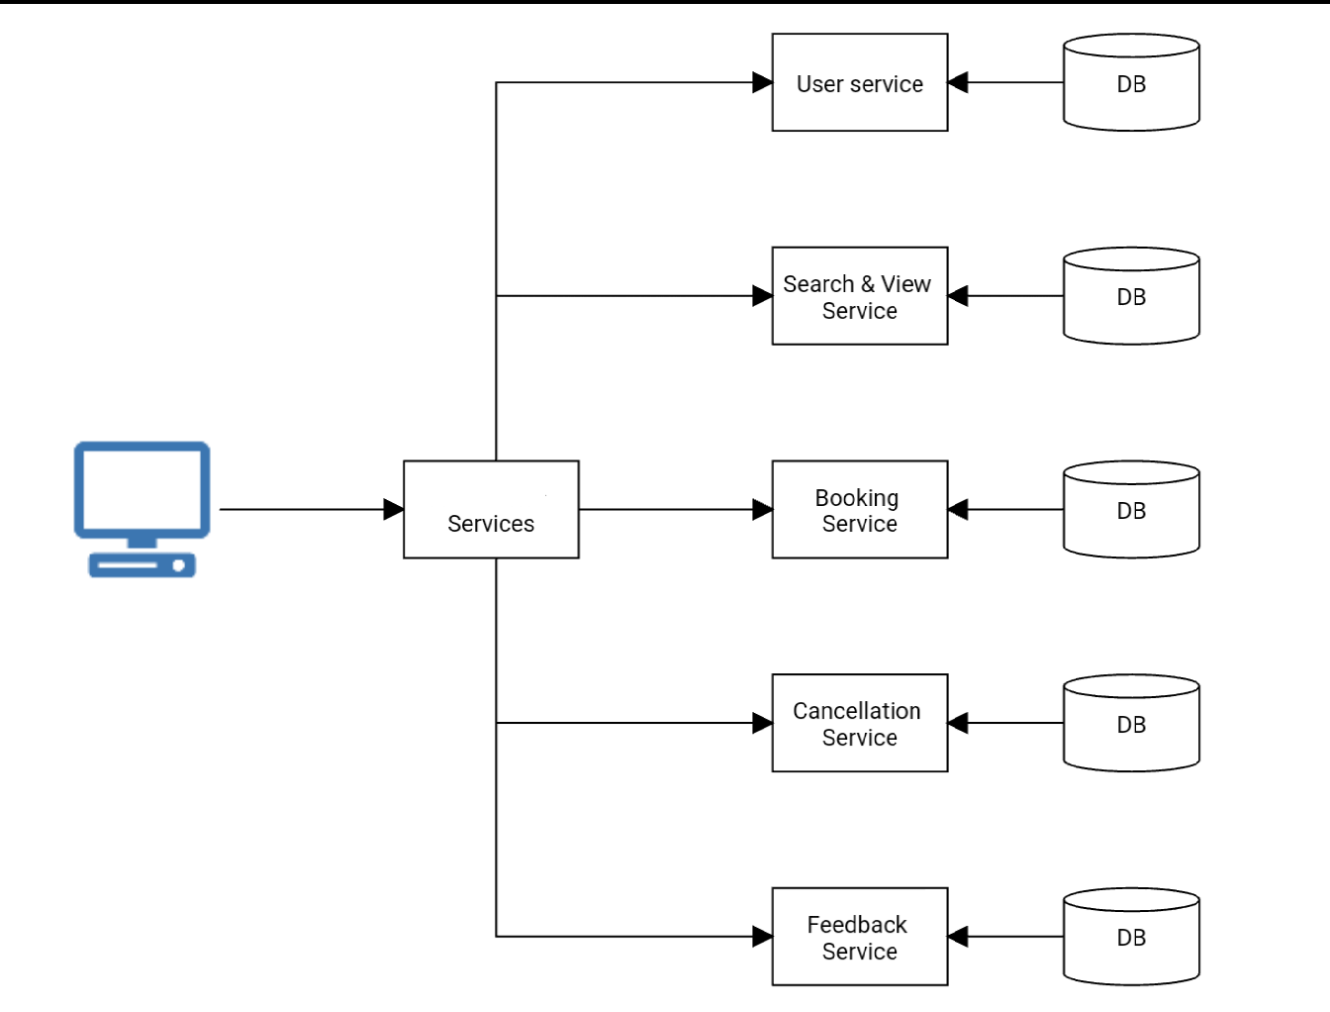

**Overall Entity Relationship Diagram:**

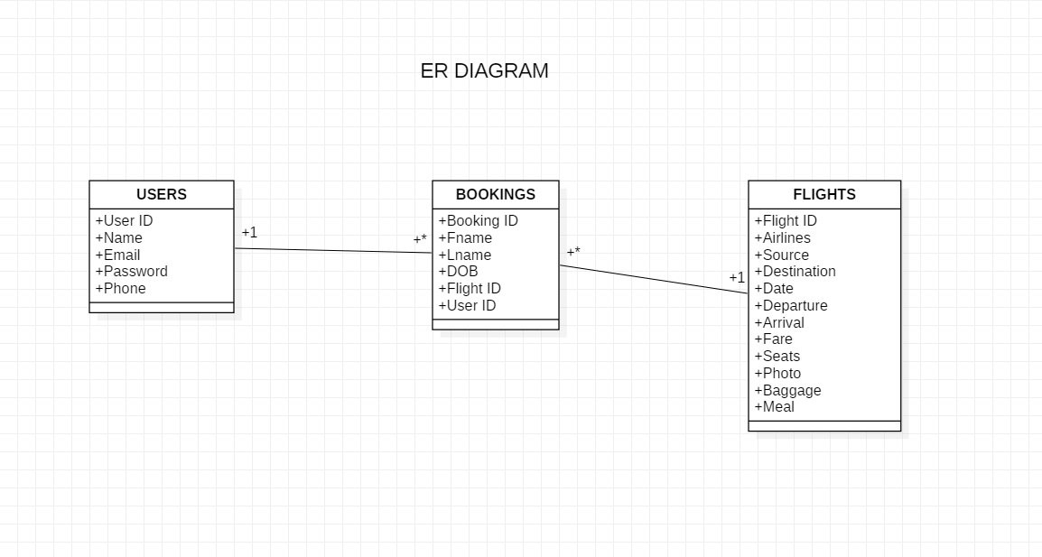

**Sequence Diagrams:**

**SIGN UP-**

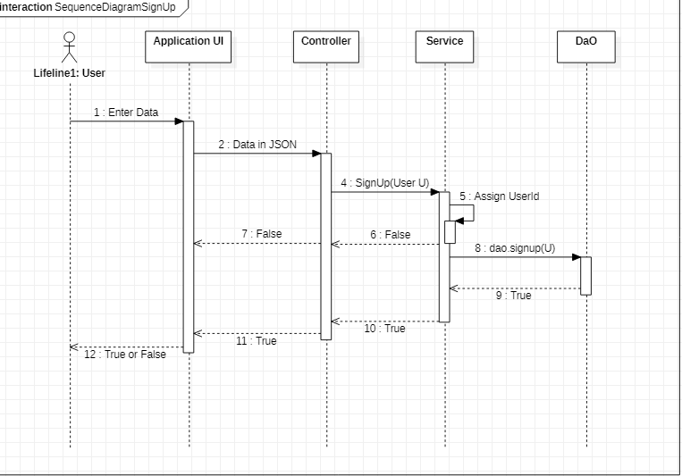

SIGN IN-

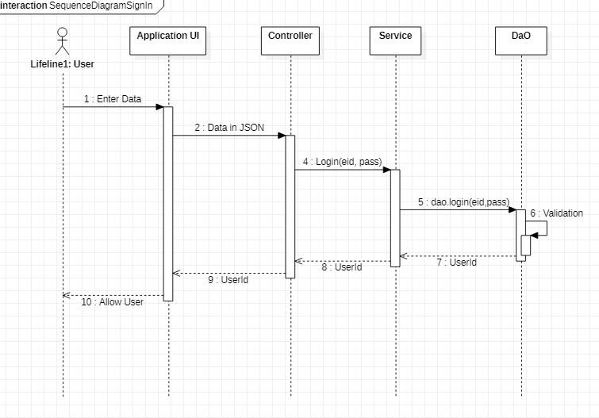

**Class Diagrams-**

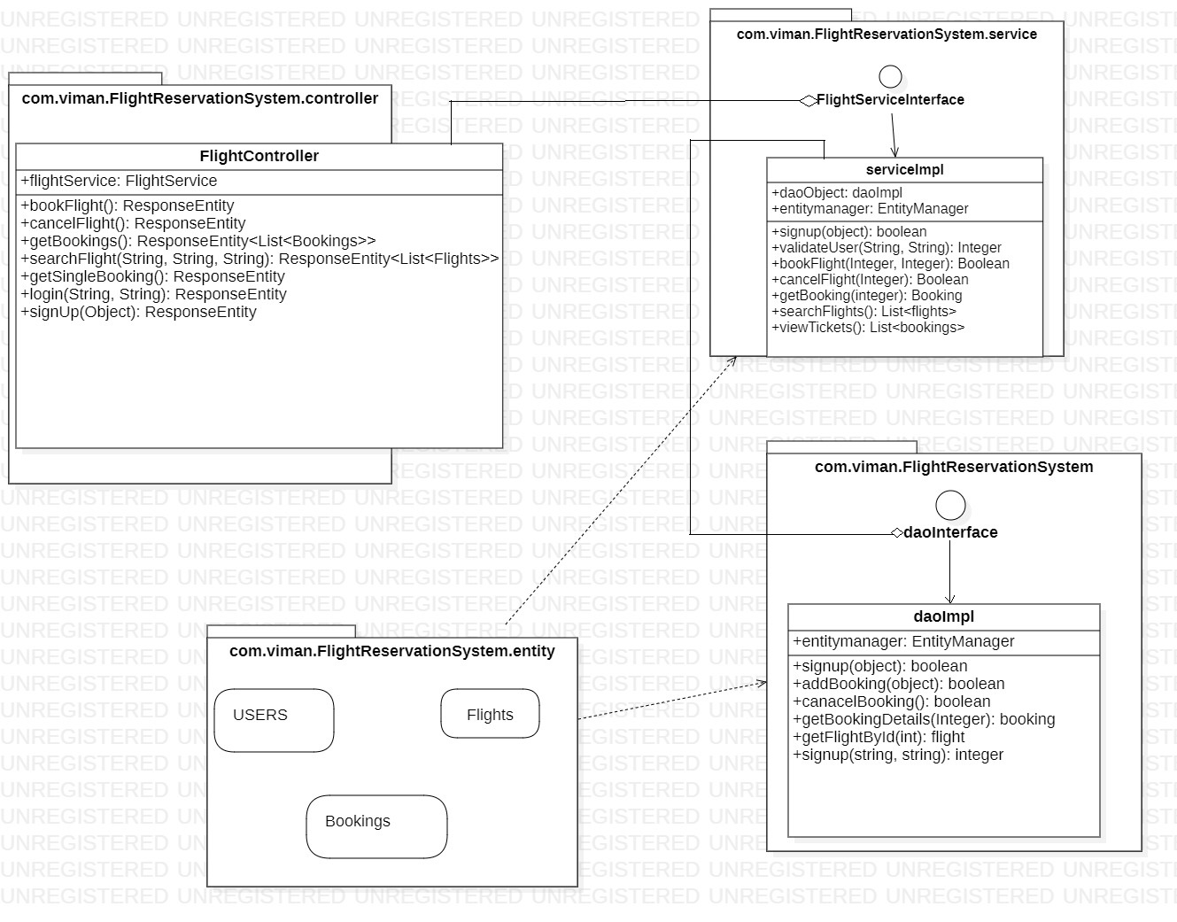

**Activity Diagrams-**

**SIGNUP-**

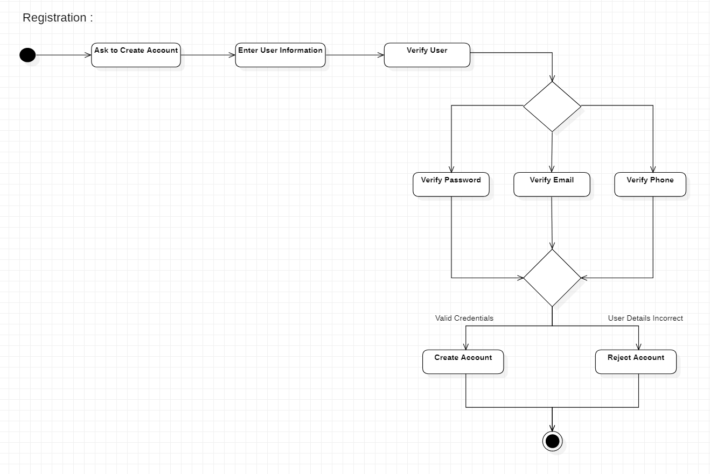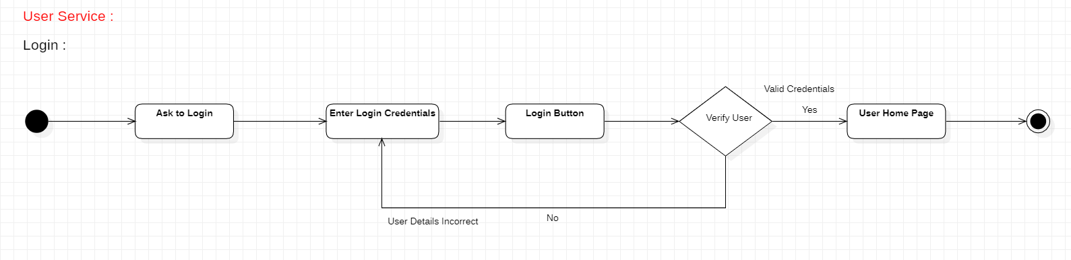

**LOGIN-**

**Wireframes-**

**SIGNUP-**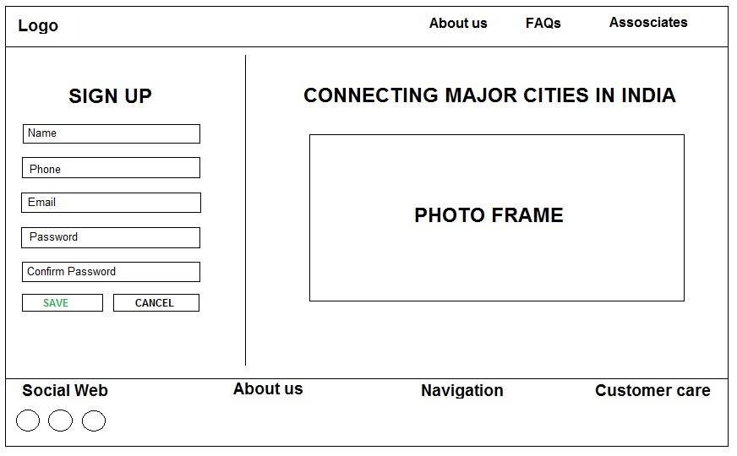

**LOGIN-**

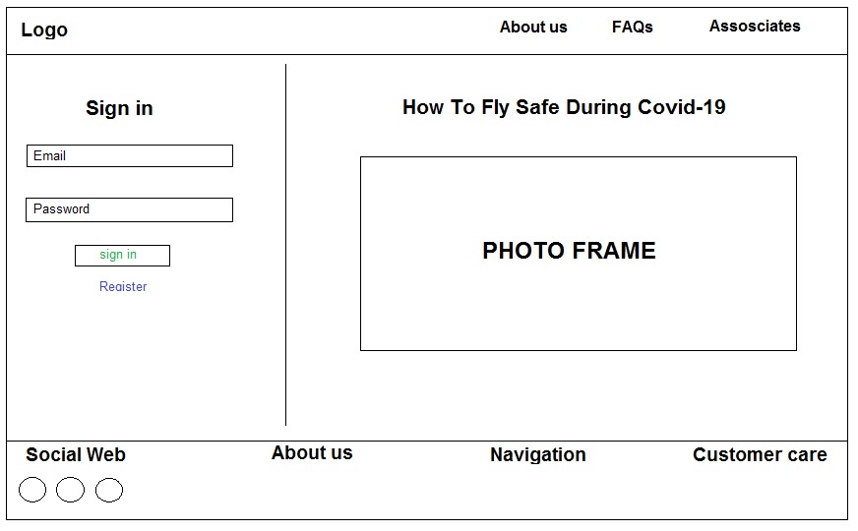

**SEARCH FLIGHT-**

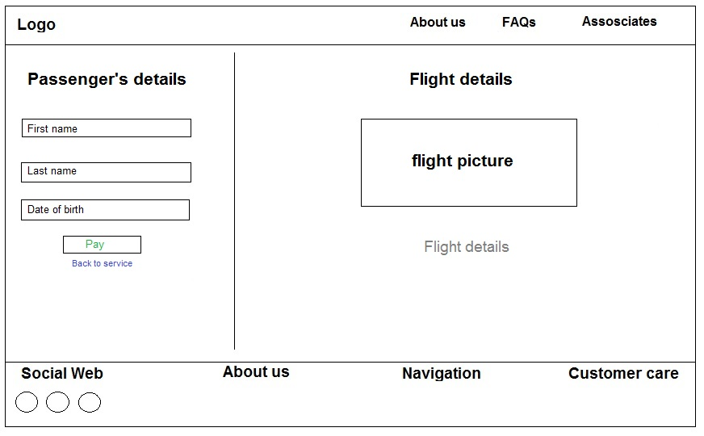

**VIEW FLIGHTS-**

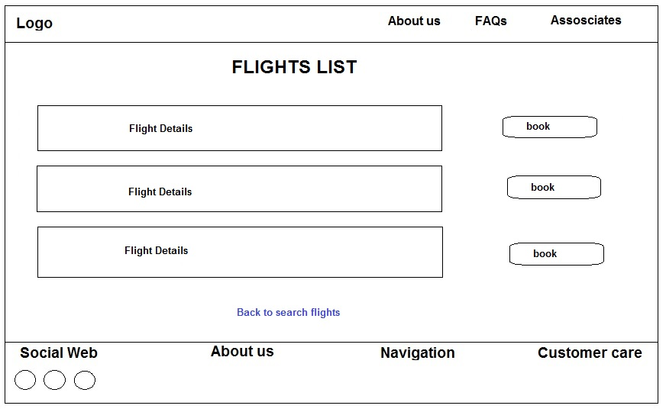

**PASSENGER DETAILS-**



**PAYMENT GATEWAY-**

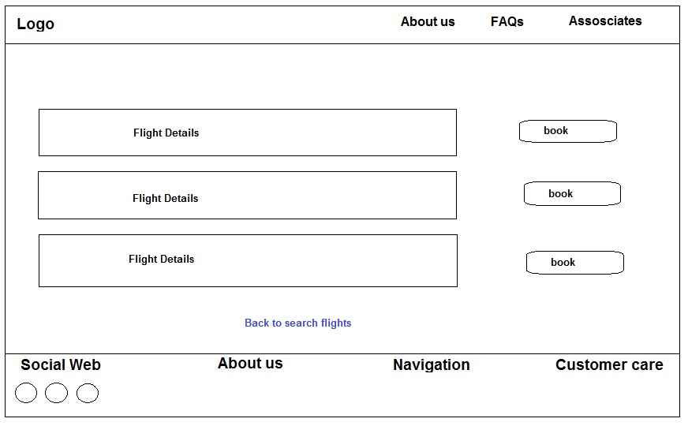

**VIEW BOOKINGS-**

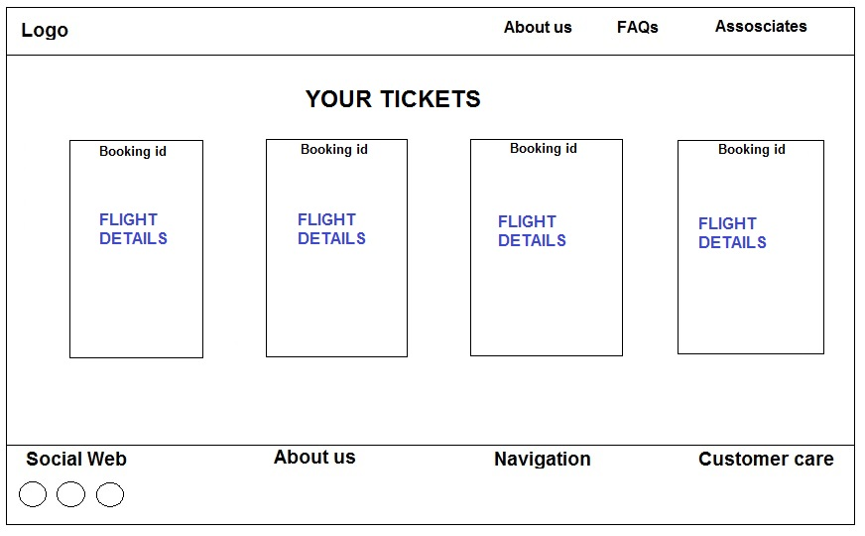

**CANCEL TICKETS-**

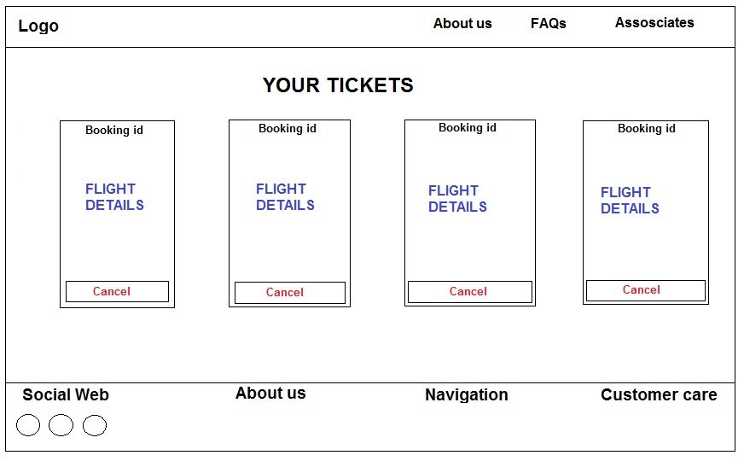

**FEEDBACK-**

