**PROCESS TO IMPORT CERTIFICATE**

**Step 1**: - Get the Software “**Kse-541**” from the below path: -

\\ftwdvnasci01\AIGDATA\Cloud Enablement_2021\TCS-AIG\POD 1\In Progress\3593-UW- NextGenerationeStart\Softwares\Jks_Certs

**Step 2**: - Unzip the file

**Step 3:** - Open the unzip folder of kse-541.

**Step 4:** - Run the **kse.exe** but double clicking **kse.exe**.

**Step 5:** - Closed any prompt came for update or anything.

**Step 6:** - Click on “**Open an existing KeyStore**” and browse to “**$JDK_Directory**\**jdk-11.0.12+1\lib\security**”.

**Step 7:** - open “**cacerts**”.

**Step 8:** - Enter the password “**changeit**”.

**Step 9:** - Click on “**Tools 🡪 Import Trusted Certificate**”

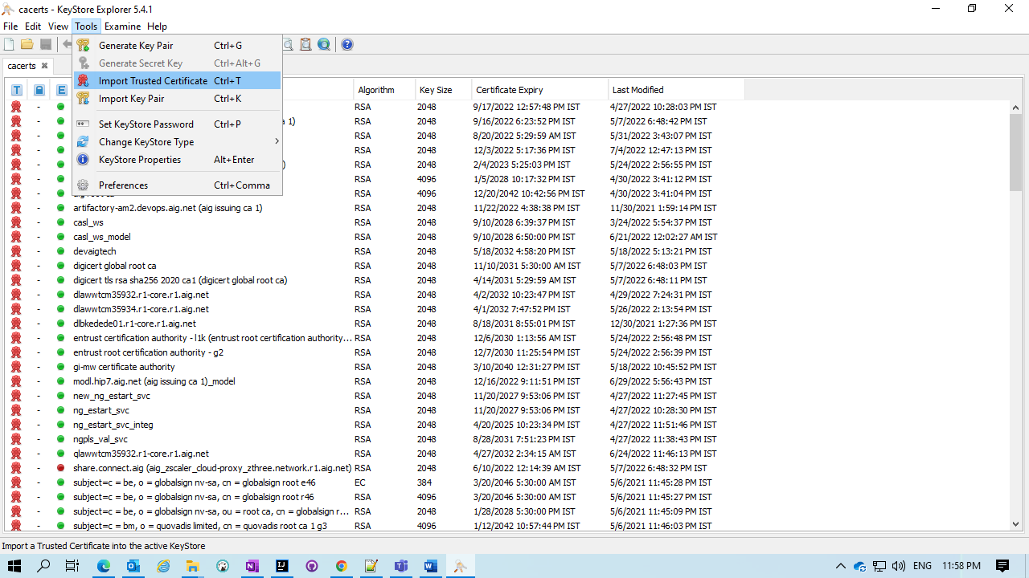

**Step 10:** - Browse the certificate you want to Import.

**Step 11:** - Change the certificate name if you want to change.

**Step 12:** - click oK.