**Workspace Setup document**

**Source code Repo** : <https://github.aig.net/commercial-it-common/uw-next-generation-estart-ui-3593/tree/Release-3.0.0-0527>

**NGE UI Property file**: [common-lob-non-prod/uw-next-generation-estart-ui-3593 at master · commercial-it-config/common-lob-non-prod (aig.net)](https://github.aig.net/commercial-it-config/common-lob-non-prod/tree/master/uw-next-generation-estart-ui-3593)

**Steps to build EAR/WAR:**

**Intellij**

1. Download and install latest version of IntelliJ IDE.
   1. You can download the community version from the below URL.

<https://www.jetbrains.com/idea/download/#section=windows>

* 1. You can get the zip file from the below path: -

\\ftwdvnasci01\AIGDATA\Cloud Enablement_2021\TCS-AIG\POD 1\In Progress\3593-UW-NextGenerationeStart\Softwares\IDE

1. Download the source code (Zip file) from git repo.
2. Create a workspace folder in Window Explorer and unzip the source code.
3. Open IntelliJ
4. Import the Gradle project via the below path
   1. File 🡪 Open 🡪 Browser the project 🡪 Import

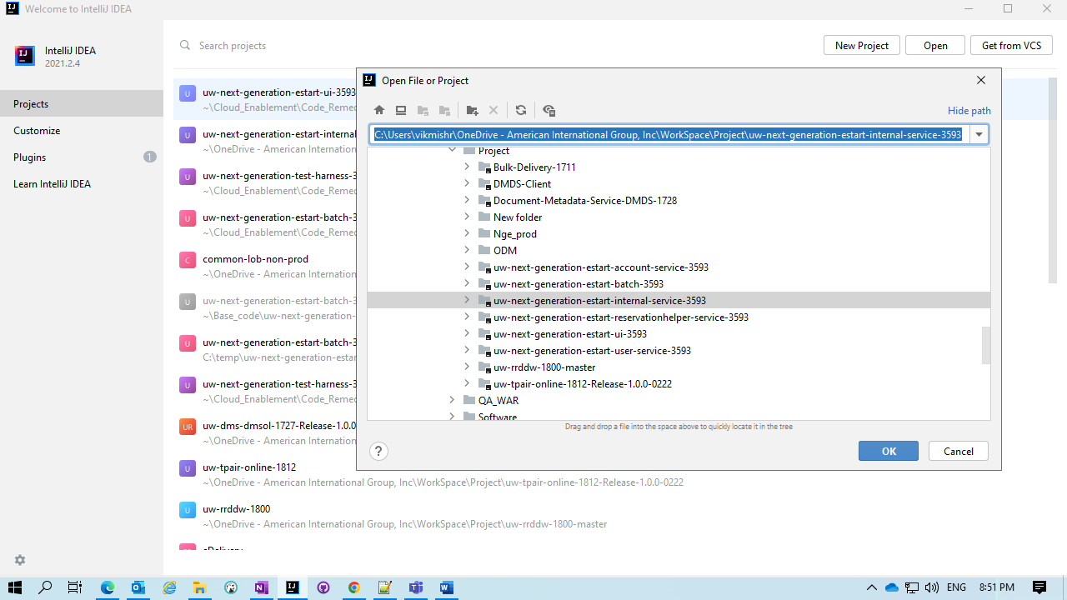

1. Set the java version as 11.

Get the JDK 11 from below mentioned Path: -

\\ftwdvnasci01\AIGDATA\Cloud Enablement_2021\TCS-AIG\POD 1\In Progress\3593-UW-NextGenerationeStart\Softwares\JDK

* 1. File 🡪 Project Structure 🡪 Project setting 🡪 Project 🡪 Project SDK 🡪 Browser your JDK 11 🡪 select 🡪 apply.

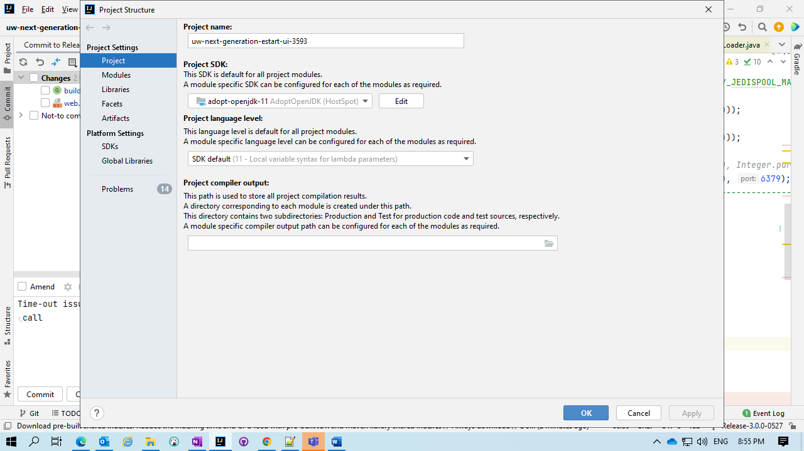

1. Set the Gradle JVM as Project JDK 11.
   1. File 🡪 setting 🡪 Build, Execution, Deployment 🡪 Build Tool 🡪 Gradle 🡪 Gradle JVM 🡪 select “**Project SDK**”.

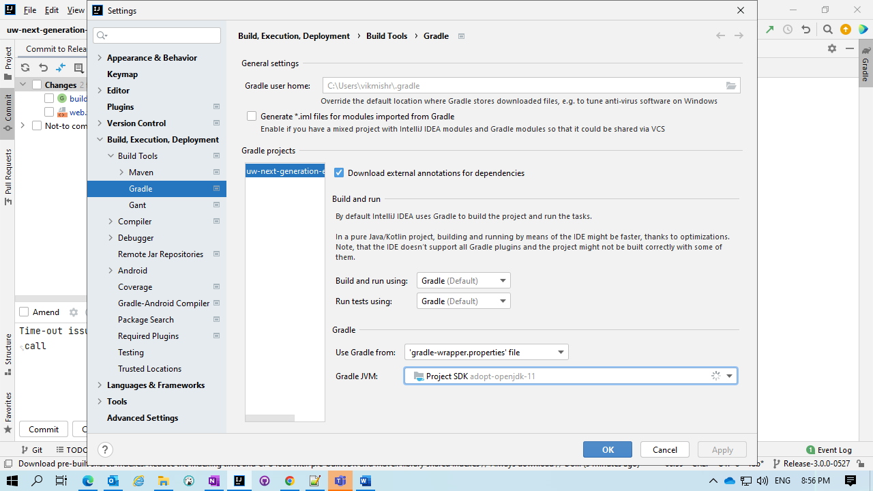

* **Adding the necessary certificates for the Project**
* Replace the below file to “**$Jdk_directory\jdk-11.0.12+1\lib\security**”.



* If still any certificate missed to ADD use the below doc to ADD the certificate the “**cacerts**” file.

\\ftwdvnasci01\AIGDATA\Cloud Enablement_2021\TCS-AIG\POD 1\In Progress\3593-UW-NextGenerationeStart\Handover Documents\Helping_Docs\ProcessToCertificateImport.docx

1. Add the below file to “**uw-next-generation-estart-ui-3593\src\main\resources\metadata\<Environment/Region>**” project location.

* For local setup please do create a local folder under “**uw-next-generation-estart-ui-3593\src\main\resources\metadata\**” and place the below file under “**uw-next-generation-estart-ui-3593\src\main\resources\metadata\local**”



1. Refresh Gradle
2. Select the project and click ctrl key twice .Run prompt will open. Now type command gradlew clean build.
3. Once the build is successful, **target** folder would be created. WAR would be created in project workspace \target\archives folder.

**Installation: Install and configure apache-tomee-8.0.7-plus**

*Note 1: - edit the “****apache-tomee-plus-8.0.7\conf\tomee.xml****”*

Change “**<!-- <Deployments dir="apps" /> -->**”to “ **<Deployments dir="apps" />** “

Create a “**apps**” folder under “$**tomcat_installation_dir**”.

* **Start the Redis Server**
  1. Get the Redis software from the below mentioned path.

\\ftwdvnasci01\AIGDATA\Cloud Enablement_2021\TCS-AIG\POD 1\In Progress\3593-UW-NextGenerationeStart\Softwares\Redis_Server

* 1. Copy the file to your system and unzip it.
  2. Go inside “**redis-2.4.5-win32-win64\64bit**” folder
  3. Start the Redis by double clicking the “**redis-server.exe**”.
* **Manual Process - Deployment of application WAR in Tomee Server**

1. war copy: Navigate to $tomcat_installation_dir\apps and place the WAR
2. Make sure you have created setenv.bat in $tomcat_installation_dir\bin with all environment variables declared in them.
3. The environment Variables mentioned below need to be added in setenv.bat:

**set APPLICATION_NAME=** **uw-next-generation-estart-ui-3593 set CONFIG_SERVER_URL=https://springcloudconfignonprod.apps.nprd-pcf.aig.net**

**set ENCRYPT_KEY=nonprodencryptkey**

**set ENVIRONMENT_NAME=local**

**set JAVA_OPTS=%JAVA_OPTS% -Dpath=C:/Softwares/apache-tomee-8.0.7-plus_acc/apache-tomee-plus-8.0.7/apps/estart**

**set JAVA_OPTS=%JAVA_OPTS% -Dlogs=C:/temp/logs**

1. Start Server: Navigate to **$tomcat_installation_dir\bin** directory.Double click startup.bat file.

* **Validate on browser by hitting below URL…**

<http://localhost:8080/ngestart/>

* **For Automated process follow the below steps: -**
  + 1. Add the below mentioned “**custom-task. gradle**” file to the project.



* + 1. Edit the below mentioned highlighted details: -

task tomee () {

TOMCAT_HOME = “**$tomee_installation_dir** /apache-tomee-plus-8.0.7/'

DEPLOYMENT_DIR = 'apps/'

DEPLOYABLE_TYPE = 'war'

}

* + 1. Add “**apply from: 'custom-task.gradle'**” in build.gradle file.If this line is commented, uncomment this line .please do not check-in this.
* **Commands for automated process: -**

1. **gradlew clean tomee automate**: - command when you made any changes to code and start the server .
2. **gradlew start tomee: -** Command for just start the tomee server.
3. **gradlew compileJava: -** Command to compile the java files.
4. **gradlew clean build: -** Command to build a new clean war file.

*Note 1: - Remove SAML Related Jars (13 jars) from TomEE lib folder mentioned below.*

**List of SAML jars to remove: -**

opensaml-core-3.4.6.jar

opensaml-profile-api-3.4.6.jar

opensaml-saml-api-3.4.6.jar

opensaml-saml-impl-3.4.6.jar

opensaml-security-api-3.4.6.jar

opensaml-security-impl-3.4.6.jar

opensaml-soap-api-3.4.6.jar

opensaml-xacml-api-3.4.6.jar

opensaml-xacml-impl-3.4.6.jar

opensaml-xacml-saml-api-3.4.6.jar

opensaml-xacml-saml-impl-3.4.6.jar

opensaml-xmlsec-api-3.4.6.jar

opensaml-xmlsec-impl-3.4.6.jar

*Note 2: - please edit the “****apache-tomee-plus-8.0.7\conf\tomee.xml****”*

Change “**<!-- <Deployments dir="apps" /> -->**”to “ **<Deployments dir="apps" />** “

*Note 3: - To enable Debug to check the below document: -*

\\ftwdvnasci01\AIGDATA\Cloud Enablement_2021\TCS-AIG\POD 1\In Progress\3593-UW-NextGenerationeStart\Handover Documents\Helping_Docs\ProcessTo EnableDebug.docx