Experiment – 10:
Zero-State and Zero-Input Response, Impulse Response and Convolution
(i) To distinguish the responses produced by initial stored energy and external excitation, obtain the impulse response of a continuous-time LTI system, and verify that the total response is the sum of the zero-input and zero-state responses, with the zero-state response also obtained through convolution.
Expected Outcomes
- Distinguish zero-input response from zero-state response for a continuous-time LTI system.
- Obtain and plot the impulse response using MATLAB.
- Evaluate the zero-state response using convolution.
- Verify the superposition relation between zero-input, zero-state and total responses.
Software / Laboratory Environment
MATLAB
Formulae / Analysis
System model: dy(t)/dt + 3y(t) = x(t), with y(0−) = 2 and x(t) = u(t).
Transfer function (zero initial conditions): H(s) = Y(s)/X(s) = 1/(s+3).
Impulse response: h(t) = e^(−3t)u(t).
Zero-state response: y_{zs}(t) = x(t) * h(t) = ∫₀^{t} e^(−3(t−τ)) dτ = (1/3)[1 − e^(−3t)]u(t).
Zero-input response (x(t) = 0): y_{zi}(t) = 2e^(−3t)u(t).
Total response: y(t) = y_{zi}(t) + y_{zs}(t) = 1/3 + (5/3)e^(−3t), t≥0.
The convolution result and the lsim zero-state response should agree within numerical tolerance.
Experimental Procedure
- Define the system dy(t)/dt + 3y(t) = x(t) and obtain H(s) under zero initial conditions.
- Display the transfer function and its pole in MATLAB.
- Plot the impulse response and identify its decay pattern.
- Obtain the zero-input response for y(0−) = 2 with x(t) = 0.
- Obtain the zero-state response to x(t) = u(t) with zero initial conditions.
- Compute the convolution of the unit-step input and the impulse response, and compare it with the lsim result.
- Add the zero-input and zero-state responses and verify the total response.

Key Conditions & Threshold Values for Analysis
- Use zero initial conditions for H(s) and the zero-state response.
- Use y(0−) = 2 only for the zero-input response and the total-response test.
- Use the same time vector for all plots to support comparison.
- The system pole is s = −3, so the natural response decays with time.
- The convolution result and the lsim response should agree within numerical tolerance.

MATLAB Coding
clc;
clear;
close all;
% Experiment 10: Zero-input, zero-state, impulse response and convolution
% System: dy(t)/dt + 3y(t) = x(t), y(0-) = 2, x(t) = u(t)
num = [1];
den = [1 3];
G = tf(num, den);
disp('Transfer function H(s):');
G
disp('Pole:');
disp(pole(G));
y0 = 2; % initial condition y(0-)
t = 0:0.01:4;
dt = t(2) - t(1);
h = exp(-3*t); % impulse response for t >= 0
xs = ones(size(t)); % unit-step input
% Impulse response
figure;
impulse(G, t);
grid on;
title('Impulse Response h(t)');
xlabel('Time (s)');
ylabel('h(t)');
% Zero-input response: y(0-) = 2, x(t) = 0
yzi = y0*exp(-3*t);
figure;
plot(t, yzi, 'LineWidth', 1.5);
grid on;
title('Zero-Input Response');
xlabel('Time (s)');
ylabel('y_{zi}(t)');
% Zero-state response to unit step (zero initial conditions)
[yzs, tout] = step(G, t);
yzs = yzs(:).';
figure;
plot(tout, yzs, 'LineWidth', 1.5);
grid on;
title('Zero-State Response to Unit Step');
xlabel('Time (s)');
ylabel('y_{zs}(t)');
% Convolution: y_zs(t) = integral of x(tau)h(t-tau) d(tau)
yc = conv(xs, h)*dt;
yc = yc(1:length(t));
yc = yc - (dt/2)*(xs(1)*h + h(1)*xs); % trapezoidal correction
% Total response
ytot = yzi + yzs;
figure;
plot(t, yzi, t, yzs, t, ytot, 'LineWidth', 1.3);
grid on;
legend('Zero-input', 'Zero-state', 'Total response', 'Location', 'best');
title('Comparison of Response Components');
xlabel('Time (s)');
ylabel('Response');
% Compare convolution with lsim
ylsim = lsim(G, xs, t);
figure;
plot(t, yc, '--', t, ylsim(:).', '-');
grid on;
legend('Convolution approximation', 'lsim zero-state response', 'Location', 'best');
title('Convolution Verification');
xlabel('Time (s)');
ylabel('y_{zs}(t)');
fprintf('Max error (conv vs lsim) = %.2e\n', max(abs(yc - ylsim(:).')));
OUTPUT
Impulse response
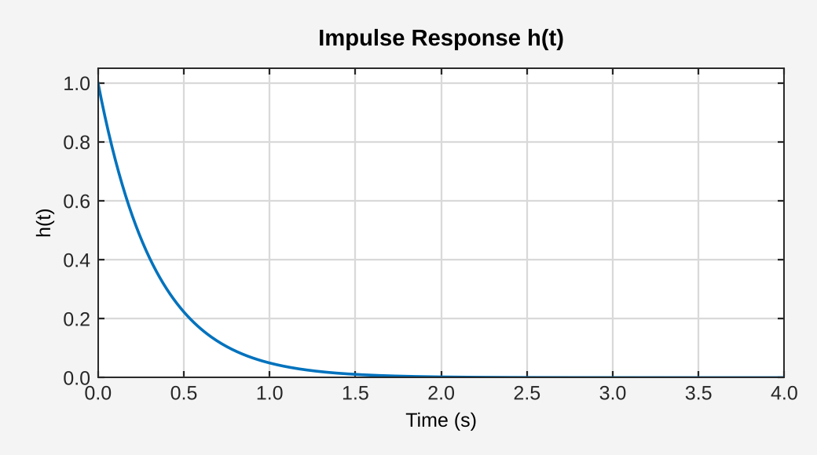
Zero-input response
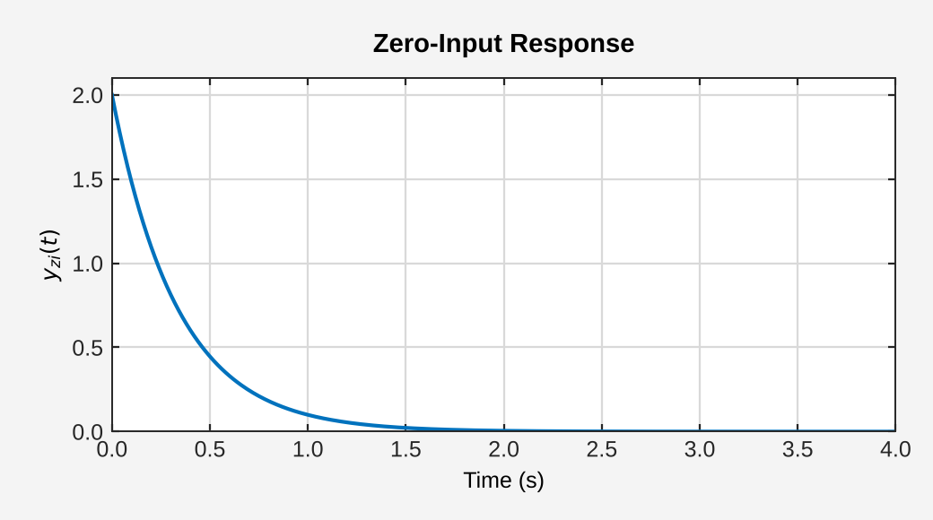
Zero-state response
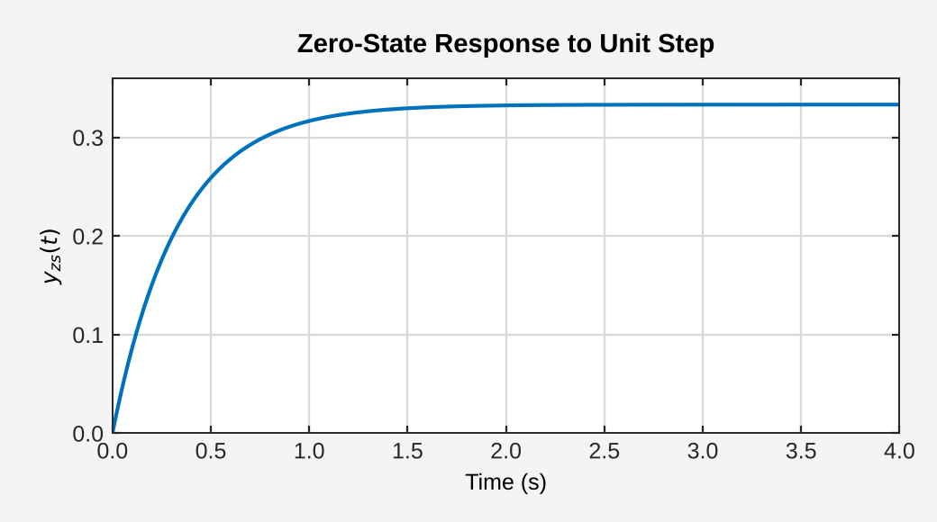
Response-component comparison
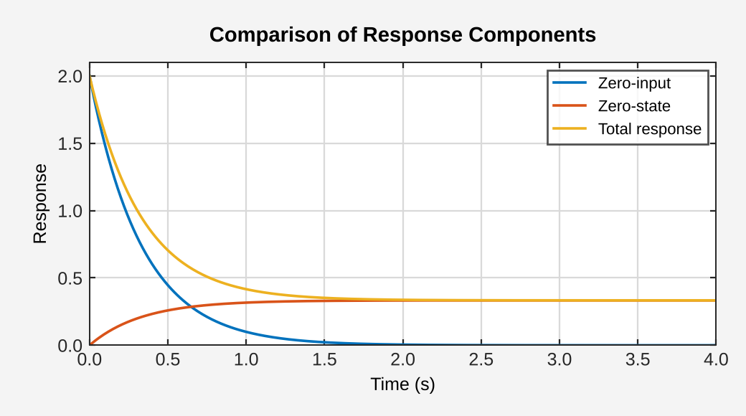
Convolution verification
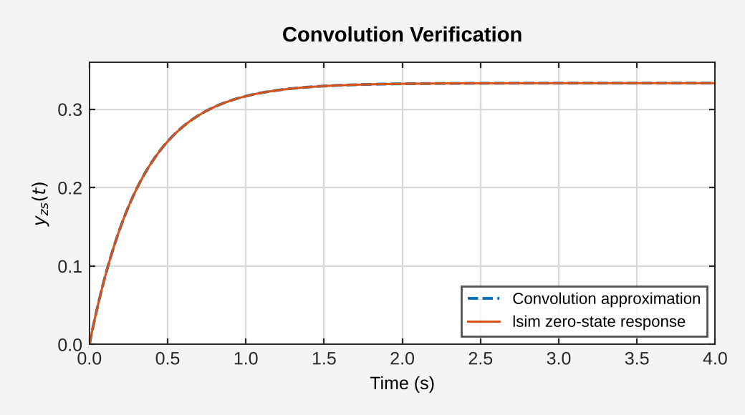
Result:
The zero-input, zero-state, impulse and total responses of the continuous-time LTI system dy(t)/dt + 3y(t) = x(t) were analyzed using MATLAB. The zero-input response 2e^(−3t) decays to zero, the zero-state step response rises to 1/3, and the total response, equal to their sum, starts at y(0) = 2 and settles at 1/3. The convolution result matched the lsim zero-state response with a maximum error of the order of 10⁻⁵, which verifies the superposition relation.

