Starting Apache solr server:-

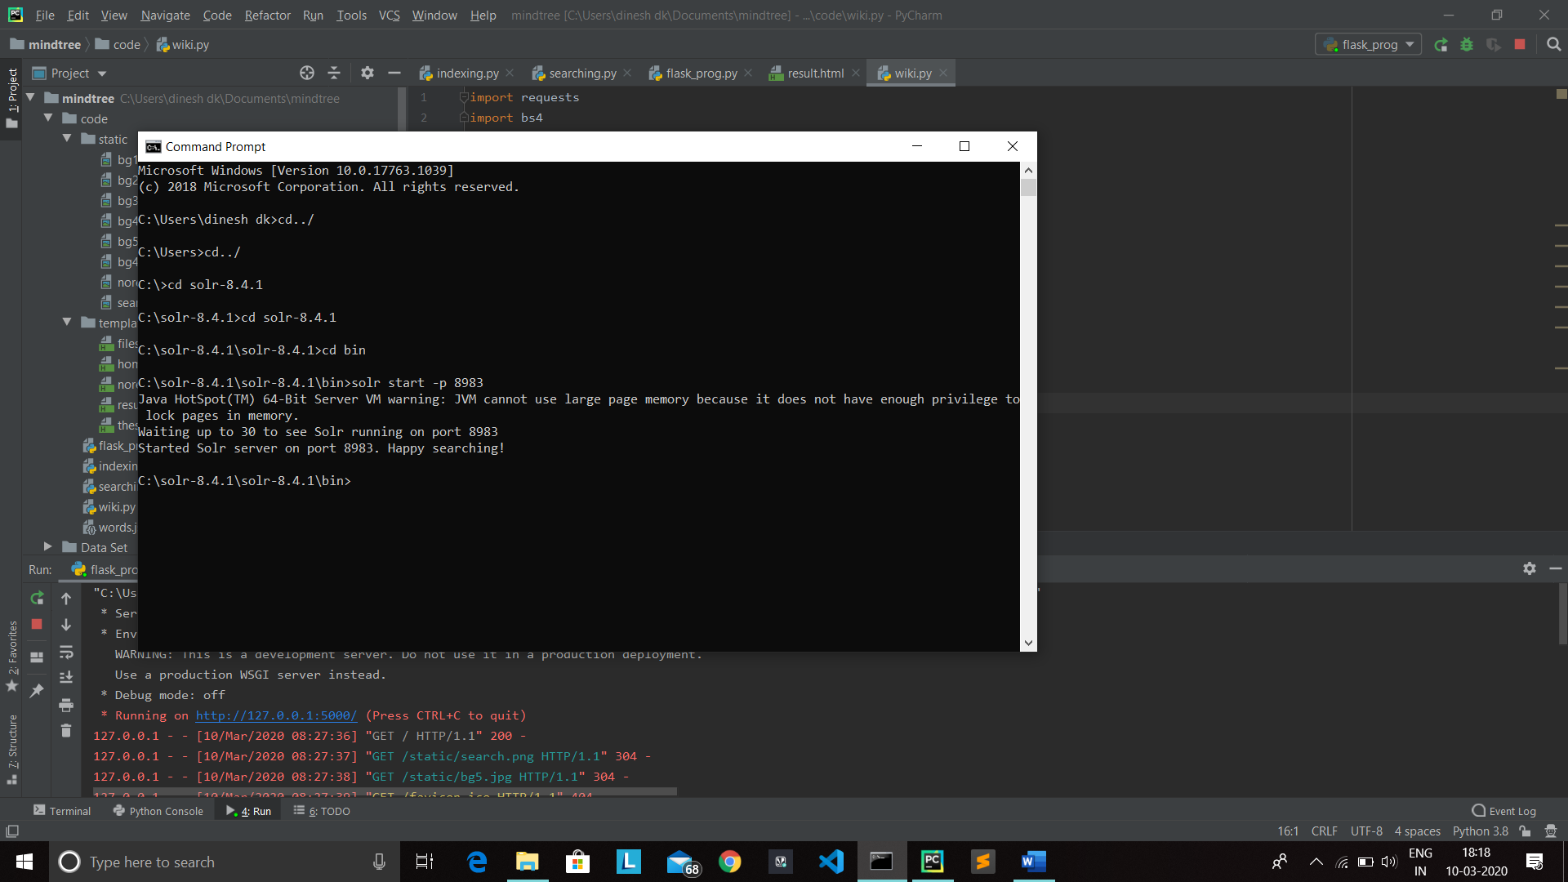

Run the Flask program

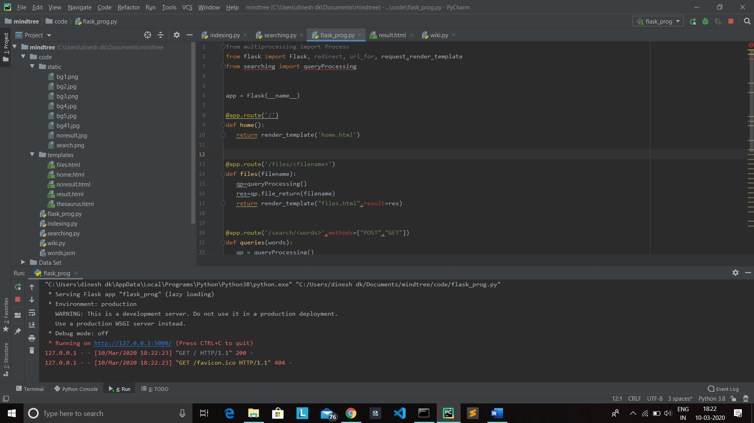

Open browser and Type url (<http://127.0.0.1:5000/>) Home page of search engine will appear.Search whatever you want in the input field and click search.Results related to your query will be displayed.

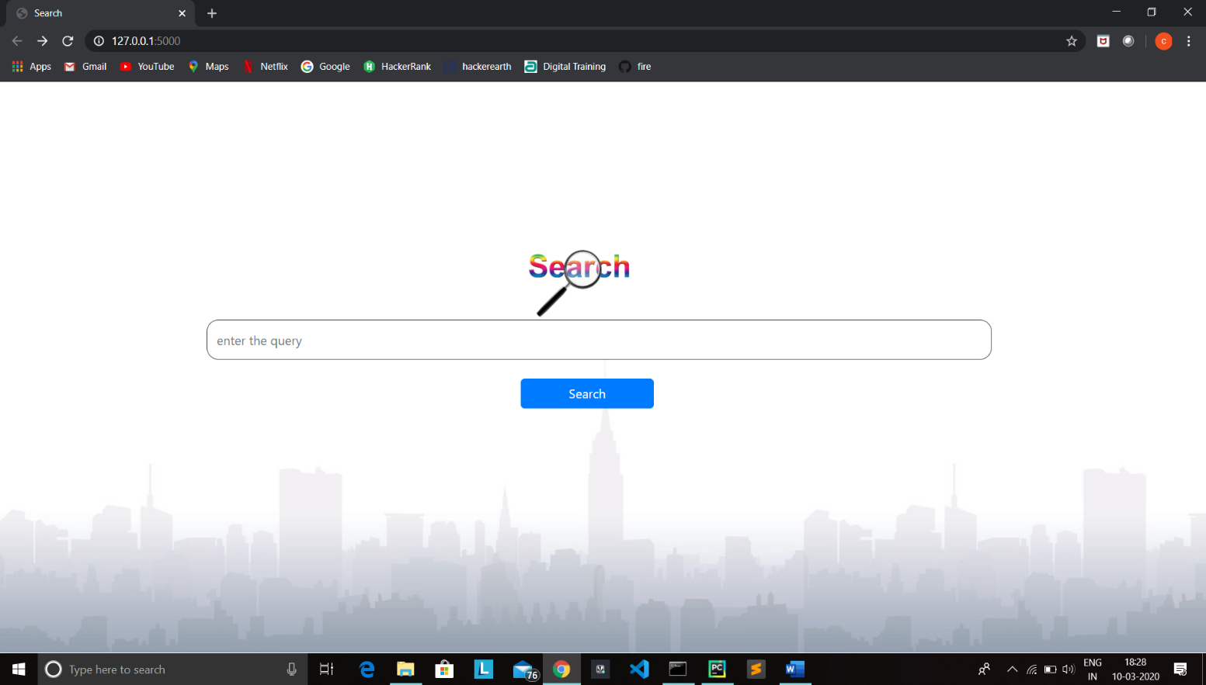

When you search for the word ‘BUBBLERS’, results related to that will be displayed.

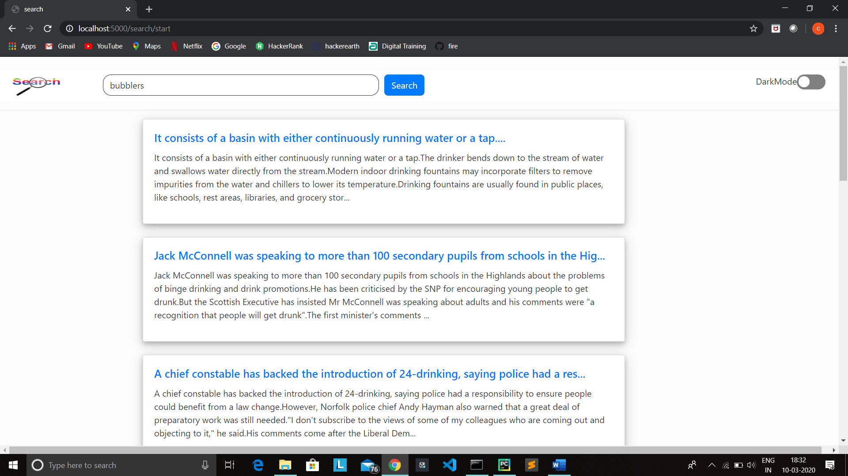

Here the first result shown for ‘BUBBLER’ actually does not contain the word bubbler.While searching program not only search for keywords entered by user it also find the meaning for the query include thesaurus words for the query and consider the thesaurus words also as searching parameter.

Drinking fountain,Water fountain are the thesaurus words for bubblers.So the program take those words as searching parameter.See the file does not contain the word ‘BUBBLER’ but it has “DRINKING FOUNTAIN”.

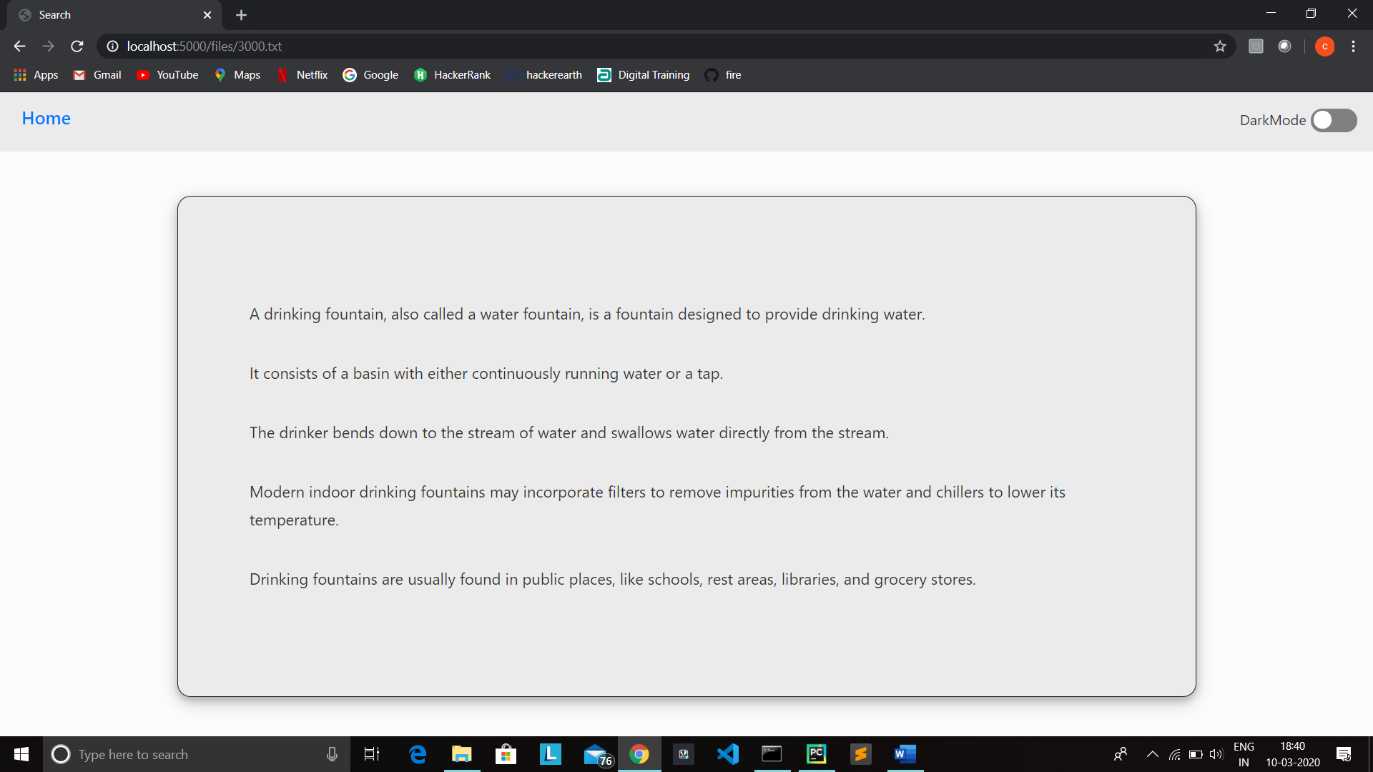

Searching parameters for word BUBBLER.

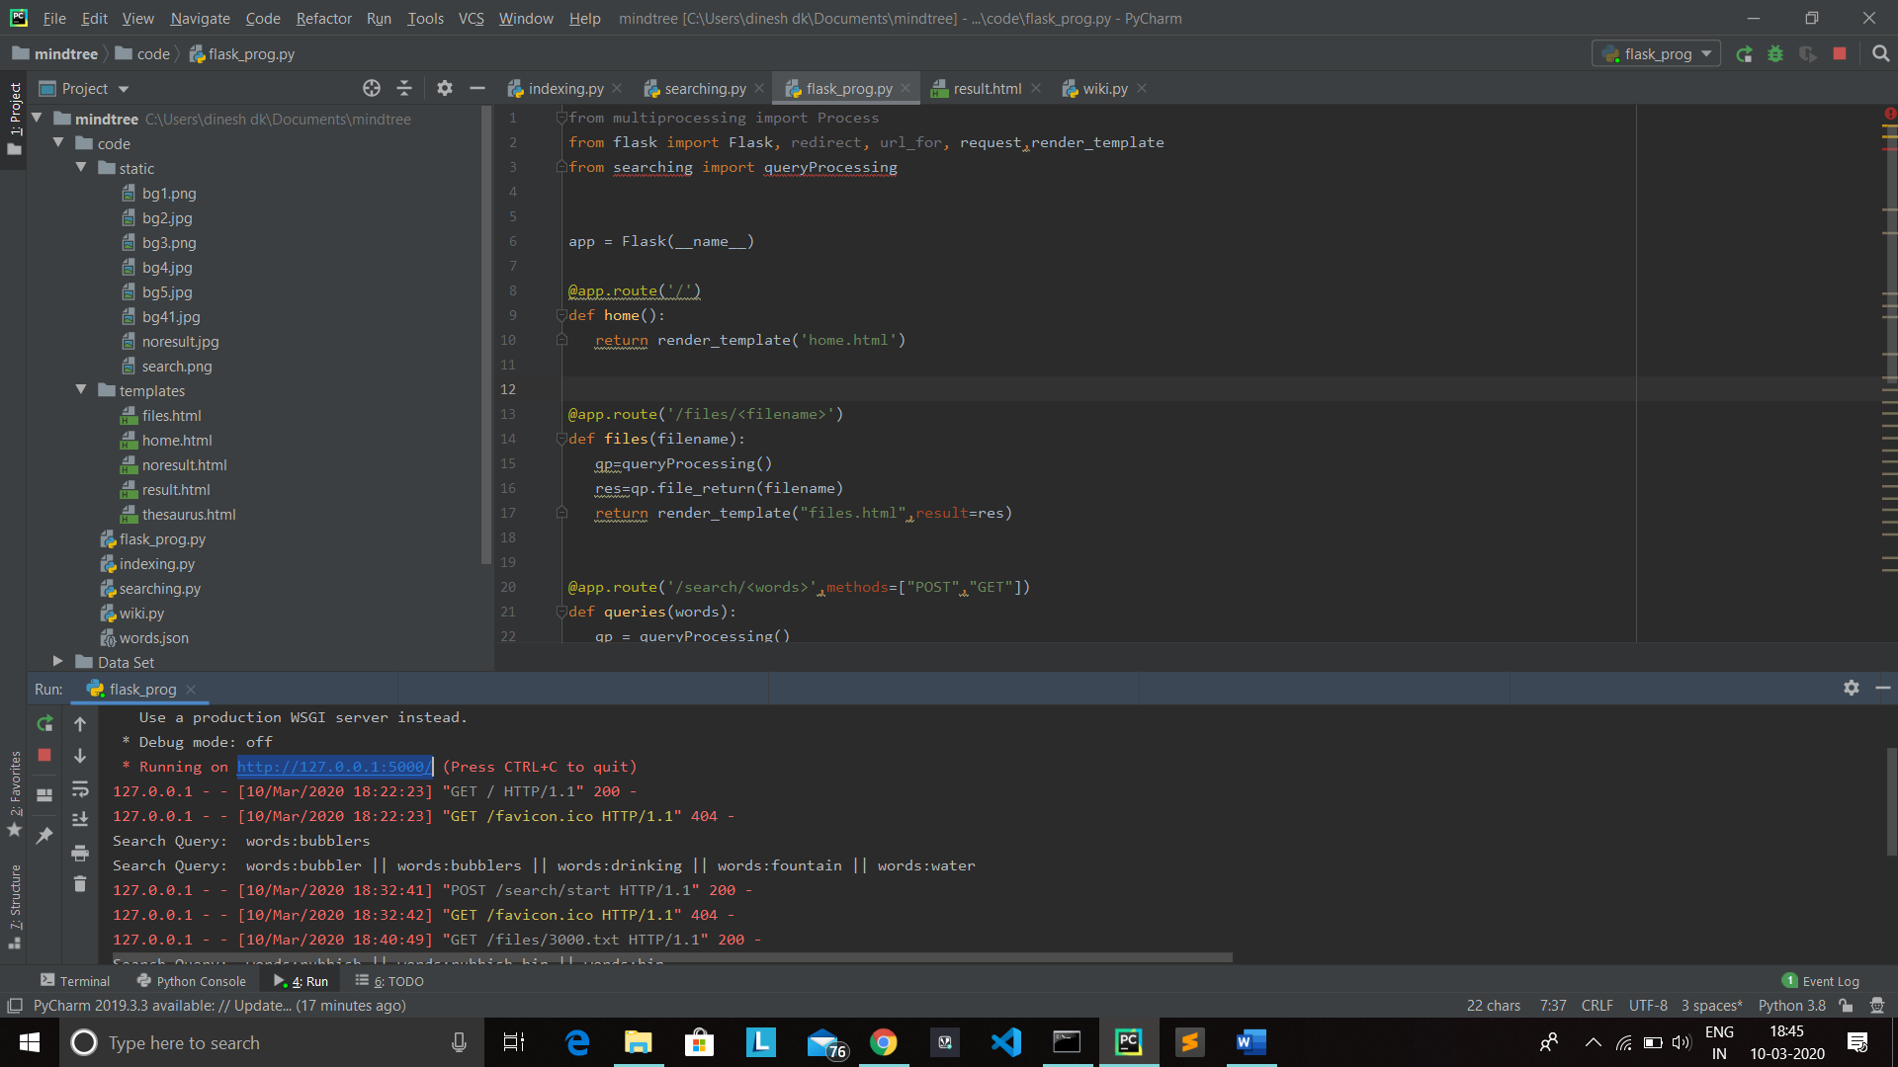

So we have successfully combined semantic search features and thesaurus.

For query “GARBAGE BIN”

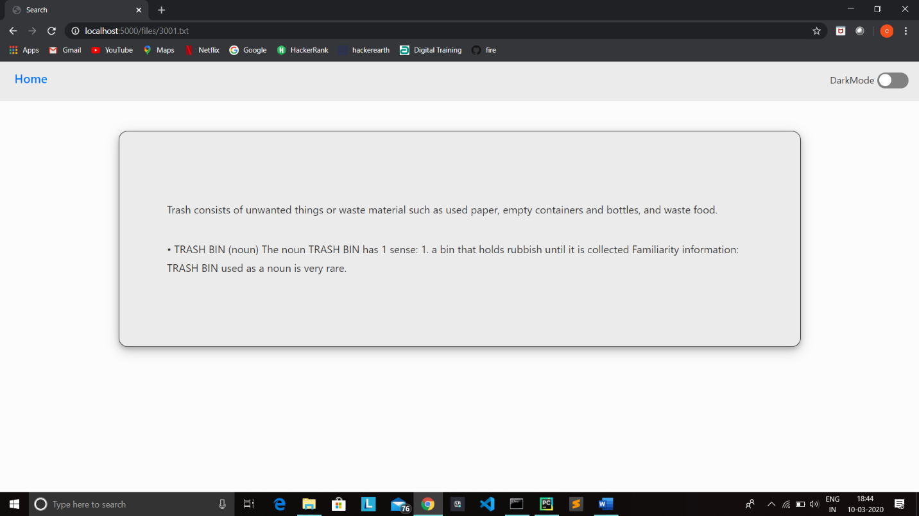

Search parameters for ‘GARBAGE BIN’

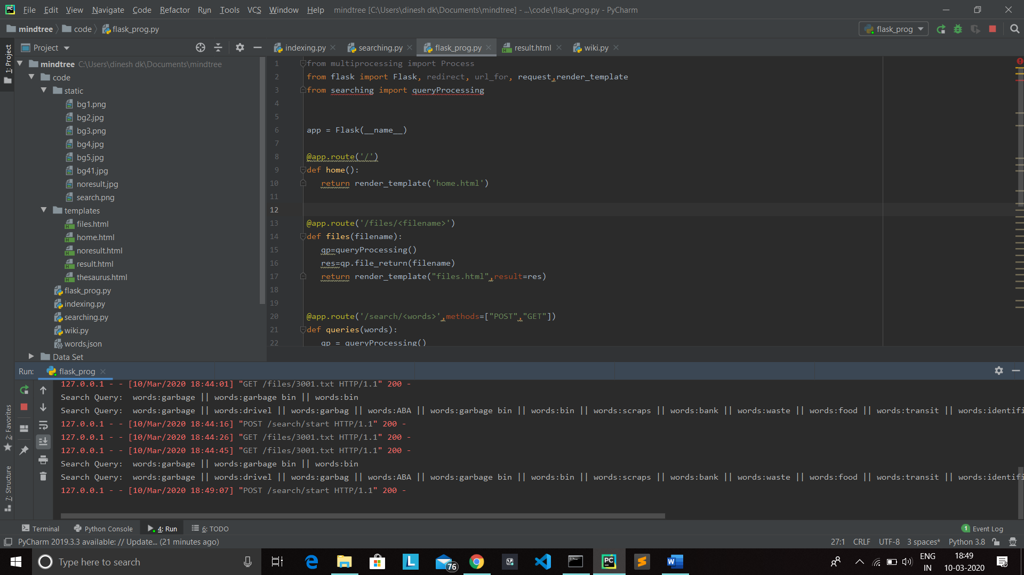

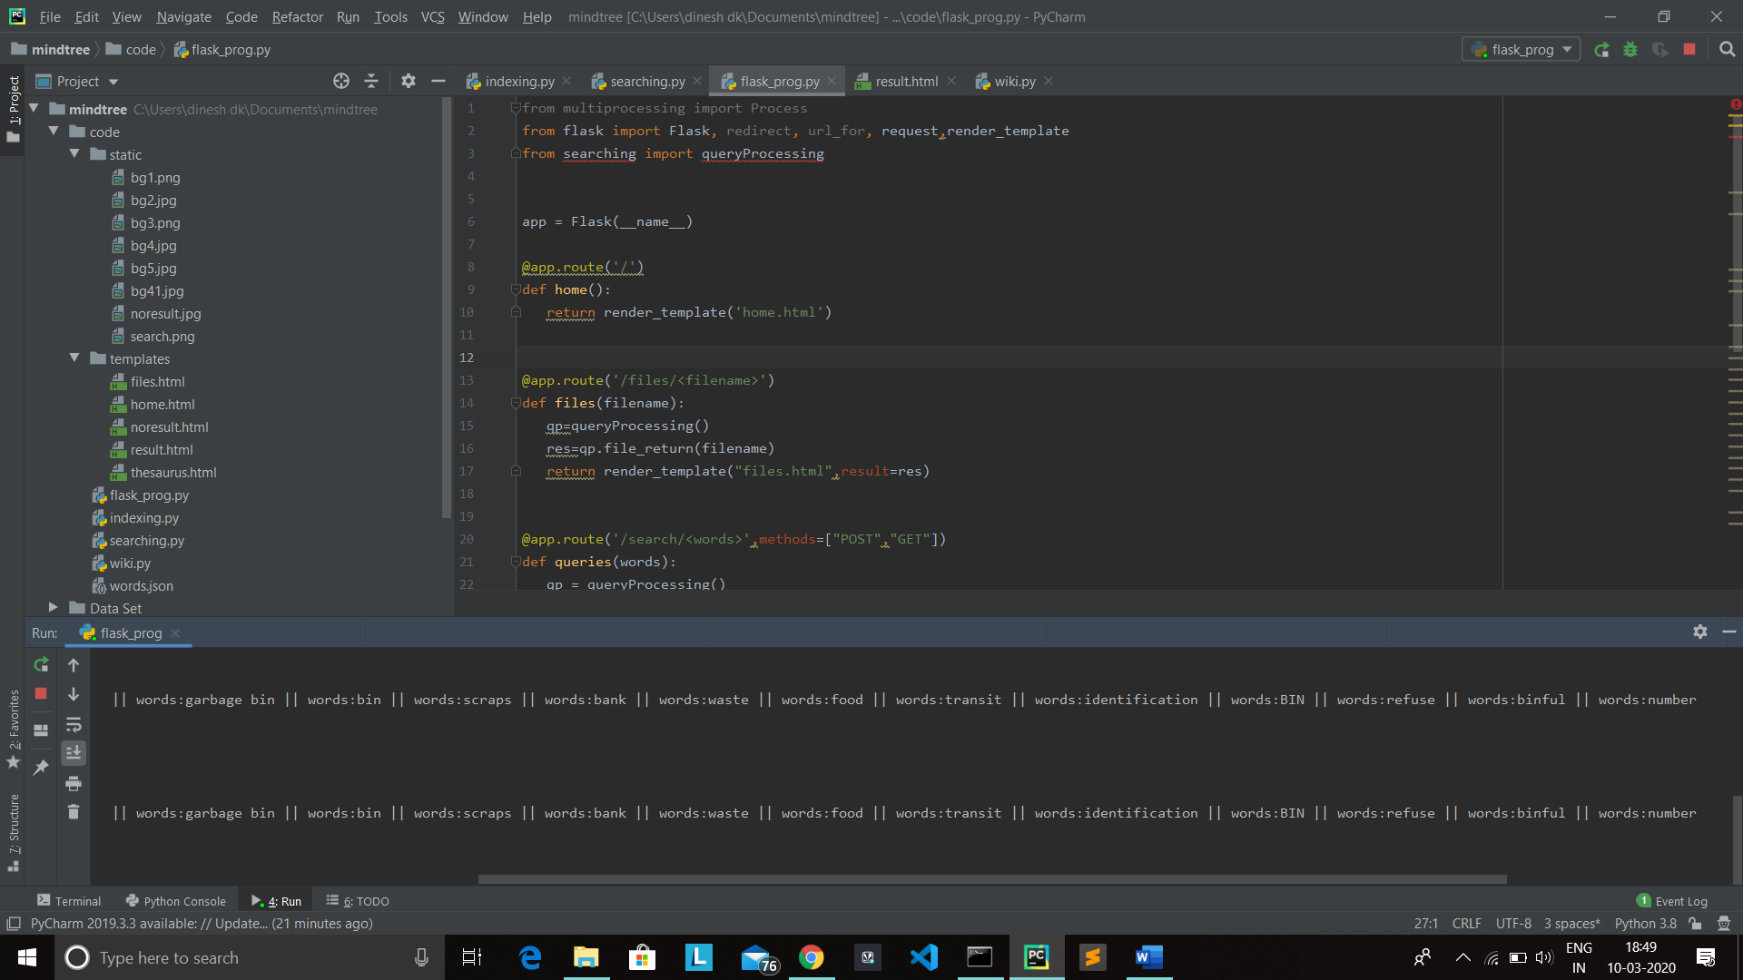

Search engine also shows words related to the user search query.When you search for ‘GARBAGE BIN’ It shows some suggestions like ‘ASHCAN’ , ‘RECYCLING BIN’ etc..The leftmost side of the browser are the suggestions related to given query.

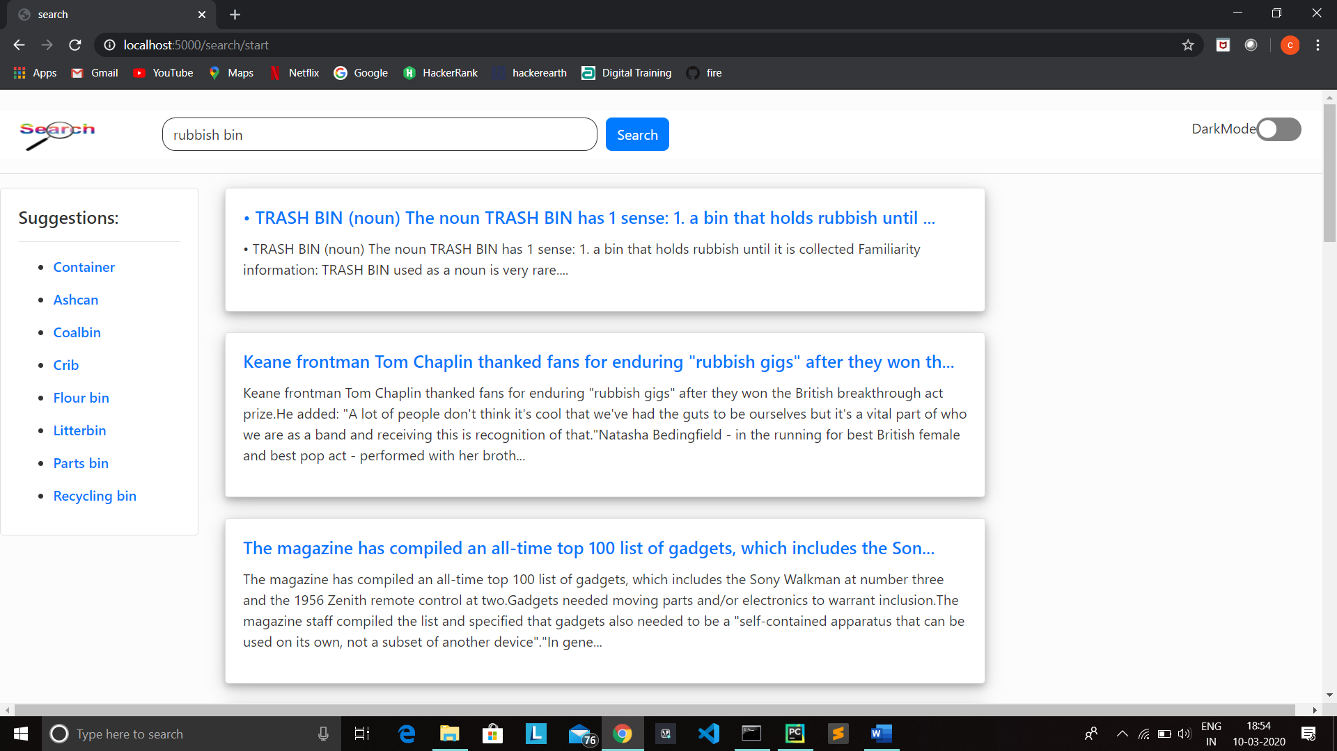



For query ‘DOG’

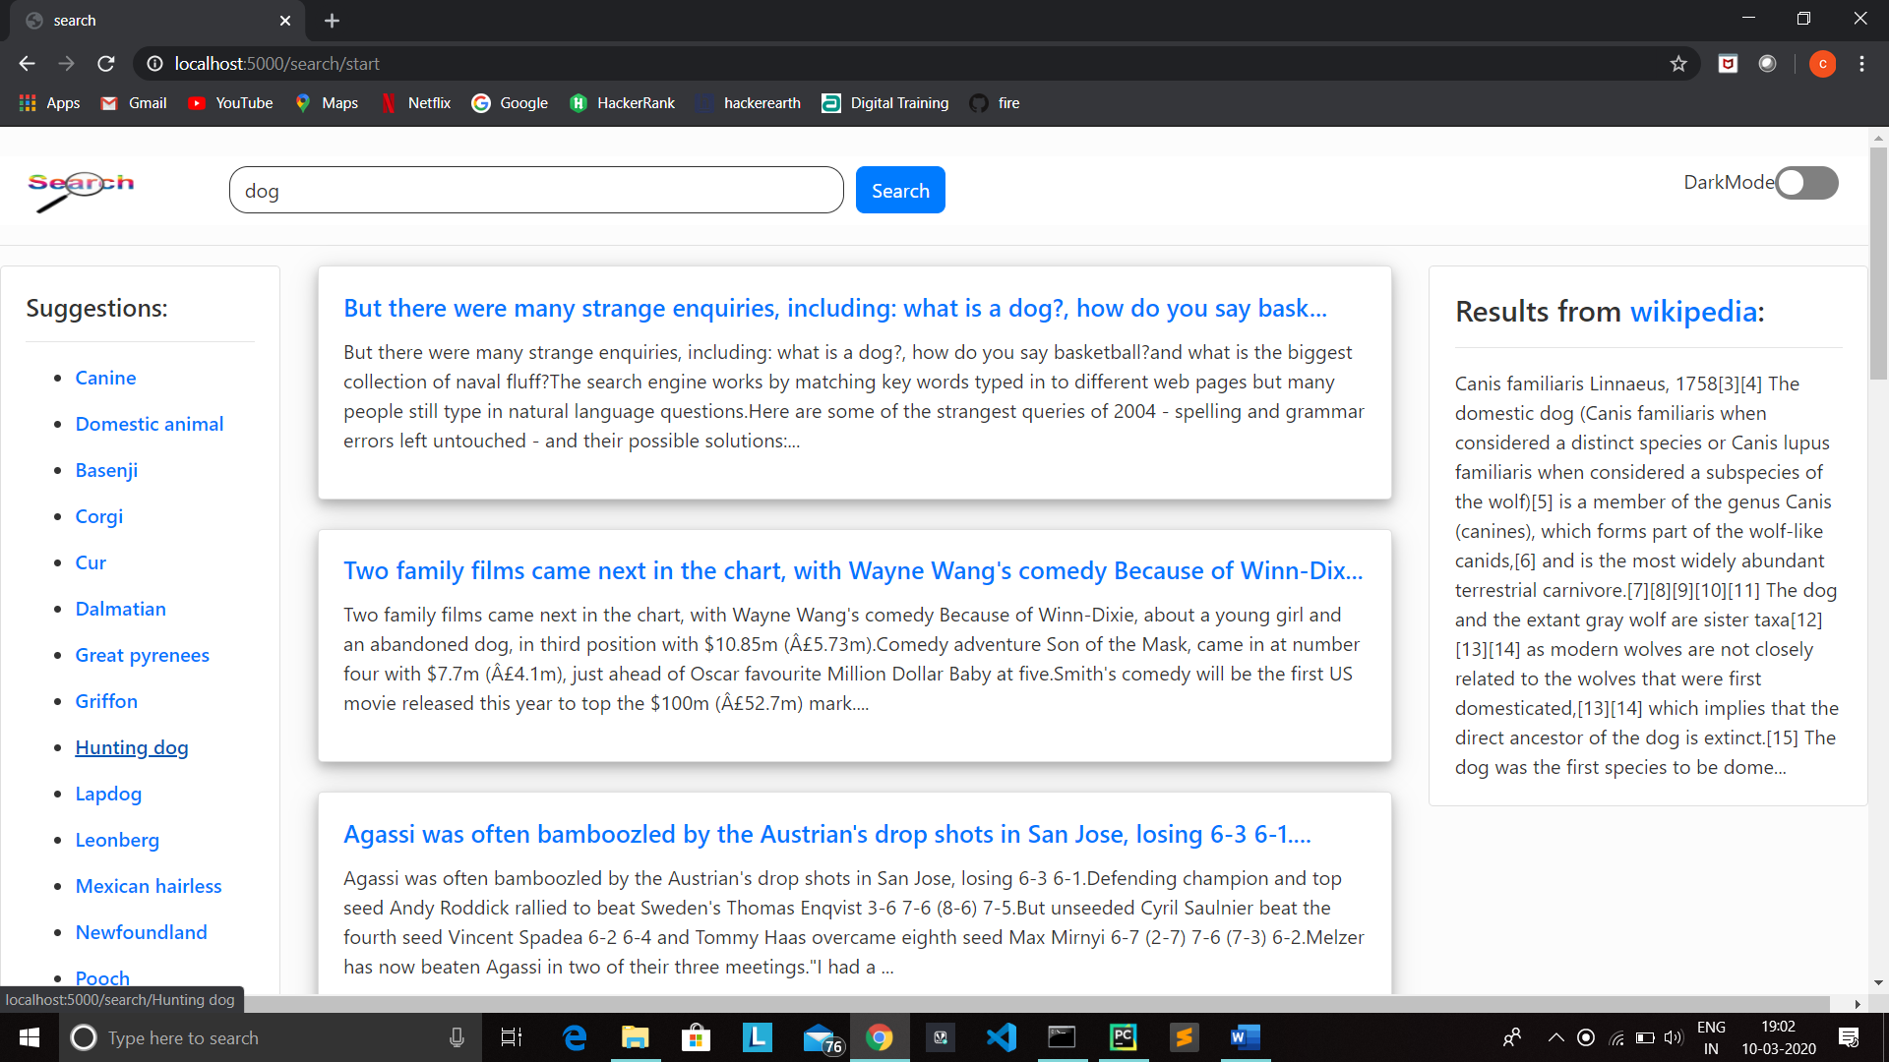

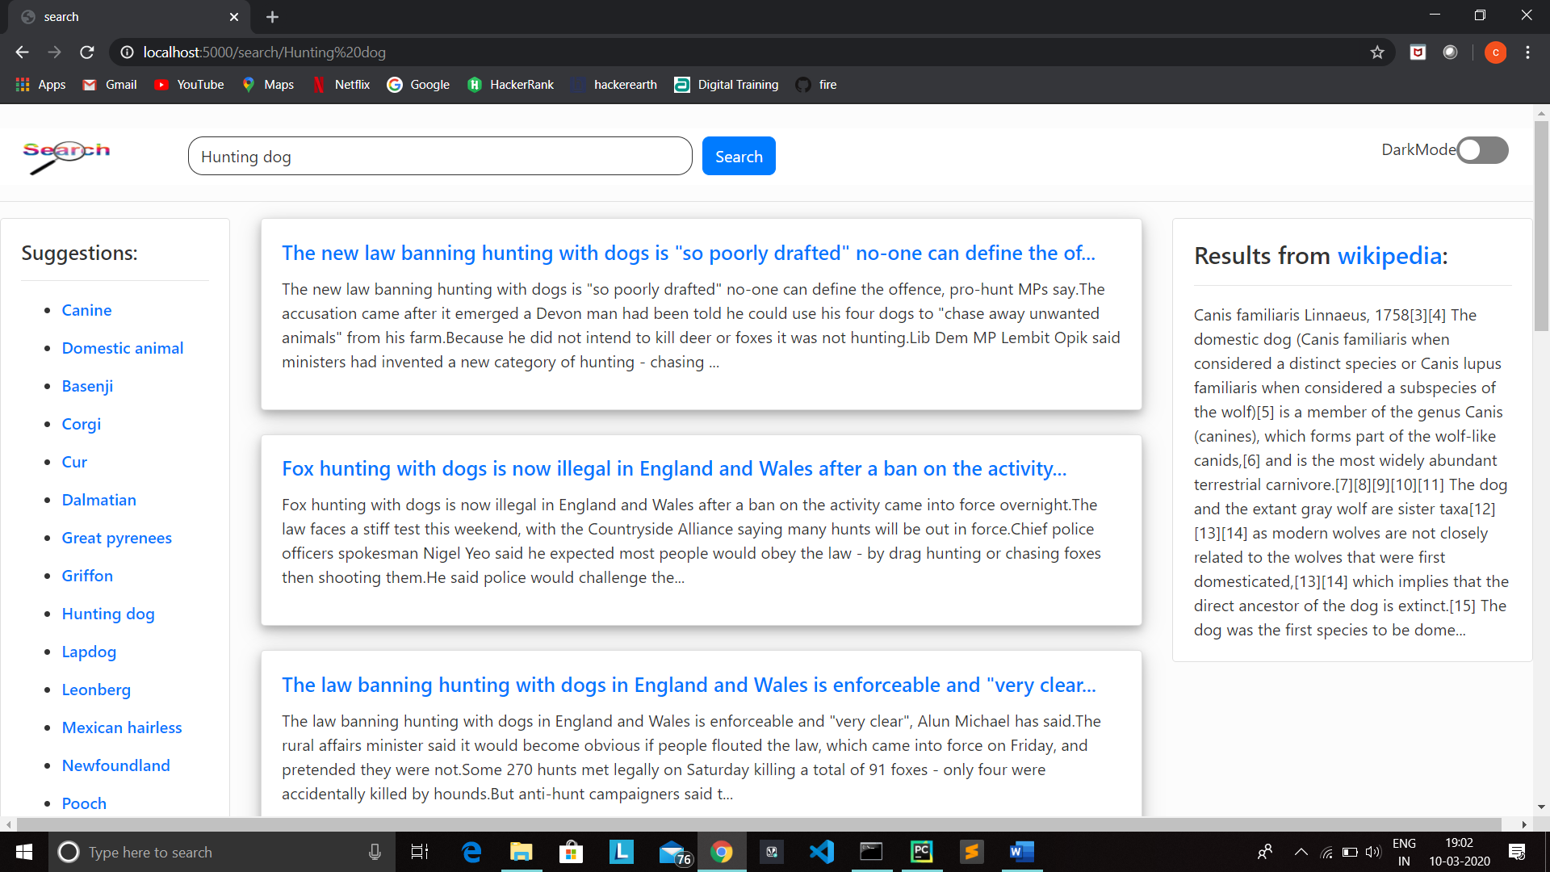

Web Scraping:-

On rightside of browser, result fetched from the Wikipedia will be displayed. On clicking that link the user will be redirected to corresponding Wikipedia page.

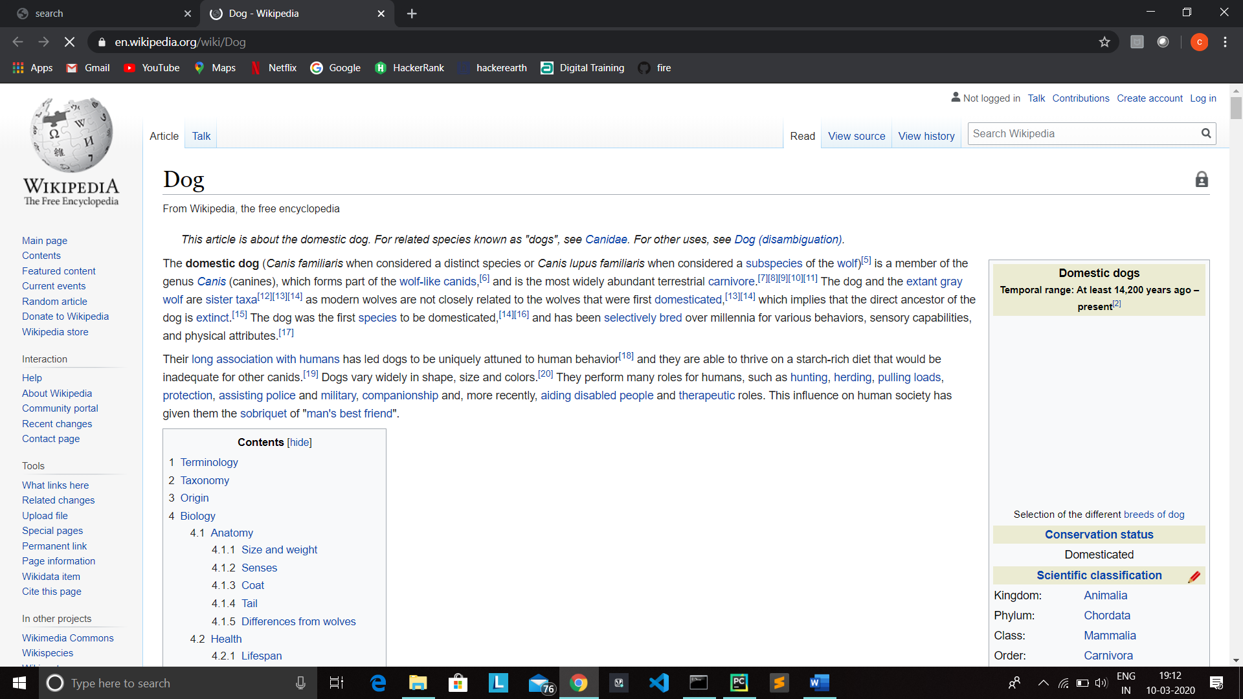

No result:-

If the query does not match any of the files,no result found page will be displayed.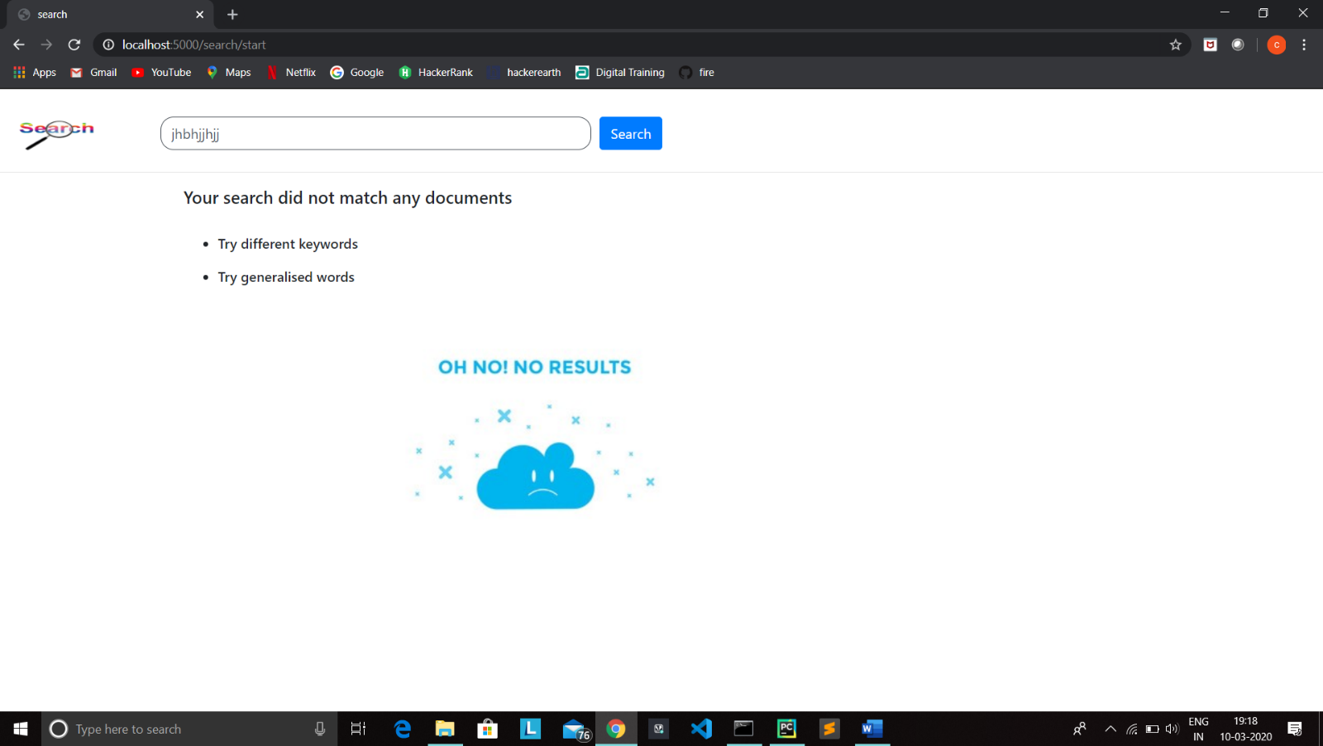

Dark Mode:-

You can toggle between light mode and dark mode using dark mode toggle button.

