**CLOUD COMPUTING**

**Introduction**

Cloud computing is a virtualization-based technology that allows us to create, configure, and customize applications via an internet connection. The cloud technology includes a development platform, hard disk, software application, and database.

**What is Cloud Computing?**

The term cloud refers to a network or the internet. It is a technology that uses remote servers on the internet to store, manage, and access data online rather than local drives. The data can be anything such as files, images, documents, audio, video, and more.

**There are the following operations that we can do using cloud computing:**

Developing new applications and services

Storage, back up, and recovery of data

Hosting blogs and websites

Delivery of software on demand

Analysis of data

Streaming videos and audios

**Why Cloud Computing?**

Small as well as large IT companies, follow the traditional methods to provide the IT infrastructure. That means for any IT company, we need a Server Room that is the basic need of IT companies.

In that server room, there should be a database server, mail server, networking, firewalls, routers, modem, switches, QPS (Query Per Second means how much queries or load will be handled by the server), configurable system, high net speed, and the maintenance engineers.

To establish such IT infrastructure, we need to spend lots of money. To overcome all these problems and to reduce the IT infrastructure cost, Cloud Computing comes into existence.

**Characteristics of Cloud Computing**

The characteristics of cloud computing are given below:

**1) Agility**

The cloud works in a distributed computing environment. It shares resources among users and works very fast.

**2) High availability and reliability**

The availability of servers is high and more reliable because the chances of infrastructure failure are minimum.

**3) High Scalability**

Cloud offers "on-demand" provisioning of resources on a large scale, without having engineers for peak loads.

**4) Multi-Sharing**

With the help of cloud computing, multiple users and applications can work more efficiently with cost reductions by sharing common infrastructure.

**5) Device and Location Independence**

Cloud computing enables the users to access systems using a web browser regardless of their location or what device they use e.g. PC, mobile phone, etc. As infrastructure is off-site (typically provided by a third-party) and accessed via the Internet, users can connect from anywhere.

**6) Maintenance**

Maintenance of cloud computing applications is easier, since they do not need to be installed on each user's computer and can be accessed from different places. So, it reduces the cost also.

**7) Low Cost**

By using cloud computing, the cost will be reduced because to take the services of cloud computing, IT company need not to set its own infrastructure and pay-as-per usage of resources.

**8) Services in the pay-per-use mode**

Application Programming Interfaces (APIs) are provided to the users so that they can access services on the cloud by using these APIs and pay the charges as per the usage of services.

**Advantages and Disadvantages of Cloud Computing**

**Advantages of Cloud Computing**

**1) Back-up and restore data**

Once the data is stored in the cloud, it is easier to get back-up and restore that data using the cloud.

**2) Improved collaboration**

Cloud applications improve collaboration by allowing groups of people to quickly and easily share information in the cloud via shared storage.

**3) Excellent accessibility**

Cloud allows us to quickly and easily access store information anywhere, anytime in the whole world, using an internet connection. An internet cloud infrastructure increases organization productivity and efficiency by ensuring that our data is always accessible.

**4) Low maintenance cost**

Cloud computing reduces both hardware and software maintenance costs for organizations.

**5) Mobility**

Cloud computing allows us to easily access all cloud data via mobile.

**6) IServices in the pay-per-use model**

Cloud computing offers Application Programming Interfaces (APIs) to the users for access services on the cloud and pays the charges as per the usage of service.

**7) Unlimited storage capacity**

Cloud offers us a huge amount of storing capacity for storing our important data such as documents, images, audio, video, etc. in one place.

**8) Data security**

Data security is one of the biggest advantages of cloud computing. Cloud offers many advanced features related to security and ensures that data is securely stored and handled.

**Disadvantages of Cloud Computing**

**1) Internet Connectivity**

As you know, in cloud computing, every data (image, audio, video, etc.) is stored on the cloud, and we access these data through the cloud by using the internet connection. If you do not have good internet connectivity, you cannot access these data. However, we have no any other way to access data from the cloud.

**2) Vendor lock-in**

Vendor lock-in is the biggest disadvantage of cloud computing. Organizations may face problems when transferring their services from one vendor to another. As different vendors provide different platforms, that can cause difficulty moving from one cloud to another.

**3) Limited Control**

As we know, cloud infrastructure is completely owned, managed, and monitored by the service provider, so the cloud users have less control over the function and execution of services within a cloud infrastructure.

**4) Security**

Although cloud service providers implement the best security standards to store important information. But, before adopting cloud technology, you should be aware that you will be sending all your organization's sensitive information to a third party, i.e., a cloud computing service provider. While sending the data on the cloud, there may be a chance that your organization's information is hacked by Hackers.

**History of cloud computing**

**In 1999, Salesforce.com** started delivering of applications to users using a simple website. The applications were delivered to enterprises over the Internet, and this way the dream of computing sold as utility were true.

**In 2002, Amazon started Amazon Web Services**, providing services like storage, computation and even human intelligence. However, only starting with the launch of the Elastic Compute Cloud in 2006 a truly commercial service open to everybody existed.

**In 2009, Google Apps** also started to provide cloud computing enterprise applications.

Of course, all the big players are present in the cloud computing evolution, some were earlier, some were later. In **2009, Microsoft launched Windows Azure**, and companies like Oracle and HP have all joined the game. This proves that today, cloud computing has become mainstream.

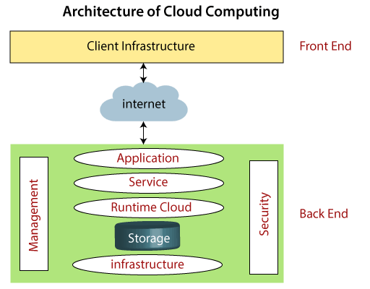

**Components of Cloud Computing Architecture**

There are the following components of cloud computing architecture -

**1. Client Infrastructure**

Client Infrastructure is a Front end component. It provides GUI (Graphical User Interface) to interact with the cloud.

**2. Application**

The application may be any software or platform that a client wants to access.

**3. Service**

A Cloud Services manages that which type of service you access according to the client’s requirement.

**Cloud computing offers the following three type of services:**

**i. Software as a Service (SaaS)** – It is also known as cloud application services. Mostly, SaaS applications run directly through the web browser means we do not require to download and install these applications. Some important example of SaaS is given below –

Example: Google Apps, Salesforce Dropbox, Slack, Hubspot, Cisco WebEx.

**ii. Platform as a Service (PaaS)** – It is also known as cloud platform services. It is quite similar to SaaS, but the difference is that PaaS provides a platform for software creation, but using SaaS, we can access software over the internet without the need of any platform.

Example: Windows Azure, Force.com, Magento Commerce Cloud, OpenShift.

**iii. Infrastructure as a Service (IaaS)** – It is also known as cloud infrastructure services. It is responsible for managing applications data, middleware, and runtime environments.

Example: Amazon Web Services (AWS) EC2, Google Compute Engine (GCE), Cisco Metapod.

**4. Runtime Cloud**

Runtime Cloud provides the execution and runtime environment to the virtual machines.

**5. Storage**

Storage is one of the most important components of cloud computing. It provides a huge amount of storage capacity in the cloud to store and manage data.

**6. Infrastructure**

It provides services on the host level, application level, and network level. Cloud infrastructure includes hardware and software components such as servers, storage, network devices, virtualization software, and other storage resources that are needed to support the cloud computing model.

**7. Management**

Management is used to manage components such as application, service, runtime cloud, storage, infrastructure, and other security issues in the backend and establish coordination between them.

**8. Security**

Security is an in-built back end component of cloud computing. It implements a security mechanism in the back end.

**9. Internet**

The Internet is medium through which front end and back end can interact and communicate with each other.

**How does cloud computing work**

Assume that you are an executive at a very big corporation. Your particular responsibilities include to make sure that all of your employees have the right hardware and software they need to do their jobs. To buy computers for everyone is not enough. You also have to purchase software as well as software licenses and then provide these softwares to your employees as they require. Whenever you hire a new employee, you need to buy more software or make sure your current software license allows another user. It is so stressful that you have to spend lots of money.

But, there may be an alternative for executives like you. So, instead of installing a suite of software for each computer, you just need to load one application. That application will allow the employees to log-in into a Web-based service which hosts all the programs for the user that is required for his/her job. Remote servers owned by another company and that will run everything from e-mail to word processing to complex data analysis programs. It is called cloud computing, and it could change the entire computer industry.

**How cloud works**

In a cloud computing system, there is a significant workload shift. Local computers have no longer to do all the heavy lifting when it comes to run applications. But cloud computing can handle that much heavy load easily and automatically. Hardware and software demands on the user's side decrease. The only thing the user's computer requires to be able to run is the cloud computing interface software of the system, which can be as simple as a Web browser and the cloud's network takes care of the rest.

Cloud Service Provider Companies

Cloud Service providers (CSP) offers various services such as **Software as a Service**, **Platform as a service**, **Infrastructure as a service**, **network services**, **business applications**, **mobile applications**, and **infrastructure** in the cloud. The cloud service providers host these services in a data center, and users can access these services through cloud provider companies using an Internet connection.

There are the following Cloud Service Providers Companies -

Amazon Web Services (AWS)

[AWS](https://www.javatpoint.com/aws-tutorial) (Amazon Web Services) is a **secure cloud service platform** provided by **Amazon**. It offers various services such as database storage, computing power, content delivery, Relational Database, Simple Email, Simple Queue, and other functionality to increase the organization's growth.

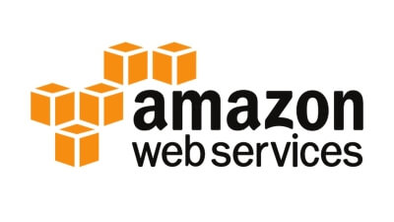

Features of AWS

AWS provides various powerful features for building scalable, cost-effective, enterprise applications. Some important [features of AWS](https://www.javatpoint.com/features-of-aws) is given below-

* AWS is **scalable** because it has an ability to scale the computing resources up or down according to the organization's demand.
* AWS is **cost-effective** as it works on a **pay-as-you-go** pricing model.
* It provides various flexible storage options.
* It offers various **security services** such as infrastructure security, data encryption, monitoring & logging, identity & access control, penetration testing, and DDoS attacks.
* It can efficiently manage and secure Windows workloads.

2. Microsoft Azure

[Microsoft Azure](https://www.javatpoint.com/microsoft-azure) is also known as **Windows Azure**. It supports various operating systems, databases, programming languages, frameworks that allow [IT](https://www.javatpoint.com/it-full-form) professionals to easily build, deploy, and manage applications through a worldwide network. It also allows users to create different groups for related utilities.

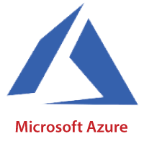

Features of Microsoft Azure

* Microsoft Azure provides **scalable**, **flexible**, and **cost-effective**
* It allows developers to quickly manage applications and websites.
* It managed each resource individually.
* Its IaaS infrastructure allows us to launch a general-purpose virtual machine in different platforms such as Windows and Linux.
* It offers a **Content Delivery System (CDS)** for delivering the Images, videos, audios, and applications.

3. Google Cloud Platform

Google cloud platform is a product of **Google**. It consists of a set of physical devices, such as computers, hard disk drives, and virtual machines. It also helps organizations to simplify the migration process.

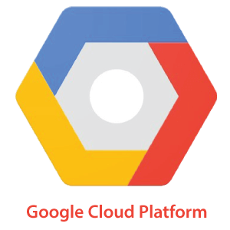

Features of Google Cloud

* Google cloud includes various **big data services** such as Google BigQuery, Google CloudDataproc, Google CloudDatalab, and Google Cloud Pub/Sub.
* It provides various services related to **networking**, including Google Virtual Private Cloud (VPC), Content Delivery Network, Google Cloud Load Balancing, Google Cloud Interconnect, and Google Cloud DNS.
* It offers various **scalable** and **high-performance**
* GCP provides various **serverless services** such as Messaging, Data Warehouse, Database, Compute, Storage, Data Processing, and Machine learning (ML)
* It provides a free cloud shell environment with Boost Mode.

4. IBM Cloud Services

IBM Cloud is an open-source, faster, and more reliable platform. It is built with a suite of advanced data and [AI](https://www.javatpoint.com/artificial-intelligence-tutorial) tools. It offers various services such as [Infrastructure as a service](https://www.javatpoint.com/infrastructure-as-a-service), [Software as a service](https://www.javatpoint.com/software-as-a-service), and [platform as a service](https://www.javatpoint.com/platform-as-a-service). You can access its services like compute power, cloud data & Analytics, cloud use cases, and storage networking using internet connection.

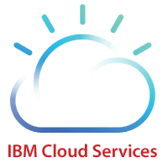

Feature of IBM Cloud

* IBM cloud improves operational efficiency.
* Its speed and agility improve the customer's satisfaction.
* It offers Infrastructure as a Service (IaaS), Platform as a Service (PaaS), as well as Software as a Service (SaaS)
* It offers various cloud communications services to our IT environment.

5. VMware Cloud

VMware cloud is a Software-Defined Data Center (SSDC) unified platform for the Hybrid Cloud. It allows cloud providers to build agile, flexible, efficient, and robust cloud services.

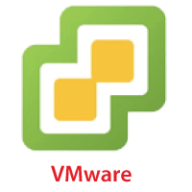

Features of VMware

* VMware cloud works on the **pay-as-per-use** model and **monthly subscription**
* It provides better customer satisfaction by protecting the user's data.
* It can easily create a new VMware **Software**-**Defined Data Center (SDDC)** cluster on AWS cloud by utilizing a RESTful API.
* It provides flexible storage options. We can manage our application storage on a per-application basis.
* It provides a dedicated high-performance network for managing the application traffic and also supports multicast networking.
* It eliminates the time and cost complexity.

6. Oracle cloud

[Oracle](https://www.javatpoint.com/oracle-tutorial) cloud platform is offered by the **Oracle Corporation**. It combines Platform as a Service, Infrastructure as a Service, Software as a Service, and Data as a Service with cloud infrastructure. It is used to perform tasks such as moving applications to the cloud, managing development environment in the cloud, and optimize connection performance.

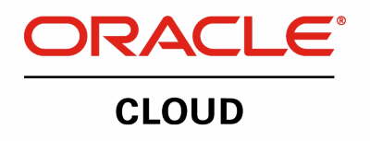

Features of Oracle cloud

* Oracle cloud provides various tools for build, integrate, monitor, and secure the applications.
* Its infrastructure uses various languages including, Java, Ruby, PHP, Node.js.
* It integrates with Docker, VMware, and other DevOps tools.
* Oracle database not only provides unparalleled integration between IaaS, PaaS, and SaaS, but also integrates with the on-premises platform to improve operational efficiency.
* It maximizes the value of IT investments.
* It offers customizable Virtual Cloud Networks, firewalls, and IP addresses to securely support private networks.

7. Red Hat

Red Hat virtualization is an open standard and desktop virtualization platform produced by Red Hat. It is very popular for the [Linux](https://www.javatpoint.com/linux-tutorial) environment to provide various infrastructure solutions for virtualized servers as well as technical workstations. Most of the small and medium-sized organizations use Red Hat to run their organizations smoothly. It offers higher density, better performance, agility, and security to the resources. It also improves the organization's economy by providing cheaper and easier management capabilities.



Features of Rad Hat

* Red Hat provides secure, certified, and updated container images via the Red Hat Container catalog.
* Red Hat cloud includes **OpenShift,** which is an app development platform that allows developers to **access**, **modernize**, and **deploy apps**
* It supports up to 16 virtual machines, each having up to 256GB of RAM.
* It offers better reliability, availability, and serviceability.
* It provides flexible storage capabilities, including very large SAN-based storage, better management of memory allocations, high availability of LVMs, and support for particularly roll-back.
* In the Desktop environment, it includes features like New on-screen keyboard, GNOME software, which allows us to install applications, update application, as well as extended device support.

8. DigitalOcean

DigitalOcean is the unique cloud provider that offers computing services to the organization. It was founded in 2011 by Moisey Uretsky and Ben. It is one of the best cloud provider that allows us to manage and deploy web applications.



Features of DigitalOcean

* It uses the KVM hypervisor to allocate physical resources to the virtual servers.
* It provides high-quality performance.
* It offers a digital community platform that helps to answer queries and holding feedbacks.
* It allows developers to use cloud servers to quickly create new virtual machines for their projects.
* It offers one-click apps for droplets. These apps include MySQL, Docker, MongoDB, Wordpress, PhpMyAdmin, LAMP stack, Ghost, and Machine Learning.

9. Rackspace

Rackspace offers [cloud computing](https://www.javatpoint.com/cloud-computing-tutorial) services such as hosting web applications, Cloud Backup, Cloud Block Storage, Databases, and Cloud Servers. The main aim to designing Rackspace is to easily manage private and public cloud deployments. Its data centers operating in the USA, UK, Hong Kong, and Australia.

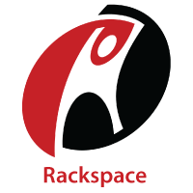

Features of Rackspace

* Rackspace provides various tools that help organizations to collaborate and communicate more efficiently.
* We can access files that are stored on the Rackspace cloud drive, anywhere, anytime using any device.
* It offers 6 globally data centers.
* It can manage both virtual servers and dedicated physical servers on the same network.
* It provides better performance at a lower cost.

10. Alibaba Cloud

Alibaba Cloud is used to develop data management and highly scalable cloud computing services. It offers various services, including Elastic Computing, Storage, Networking, Security, Database Services, Application Services, Media Services, Cloud Communication, and Internet of Things.

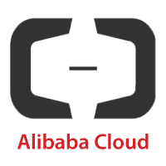

Features of Alibaba Cloud

* Alibaba cloud offers a suite of global cloud computing services for both international customers and Alibaba Group's e-commerce ecosystem.
* Its services are available on a pay-as-per-use basis.
* It globally deals with its 14 data centers.
* It offers scalable and reliable data storage.