https://gemini.google.com/app/82f55ef054665545
https://gemini.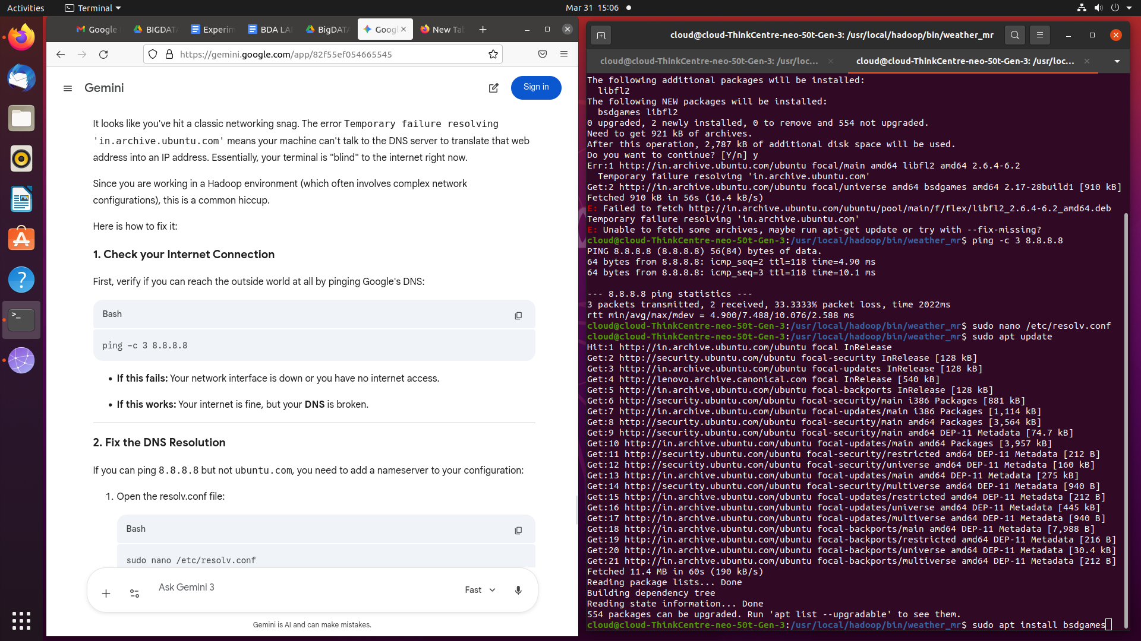google.com/app/82f55ef054665545

