**1.What is active function?**

**A)** 1.Decides whether a neuron should be activated or not.

2.They help to decide if the neuron would fire or not

3.Is the last component of the convolutional layer to increase the non-linearity in the output.

4.Helps the neural network to use important information while suppressing irrelevant data points.

**2.What is purpose and role Ac ?**

* These are necessary to prevent linearity.
* Without them, the data would pass through the nodes and layers of the network only going through linear functions (a*x+b)
* **Role:** To transform the summed weighted input from the node into an output value to be fed to the next hidden layer or as output.

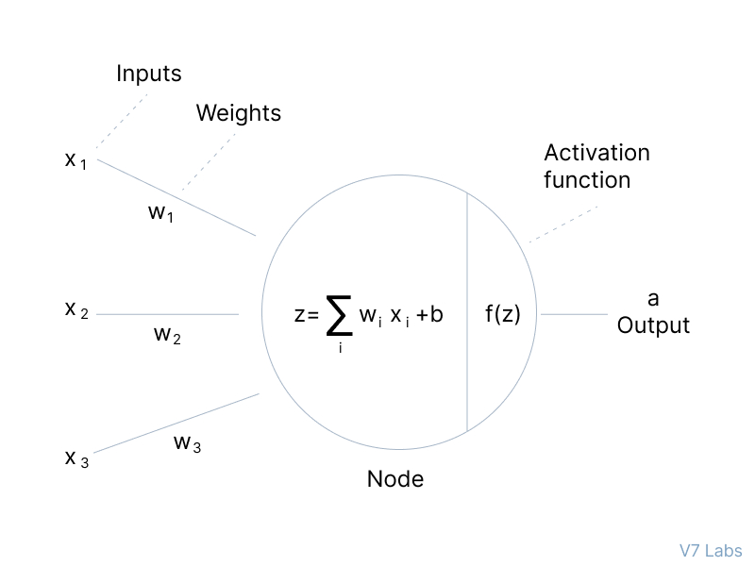

1. **Why active function?**

The purpose of an activation function is to add non-linearity to the neural network.

It introduce an additional step at each layer during the forward propagation, but its computation is worth it.  
*without the activation functions*.

every neuron will only be performing a linear transformation on the inputs using the weights and biases

* Every neuron will only be performing a linear transformation on the inputs using the weights and biases
* All layers will behave in the same way because the composition of two linear functions is a linear function itself.
* Although the neural network becomes simpler, learning any complex task is impossible, and our model would be just a linear regression model.

1. **Types of activation function?**

**🡪 *Binary Step Function*:** Depends on a threshold value that decides whether a neuron should be activated or not.

**🡪 *Linear activation function:*** also known as "no activation," or "identity function" (multiplied x1.0), is where the activation is proportional to the input.

***Limitations of Linear activation function:***

* However, a linear activation function has two major problems :
* It’s not possible to use backpropagation as the derivative of the function is a constant and has no relation to the input x.
* All layers of the neural network will collapse into one if a linear activation function is used.

***Non-Linear activation functions:***

There are several commonly used activation functions such as:

1. ReLU (Rectified Linear Unit)
2. Leaky ReLU Function
3. Exponential Linear Units (ELUs) Function
4. Softmax,
5. tanH **(**Hyperbolic Tangent**)**
6. Sigmoid functions/Logistic
7. .Gaussian Error Linear Unit (GELU)
8. Scaled Exponential Linear Unit (SELU)