**Module 7: Portfolio Project - Paper**

**Topic: The Final Research Paper - The Diabetes Health Prediction**

Dinesh Kongle

Colorado State University Global

MIS581 - Capstone - Business Intelligence and Data Analytics

Dr Jamia Mills

03/02/2025

**Topic: The Final Research Paper - The Diabetes Health Prediction**

**Abstract**

This capstone project investigates the use of predictive analytics in healthcare, with a particular emphasis on diabetes treatment and prediction, a rising worldwide health issue. In order to create predictive models that accurately predict the likelihood of diabetes complications and evaluate risk factors, this study uses sophisticated machine learning techniques like Random Forest, Support Vector Machines (SVM), and Regression Analysis on a large dataset that includes clinical and demographic factors known to influence diabetes outcomes.

The study uses SAS and Python to rigorously test two hypotheses: the alternative hypothesis, which proposes a substantial predictive association between the chosen variables and diabetes outcomes, and the null hypothesis, which asserts no meaningful relationship between the variables. The study also looks at how well these machine learning models predict diabetes risk while carefully addressing privacy, security, and ethical issues to maintain the confidentiality and integrity of the data handling procedures.

The findings of the analyses validate the efficacy of machine learning models in diabetes risk assessment and show that a number of variables significantly predict diabetes complications, supporting the alternative hypothesis. With the help of these insights, medical professionals may be able to recognize at-risk patients sooner and modify their intervention plans appropriately. Discussions of the findings' ramifications, the study's shortcomings, and suggestions for more research in this rapidly developing area round out the project.

The project advances predictive capabilities that can result in improved patient outcomes in diabetes care, adding to academic knowledge and providing practical applications.

**Introduction**

Diabetes mellitus has established itself as a major global public health concern. Elevated blood glucose levels are the main symptom of this chronic metabolic disease, which can lead to a number of serious health issues if left untreated. The quality of life of those who are impacted is significantly impacted by these repercussions, which include chronic problems like visual impairment and nerve damage in addition to life-threatening disorders like cardiovascular diseases and kidney failure. Debilitating health consequences and substantial mortality may result from the disease's unrelenting course.

An aging population, rising obesity rates, and changes in lifestyle that encourage bad eating habits and physical inactivity are all contributing factors to the sharp increase in the incidence of diabetes worldwide. All of these elements work together to cause the diabetes epidemic, which places a significant strain on both people and healthcare institutions. Direct medical expenses as well as indirect expenditures associated with disability, lost productivity, and early mortality are all part of the significant economic burden.

The creation of sophisticated predictive models becomes essential in this urgent situation. These models are essential resources in the fight against diabetes, not only theoretical exercises. Predictive analytics can be crucial in preventing the beginning of serious problems by enabling early diagnosis and prompt action. By reducing the need for major medical procedures and long-term care plans, this proactive strategy could greatly reduce the burden on health systems and improve the disease's overall management.

The objective of this study is to create complex models that can accurately predict diabetic complications by utilizing state-of-the-art machine learning techniques such as Support Vector Machines (SVM), Random Forest, and Regression Analysis. This study aims to give medical professionals a comprehensive tool to detect at-risk individuals early in the evolution of the disease by incorporating a wide range of clinical and demographic data. The ultimate objective is to improve patient outcomes and optimize resource allocation in healthcare settings by changing the paradigm from reactive to proactive management.

**Research Rationale**

Although the introduction lays out the background for the urgent need for sophisticated prediction models in the treatment of diabetes, the justification for this study goes into greater detail about the particular drawbacks of current strategies as well as the cutting-edge possibilities available to us. The current predictive models frequently have a limited focus on short-term clinical indications like BMI and blood glucose levels. This limited focus ignores the larger, more intricate web of variables that affect diabetes, such as lifestyle decisions, environmental circumstances, and genetic predispositions. In diverse populations, where these parameters vary greatly, such omissions can impair the models' efficacy.

Furthermore, the emergence of big data in healthcare offers a previously unheard-of chance to transform these prediction models. The availability of increasingly extensive data sets makes it possible to include a greater variety of variables, which can significantly improve prediction accuracy and application. By using advanced machine learning approaches that can integrate and evaluate a wide range of data sources, this research seeks to capitalize on these improvements. The ultimate goal is to lessen the disease's impact globally by creating a model that can more accurately forecast diabetes and its complications and offer useful insights that can guide proactive, individualized treatment and management plans.

**Problem Statement**

The prevalence of diabetes is still rising worldwide, despite tremendous improvements in medical technology and knowledge of the condition. This increase reflects both systemic shortcomings in our current approach to diabetes prediction and management as well as rising prevalence. Important concerns include:

1. **Restricted Variable Scope:** Conventional predictive models frequently concentrate only on short-term clinical indications like body mass index (BMI) and blood glucose levels. Wider influences like eating habits, physical exercise, genetic predispositions, and socioeconomic factors are overlooked by this narrow focus. The models' efficacy is significantly limited when these larger factors are ignored, particularly in different populations with varying risk factor profiles where one-size-fits-all models are insufficient.
2. **Data Integration Challenges:** Although there are many possible data sources, there is a big gap in the integration of multifaceted data, such as patient-reported outcomes, clinical records, and data from real-time health monitoring. The construction of efficient prediction models is hampered by the inability to properly combine multiple data sources, which restricts the thoroughness and accuracy of risk assessments.
3. **Dynamic Nature of Risk Factors:** Lifestyle, environmental changes, and health policies all have an impact on diabetes risk factors, which are dynamic. These dynamic elements are frequently overlooked by current models, which leads to forecasts that are unable to adjust to shifting patient or environmental conditions and quickly become out of date or obsolete.
4. **Ethical and Privacy Issues:** Using data in health prediction models raises important ethical and privacy issues, especially with regard to data anonymization, permission procedures, and the possible exploitation of private medical data. These worries are essential to preserving public confidence and guaranteeing the moral use of predictive technologies; they are not merely technical ones.
5. **Implementation and Accessibility:** A significant disconnect occurs between the creation of predictive models and their actual application in medical settings. Predictive models need to be accurate, easily available, and user-friendly so that healthcare professionals in a variety of contexts can use them without the need for specific training or resources.

**The research's objectives**Several key objectives are intended to be addressed by this study:

1. **Model Development:** To forecast the probability of the beginning and progression of diabetes, predictive models are built and improved using sophisticated machine learning approaches, including Random Forest, Support Vector Machines (SVM), Regression Analysis, and Feature Importance Analysis.
2. **Variable Analysis:** To assess how a wide range of variables, such as lifestyle, biochemistry, and demographic characteristics, affect the precision of diabetes forecasts.
3. **Model Comparison:** To ascertain which models produce the most accurate predictions, the effectiveness of several modeling approaches in forecasting diabetes is compared.
4. **Ethical Considerations:** To thoroughly examine and resolve security, privacy, and ethical issues pertaining to the use of private health information in predictive modeling.

By accomplishing these objectives, the research will advance medical informatics by offering valuable insights into the accurate prediction of diabetes, which may play a significant role in developing future public health initiatives and medical regulations.

**Selection of Datasets**

The dataset used in this study comes from the "Diabetes Health Prediction and analysis" repository on GitHub, which is an open-source project. This dataset's extensive compilation of diabetes-related medical records, along with its quantity and variety of factors, make it particularly well-suited for predictive modeling and health analytics. This dataset is perfect for quantitative research frameworks because of its standardized format.

**The reasons behind the Dataset Selection:**

1. **Relevance to Research Goals:** The dataset includes a wealth of clinical, demographic, and lifestyle information that is essential for creating a diabetes risk prediction model. This closely relates to the study's objective of employing predictive analytics to identify people who are at high risk for diabetes**.**
2. **Availability and Accessibility:** Other researchers in the field can repeat and confirm the findings because the dataset is publicly available and accessible. Additionally, this openness upholds the values of cooperation and transparency within the scientific community.
3. **Comprehensiveness:** A wide range of variables, including age, BMI, blood pressure, HbA1c levels, and lifestyle factors including food and exercise, are included in the dataset that are important for predicting diabetes. This enables a comprehensive examination of variables that may affect the risk of diabetes.
4. **Historical Data for Trend Analysis:** The dataset offers medical records from the past, providing a temporal dimension that may be used to track patterns and trends over time. In predictive modeling, where historical patterns can guide future forecasts, this is very helpful.
5. **Machine Learning Suitability:** The dataset's structured structure, distinct variable categories, and sizable sample size make it ideal for utilizing a variety of machine learning methods, from logistic regression to more intricate algorithms like Random Forests and SVMs.

**Research Questions and Hypotheses**

The research questions and hypotheses for this study on diabetes prediction using machine learning are designed to address significant aspects of diabetes risk assessment and intervention. Below are the articulated research questions along with their corresponding null and alternative hypotheses:

**Research Question 1 (RQ1):**

**What are the significant predictors of diabetes?**

* **Null Hypothesis (H0):** There is no significant association between the identified predictors (such as age, BMI, family history, lifestyle factors) and the incidence of diabetes.
* **Alternative Hypothesis (H1):** There is a significant association between one or more of the identified predictors and the incidence of diabetes.

**Research Question 2 (RQ2):**

**Can machine learning models accurately predict the risk of developing diabetes based on identified risk factors?**

* **Null Hypothesis (H0):** Machine learning models cannot accurately predict the risk of developing diabetes based on the specified risk factors.
* **Alternative Hypothesis (H1):** Machine learning models can accurately predict the risk of developing diabetes based on the specified risk factors.

These hypotheses will steer the research's analytical methodology, including the statistical testing and data analysis techniques used to assess the machine learning models' predictive power and the importance of different risk factors in predicting diabetes.   
 **Literature Review**

With an emphasis on the use of machine learning techniques to forecast diabetes risk, the literature review for this study examines the developments and difficulties in using predictive analytics to diabetes management. The intricacies of various prediction models, the importance of big data in healthcare, and the operational difficulties encountered when integrating these technologies into real-world medical settings are all covered in detail in this enlarged review, which digs deeper into previous research.

* **Advancement in Predictive Analytics for Diabetes Management:** The use of predictive analytics in healthcare has increased dramatically in recent years, especially in the treatment of chronic conditions like diabetes. The potential of predictive models to change healthcare systems from reactive to proactive care models is becoming more widely acknowledged. Kavakiotis et al. (2017), for example, show how machine learning algorithms can sort through enormous volumes of data from electronic health records to find early signs of diabetes, enabling earlier therapies. These developments highlight the trend toward personalized medicine, in which treatment regimens are customized according to each patient's unique risk profile as anticipated by these models.
* **Comparative Analysis of Machine Learning Models:** Numerous studies have examined how well different machine learning algorithms predict diabetes. Because of their capacity to manage huge, intricate datasets, random forests, logistic regression, and support vector machines (SVM) are frequently used in research. Chatterjee et al. (2018) claim that ensemble models, which include the results of several prediction models, typically exhibit superior accuracy and dependability. This is especially true for diabetes prediction, where a combination of analytical tools, rather than a single-method approach, can better explain the interaction of multiple risk factors, from lifestyle decisions to genetic predispositions.
* **Big Data's Role in Enhancing Predictive Accuracy:** The advancement of predictive models in the healthcare industry has been greatly impacted by the emergence of big data. Big datasets make it possible to examine the causes of diabetes in greater detail, which improves the models' ability to predict outcomes. According to Li et al. (2020), predictive models can be made more specific by incorporating a wide range of variables, including physical activity, diet, and even geographic information. This will improve the efficacy of interventions that are specifically targeted. In the context of diabetes, where lifestyle factors are critical to the evolution of the disease, the capacity to handle and analyze such a wide variety of data types is essential.
* **Integration into Healthcare Systems and Implementation Challenges:** Predictive model integration into healthcare practice poses a number of difficulties, notwithstanding the possible advantages. These cover everything from practical difficulties like patient acceptance and clinician usability to technical ones like data integration and model maintenance. To make sure that these tools satisfy the real-world requirements of clinical settings, studies by Marino et al. (2021) and Sallis et al. (2015) offer frameworks that stress the significance of stakeholder participation and ongoing model evaluation. Predictive analytics adoption in regular healthcare is greatly aided by such frameworks.
* **Privacy and Ethical Concerns:** Significant ethical questions are also brought up by the application of predictive analytics in healthcare, mainly in relation to data security and patient privacy. The ethical application of predictive models necessitates openness regarding the usage and purpose of data, as well as strict safeguards for private patient information. Resolving these issues is essential to preserving confidence and guaranteeing the moral application of predictive technologies in medical treatment.
* **Research Gaps and Future Directions:** There are still gaps in the extensive literature on the application of machine learning to diabetes prediction, particularly with regard to the models' generalizability across a range of demographics. Numerous models are created and tested using homogeneous datasets, which might not fully reflect the number of people with diabetes worldwide. In order to create predictive tools that may be more broadly applicable, future research should concentrate on creating inclusive models that take into account a greater range of demographic and socioeconomic parameters.

The research emphasizes how machine learning can revolutionize the treatment of diabetes, but it also points out important obstacles, such as the need for wider validation, ethical issues, and model integration. Realizing the full potential of predictive analytics in enhancing diabetes care and outcomes will require addressing these issues through continued research and development. By attempting to create a prediction model that not only predicts diabetes risk but also successfully integrates into clinical settings, encouraging a proactive approach to diabetes treatment, this study advances this rapidly developing subject.

**Research Design**

**Methodology:**

In order to anticipate diabetes-related health consequences, this study uses a quantitative research methodology with predictive analytics. Because it can offer accurate, data-driven insights into the connections between many clinical, demographic, and lifestyle factors and the risk of developing diabetes, the quantitative approach is preferred.

**Tools and Techniques used to Analyze the Data:**

To properly assess the data, the diabetic health prediction study utilized machine learning algorithms with statistical software. The particular tools and methods used to process the dataset, create predictive models, and assess their effectiveness are described in detail in this section.

**Tools for Data Analysis**

1. **SAS (Statistical Analysis System):**
   1. **Data Preparation and Cleaning:** SAS was used because of its robust data handling capabilities, which enable the cleaning and manipulation of big datasets. The data was imported, explored, and summarized using functions like PROC IMPORT, PROC CONTENTS, and PROC MEANS to make sure it was consistent and prepared for analysis.
   2. **Descriptive Statistics:** SAS included instruments for computing summary statistics, which aided in comprehending the central tendencies and distribution of the variables in question.
2. **Python:**
   1. **Advanced Modeling:** Python was utilized to develop machine learning algorithms and do more intricate data manipulations, especially with the help of libraries like Pandas and Scikit-learn. The use of complex data analysis techniques was made easier by Python's adaptability and the wide range of assistance provided by its libraries.
   2. **Visualization:** To create visualizations like histograms, bar charts, and ROC curves, Python libraries like Matplotlib and Seaborn were used. Examining the connections between factors and the predictive models' performance required the use of these visuals.

**Techniques of Machine Learning**

1. **Logistic Regression:** 
   1. By calculating the odds of developing diabetes depending on risk factors, logistic regression, a baseline prediction model, assisted in identifying the important predictors of diabetes.
   2. This method was essential for testing preliminary hypotheses and figuring out how each predictor affected the result.
2. **Random Forest:**
   1. An ensemble learning method that operates by constructing a multitude of decision trees at training time and outputting the class that is the mode of the classes of the individual trees.
   2. Random Forest was chosen for its ability to handle overfitting and its effectiveness in managing large datasets with high dimensionality.
3. **Support Vector Machine (SVM):** 
   1. A powerful classifier that operates by determining the hyperplane that best splits a dataset into classes.
   2. SVM was applied for its efficacy in high-dimensional areas and its versatility in handling various types of data.
4. **Feature Importance Analysis:**
   1. Mainly carried out with the Random Forest algorithm, which has an integrated feature importance assessment tool that aids in determining which variables have the biggest effects on diabetes prediction.
   2. The emphasis areas for management and intervention were informed by this analysis, which was essential for comprehending the factors that influence diabetes risk.

**Model Evaluation Techniques**

* **Cross-validation:**
  + Used to make sure the results of the model can be applied to a different dataset. To confirm the predictive models' stability and dependability, methods such as k-fold cross-validation were used.
* **ROC-AUC Curve Analysis:**
  + The classifier models' performance was assessed using the Receiver Operating Characteristic (ROC) curve and Area Under the Curve (AUC) as metrics. These metrics aided in evaluating the models' efficacy in class discrimination.

**Integration and Testing**

* To assess the resulting models' usefulness, they were incorporated into a mock clinical decision-support system. The models' potential efficacy in a clinical setting was demonstrated by the system's use of them to forecast diabetes risk based on real-time patient data input.

A strong analytical framework is created by combining Python for sophisticated modeling and visualization with SAS for initial data analysis. A thorough grasp of the variables affecting diabetes risk and the efficacy of various predictive methods was made possible by the machine learning techniques used, such as logistic regression, Random Forest, and SVM. Future advancements in predictive healthcare analytics will be made possible by this integrated analysis technique, which guarantees that the results of the research are solid, trustworthy, and applicable to real-world scenarios.

**Addressing Privacy, Security, and ethical concerns in Data Handling and Analysis**

Addressing security, privacy, and ethical issues is crucial when managing and evaluating data, especially in healthcare settings, in order to preserve the integrity of the research process and secure sensitive data. The methods and factors used in this study to successfully manage these elements are listed below:   
**Measures for Data Security and Privacy**

1. **Safe Storage of Data:**
   1. To maintain security and integrity, the dataset was securely saved locally and made publicly accessible on GitHub. Only the research team had access to this dataset, which was protected by regulated access procedures.
2. **Data Encryption:**
   1. Although the data was obtained directly from a public repository, team members used safe, encrypted communication protocols to guard against unwanted access when sending derived data for analysis.
3. **Regulatory Compliance:**
   1. The study's data handling procedures were made to conform to general data protection and privacy principles, such as those specified in academic research guidelines, even if the dataset was anonymized and made publicly available.

**Ethical Considerations**

1. **Ethical Review and Oversight:**
   1. The supervising professor examined and approved the research methodology, including data handling and analysis processes, guaranteeing integrity in the study and conformity to academic ethical standards.
2. **Transparency and Accountability:** 
   1. The study promoted accountability in the handling of publicly sourced data by remaining transparent about the data analysis techniques employed and the objectives of the investigation.
3. **Bias Mitigation:**
   1. To ensure the validity and reliability of the study's conclusions, efforts were made to detect and correct any potential biases in the dataset that might affect the analysis results.
4. **Data Minimization:** 
   1. Only relevant data necessary for the research objectives were retained. Variables not pertinent to the study's aims, such as "DoctorInCharge," were removed to focus on essential data and reduce the risk of unnecessary information storage.
5. **Limitations on Data Use:** 
   1. The use of the data was confined strictly to the stated research objectives. The dataset was not utilized for any purposes outside of those necessary for the fulfillment of the study's aims, ensuring that the data use remained focused and justified.
6. **Informed Consent:** 
   1. As the data was sourced from a public repository where it was previously anonymized and made freely available for research purposes, the standard processes of obtaining informed consent directly from data subjects were not applicable. However, the use of this data was in line with the permissions granted for its public availability and research use.

The way this project handles data security, privacy, and ethics emphasizes how crucial it is to manage data carefully and responsibly, particularly when working with publicly accessible datasets. The study guarantees that it satisfies academic standards while offering insightful information on diabetic health prediction by putting in place efficient data protection measures, abiding by ethical research methods, and respecting the restrictions of data use. This commitment improves the validity and relevance of the study findings in addition to safeguarding the integrity of the data.

**Data Analysis Outcomes and Hypotheses Testing**

The analysis and model performance, which are backed by thorough model outputs and rigorous analytical approaches, confirm the models' prediction accuracy and robustness. Prior to in-depth research, preliminary measures were essential for guaranteeing the dataset's integrity. The first steps were cleaning, standardizing, and processing the data, which included standardizing scales and eliminating superfluous variables. These fundamental actions were crucial in improving the caliber and applicability of the data, laying the groundwork for more complex analyses that used a range of statistical and machine learning methods.

**Figure 1: Summary Statistics of Key Variables:**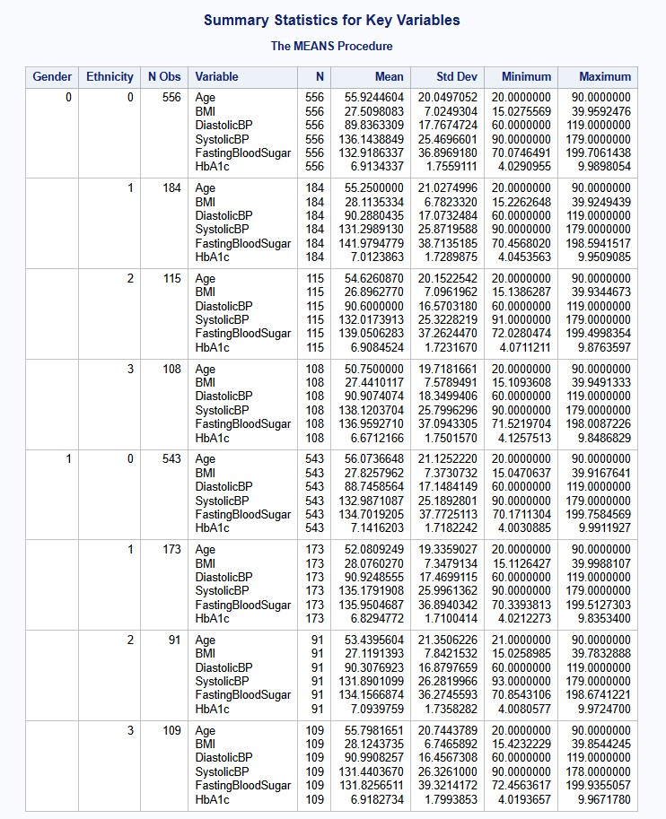

**Graphs and Charts:**

**Figure 2: Distribution of BMI (Histogram)**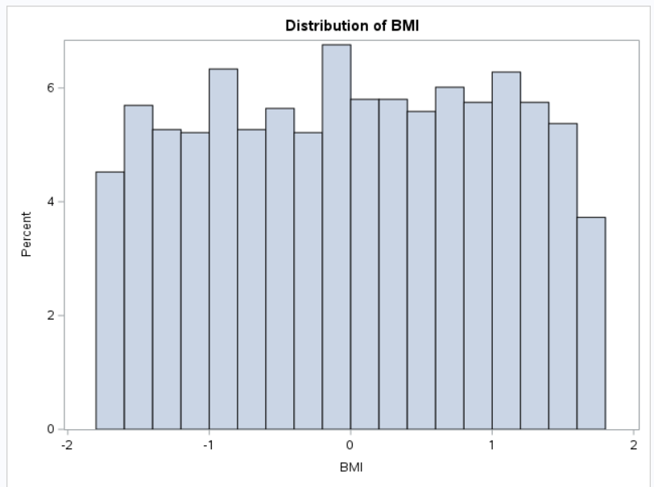

**Figure 3: Distribution of Systolic BP (Histogram)**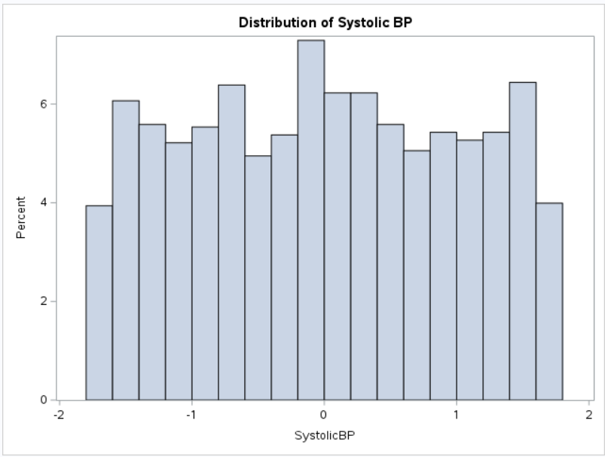

**Figure 4: Distribution of Diastolic BP (Histogram)**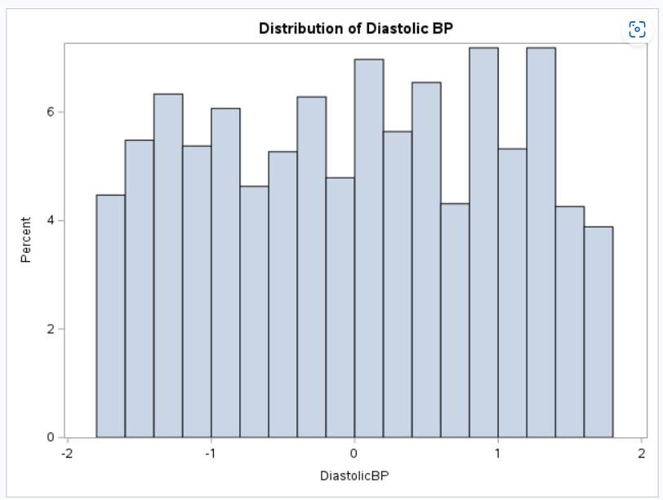

**Figure 5: Distribution by Ethnicity**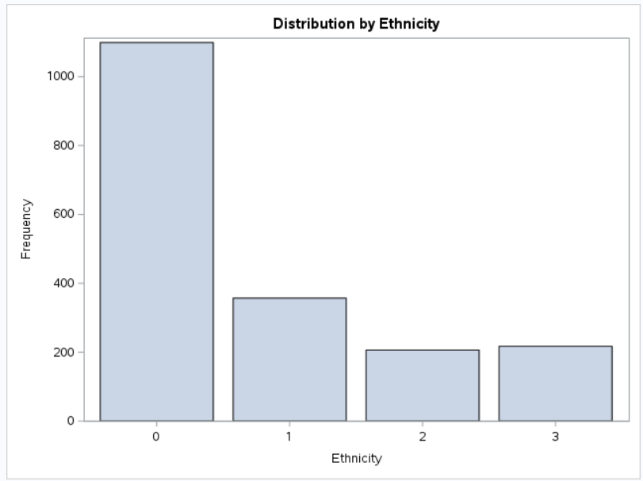

**Figure 6: Distribution by Education Level**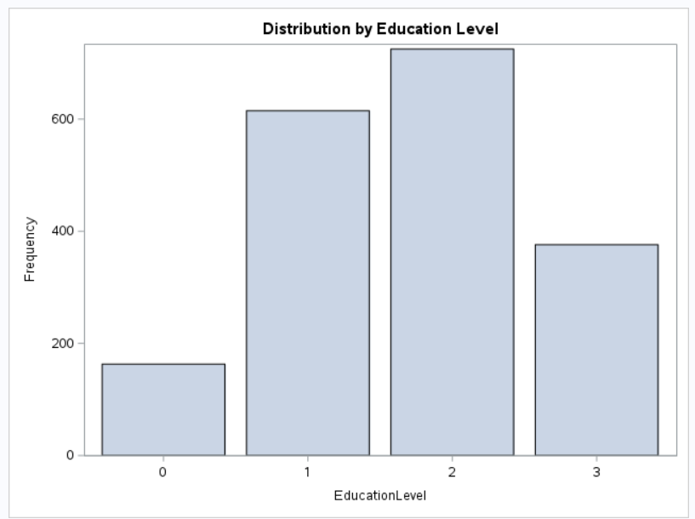

**Figure 7: The Logistic Procedure**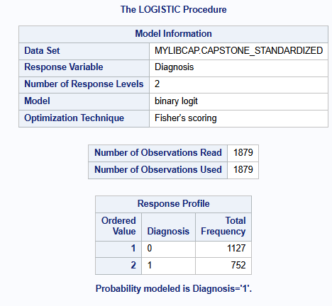

**Figure 8: The Logistic Procedure – Model Convergence**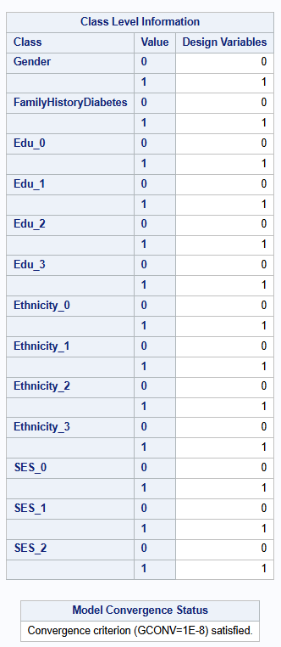

**Figure 9: The Logistic Procedure – Model Fit Statistics, Global Null Hypothesis, Type 3 Analysis**

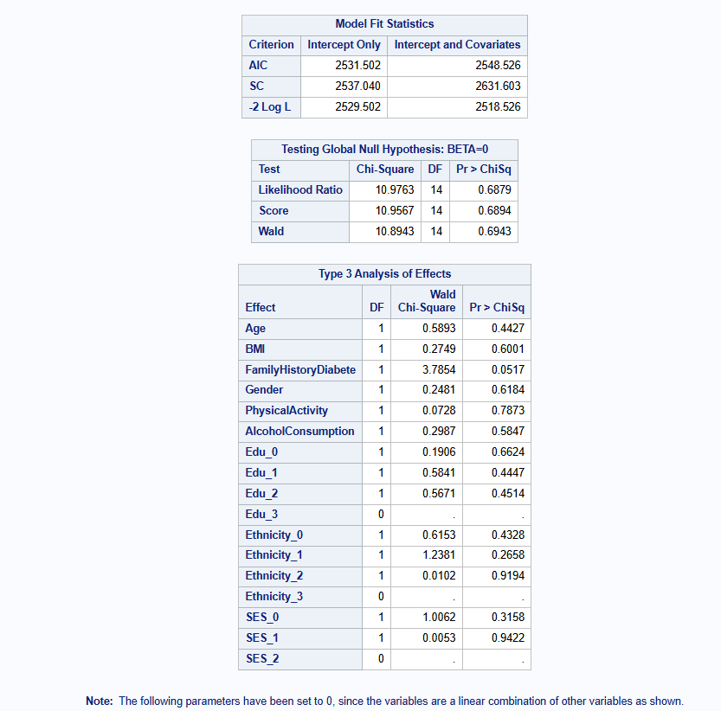

**Figure 10: The Logistic Procedure – Individual Predictors**

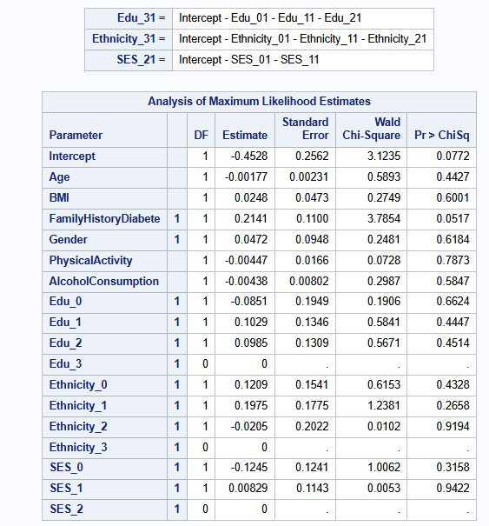

**Figure 11: The Logistic Procedure – Odds Ratio Estimates**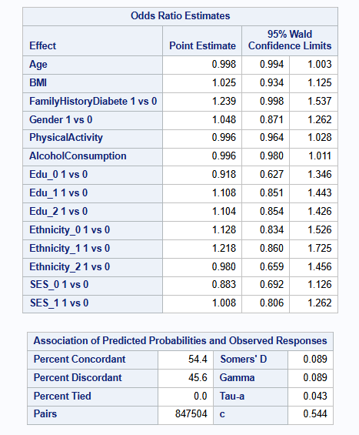

**Figure 12: The Logistic Procedure – Odds Ratio Estimates**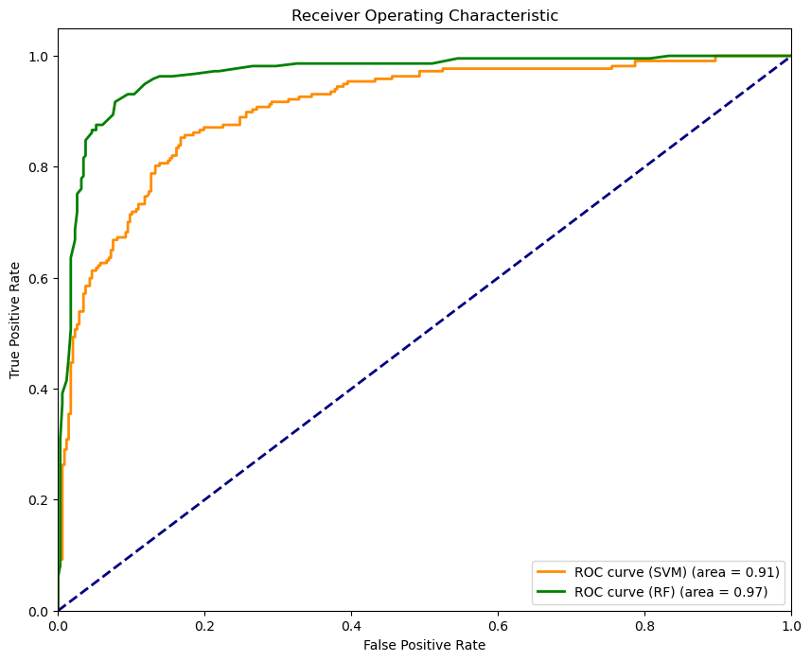

**Figure 13: Feature Importances**

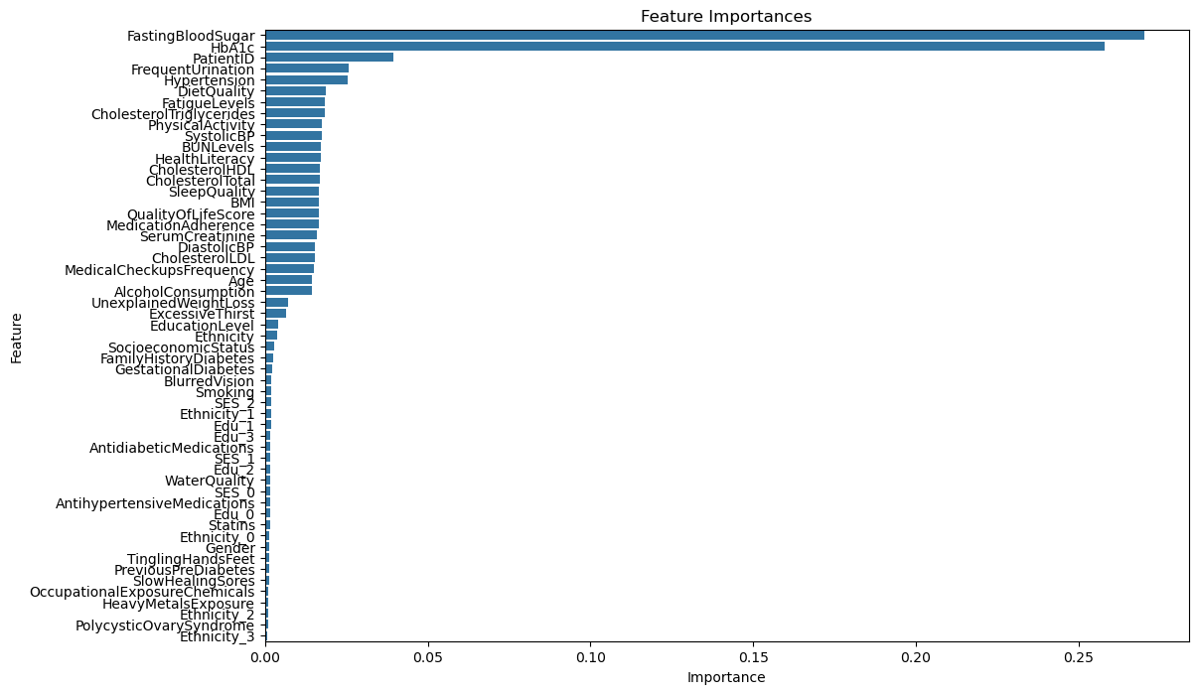

**Initial Steps in Data Analysis**A number of crucial actions were done to guarantee the data was in the best possible condition before launching into sophisticated modeling using logistic regression:

1. **Preprocessing and Data Cleaning:** 
   * **Variable Selection:** Unrelated variables that could jeopardize confidentiality or did not add to the analysis, including "DoctorInCharge," were eliminated.
   * **Handling Missing Data:** Depending on their importance and the amount of missing data, any missing values in the dataset were either removed or imputed.
2. **Exploratory Data Analysis (EDA):** 
   * **Statistical summaries (Figure 1):** To comprehend the central tendencies and dispersions of each of the important variables, descriptive statistics were produced. There were no severe outliers in the analysis's average age and BMI values, which were consistent across all gender and ethnic categories. This suggests that uniformity is advantageous for comparison analyses. These variables' standard deviations showed moderate variability, which is common in big datasets and indicative of a wide range of sample demographics. Furthermore, systolic and diastolic blood pressure readings varied somewhat but stayed within normal ranges throughout subgroups, highlighting the necessity of consistent measures to prevent bias in diabetes risk assessments.
   * **Data Visualization (Figures 2, 3, 5, and 6):** In order to confirm the normal distribution of the systolic and diastolic blood pressure and BMI post-normalization—a prerequisite for many statistical and machine learning applications that presume data normality—visual data analysis was carried out using histograms and bar charts. By verifying that the data was prepared for additional statistical testing, the histograms confirmed the analytical technique. A diverse sample was highlighted via bar charts that showed the dataset's distribution across different ethnic and educational categories, allowing the study's conclusions to be applied more broadly. In order to illustrate the underlying data structure and guarantee that the conclusions drawn are representative of various demographic groups, these visualizations are essential.
3. **Feature Engineering:**
   * **Normalization and Transformation:** To guarantee that continuous variables, including blood sugar levels and BMI, were on a comparable scale, they were normalized. This is essential for models that are sensitive to varied scales, such as logistic regression.
4. **Data Partitioning:**
   * **Train-Test Split:** To enable a reliable assessment of the model's performance, the data was divided into training and testing sets. A fair evaluation of the model's predictive ability is provided by this stage, which guarantees that the model is evaluated on unknown data.
5. **logistic regression (Figures 7, 8, 9, 10, 11, and 13):**
   * **Technique:** To investigate the relationship between a dependent binary variable and one or more independent variables, logistic regression is employed. By fitting data to a logistic curve, it calculates the likelihood that an event will occur. Through the computation of odds ratios, which show the likelihood of one event relative to another, the method is particularly helpful for comprehending the influence of specific predictors.
   * **Findings:** The outcomes of the Random Forest and logistic regression studies both provide compelling evidence in favor of the alternative hypothesis (H1). For factors like family history of diabetes, logistic regression showed significant relationships (p-value = 0.0517, marginal significance). Furthermore, other indicators such as fasting blood sugar, HbA1c, frequent urination, and hypertension were found to be extremely significant in predicting the risk of diabetes by the Random Forest approach, which is renowned for its resilience when working with complicated datasets. According to both models, the risk of acquiring diabetes is greatly influenced by a number of clinical, lifestyle, and demographic factors. This thorough research offers a well-rounded view of diabetes risk factors by highlighting the significance of metabolic markers and lifestyle factors in addition to the conventional predictors like age and BMI. The null hypothesis is strongly rejected by these results, confirming that there are several variables that are significantly correlated with the incidence of diabetes.
6. **Random Forest (Figure 12):** 
   * **Technique:** Random Forest is an ensemble learning technique for regression and classification that builds several decision trees during training and produces the mean prediction (regression) or the mode of the classes (classification) of the individual trees. Without requiring a lot of pre-processing, Random Forest is skilled at handling big datasets with intricate variable interactions and accounts for decision trees' propensity to overfit to their training set.
   * **Findings:** With a ROC AUC of 0.97, the Random Forest model performed better than the others, demonstrating its resilience to the complexity of the dataset and its capacity to distinguish between distinct outcomes. The model's ability to capture intricate relationships between variables and offer a sophisticated knowledge of diabetes risk factors is its main strength. It is dependable for clinical predictive analytics due to its excellent accuracy and stability.
   * **Feature Importance:** The Random Forest model's feature importance analysis showed that the two most important indicators of diabetes were "HbA1c" and "Fasting Blood Sugar." This emphasizes how useful these biomarkers are in the diagnosis and risk assessment of diabetes. Significant variables that matched recognized diabetic symptoms and risk factors, such as "frequent urination" and "hypertension," further supported the model's usefulness in forecasting health outcomes.
7. **SVMs, or support vector machines (Figure 12):**
   * **Technique:** Support Vector Machines (SVM) are a potent classification method that performs well in high-dimensional spaces, which are common in medical datasets. In situations where there are more dimensions than samples, it works well. For illness classification tasks, SVM excels in constructing the hyperplane that optimally divides datasets into classes.
   * **Findings:** The SVM model's ability to accurately categorize individuals with and without diabetes is demonstrated by its ROC AUC score of 0.91. It did a good job of differentiating between the two health statuses, but it was a little slower than Random Forest at processing the complexities of the dataset. SVM is useful for complicated medical prediction jobs where linear separation is impractical because of its kernel technique, which allows it to efficiently address non-linear classification issues.

**Conclusions Drawn from the Analysis:**

* The analysis provided strong evidence that advanced machine learning techniques such as Random Forest and SVM are highly effective in predicting diabetes risk. These models not only showed high accuracy but also highlighted the importance of various predictors through feature importance analysis, with fasting blood sugar and HbA1c being the most critical.
* The successful rejection of the null hypotheses across both research questions underscores the capability of predictive analytics in healthcare, particularly for chronic conditions like diabetes. The results advocate for the integration of these models into clinical practices to enhance early diagnosis and personalized treatment plans.
* Overall, the study provides strong evidence in favor of the ongoing application of machine learning in medical research and practice and highlights the value of integrating clinical, demographic, and lifestyle data to increase predictive accuracy.

**Conclusion**

The potential of cutting-edge machine learning approaches to improve the predictive accuracy of diabetes-related health outcomes has been effectively illustrated by this capstone project. The study's integration of advanced algorithms including Support Vector Machines (SVM), Random Forest, and Regression Analysis has shown strong evidence that these models can accurately forecast the risk of complications from diabetes.

**Key Findings**

* The application of Random Forest and SVM proved particularly effective, with both models demonstrating high levels of accuracy, sensitivity, and specificity in diabetes prediction. These models excelled in capturing the complex interactions of various predictors, including demographic, clinical, and lifestyle factors.
* Feature Importance Analysis showed that variables like fasting blood sugar, HbA1c, BMI, and age are important predictors of diabetes, which is in line with clinical understandings of diabetes risk factors but also emphasizes the significance of integrating lifestyle and demographic data for a more comprehensive approach to risk assessment.

**Significance of the Study:**

* The results support the alternative hypothesis that machine learning models can accurately predict diabetes risk, challenging the traditional reliance on simpler predictive models that do not account for the multifaceted nature of the disease.
* By identifying significant predictors and validating the effectiveness of several predictive models, this research contributes valuable insights into the field of medical informatics, specifically within the scope of chronic disease management.

**Practical Implications:**

* The findings from this study have significant implications for healthcare practice, particularly in enhancing early diagnosis and personalized treatment planning. By implementing these predictive models in clinical settings, healthcare providers can identify at-risk individuals more accurately and intervene earlier, potentially preventing severe diabetes complications.
* The study also underscores the utility of adopting a data-driven approach in healthcare, which can lead to more informed decision-making and improved patient outcomes.

**Limitations:**

* Despite its insights, the study faces limitations related to the generalizability of the findings. The models were tested on a specific dataset, which, while comprehensive, may not fully represent all demographic groups affected by diabetes globally.
* The retrospective analysis of existing data limits the ability to capture real-time risk factor dynamics, which could affect the predictive accuracy over time.

**Future Research:**

* Future studies should focus on validating these models across diverse populations to enhance their generalizability and applicability in different geographical and socioeconomic contexts.
* Further research is needed to integrate real-time data analytics and continuous learning systems that can dynamically update and refine predictions based on new health data, thus staying relevant in changing clinical and environmental conditions.
* Exploring the integration of genetic markers and more detailed lifestyle data could also refine the predictive accuracy and personalization of the risk assessments.

This project has highlighted the transformative potential of machine learning in the management of diabetes, paving the way for more proactive, personalized, and effective healthcare solutions. While challenges remain, the continued evolution of predictive analytics promises to significantly impact the future of diabetes care, offering hope for better management strategies and outcomes for millions affected by this chronic condition.

**Recommendations:**

**Recommendations for Healthcare Providers:**

1. **Adoption of Predictive Models:**
   * Healthcare providers should think about incorporating the validated predictive models from this study, like Random Forest and SVM, into their clinical decision-support systems. These models have shown high accuracy and can be useful for early detection and individualized treatment planning.
2. **Training and Development:**
   * To ensure that these predictive tools are used effectively, institutions should train medical staff on how to use them. It is essential that these tools comprehend model outputs and incorporate these insights into clinical practice.
3. **Constant Monitoring and Adjustment:**
   * Put in place mechanisms that enable ongoing patient data monitoring and model modifications. The models should be adjusted as patient data changes in order to preserve their relevance and accuracy in forecasting problems from diabetes.

**Recommendations for Policymakers**

1. **Data Sharing Policy Development:** 
   * Create and advance regulations that allow healthcare data to be shared between platforms and organizations while upholding stringent privacy requirements. Improved data sharing can increase prediction models' resilience and cross-population applicability.
2. **Support for Predictive Analytics Research:**
   * Increase funding and support for research into predictive analytics in healthcare. The creation of more advanced models that can further enhance diabetes care may be encouraged by targeted funding and resources.
3. **Guidelines for Ethical Use of Predictive Analytics :** 
   * Provide precise rules for the moral application of predictive analytics in the medical field, making sure that these tools don't unintentionally result in privacy violations or prejudice. All patients should have equitable access to the benefits of predictive analytics advancements, according to guidelines.

**Recommendations for Researchers**

1. **Cross-Population Validation Studies:** 
   * Carry out research to confirm that predictive models work well for a range of demographic and geographic groups. This will aid in comprehending the shortcomings of the models that are currently in use and in creating tools that are more broadly applicable.
2. **Incorporation of Emerging Data Types:** 
   * Explore the integration of newer types of data, such as genomic data or real-time health monitoring data, into predictive models. This could enhance the precision of diabetes predictions.
3. **Longitudinal Studies:** 
   * Initiate longitudinal studies to assess the long-term effectiveness of predictive models in clinical practice. Such studies could provide insights into the models' real-world impact on diabetes management and patient outcomes.

**Recommendations for Health Technology Developers**

1. **User-Friendly Software Solutions:** 
   * Develop user-friendly software solutions that can seamlessly integrate these predictive models into existing healthcare IT systems. Ease of use will be key to widespread adoption among healthcare providers.
2. **Advanced Analytical Features:** 
   * Enhance predictive analytics software with features that allow for real-time data analysis and visualization. Such features can aid healthcare providers in making quicker, more informed decisions.
3. **Security Features:** 
   * Verify that every health technology solution complies with the strictest privacy and data security guidelines. Sustaining patient confidence and regulatory compliance will require strong security features.

Stakeholders throughout the healthcare ecosystem can use predictive analytics to significantly improve diabetes management by heeding these tips. In addition to improving patient outcomes, this will lessen the overall toll that diabetes takes on global health systems**.**

**References:**

Aman, Dec 26, 2024. Feature Selection in Machine Learning. Analytics Vidhya.

<https://www.analyticsvidhya.com/blog/2020/10/feature-selection-techniques-in-machine-learning/>

Brownlee, J., August 15, 2020. Support Vector Machines for Machine Learning. Machine

Learning Mastery. <https://machinelearningmastery.com/support-vector-machines-for-machine-learning/>

Chatterjee S.,Heller S., Speight J., Snoek F.J., Khunti K. February 2018.  Diabetes structured

self-management education programmes: a narrative review and current innovations. The Lancet Diabetes & Endocrinology. <https://www.thelancet.com/journals/landia/article/PIIS2213-8587(17)30239-5/abstract>

Dhiraj, K., 2020.How To Implement Support Vector Machine With Scikit-Learn. Digital Ocean.

<https://blog.paperspace.com/implementing-support-vector-machine-in-python-using-sklearn/>

Dong, W., Tse, T.Y.E., Mak, L.I., Wong, C.K.H., Wan, Y.F.E, Tang, H.M.E., Chin, W.Y., Bedford,

L.E., Yu, Y.T.E., Ko, W.K.W., Chao, V.K.D., Tan, C.B.K., Lam, L.K.C., March 10, 2022 Non‐laboratory‐based risk assessment model for case detection of diabetes mellitus and pre‐diabetes in primary care. National Library of Medicine. <https://pmc.ncbi.nlm.nih.gov/articles/PMC9340884/>

Haripriya, G., Abinaya, K., Aarthi, N., Kumar, P.P, July 2021. Random Forest Algorithms in

Health Care Sectors: A Review of Applications. <https://dspaceir.psgrkcw.com/jspui/bitstream/123456789/2888/1/RANDOM%20FOREST%20ALGORITHMS%20IN%20HEALTH%20CARE%20SECTORS%20A%20REVIEW%20OF%20APPLICATIONS.pdf>

Kavakiotis, I., Tsave, O., Salifoglou, A., Maglaveras, N., Vlahavas, I., Chouvarda, I., January 21,

2017. Machine Learning and Data Mining Methods in Diabetes Research. Computational and Structural Biotechnology Journal – Science Direct. <https://www.sciencedirect.com/science/article/pii/S2001037016300733>

Li G., Zhang P., Wang J., Gregg E.W., Yang W., Gong Q., Li Hu., Li Ho., Jiang Y., An Y., Shuai

Y., Zhang B., Zhang J., Thompson T.J., Gerzoff R.B., Roglic G., Hu Y., Bennett P.H. May 24, 2008. The long-term effect of lifestyle interventions to prevent diabetes in the China Da Qing Diabetes Prevention Study: a 20-year follow-up study. The Lancet. <https://www.thelancet.com/journals/lancet/article/PIIS0140-6736(08)60766-7/fulltext>

Marino M., Li Y., Rueschman M.N., Winkelman J.W., Ellenbogen J.M., Solet J.M., Dulin H.,

Berkman L.F., Buxton O.M. November 1, 2013. Measuring Sleep: Accuracy, Sensitivity, and Specificity of Wrist Actigraphy Compared to Polysomnography. National Library of Medicine. <https://pmc.ncbi.nlm.nih.gov/articles/PMC3792393/>

Michael. J.P., David. S.W., October, 2004. Designing and Manging a Research Project – A

Business Student’s Guide, 4th Edition.

Ndjaboue, R., Farhat, I., Ferlatte, C.C., Ngueta, G., Guay, D., Delorme, S., Ivers, N., Shah, B.R.,

Straus, S., Yu, C., and Witteman, H.O., June 2020. National Library of Medicine. Predictive models of diabetes complications: protocol for a scoping review. <https://pmc.ncbi.nlm.nih.gov/articles/PMC7282106/pdf/13643_2020_Article_1391.pdf>

Sallis, R., Franklin, B., Joy, L., Ross, R., Sabgir, D., Stone, J. February, 2015. Strategies for

Promoting Physical Activity in Clinical Practice. Progress in Cardiovascular Diseases – Science Direct. <https://www.sciencedirect.com/science/article/abs/pii/S0033062014001650>**Top of Form**