Experiment: 6
5G NR Frame Structure Analysis with Different Subcarrier Spacing
RESULT
OB-1:
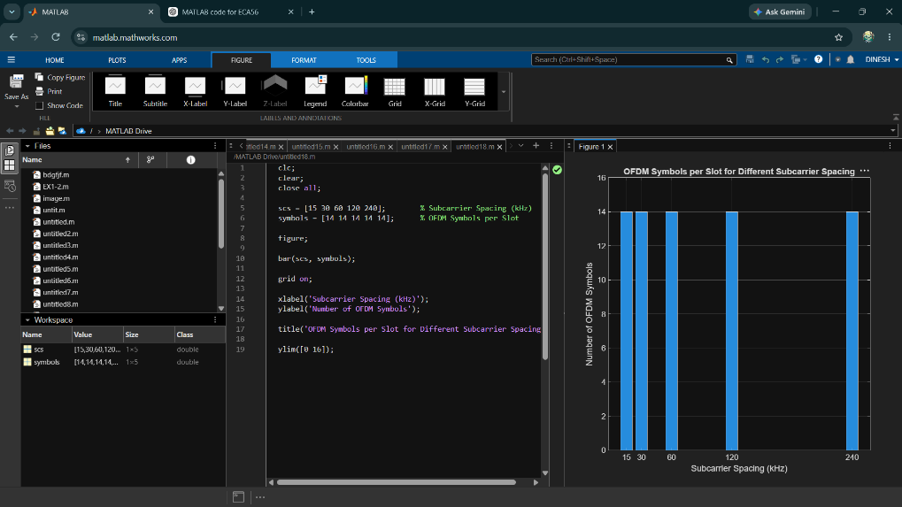
OB-2:
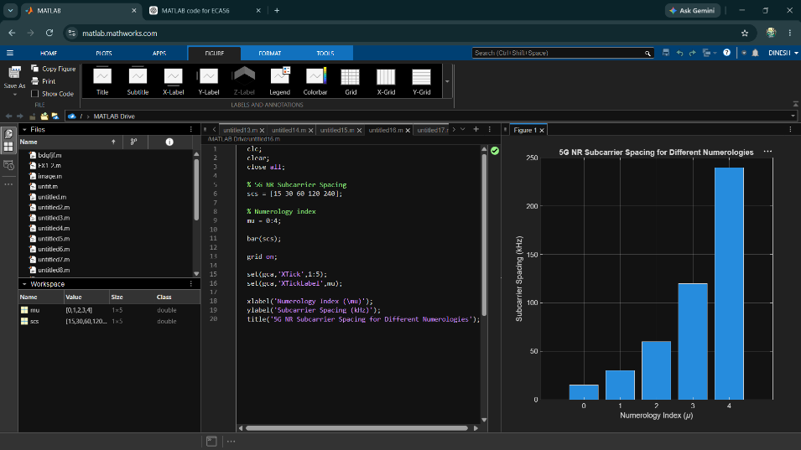

OB-3:
