Ex.No.4: OFDMA Resource Block Allocation Date
RESULT:
OB-1:
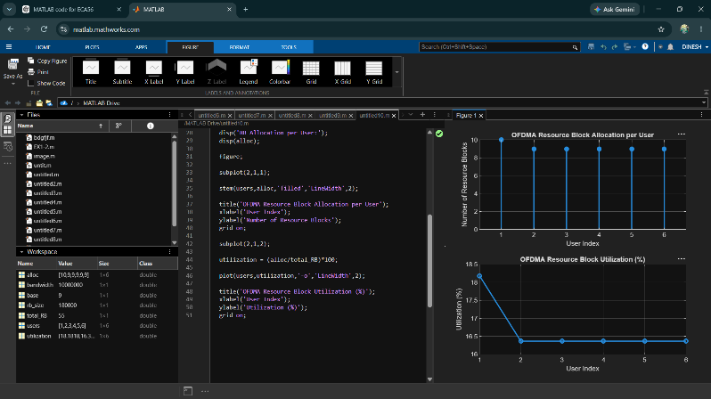
OB-2:
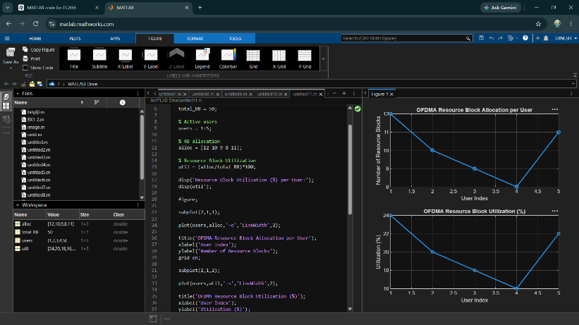
OB-3:
