Ex.No.5: MIMO System Simulation with BER Analysis Data
RESULT:
OB1-
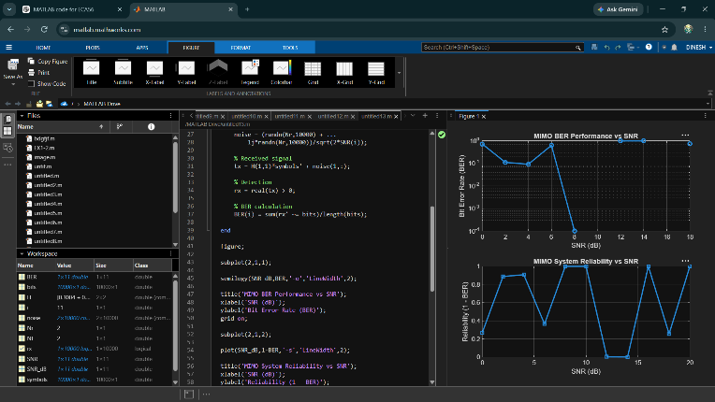
OB2-
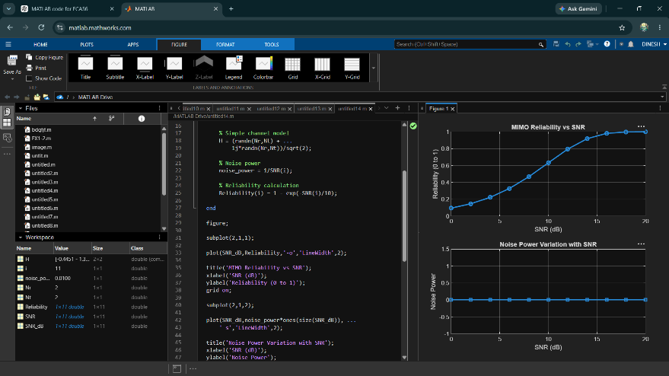
OB-3
