ExNo:1: Simulation of FDMA in MATLAB

RESULTS:
OB-1
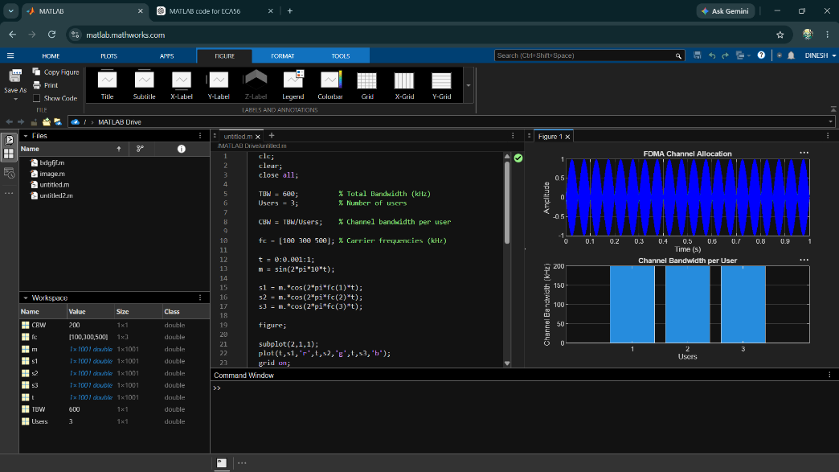

OB-2
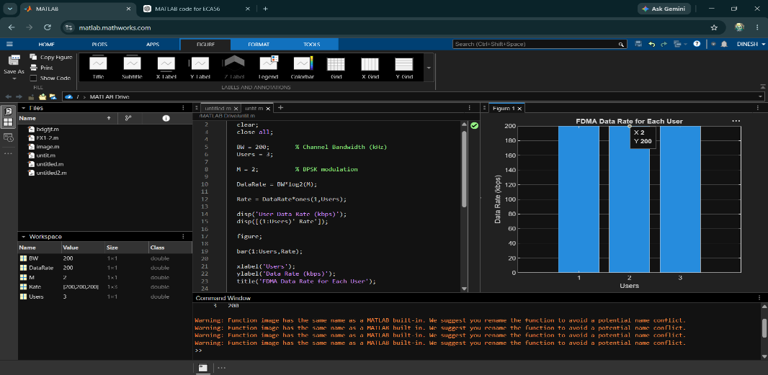

OB-3
