ExNo - 2: Implementing TDMA Slot Allocation
RESULTS:
OB-1
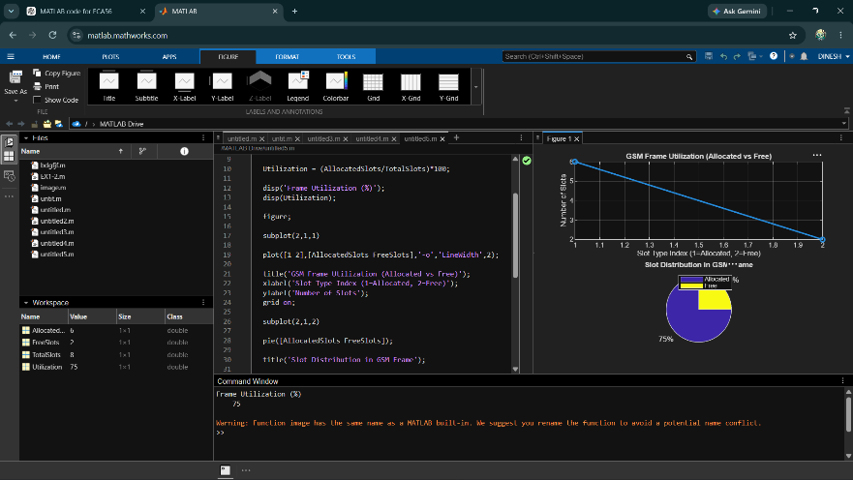
OB-2
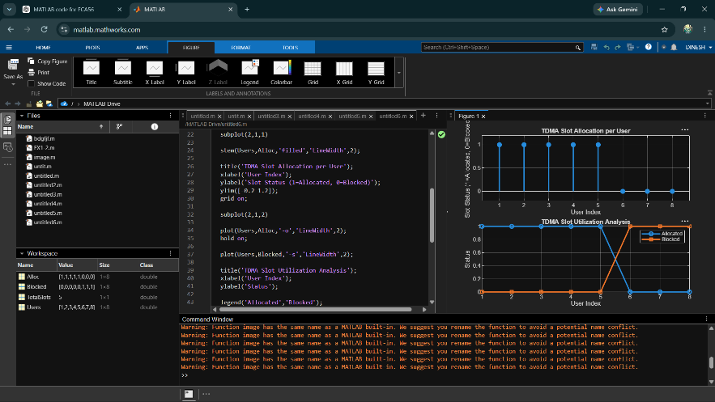
OB-3
