Ex.N.3: Spectrum Analysis of Sub-1 GHz, Mid-band & mmWave by Plotting Propagation Loss
RESULT:
OB-1
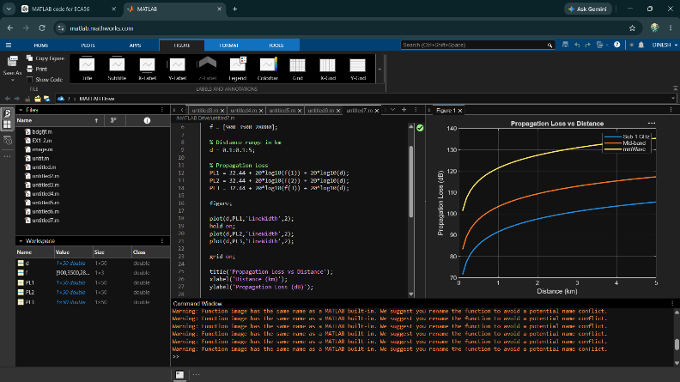
OB-2
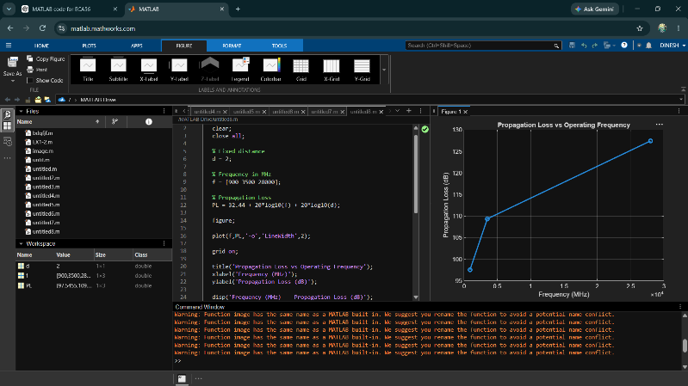
OB-3
