Python Assessment

Dinesh Kumar. B

Question: Write a python program for converting json file csv file

Program link:

<https://github.com/dineshkumar27471/json-to-csv-in-python.git>

output:

JSON FILE: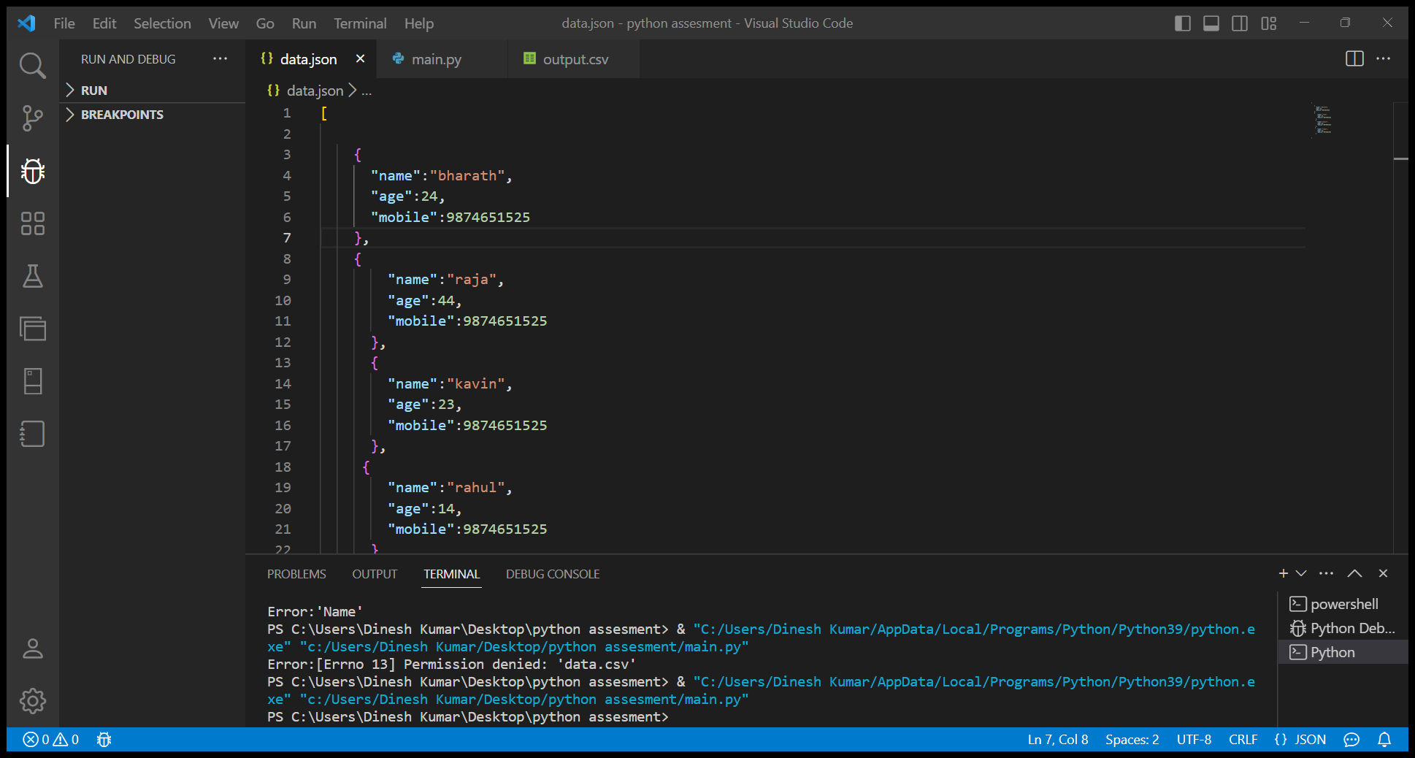

Python file:

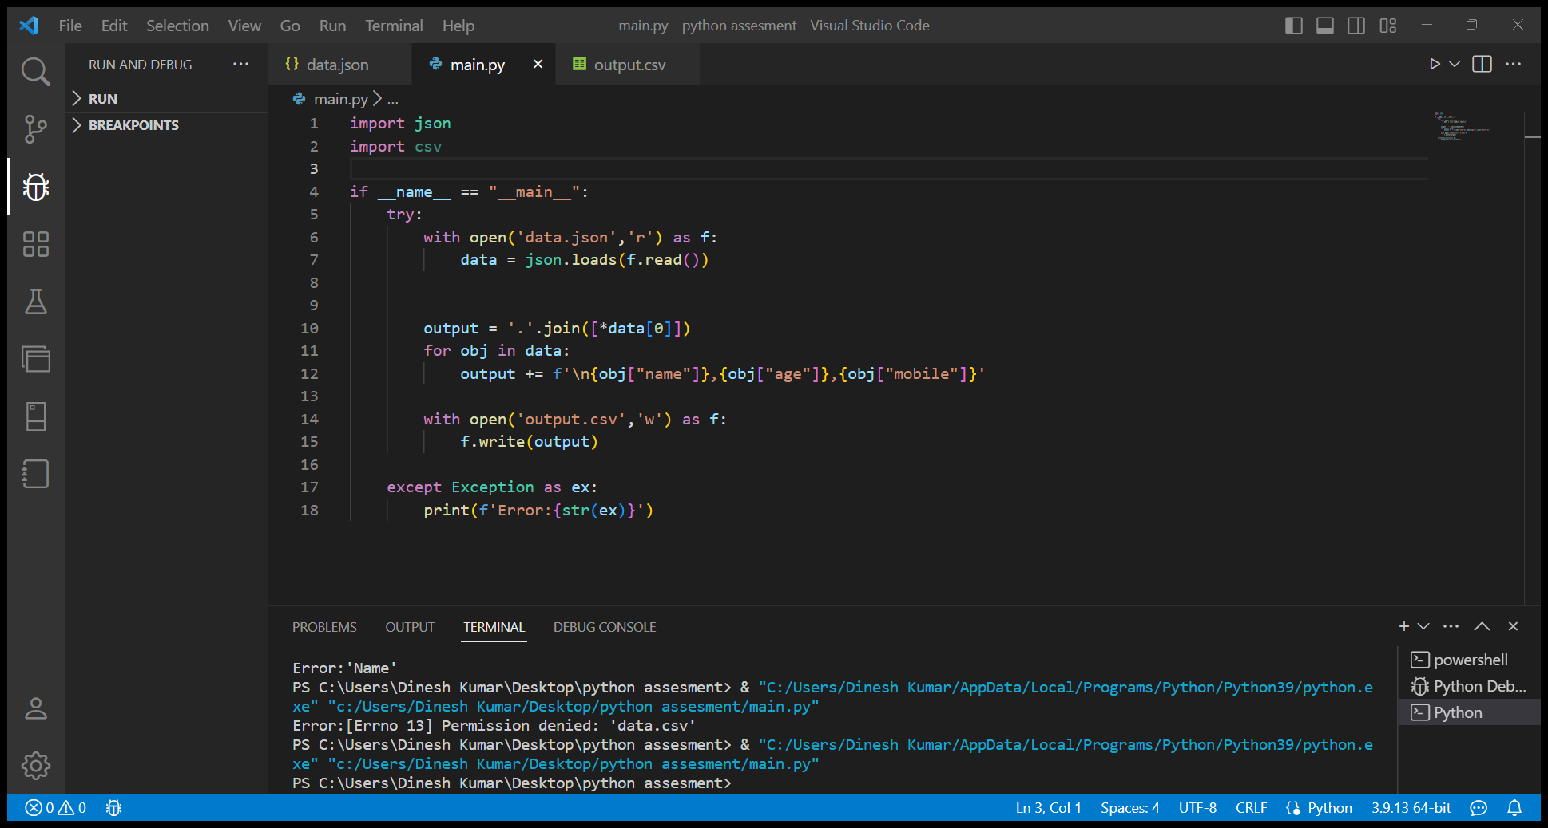Final output:

