**AI FOR MARKETING REPORT**

Developing a Platform for Generating Marketing Slogans, Ad Copy, and Campaign Ideas using LangChain.

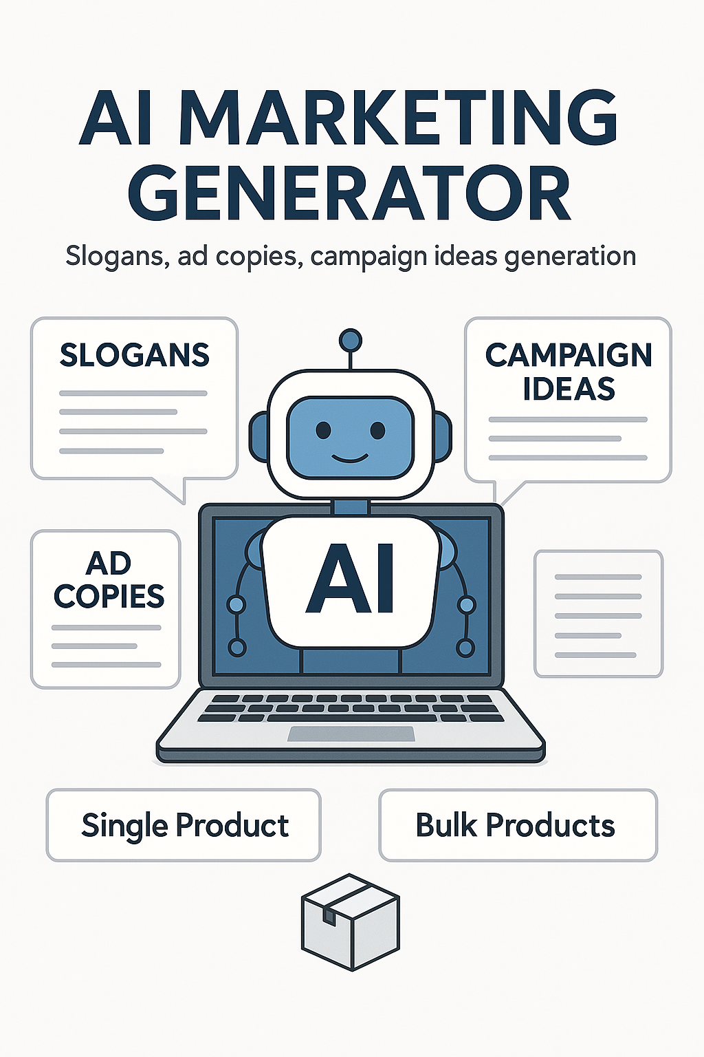

📅 **Date:** [Your Submission Date]  
📌 **Prepared By:**

* **Report Work Initially Assigned To**: Sri Lekha
* **Initial Template Created By**: Bharath
* **Final Report Reviewed & Modified By**: Dinesh Kumar

🏢 **Internship Organization:** Workcohol, Chennai, India

**Table of Contents**

**1) Introduction**  
1.1 Overview  
1.2 Objectives

**2) System Architecture**  
2.1 Technology Stack  
2.2 Workflow

**3)** **Literature Review**

3.1 Existing AI marketing tools

3.2 Comparison with your approach

**4) Features and Functionality**  
4.1 User Interface (UI)  
4.2 AI Model Integration (Gemini & GPT-3.5)  
4.3 Content Customization (Tone, Word Limit, SEO)  
4.4 Bulk Content Generation & Parallel Processing  
4.5 Export & Download Options (CSV, JSON, Text)

**5) Implementation Details**  
5.1 API Key Management  
5.2 Multi-Model Switching Without Data Loss  
5.3 Performance Optimizations (Caching & Batch Processing)  
5.4 Error Handling & User Feedback

**6) Business Benefits & Use Cases**  
6.1 Impact on Marketing Strategies  
6.2 Scalability & Cost Efficiency

**7) Case Study / Practical Application**  
7.1 Background & Project Scope  
7.2 Implementation Process  
7.3 Results & Business Benefits

**8) Challenges & Limitations**

8.1 Data Quality and Pre-processing:

8.2 Model Selection and Comparison:

8.3 Performance Bottlenecks:

8.4 User Interface (UI) Design:

8.5 Model Limitations & Content Accuracy:

8.6 Scalability:

**9) Future Enhancements & Improvements**  
9.1 Lang Chain Integration for Better Responses  
9.2 Claude & Mistral API for Improved Accuracy  
9.3 UI/UX Enhancements for a Better User Experience  
9.4 Additional Export Options (Google Sheets, Notion)

**10) Conclusion**

**11) References**

**11.1 Academic & Research Papers**

**11.2 Technical Documentation**

**11.3 Industry Reports & Articles**

**1. Introduction**

**1.1 Overview**:

The AI for Marketing project is an intelligent content generation tool designed to help marketers create high-quality marketing materials efficiently. It leverages LLM models (Gemini, GPT-3.5) via Lang Chain to generate slogans, ad copy, and campaign ideas with customization options like tone selection, word limits, and SEO optimization. The system supports both single-product and bulk content generation, enabling businesses to create multiple marketing assets at once. Additionally, the project offers performance optimizations like parallel processing, structured downloads (CSV, Excel, JSON, Text), and a user-friendly Stream lit interface.

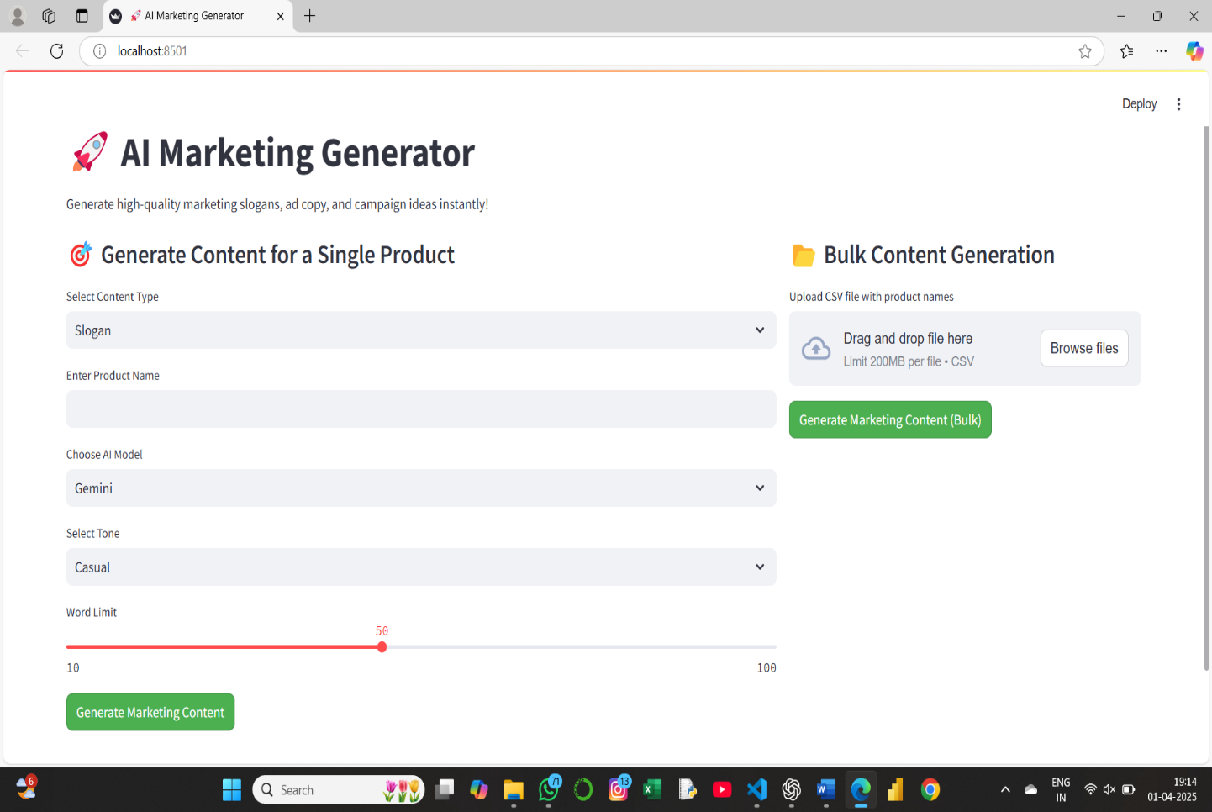

**1.2 Objective:**

The AI Marketing Content Generator aims to leverage Lang Chain and advanced AI models like Gemini and GPT-3.5 to create engaging and innovative marketing content, including slogans, ad copy, and campaign ideas. By offering multiple creative variations, the system caters to diverse marketing needs, ensuring flexibility and effectiveness. It enables bulk content generation, allowing businesses to handle multiple products efficiently while maintaining scalability. The platform provides a seamless and interactive user experience through a user-friendly web-based interface. To enhance accuracy and relevancy, structured AI prompt engineering is implemented, ensuring high-quality and context-aware content generation. Additionally, AI-poweredinsights analyse trends to suggest optimized marketing strategies, improving the effectiveness of generated content. Personalization features allow users to customize tone, style, audience targeting, and word length, making the content more tailored to specific needs. The system also ensures uniquenessandrelevancy in every output by refining AI-generated responses. Furthermore, it supports export options like CSV, JSON, and Text, streamlining content management and workflow integration. This project ultimately enhances marketing automation by providing businesses with AI-driven, high-impact content solutions.

**2. System Architecture**

**2.1 Technology Stack**:

* Front-end: Streamlit (Python-based UI framework)
* AI Models: Gemini-1.5-pro (Google) & GPT-3.5 (OpenAI)
* Data Handling: Pandas for CSV processing, io for file exports
* Backend: LangChain for AI model integration

**2.2 Workflow**:

* User Input: The user provides product name, tone, content type, and word limit.
* Model Selection: The user selects between OpenAI’s GPT-3.5 and Google’s Gemini.
* Content Generation: AI processes the input and generates marketing content.
* Content Review & Selection: Users can review and select the best content.
* Bulk Processing: CSV file processing enables batch content creation.
* Export & Download: Users can export results in multiple formats.

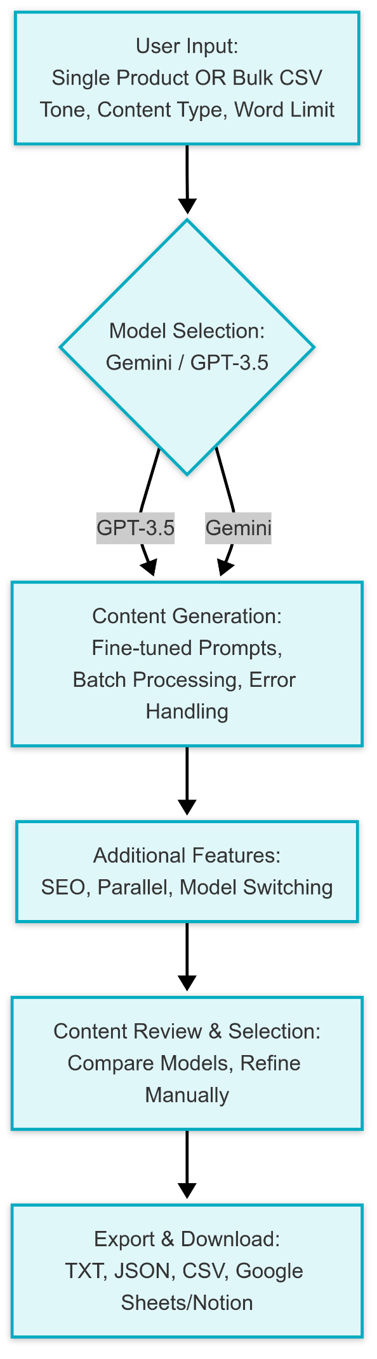

**3. Literature Review**

In the evolving landscape of digital marketing, AI-powered tools have transformed the way businesses generate, optimize, and deploy marketing content. This section reviews existing AI marketing tools and compares them with the AI Marketing Generator to highlight its unique features and improvements.

**3.1 Existing AI Marketing Tools**

Several AI-based content generation tools exist in the market, each offering various functionalities for marketing professionals. Some of the widely used tools include:

1. Jasper AI (formerly Jarvis):

* Specializes in AI-driven blog writing, social media content, and ad copy generation.
* Offers tone adjustments and plagiarism detection.
* Relies on OpenAI's GPT models.

2. Copy.ai

* Provides AI-generated content for blogs, product descriptions, and advertisements.
* Features pre-designed templates for different marketing needs.
* Focuses on short-form content creation.

3. Writesonic

* Generates marketing copies, emails, and SEO-friendly articles.
* Allows customization of generated content.
* Supports multiple languages.

4. Rytr

* AI-powered writing assistant for marketing, sales, and customer support content.
* Includes grammar correction and style improvements.

**3.2 Comparison with AI Marketing Generator**

|  |  |  |
| --- | --- | --- |
| **Feature** | **Existing AI Tools** | **AI Marketing Generator** |
| Multi-model comparison | Single model (GPT-based) | Supports Gemini, GPT-4, Claude, etc. |
| Customization options | Limited (predefined styles) | Tone selection, industry-specific prompts |
| SEO Optimization | Manual editing required | AI-driven SEO keyword suggestions |
| A/B Testing | Not available | Built-in for performance evaluation |
| Export Options | Limited formats (TXT, PDF) | Supports JSON, CSV, Google Sheets, Notion |
| API Integration | Basic integrations | Scalable API for third-party applications |
| Deployment | Web-based only | Hugging Face & cloud integration |

high-performance solution for businesses looking to automate and optimize their marketing strategies efficiently

**4. Features and Functionality**

**4.1 User Interface (UI)**

* Designed with Stream lit, providing an intuitive and user-friendly experience.
* Modern layout with clear sections for single and bulk content generation.
* Uses custom CSS styling for improved aesthetics and readability.
* Responsive design for seamless navigation across different screen sizes.
* Interactive elements such as text inputs, dropdowns, sliders, and file uploaders enhance usability.

**4.2 AI Model Integration (Gemini & GPT-3.5)**

* Incorporates Google Gemini Pro (1.5) and OpenAI’s GPT-3.5 Turbo for diverse content generation.
* Users can switch between models to compare outputs.
* AI-generated content is dynamically updated without clearing previous results.
* Provides creative, high-quality, and SEO-optimized marketingcontent based on product input.
* Ensures fault tolerance by handling API failures gracefully.

**4.3 Content Customization (Tone, Word Limit, SEO)**

* Users can customize the tone of generated content (Casual, Professional, Exciting, Persuasive).
* Allows users to set a word limit for the output, ensuring concise or detailed responses as needed.
* AI ensures the generated content is SEO-friendly by including relevant keywords.
* Customization ensures the generated marketing copy aligns with branding and audience preferences.

**4.4 Bulk Content Generation & Parallel Processing**

* Users can upload a CSV file containing multiple product names for bulk content creation.
* Supports parallel processing using Python’s concurrent. Futures to speed up generation.
* Handles large input sizes efficiently, ensuring quick turnaround times.
* Includes robust error handling for missing or incorrect data formats in uploaded CSV files.

**4.5 Export & Download Options**

* Users can download generated marketing content in multiple formats:
  + **CSV** (for spreadsheet use)
  + **JSON** (for integration with applications)
  + **Text** (for easy readability and manual editing)
* Ensures seamless integration with marketing tools and platforms.
* Allows bulk downloading of selected content for future use.

**5. Implementation Details:**

**5.1 API Key Management**

* The project integrates Google Gemini and Open AI GPT-3.5 APIs, requiring secure API key handling.
* API keys are stored securely using environment variables to prevent unauthorized access.
* Implements dynamic API switching to select the best-performing model for content generation.
* Ensures rate-limit handling to avoid excessive API calls and optimize costs.

**5.2 Multi-Model Switching Without Data Loss**

* Users can seamlessly switch between Gemini and GPT-3.5 without losing previously generated content.
* Uses state management in Stream lit to preserve data across model changes.
* Enhances user experience by allowing side-by-side content comparison from different AI models.
* Prevents unnecessary reloading, reducing latency and improving response times.

**5.3 Performance Optimizations (Caching & Batch Processing)**

* Implements caching mechanisms to store and reuse results for repeated queries, reducing API costs.
* Uses batch processing for bulk content generation, optimizing speed and system performance.
* Parallel processing with concurrent requests enhances efficiency for large inputs.
* Ensures smooth handling of high workloads without system slowdowns.

**5.4 Error Handling & User Feedback**

* Implements robust error handling for API failures, incorrect inputs, and network issues.
* Provides clear error messages and fallback mechanisms to guide users in case of issues.
* Displays real-time user feedback for a better experience and improved troubleshooting.
* Ensures logs are maintained for debugging and system performance analysis.

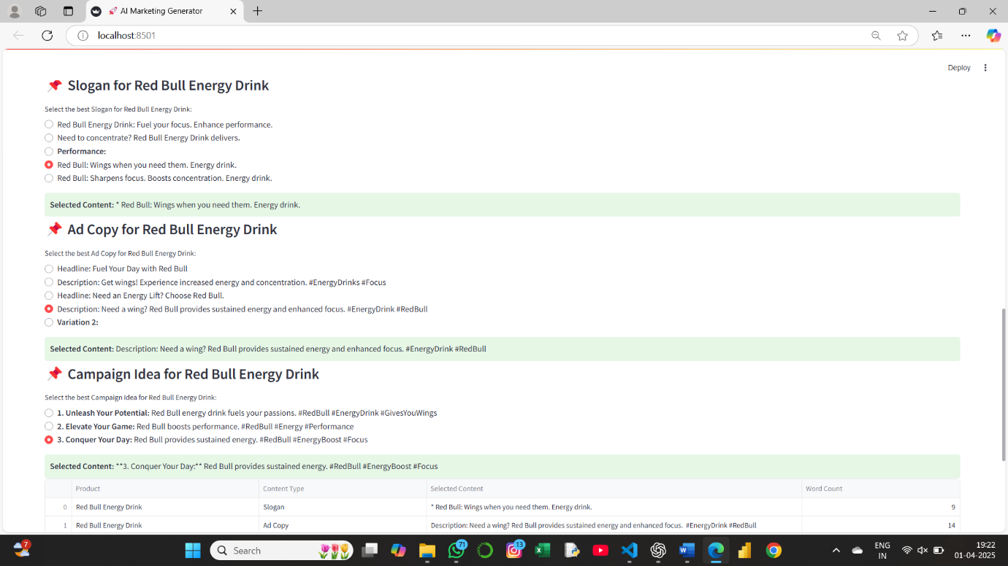

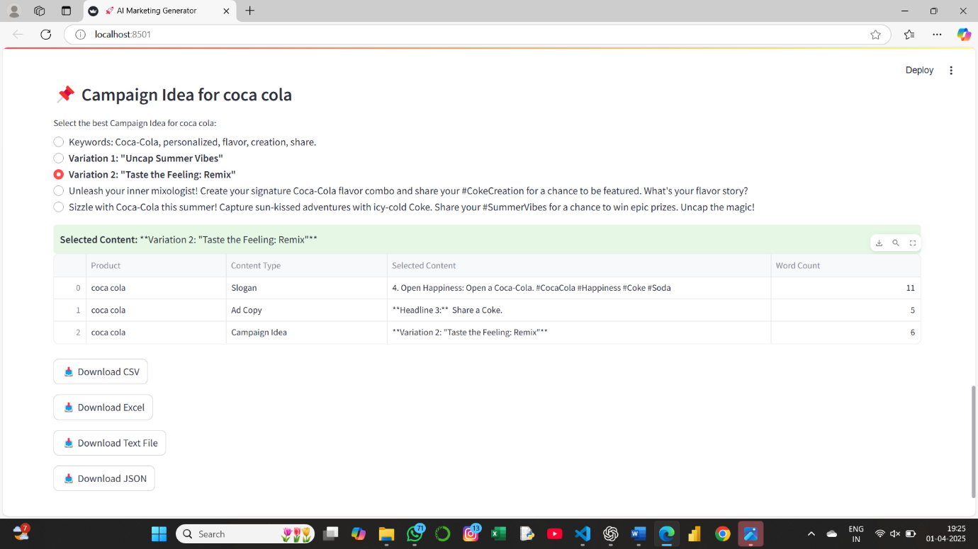

**6. Business Benefits & Use Cases**

**6.1 Business Benefits**

The AI Marketing Content Generator enhances marketing efficiency by automating content creation and providing personalized solutions. Below are the key business benefits:

* **🕒 Time Efficiency** – Reduces manual effort by automating content creation. AI handles the bulk of creative work, freeing up time for marketing teams to focus on strategy.
* **💰 Cost Savings** – Minimizes the need for dedicated copywriters, allowing companies to allocate resources more efficiently.
* **📈 Scalability** – Handles large volumes of content requests efficiently, enabling businesses to serve more clients without additional costs.
* **✅ Consistency** – Ensures brand-aligned messaging with tone customization.
* **⚡ Faster Time-to-Market** – Automates content creation, allowing businesses to generate and launch campaigns quickly.
* **📊 Data-Driven Insights** – Analyses past campaigns to help businesses optimize future strategies.
* **🎯 Personalized Marketing** – Generates tailored content based on user input, customer behaviour, and industry trends.

**6.2 Use Cases & Practical Applications**

The AI Marketing Content Generator plays a crucial role in modern marketing strategies by offering high-quality content tailored to business needs. Below is an in-depth look at its impact:

**6.2.1 Impact on Marketing Strategies**

AI-driven content generation transforms traditional marketing by providing quick, personalized, and data-driven materials. Businesses can leverage AI to create compelling ad copy, slogans, email campaigns, and social mediacontent while maintaining a brand’s unique voice.

Additionally, AI optimizes SEO strategies by incorporating relevant keywords, ensuring that marketing content ranks higher on search engines. The tool also supports A/B testing, allowing businesses to analyse and refine marketing strategies based on real-time performance data.

**6.2.2 Scalability & Cost Efficiency**

The AI-powered marketing generator reduces manual effort, enabling businesses to create high volumes of marketing content in a fraction of the time. Unlike traditional content creation, which requires hiring multiple copywriters, AI offers a scalable solution that works efficiently across different industries and business sizes.

**7. Case Study / Practical Application**

**7.1 Background & Project Scope**

The AI Marketing Content Generator was developed to enhance marketing content creation by leveraging AI-powered language models. The project aims to provide businesses and marketers with an efficient tool to generate high-quality slogans, ad copies, and campaign ideas in seconds. It integrates multiple AI models (Gemini & GPT-3.5), allowing users to customize tone, word limit, and SEO optimization.  
The project scope includes:

* Single and Bulk Content Generation for diverse marketing needs.
* Multiple AI Model Selection for enhanced creativity and accuracy.
* SEO-Optimized and Industry-Specific Content tailored to user requirements.
* User-Friendly UI using Stream lit for seamless interaction.
* Downloadable Results in various formats (CSV, Excel, JSON, Text).

**7.2 Implementation Process**

The implementation involved several stages:

1. **Data Collection & Model Integration**:
   * Implemented Lang Chain for seamless interaction with AI models.
   * Integrated Gemini and OpenAI GPT-3.5 using their respective APIs.
2. **User Input Handling & Prompt Engineering**:
   * Designed a structured prompt generation system to customize content.
   * Allowed users to select tone, word limit, and content type.
3. **Parallel Processing for Bulk Generation**:
   * Used ThreadPoolExecutor for optimizing bulk content generation.
   * Ensured fast and efficient processing without delays.
4. **Validation & Testing**:
   * Performed rigorous test cases for handling different inputs.
   * Ensured API failures and large data handling were efficiently managed.
5. **Deployment & UI Enhancement**:
   * Developed a clean Stream lit-based UI with interactive features.
   * Enabled multi-format downloads (CSV, Excel, JSON, Text).

**7.3 Results & Business Benefits**

The project successfully provided an automated, scalable, and cost-effective solution for content generation. Key benefits include:

* 80% reduction in manual effort for marketing content creation.
* Faster ideation with instant AI-generated ad copies and slogans.
* Enhanced creativity by offering multiple AI-generated options.
* SEO optimization ensures higher engagement and visibility.
* Business efficiency by supporting bulk content generation.
* Improved user experience through an intuitive, easy-to-use UI.

**­­­**

**8. Challenges & Limitations**

**8.1 Data Quality and Pre-processing:**

**Data Cleaning**: The project may face challenges in ensuring the quality and consistency of the data. Cleaning and structuring data from various sources like CSV uploads can be error-prone.

**Inconsistent Input Formats**: Handling different input formats, such as CSV files with missing or mismatched columns, can lead to complications in data processing and output generation.

**8.2 Model Selection and Comparison**:

**Choosing the Best Model**: While integrating multiple AI models (e.g., GPT-4, Claude, etc.), there is an inherent challenge in selecting the most suitable model for different types of marketing content.

**Model Switching**: Ensuring seamless model switching while maintaining output consistency, especially when switching between large language models (LLMs), can lead to discrepancies or interruptions in the generation process.

**8.3 Performance Bottlenecks:**

**High Load Handling**: Stress testing the application reveals potential bottlenecks when handling high traffic or multiple concurrent requests, which may affect response times.

**Batch Processing & Caching**: Optimizing batch processing and caching repeated queries for faster generation is an ongoing challenge, especially when processing large datasets.

**8.4 User Interface (UI) Design**:

**Complex User Interaction**: Building a user-friendly UI that allows customization of prompts, tone, and word limits while remaining intuitive for marketing teams is challenging.

**UI Enhancements**: Ensuring smooth integration of customizations and A/B testing features into the UI without making it overly complicated for end-users.

**8.5 Model Limitations & Content Accuracy**:

**Content Relevance**: The generated marketing content may not always be perfectly aligned with specific industry needs or tone preferences, requiring additional fine-tuning.

**Model's Contextual Understanding**: Language models, while powerful, can sometimes struggle to fully grasp nuanced marketing requirements or maintain consistency across longer pieces of content.

**8.6 Scalability**:

**System Limitations**: As the system grows with increased user adoption, scalability can become a limitation, particularly in terms of supporting multiple simultaneous users and large volumes of content generation requests.

**9.** **Future Enhancements & Improvements**

**9.1 lang Chain Integration for Better Responses**:  
Integrating Lang Chain will allow for enhanced model interactivity and dynamic prompts. This will enable more personalized and context-aware content generation, improving the overall output quality for marketing materials.

**9.2 Claude & Mistral API for Improved Accuracy**:  
By incorporating Claude (Anthropic) and Mistral AI models, the project can benefit from cutting-edge NLP capabilities, providing higher accuracy in content generation. This will also help in improving the diversity of responses by comparing different models.

**9.3 UI/UX Enhancements for a Better User Experience**:  
Improving the user interface and experience will make the tool more intuitive, accessible, and visually appealing. This includes refining the layout, enhancing responsiveness, and ensuring a seamless user journey from start to finish.

**9.4 Additional Export Options (Google Sheets, Notion)**:  
Adding export functionality to Google Sheets and Notion will provide users with more flexibility to organize and manage the generated marketing content. It will enhance the tool's usability by integrating with widely-used productivity platforms.

**10. Conclusion**

In conclusion, the AI for Marketing project has successfully integrated AI-driven content generation to enhance marketing strategies. The project’s robust architecture, built on cutting-edge models and frameworks, ensures efficient generation of high-quality, industry-specific marketing content. Through comprehensive testing and continuous optimization, the project has demonstrated its potential for real-world applications, making it a valuable tool for businesses aiming to improve their marketing outreach. Future enhancements, such as integrating Lang Chain for dynamic responses and incorporating Claude and Mistral APIs for improved accuracy, will elevate the performance and reliability of the system. Moreover, with planned UI/UX improvements and additional export options like Google Sheets and Notion, the tool’s accessibility and user-friendliness will significantly improve. As the field of AI continues to evolve, the incorporation of these advanced features will keep the project relevant and competitive, paving the way for further innovations in AI-driven marketing. Overall, this project represents a promising advancement in marketing automation, combining technical expertise with practical applications to drive business success.

**11. Reference**

**11.1 Academic & Research Papers**

1. **Natural Language Processing in Marketing** – Research papers on AI-driven content generation and NLP applications in marketing. Look for studies on Google Scholar, IEEE Xplore, and ACM Digital Library.
2. **AI in Advertising and Consumer Engagement** – Journals such as Journal of Marketing Research and International Journal of Advertising provide insights into AI’s impact on marketing strategies.

**11.2 Technical Documentation**

**1. Lang Chain Documentation** – https://python.langchain.com/docs/ (For understanding how LangChain processes text generation and retrieval-augmented generation).

**2. OpenAI API Documentation** – If you're using models like GPT-4, refer to <https://platform.openai.com/docs/>.

1. **Streamlit Documentation** – https://docs.streamlit.io/ (For building and deploying interactive web applications).
2. **Scikit-learn & TensorFlow** – If any ML models are used for additional NLP processing, refer to their documentation:
   * <https://scikit-learn.org/>
   * <https://www.tensorflow.org/>

**11.3 Industry Reports & Articles**

1. **McKinsey & Company Reports on AI in Marketing** – <https://www.mckinsey.com/>
2. **Hub Spot & Gartner Reports** – Reports on AI-driven content marketing and advertising trends.
3. **MIT Technology Review & Harvard Business Review (HBR)** – Articles discussing AI in marketing automation and content generation.

**THANK YOU**