E-commerce Data Processing Project Documentation

Introduction
This documentation outlines E-commerce Data Processing Project, built on Databricks using the Medallion Architecture. Its core goal is to transform raw sales data into actionable business insights through a scalable, efficient, and reliable solution.

Medallion Architecture: Our Data Blueprint
We've adopted the Medallion Architecture, a proven data design pattern, to structure our data lake. This layered approach progressively refines and enriches data, boosting quality, reliability, and traceability.

Bronze (Raw) Layer
Directly ingests raw data from source systems with minimal or no changes, serving as an immutable historical record.

Silver (Enriched/Refined) Layer
Focuses on cleaning, filtering, and enriching data, combining various sources and resolving quality issues.

Gold (Curated/Consumption) Layer
The final layer, highly aggregated and denormalized for direct business consumption and analytics. It's optimized for BI tools and reporting.

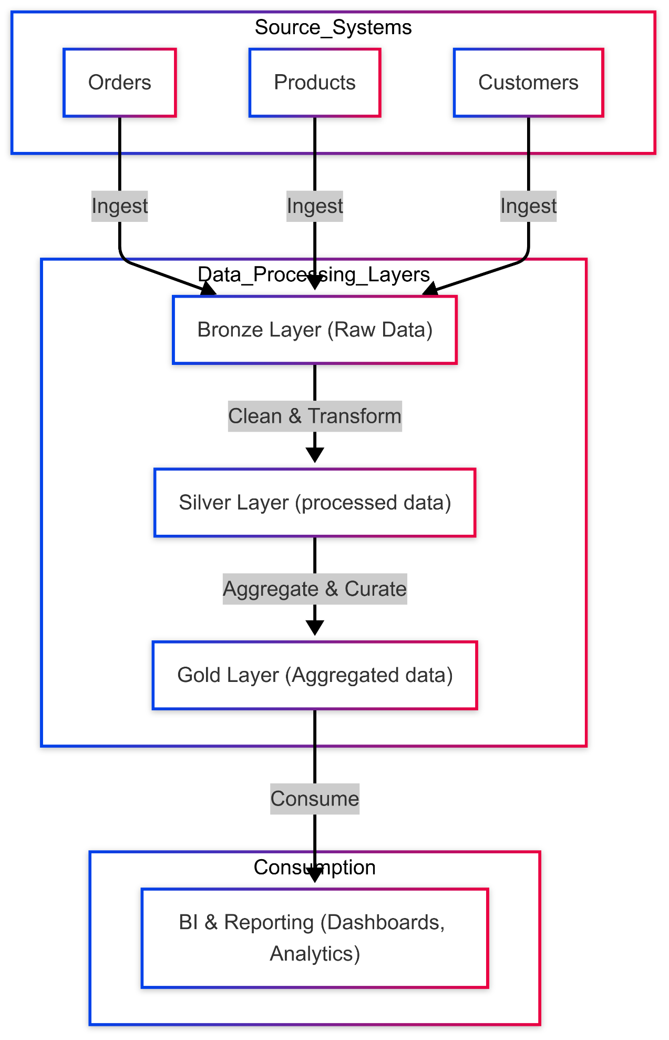

Project Implementation Details

Data Ingestion Setup
Our primary storage is Azure Data Lake Storage Gen2 (ADLS Gen2), mirroring the Medallion layers with dedicated containers:
- raw container: Bronze layer, for untransformed sales data.
- processed container: Silver layer, for cleaned and enriched data.
- presentation container: Gold layer, for curated and aggregated data.

Data Model
Our data model, built on Delta Lake, follows the Medallion Architecture:
- Bronze Layer: Raw data for Orders, Products, and Customers are stored in their respective raw Delta tables.
- Silver Layer: These raw tables are joined and transformed to create the ecomm_combined_data Delta table, offering a unified transactional view.
- Gold Layer: The ecomm_combined_data table is further aggregated to produce the ecomm_profit_agg Delta table, a fact table pre-calculating key business metrics optimized for BI tools.

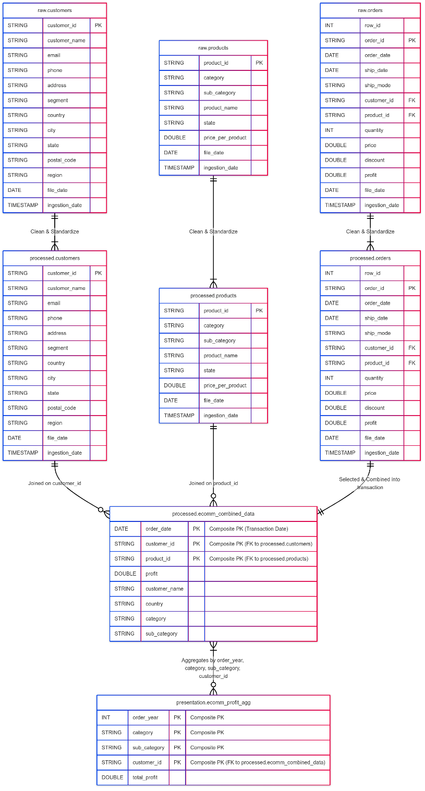

Data Governance with Unity Catalog
We ensure robust data governance through Databricks Unity Catalog. It provides centralized metadata, fine-grained access controls, and comprehensive data lineage for all our data assets.
We created external locations and access connector for data bricks to map the adls locations to corresponding raw, processed and presentation layer

Data Quality Checks and Transformations
This section outlines the specific data quality issues identified and the subsequent transformations applied during the ingestion pipelines for Customer, Order, and Product data into the processed (Silver) layer. These checks ensure data cleanliness, standardization, and readiness for downstream analysis.
1. Customers Ingestion Pipeline
- Objective: Standardize column names, handle missing values, and clean problematic string entries.
- Key Checks/Transformations Performed:
  - Column Standardization: All column names are converted to a consistent, snake_case format (e.g., "Customer ID" becomes customer_id, "Customer Name" becomes customer_name).
  - Customer Name Cleaning: Null values identified in the customer_name column are handled (e.g., replaced with a default string like 'unknown' or removed, as per business rules).
  - Phone Number Cleaning: Specific erroneous strings (e.g., #ERROR) found in the phone number column are addressed (e.g., replaced with 'unknown' or nullified).
  - Metadata Addition: file_date (from the source file path) and ingestion_date (current processing timestamp) columns are added.
2. Orders Ingestion Pipeline
- Objective: Standardize column names and ensure numerical precision for financial figures.
- Key Checks/Transformations Performed:
  - Column Standardization: Similar to customers, order-related column names are standardized (e.g., "Order ID" to order_id, "Order Date" to order_date).
  - Profit Rounding: The profit column values are rounded to two decimal places to ensure financial precision, handling various decimal lengths and edge cases (e.g., 0.005 rounding to 0.01, 0.004 rounding to 0.0).
  - Metadata Addition: file_date and ingestion_date columns are added.
3. Products Ingestion Pipeline
- Objective: Standardize column names and handle missing numerical values.
- Key Checks/Transformations Performed:
  - Column Standardization: Product-related column names are standardized (e.g., "Product ID" to product_id, "Sub-Category" to sub_category).
  - Price per Product Null Handling: Missing values (nulls) in the price_per_product column are explicitly handled (e.g., by filling them with a default value like 0.0 or a calculated average).
  - Metadata Addition: file_date and ingestion_date columns are added.

Unit Test Documentation: Data Ingestion Pipelines
Our unit tests provide strong assurance of the functional correctness and robustness of our data ingestion pipelines. Each pipeline's tests validate data loading, standardization, cleaning, and Delta table saving.
1.Customer Data Ingestion Tests
- Column Renaming: Verifies standardization of raw customer columns and accurate file_date addition.
- Null Handling (customer_name): Ensures NULL customer names are handled, coalescing to "unknown."
- Phone Error Handling: Validates replacement of "error" strings or invalid phone formats with "unknown."
- Ingestion Date: Confirms ingestion_date column addition and TimestampType.
- Pipeline Orchestration: Verifies the end-to-end flow, ensuring all sub-functions are called correctly.
2.Orders Data Ingestion Tests
- Raw JSON Loading: Validates correct loading of JSON order files, including path, schema, and dateFormat/multiLine options.
- Column Standardization: Asserts accurate renaming of order columns and file_date append.
- Profit Rounding: Parameterized test rigorously checks profit column rounding to two decimal places, including nulls and edge cases.
- Delta Save: Confirms data saving to Delta, verifying "delta" format, "overwrite" mode, and overwriteSchema option.
- Pipeline Orchestration: Comprehensive test ensuring all pipeline stages execute correctly, from loading to saving to both raw and processed Delta tables.
3.Products Data Ingestion Tests
- Raw CSV Loading: Verifies successful loading of CSV product files, including path, schema, and "header" option.
- Column Standardization: Checks accurate renaming of product columns and file_date addition.
- Price Null Handling: Specifically tests cleaning price_per_product column, confirming NULL values are filled with 0.0.
- Delta Save: Asserts data saving to Delta, validating "delta" format, "overwrite" mode, and overwriteSchema option.
- Pipeline Orchestration: End-to-end test confirming all product ingestion functions are called correctly, saving data to raw and processed Delta tables.

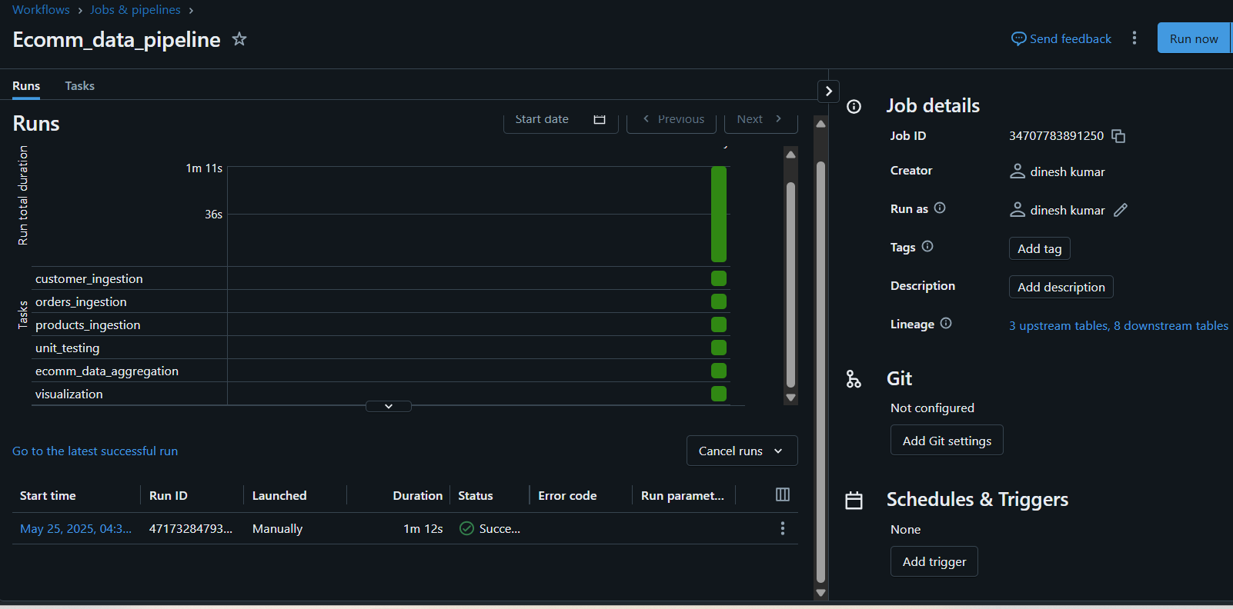
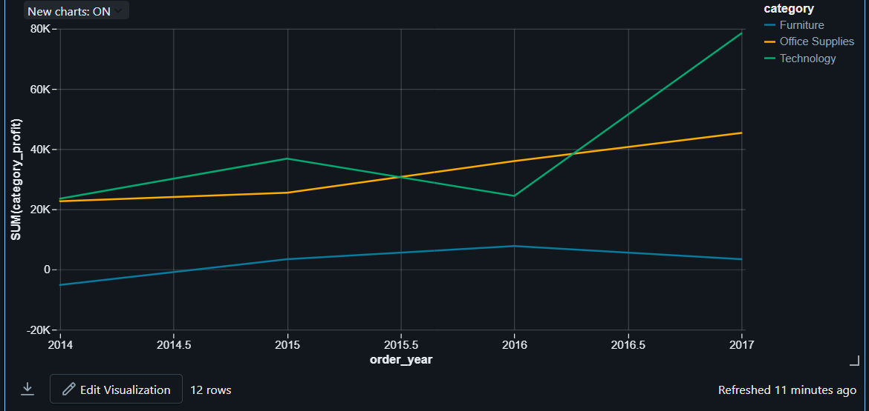
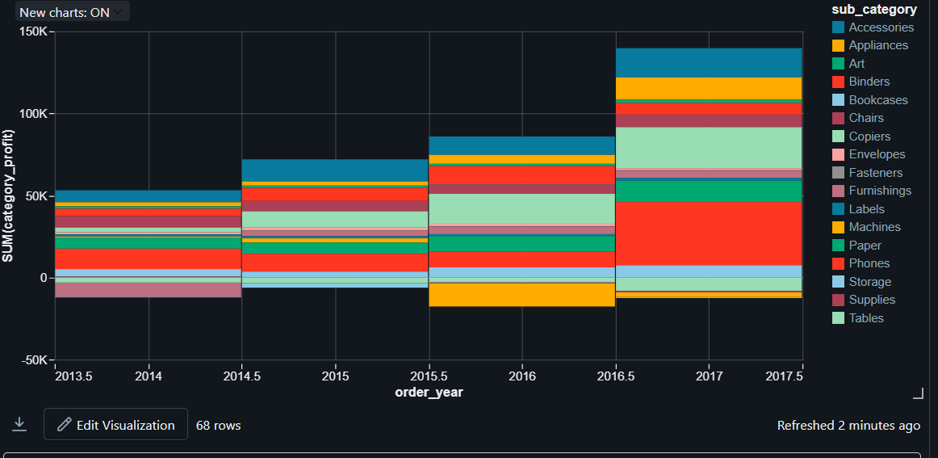
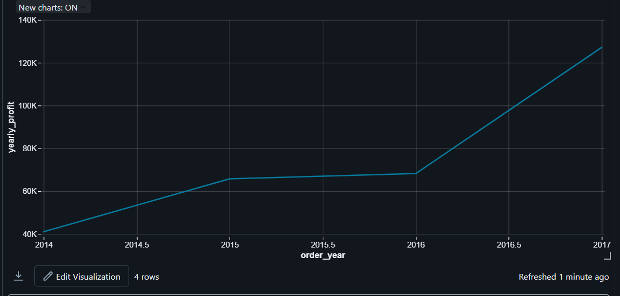
Key Insights: Positive
- 2017 Profit Surge: Overall profit exploded to $127K, up 87% from 2016.
- Technology Dominance: Consistently leads, since 2014.
- Phones & Copiers Excel: Top sub-categories driving Technology's massive growth.

Key Insights: For Improvement
- Furniture's Profit Drain: Consistently low or negative profits.
- Tables & Bookcases Lose Money: Major loss-makers within Furniture.

Azure resources -Dashboard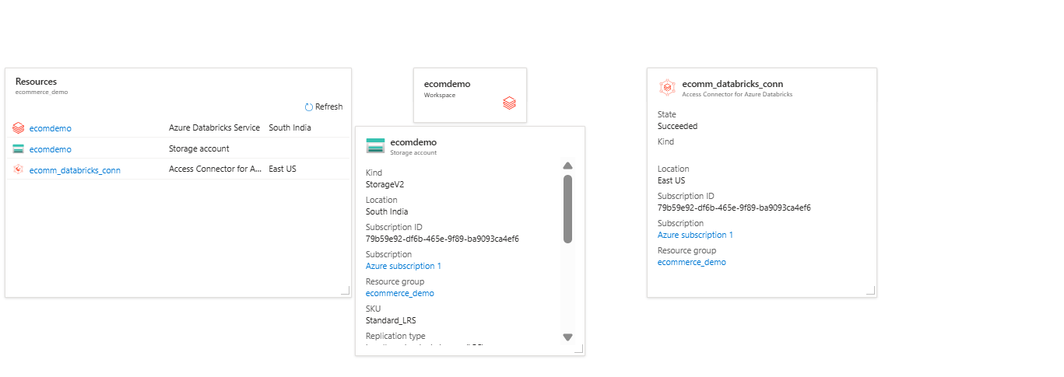

Additional Resources
For more details on Microsoft's implementation of the Medallion Architecture in Azure and Databricks, refer to the Azure Data Factory on Azure landing zones baseline architecture documentation.

Future enhancements

Incremental load enhancements

Write unit testing on aggregation logics

