**-- Use the database**

USE Ecommerce;

**-- 1.1 Insert Data into customers (Using NULL for Bob Johnson's phone)**

INSERT INTO customers (Customer_name, Phone_no, Email, Address) VALUES

('Alice Smith', '555-0101', 'alice.smith@example.com', '123 Oak St, CityA'),

('Bob Johnson', NULL, 'bob.j@example.com', '456 Pine Ave, CityB'), -- NULL Phone_no

('Charlie Brown', '555-0303', 'charlieb@example.com', '789 Maple Rd, CityC'),

('David Lee', '555-0404', 'david.lee@example.com', '101 Elm Blvd, CityD');

**-- 1.2 Insert Data into products**

INSERT INTO products (Product_name, Price, Stock) VALUES

('Laptop Pro X', 1200.00, 15),

('Wireless Mouse', 25.50, 150),

('Mechanical Keyboard', 75.99, 50),

('27-inch Monitor', 350.00, 25),

('Webcam HD', 45.00, 0);

**-- 1.3 Insert Data into orders**

INSERT INTO orders (Customer_id, Product_id, Order_date, Quantity, Order_status) VALUES

(1, 1, '2023-10-01', 1, 'delivered'),

(2, 2, '2023-10-03', 2, 'delivered'),

(1, 3, '2023-10-05', 1, 'shipped'),

(3, 4, '2023-10-06', 1, 'pending');

**-- Insert using the DEFAULT 'pending' status by omitting the column (SQLite method)**

INSERT INTO orders (Customer_id, Product_id, Order_date, Quantity) VALUES

(4, 2, '2023-10-07', 3); -- Order_status will automatically be 'pending'

**-- 1.4 Insert Data into payments**

INSERT INTO payments (Order_id, Payment_method, Payment_date, Amount, Payment_status) VALUES

(1, 'Credit Card', '2023-10-01', 1200.00, 'completed'),

(2, 'PayPal', '2023-10-03', 51.00, 'completed'),

(3, 'Debit Card', '2023-10-05', 75.99, 'pending');

**select*from customers; (Before Update Customer Table)**

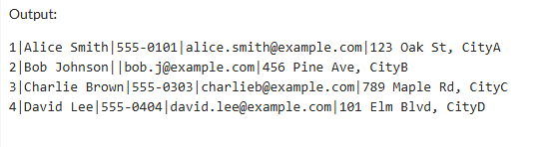

**select*from orders;(Before Update orders Table)**

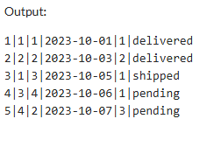

**select*from products;(Before Update products Table)**

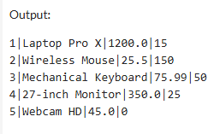

**select*from payments;(Before Update payments Table)**

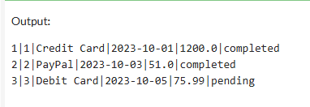

**-- 2.1 Update Bob Johnson's missing phone number**

UPDATE customers SET Phone_no = '555-0299' WHERE Customer_name = 'Bob Johnson';

**select*from customers; (After Update Customer Table)**

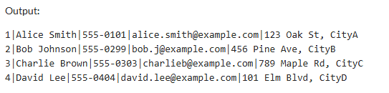

**-- 2.2 Update Product Stock (A shipment of keyboards arrived)**

UPDATE products SET Stock = Stock + 20 WHERE Product_name = 'Mechanical Keyboard';

**select*from products;(After Update products Table)**

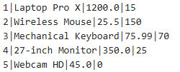

**-- 2.3 Update Order and Payment Status (Order 3 is now delivered and paid)**

**-- First, update the order status**

UPDATE orders SET Order_status = 'delivered' WHERE Order_id = 3;

**select*from orders;(After Update orders Table)**

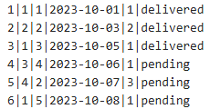

**— 2.4 Then, update the corresponding payment status and date**

UPDATE payments SET Payment_status = 'completed', Payment_date = '2023-10-10'

WHERE Order_id = 3;

**select*from payments;(After Update payments Table)**



**-- Identify the Order_id for David Lee (who has the latest pending order, Order_id 5)**

**-- We must delete the order first due to Foreign Key constraints.**

**-- 3.1 Delete the order placed by David Lee**

DELETE FROM orders WHERE Customer_id = (SELECT Customer_id FROM customers WHERE Customer_name = 'David Lee') AND Order_status = 'pending';

**select*from orders;(After Delete Orders)**

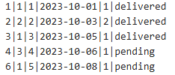

**-- 3.2 Delete the Customer record for David Lee**

DELETE FROM customers WHERE Customer_name = 'David Lee';

**select*from customers; (After Delete Customer)**

